Overview
smm-tester-connector was extracted from smm-tester. smm-tester was created by Nathan Bunker.
The smm-tester has many components which will be used to create query, parse it using proprietary java code. Also it transform query to Z34, Z32, etc. formats.
For NBS we have decided to use Hapi API to create request query and parse response. For that reason we have extracted connector piece of the code form Nathan's smm-tester.

How to create JAR smm-tester-connector.jar
1) Open this project in eclipse
2) Fix compilation errors by referring NBS\iis-smm-tester-connector\Lib jars
3) Right click on project in eclipse, and click on export
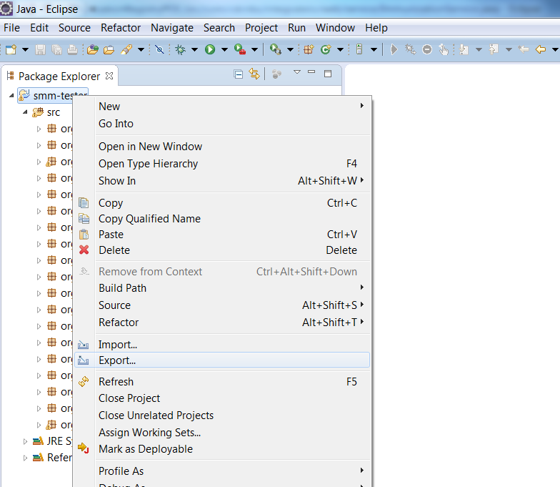
4) Select Java JAR file
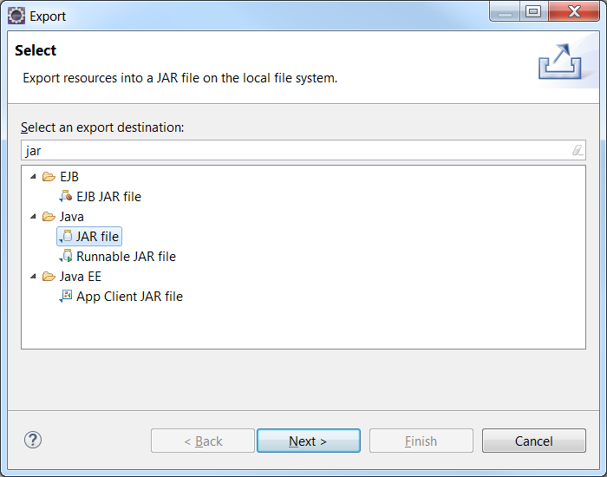

5) Click Next button, browse JAR file location to generate file
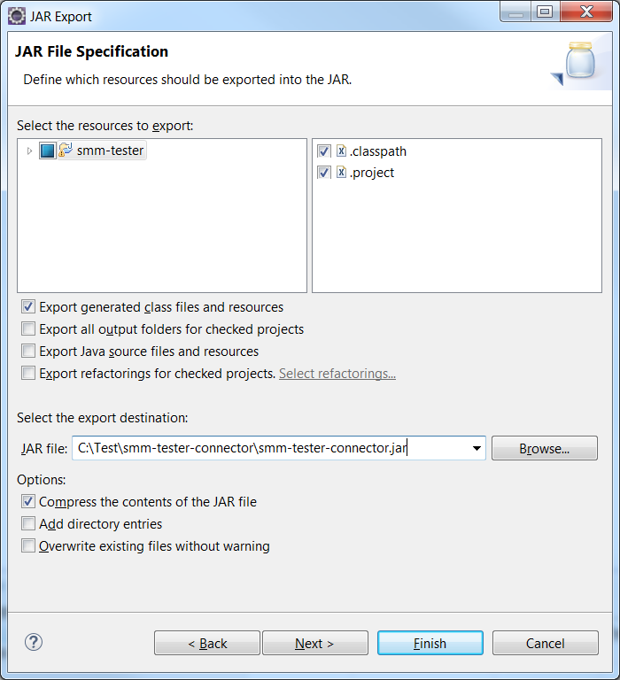
6) Click Finish, It will generate smm-tester-connector.jar at specified location.

