

SimpleReport User Guide

*Version 1.1 - 1.22.2021*  
  
  
  
  
  
  
  
  
**Clickable Table of Contents:**

**Registering for an account** **2**

**Signing in to SimpleReport** **6**

**Running a Test and Submitting it to Public Health** **7**

**Adding a new person to the People List** **9**

**Features of the Patient Card in the Test Queue** **10**

**Reviewing a Patient's Test History** **13**

**Adding or editing a Facility’s information and devices** **14**

**Joining the SimpleReport Google Group** **16**

**Resetting your SimpleReport Password** **18**

**Troubleshooting Issues & Getting support** **20**

# 

# Registering for an account

**Step 1:**

SimpleReport uses a service called “Okta” to register users and access the application. You should receive an invite in your email for an invitation to join Simple Report. Click the green “Activate your SimpleReport Account” to sign up. You must register within 7 days of receiving this invitation.

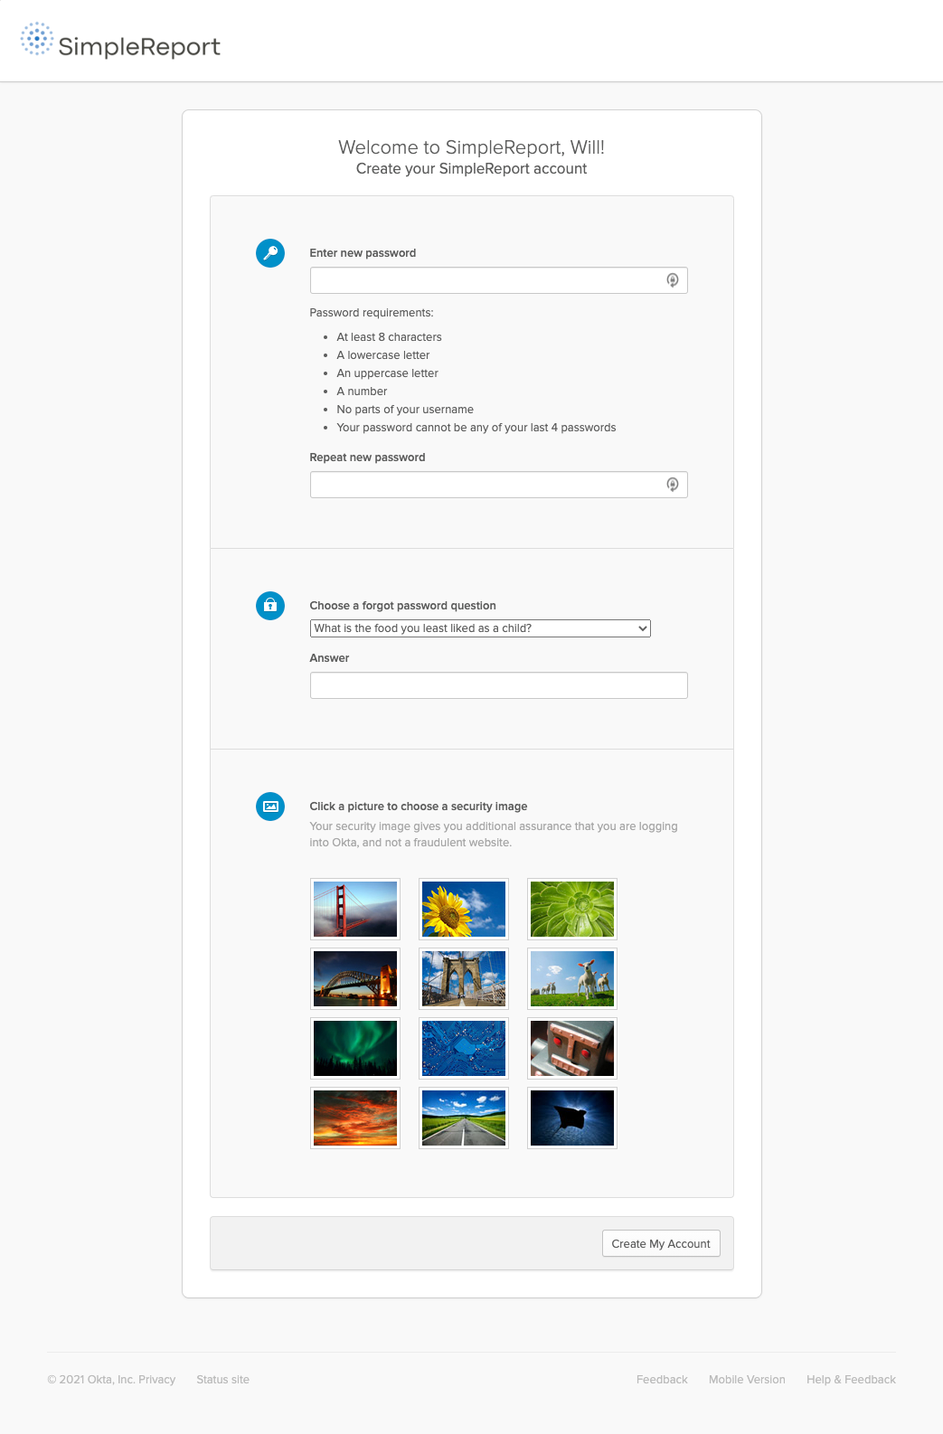

**Step 2:**

After clicking the “Activate your SimpleReport Account” from the invitation email, you’ll set up an account by choosing:

* A secure password
* A forgot password question
* A security image

Make those selections and remember/save them, then click the “Create My Account” button at the bottom.

**Step 3:**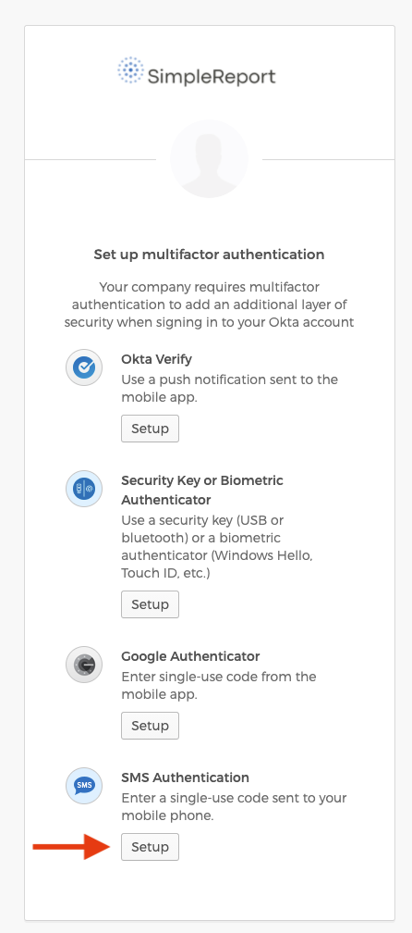

After you’ve registered, you’ll have to select a multifactor authentication option to verify your identity for SimpleReport. This can be done using any of these options For most users, SMS is the easiest and fastest option:

* An SMS text message to your phone
* Installing the Google Authentication App, downloaded to your your mobile phone
* Installing the Okta Verify Authentication App to your mobile phone
* *(Not currently active unless you have a CDC account)* Using a Security Key or Biometric Authenticator

Select your multifactor authentication choice by clicking the “Setup” button below the option you want to use.

**Step 3a:**If you choose select SMS Authentication (for Okta Verify of Google Authenticator instructions, go to step : 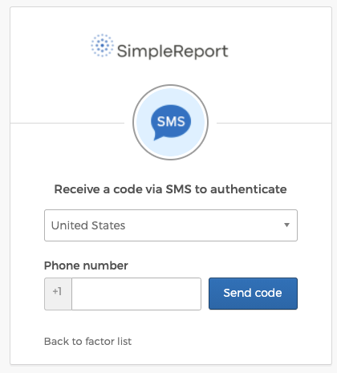

Enter your phone number in the phone number filed and click the blue Send Code button.

**Step 3b:**You’ll receive an SMS text message shortly on your mobile phone with a 6-digit code. Post that code in field marked “Enter Code” on the log in window, and click Verify. 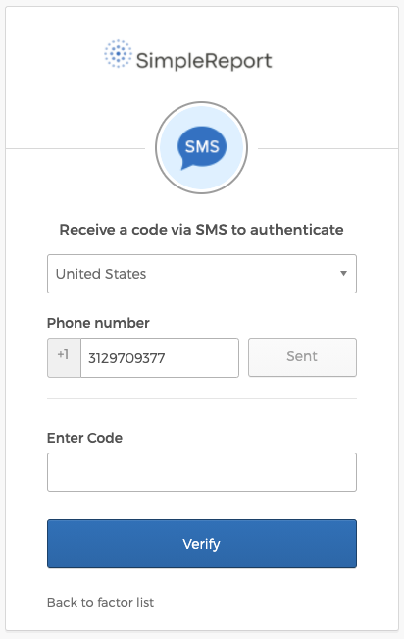

If you’re using SMS authentication, go to Step 5 in the instructions.

If you’re using Google Authenticator or Okta Verify, go to Step 4.

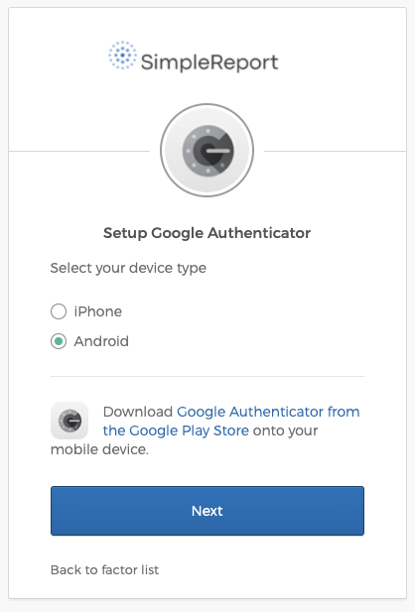

**Step 4:**

To use the Google Authenticator or Okta Verify mobile application methods, click the “Setup” button below that option.

**Step 4a:**

Select your device type, then click the link to Download the application from that App store. Wait for the app to download and install, then click “Next.”

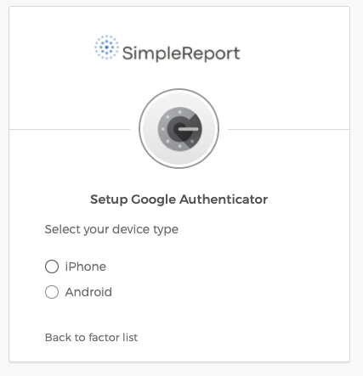

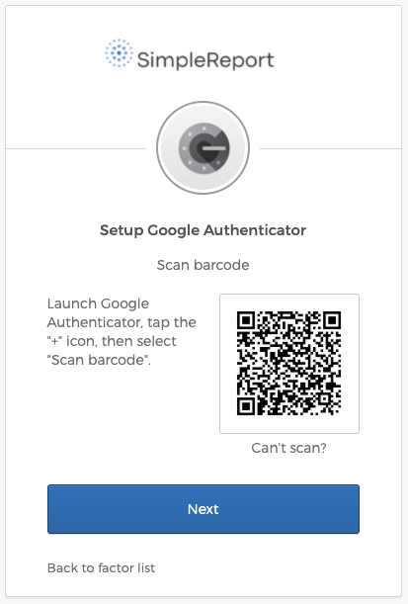

**Step 4b:**

After you’ve installed the Google Authenticator or Okta Verify app, launch the app on your phone, and scan the QR Code shown in your registration window using your phone to link your account and device.

**Step 4c:**

Go into the app and it will give you a code for Okta, type that code into the login page and click verify. The code will change every minute so you will need to look it up each time you log in.

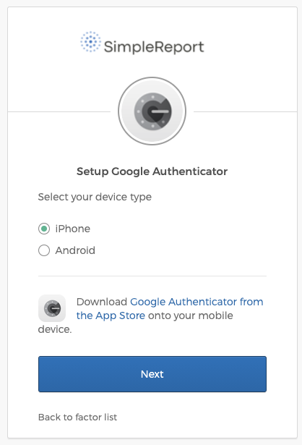

**Step 5:**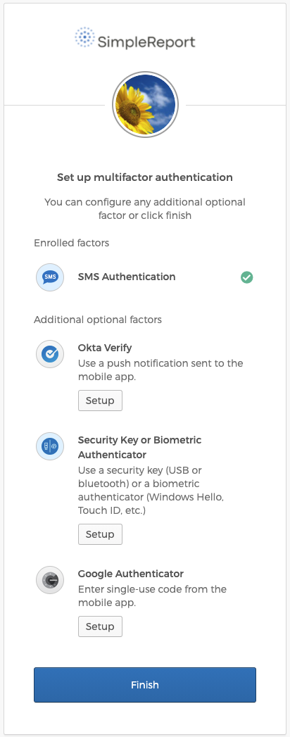

Click the “Finish” button at the bottom of the registration page, and you’ll receive a confirmation email message that your multifactor authentication has been successfully set up as well as this confirmation on the screen:

**Step 6:**Once you have confirmation that your account is registered, you can go to [SimpleReport.Gov](http://simplereport.gov) and sign in as a user to start logging test results.

# 

# 

# Signing in to SimpleReport

Once you have your SimpleReport account set up, you can now log in and start logging test results.

**Step 1:**

Go to [SimpleReport.gov](http://simplereport.gov) and click on the “Log in” button.

**Step 2:**

Enter your username and password, and if prompted verify your identity through SMS or the authentication app you chose when signing up.

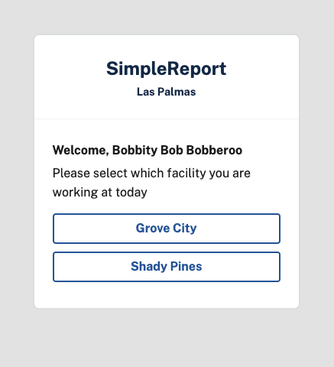

**Step 3:**

If your organization has multiple testing facilities, select your facility in the top left corner of the screen:

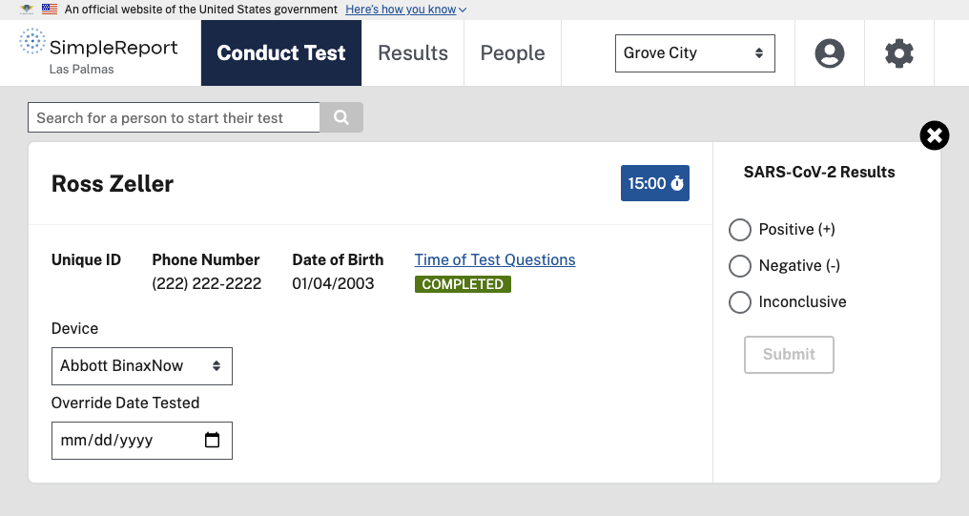

**Step 4:**

At the top of your screen you can select “Conduct Test” to run and report a test, “Results” to view previous test results, or “People” to add a new person to SimpleReport.

# Running a Test and Submitting it to Public Health

**Step 1:**

After you’ve logged in, select “Conduct Test” in the top navigation bar:

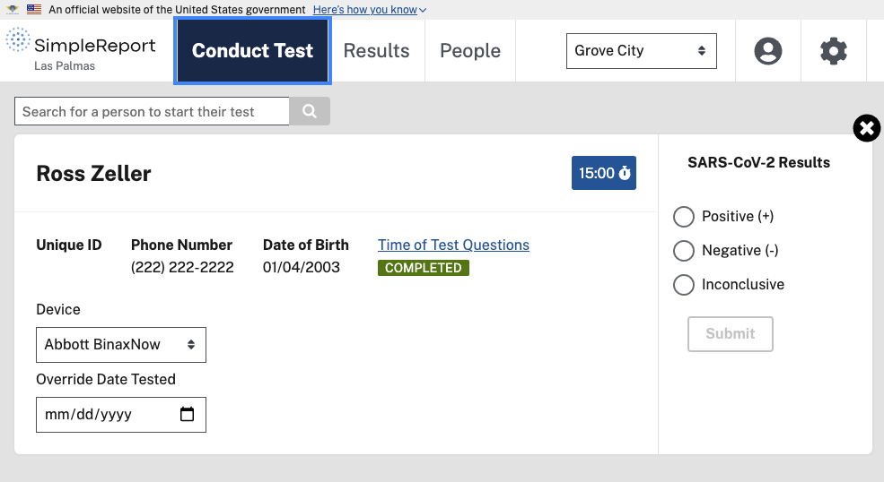

**Step 2:**

Search for the person in the search bar to start their test.If this is a new person to your testing site (visitor, new student, new staff member), select “People” in the top navigation and add them to the People List.

**Step 3:**

Once you found the person in the search results, select their name to begin the test:

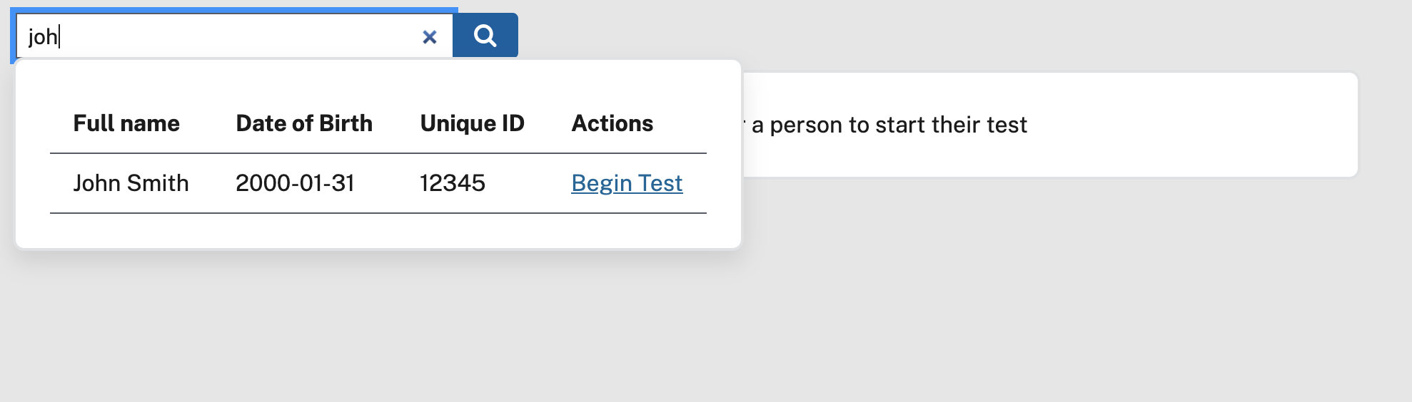

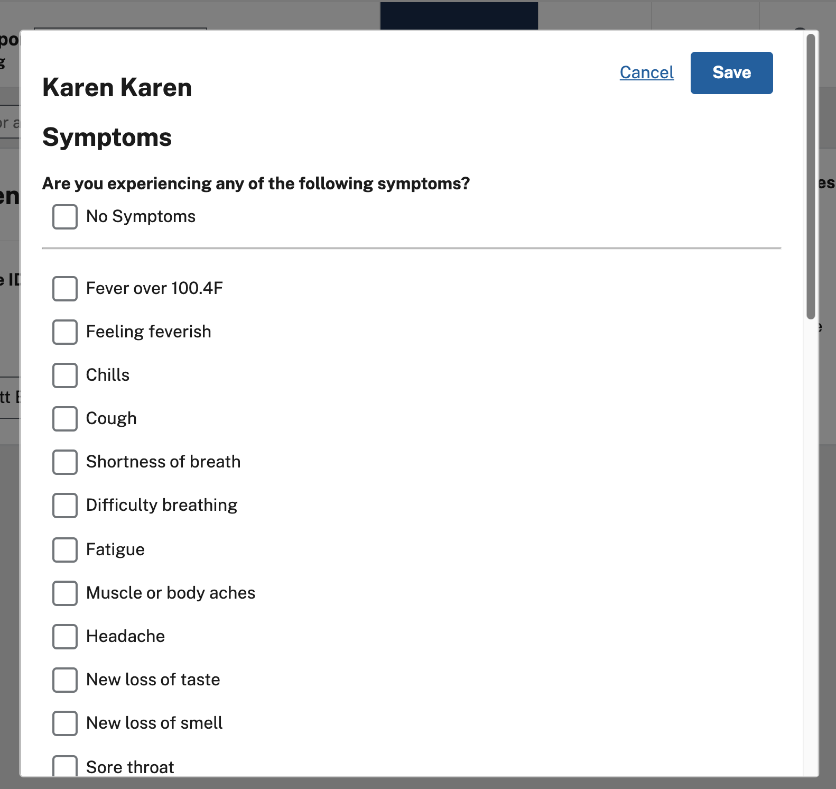

**Step 4:**

Fill out their Time of Test information, click “Save” and conduct the test.

**Step 5:**

Collect the swab from the patient, and prepare their sample in the test. Start the 15 minute Timer on the testing card for that patient. It will make a noise once the test is ready for you to read the result if your device has it’s sound turned up.

**Step 6:**

Verify the Device selected is correct (it should default to the facility’s primary device). Once the timer expires, select the result, and click “Submit.” Your test result has now been submitted to the public health department. You do not need to do anything else.

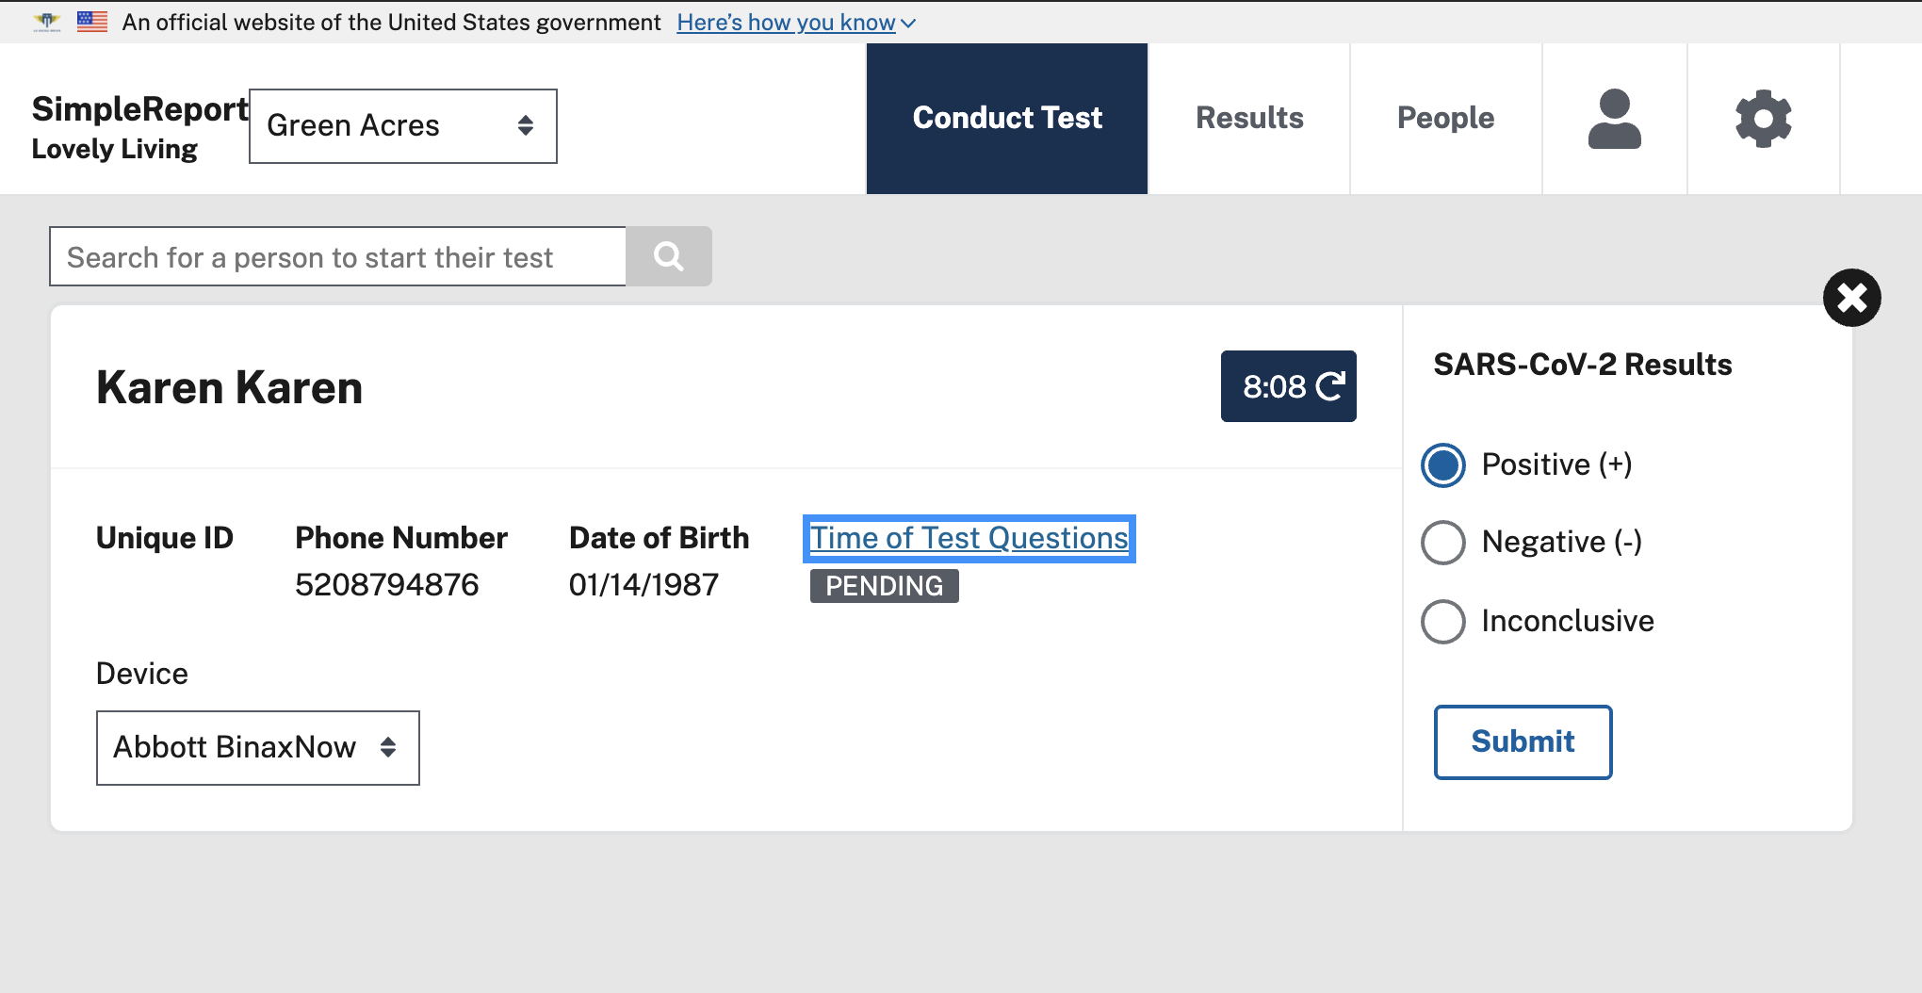

# Adding a new person to the People List

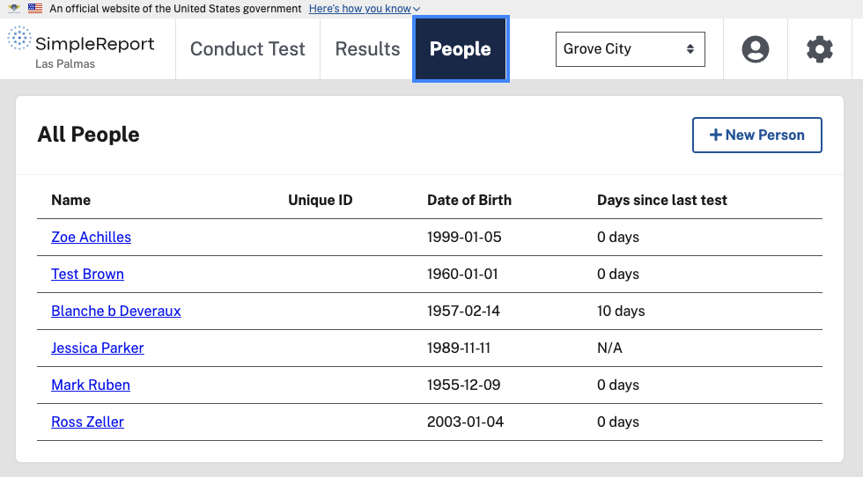

**Step 1:**After you’ve logged into the application, and select “People” in the top navigation bar, select the “New Person” button to add a new person:

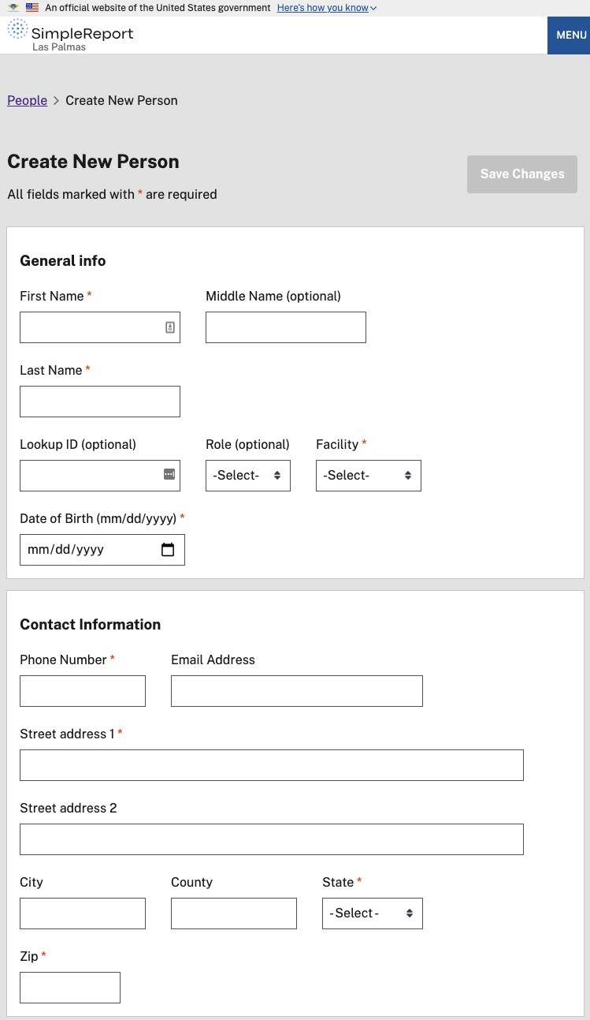

**Step 2:**Fill out their personal information in the fields provided:

Item’s with red asterisks like this * are required.

**Step 3:**

Once completed, click the “Save Changes” button at the top or the bottom of the page and they will appear in the “People” section of the site now.

# Features of the Patient Card in the Test Queue

Once you’ve found your patient and added then to your test queue, there’s many options to enter data in the patient card:

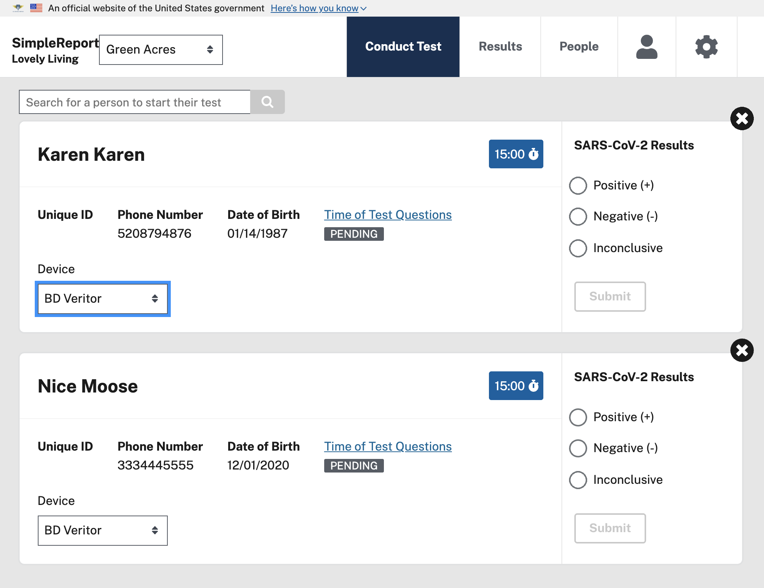

**Patient Card Features:**

Here’s a breakdown of the different functionality of the Patient card:

|  |  |
| --- | --- |
|  | **Time of Test Questions**  The questions at the time of test are editable until you click “Submit” to submit the test results. They will be “Pending” until they are filled out and show as “Completed” once all the required fields are filled in. |
|  | **Delete a test in the queue**  If you need to delete a test before submitting it, you can click the black “X” on the top right of the patient card. |
| The timer before it is started (click to start it):    Timer counting down:    After the timer was started and 15 minutes has passed it will tell you “RESULT READY”: | **15 Minute Timer**  Click to start the timer after you’ve collected the test and it will track and alert you when 15 minutes has expired. You can also start multiple timers at once if you are testing multiple patients. |
|  | **Device Type**  The testing Device will automatically be set based on the default of the Facility that the patient is tested at (Facilities can change this information and devices here), but you can change that at the time of test also if there are multiple devices. |
|  | **Test Results**  The test results have 3 options you can select. Once the Time of Test Questions and the Timer has concluded, the grey “Submit” button will turn blue and it will be clickable. |
|  | **Submit a test result**  Once all the Patient information is collected and the test result has finished the 15 minute test period, the Submit button will turn Blue and you can submit the results. |

# 

# 

# Reviewing a Patient's Test History

**Step 1:**

After you’re logged in, click on the “People” button at the top of SimpleReport.

**Step 2:**

Search for the person you’re looking for in the results and click their name:

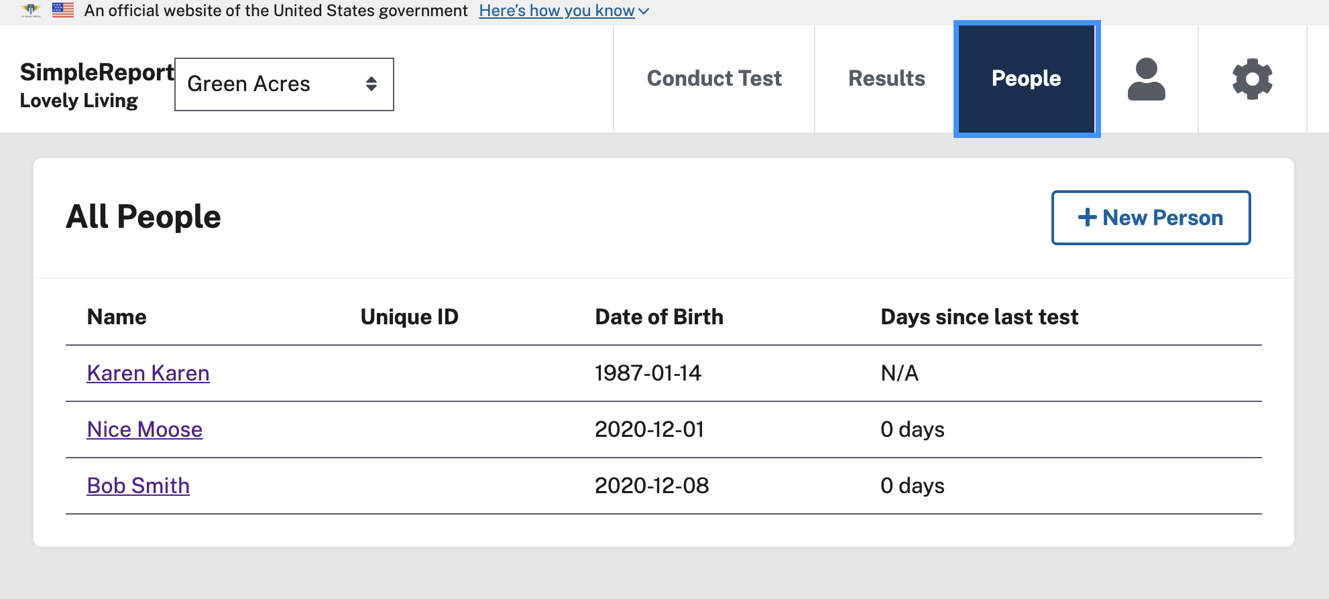

**Step 3:**

On the Patient Profile page, their Test History will be displayed at the bottom: 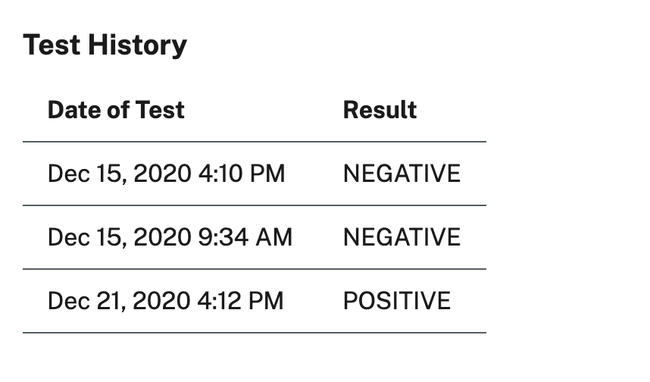

# 

# Adding or editing a Facility’s information and devices

**Step 1:**

Select the gear icon in the top right corner, then “Manage Facilities” in the subnavigation:

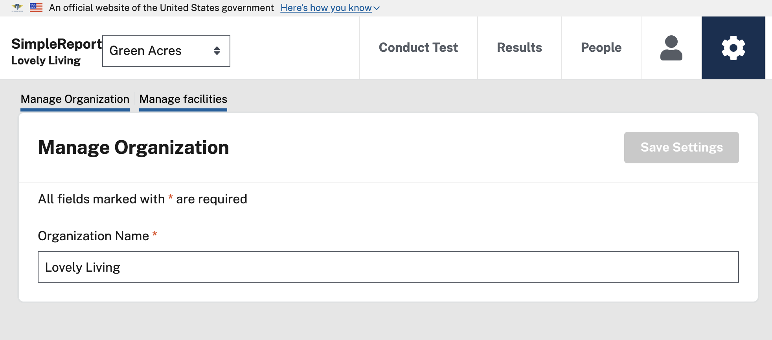

**Step 2:**

Click on the Facility name. Or if adding a new Facility, the “+ New Facility” button in the top right.

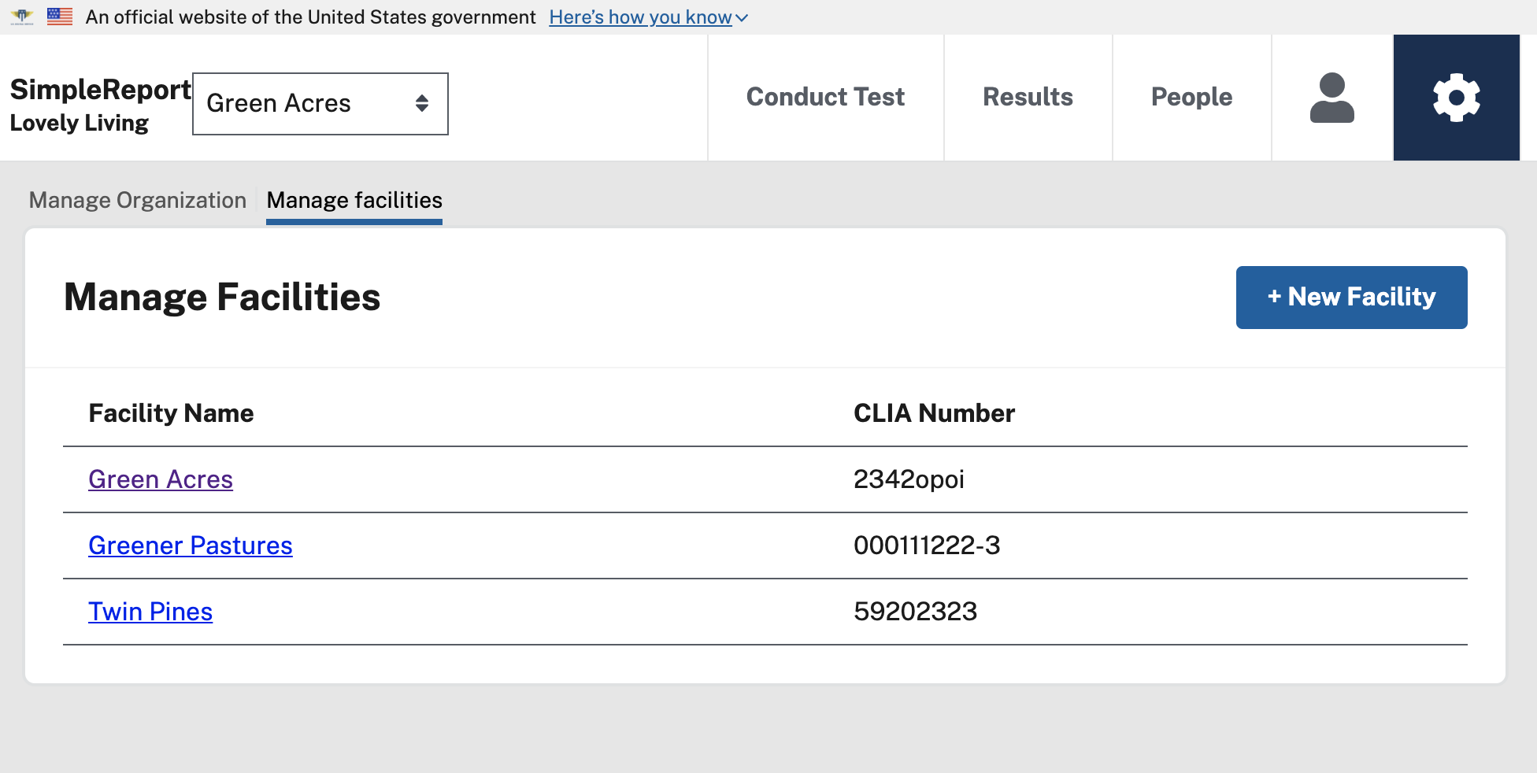

**Step 3:**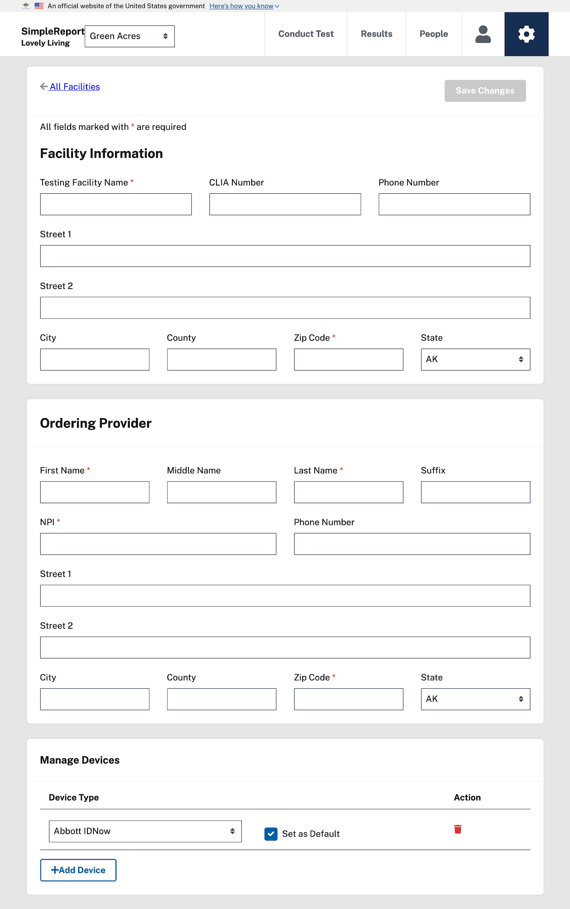

**Notable:** Changing the facility information can cause problems with reporting the data to public health and should only be done if absolutely necessary. If you will be changing the name of your facility, please contact [USDS@cdc.gov](mailto:USDS@cdc.gov) to ensure your results will be attributed to public health correctly.

Edit the Facility information and select default testing devices in the form:

**Step 4:**

Once you’ve entered all the information, click “Save” at the top right and the Facility will be saved in SimpleReport for future use.

# Joining the SimpleReport Google Group

Thanks for using the SimpleReport point of care reporting tool for combatting Covid-19! We’re setting up a [Google Group](https://groups.google.com/u/1/g/cdc-usds) as a means for quickly sharing out information on the project. In this free, email-based group, we will send out updates on our software releases, announce new features, as well as collect feedback and offer opportunities for you to share your thoughts about how we can improve the platform. In the group we’ll have a few dozen people, including USDS and CDC staff and researchers working on building out the platform, as well as our pilot partners (like you) who are helping test and share feedback about the platform. This will be a closed group just to those parties, but anyone of those parties can see responses, send messages to the group, respond, and share their feedback and thoughts with everyone else in the group.

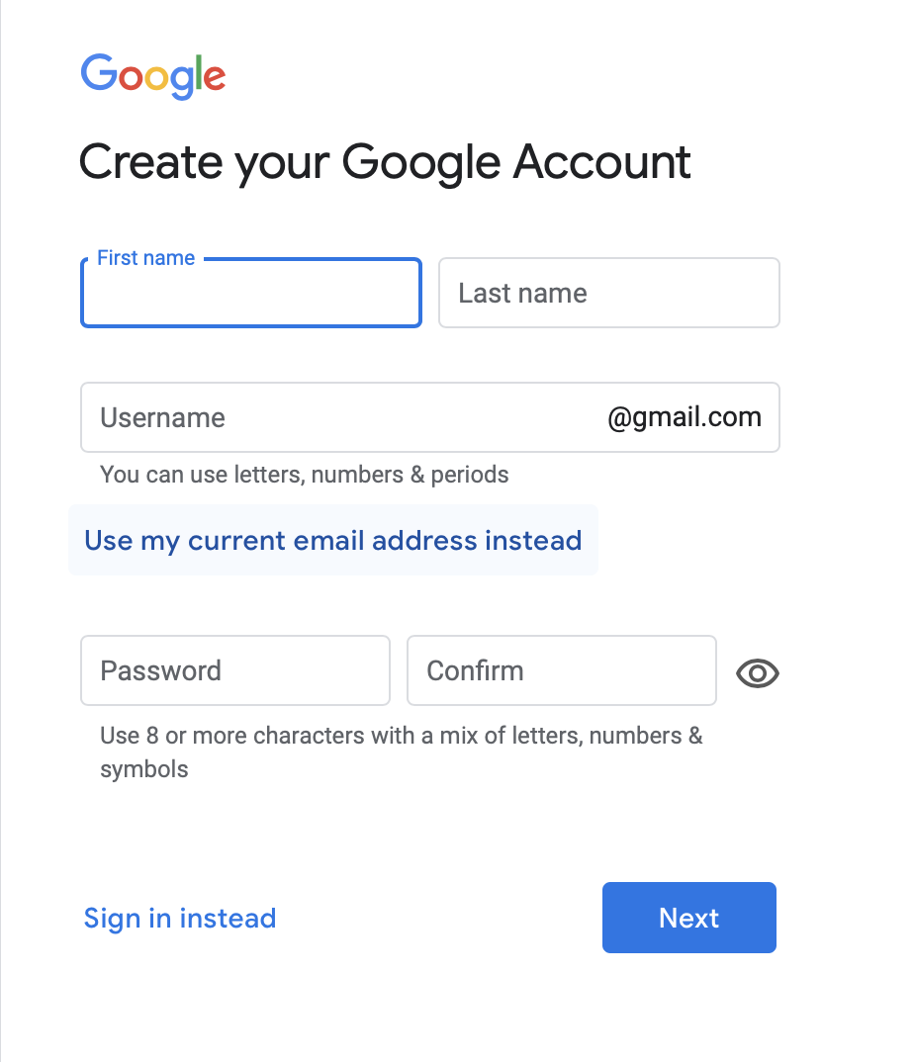**Step 1:**

You will need to use a work email address associated with a Google account to join. If you don’t have a Google account associated with your work email, go to accounts.google.com and select “Create Account” and “To Manage My Business” in the drop down (see image on the right).   
  
Also notable: If you're logged in with a different or personal google account you can click your profile picture in the upper right then choose "Add another account" to get to the [accounts.google.com](http://accounts.google.com) sign-in page that will let you click Create account.

**Step 2:**Create the new account with your name, then Google will send you a numeric code to your email, go get that and verify the account. 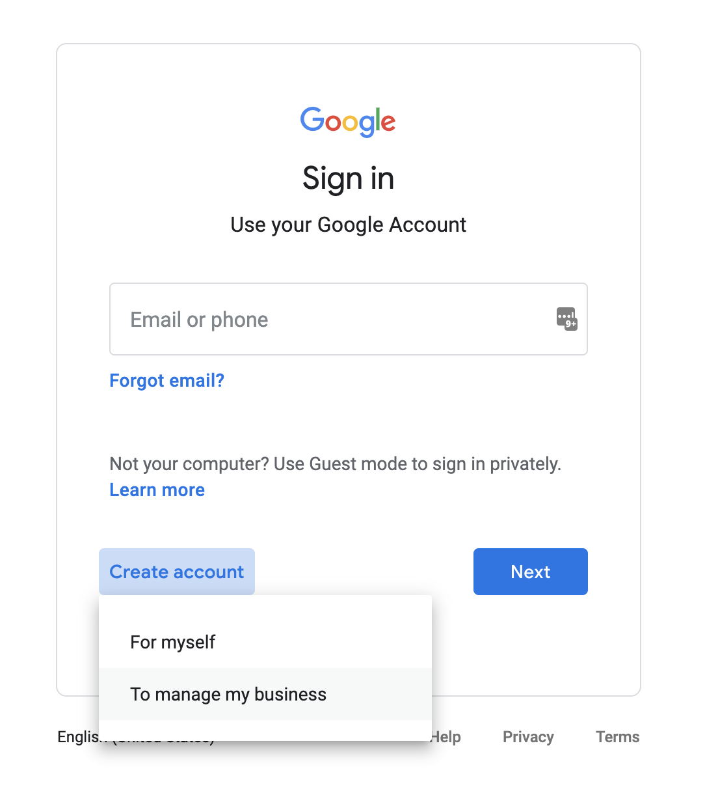

**Step 3:**

Next Google will ask for a phone number. They will use this to text you a code. Add your phone number to verify the account, and verify it with the code they send.

**Step 4:**

Fill out the last remaining fields required (or opt out if they are optional).

**Step 5:**

Once your Google account is live, email Sparkle or Will at usds@cdc.gov and they can invite you to the group.

**Step 6:**Accept the invite in your work Google account, and enjoy group conversations with the USDS, CDC, and other pilot partners in your inbox or at:

<https://groups.google.com/u/1/g/cdc-usds>

# 

# Resetting your SimpleReport Password

**Step 1:**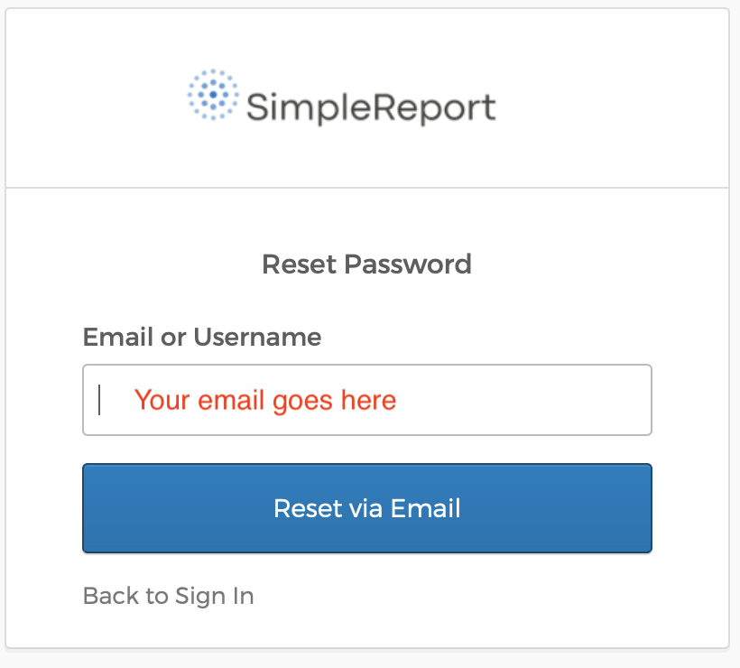

To reset your password, go to <https://hhs-prime.okta.com/signin/forgot-password> Enter your email and click the “Reset Via Email” button.

You can also get here from the SimpleReport sign-in page if you click the “Need help signing in?” text link: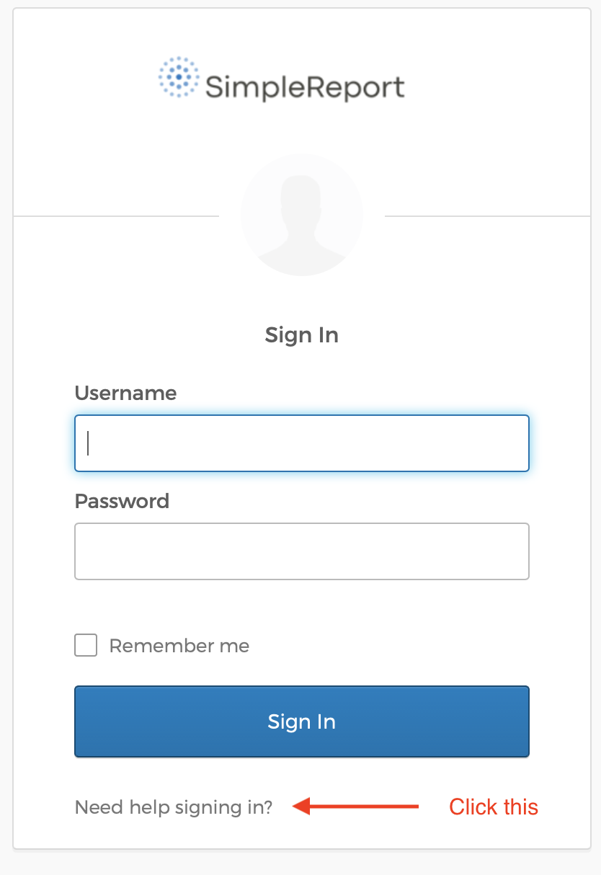

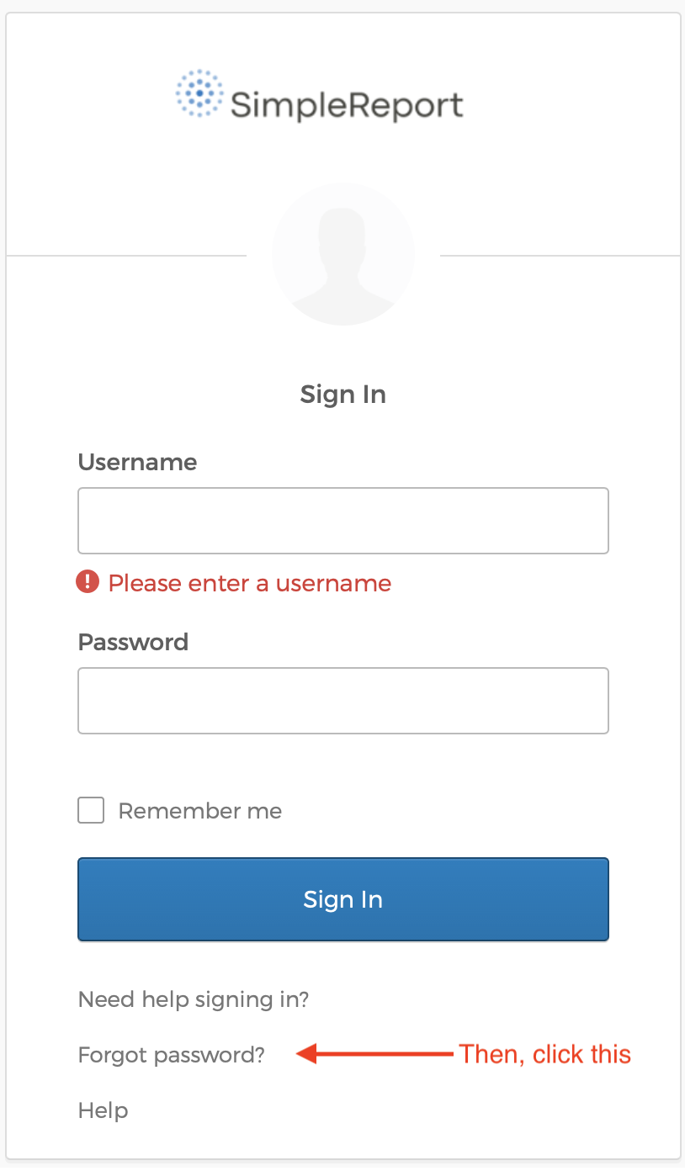

**Step 2:**

Enter your email address that you used to sign up for SimpleReport and click the “Reset via Email” button.

**Step 3:**

Check your email for a message to reset your password. Click the link in the email, and you will be able to pick a new password for your account.

# Troubleshooting Issues & Getting support

**Step 1:**

If you’re having general trouble with SimpleReport, here’s a few common troubleshooting tips:

* Try logging out and logging back into your account
* Reboot your device
* Refresh the website by pulling down on the tab or click the refresh button
* Check your internet connection to make sure it’s receiving data from other sites

**Step 2:**

If that doesn’t fix it, please contact [USDS@CDC.gov](mailto:USDS@CDC.gov) with information about the problems you're seeing. Please share any screenshots of the issue and as clearly as you can explain what is happening, what is expected, and what’s going wrong, and we’ll follow up to help.