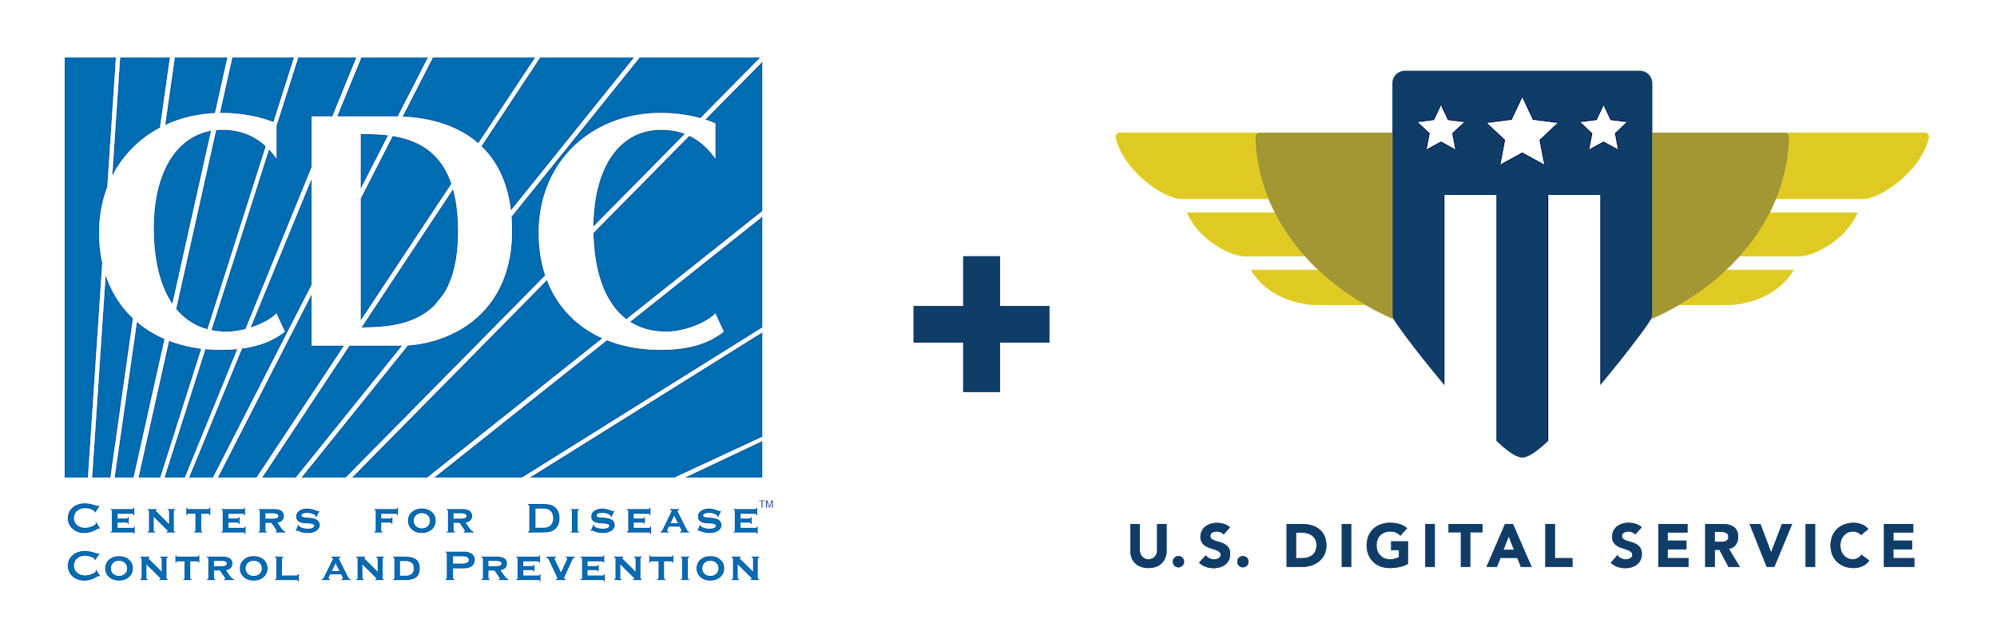

**SimpleReport**

Site Onboarding Guide

*Version 1.1 - 01.07.21*

**Onboarding Next Steps** **2**

Organization and Facility Settings 2

Staff Access 2

**Onboarding Checklist** **3**

Organization Information 3

Site Specific information 3

Staff Access 3

Schedule Training Session 3

# Onboarding Next Steps

Welcome to SimpleReport! In order to schedule a training session with your staff, we need to confirm organization and facility information in addition to getting your staff set up with accounts to access Simple Report. Below is a simple checklist that will help you keep track of the requested items. After you have completed all the steps on the checklist and confirmed that your staff members have successfully authenticated their SimpleReport login accounts, we will schedule your SimpleReport training session.

## Organization and Facility Settings

In order to get an account, you MUST fill out a SimpleReport Account request form. This form should be completed for each individual site where you plan on performing testing. It is important that the names used on this form to identify these locations are accurate as these will be the names reported to the Public Health Department.

For each site, you will have the option of doing a one-time bulk upload of individuals at that site who will be tested regularly. For example, if you have staff members who undergo repeat testing, or if you know that all testing will be done on a consistent population of students or residents, you can provide a spreadsheet of those individuals during the onboarding process and we will pre-load them into your SimpleReport account on your behalf. In order to ensure that uploads go smoothly, we have provided a sample template you can use. You can always add new users one-at-a-time after the initial set up.

## Staff Access

Everyone at your site who will need to use SimpleReport as a part of the testing workflow will need to have their own individual account (hosted by HHS OKTA) to log in. In order to set these up, as the administrator, you will need to identify all the necessary individuals and have them complete (or complete on their behalf) the SimpleReport staff access form. This information will then be used to create a SimpleReport login account for each individual. All staff members should confirm receipt of their OKTA account and verify that they are able to login prior to scheduling the training session. Detailed instructions for account set up can be found in the SimpleReport User Guide. Staff members should also request to join the USDS-CDC google group so they will receive any alerts or updates regarding SimpleReport.

If you encounter any **problems creating your SimpleReport login account**, please contact [USDS@cdc.gov](mailto:USDS@cdc.gov). If staff receive their accounts but need to **reset their passwords**, they should go to the following link: <https://hhs-prime.okta.com/signin/forgot-password>

Once these steps are all completed, please reach out to [USDS@cdc.gov](mailto:USDS@cdc.gov) to schedule your training session!

# Onboarding Checklist

## Organization Information

* Request a SimpleReport Account for your site through [this form](https://airtable.com/shrekmUp6PNvVbHAJ). If your organization has multiple sites, please submit a separate request for each site location.
  + Note: The name of your site will be reported to the Public Health Department exactly as it is listed on this form.

## Site Specific information (Optional)

* For each site, provide a spreadsheet with the information of any individuals who will be tested regularly that you’d like pre-loaded (optional)
  + We’ll provide a sample template

## Staff Access

* Fill out [this form](https://airtable.com/shrhgHlp6X8hJLrbt) for each individual who will need access to a SimpleReport testing account as a part of the COVID-19 testing workflow.
  + ALL identified staff members receive SimpleReport OKTA login information
* ALL identified staff members MUST confirm that SimpleReport OKTA login works properly
* ALL identified staff members must sign up to get alerts from the USDS-CDC Google group
* ALL identified staff should review the SimpleReport user guide

## Schedule Training Session

* Email [USDS@cdc.gov](mailto:USDS@cdc.gov) to schedule your training session once all the above steps have been completed.