1. Go to: amdportal-sams.cdc.gov

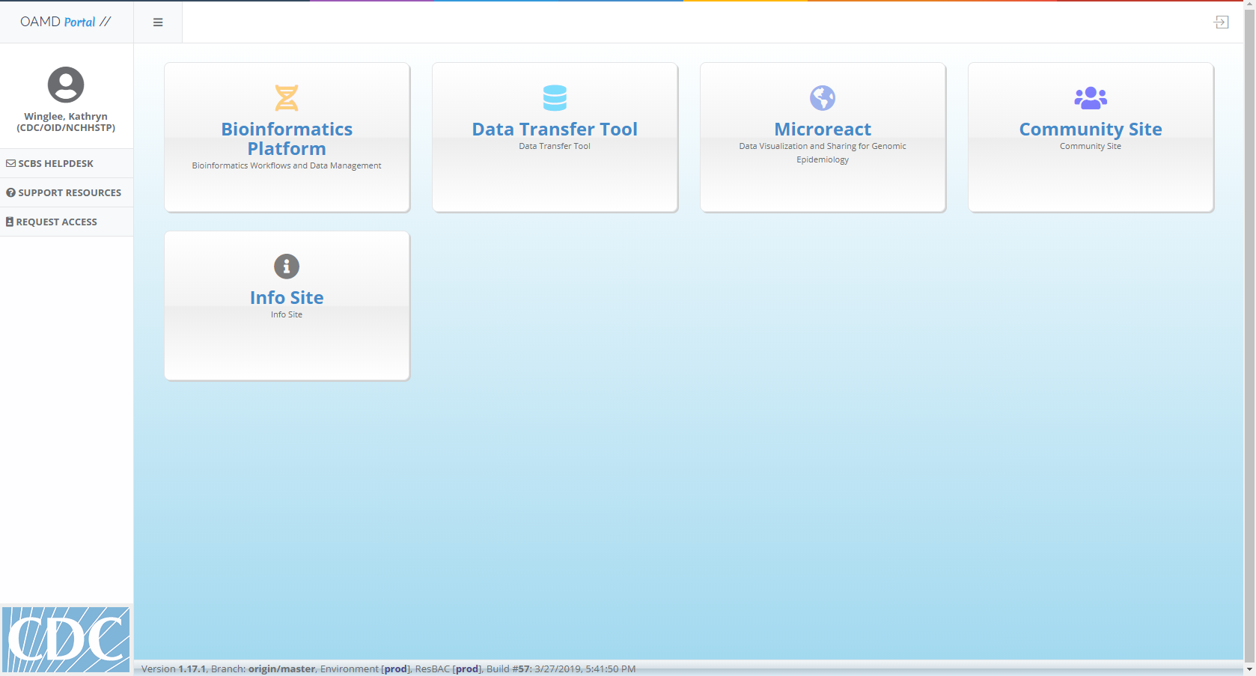

1. Click on “REQUEST ACCESS” in the left hand panel



1. Select “TB molecular epidemiology” 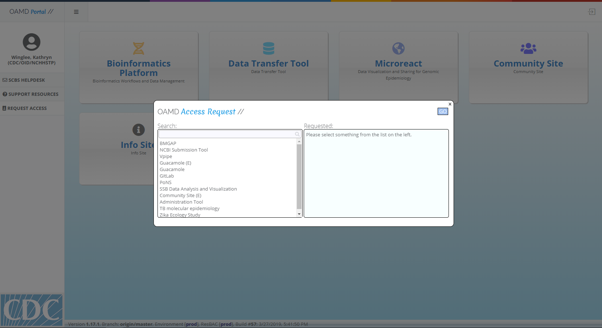
2. Click “GO” 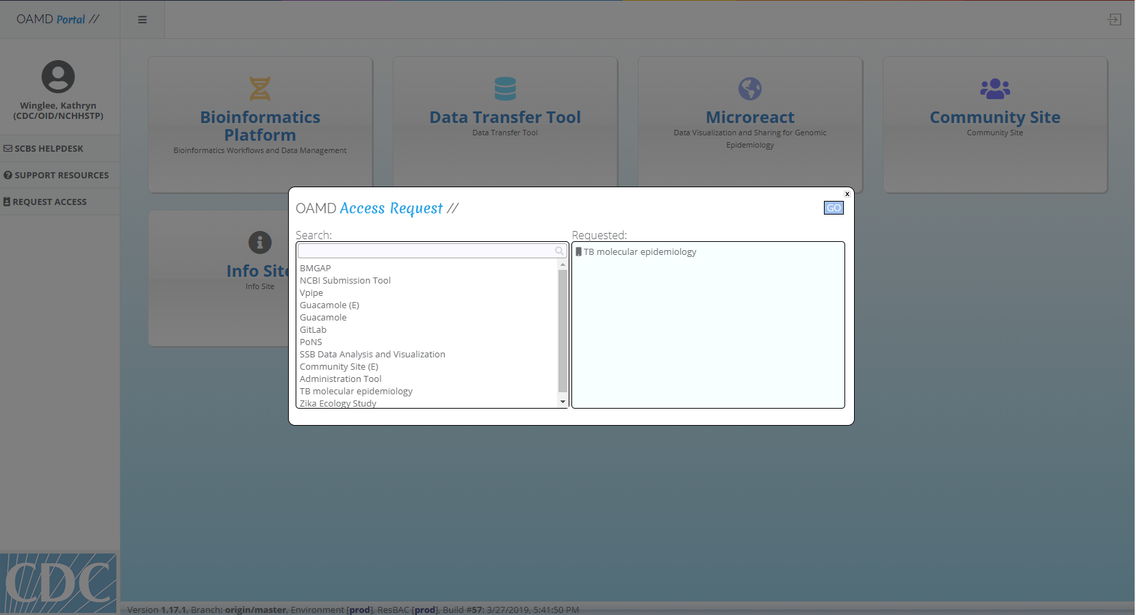
3. Select “Yes” 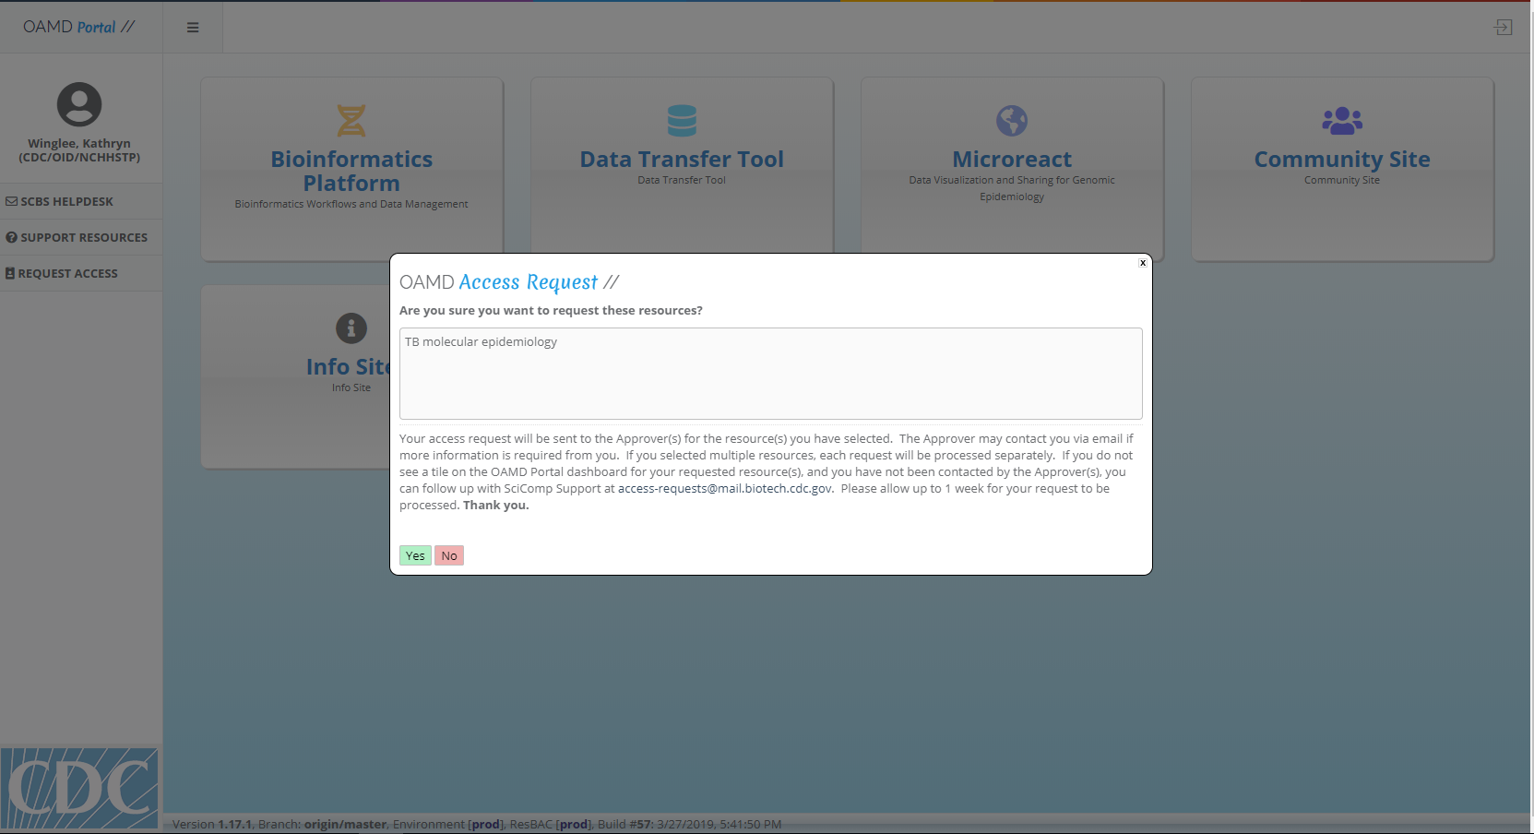
4. You should now see the “TB molecular epidemiology” tile (you may have to refresh the screen).

