# Sequence Diagrams – BDD – CBR Module

## Posting data to OpenMRS

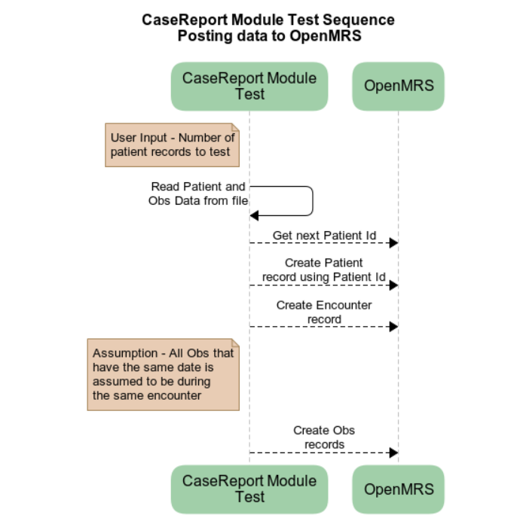

## Assert Data in OpenMRS

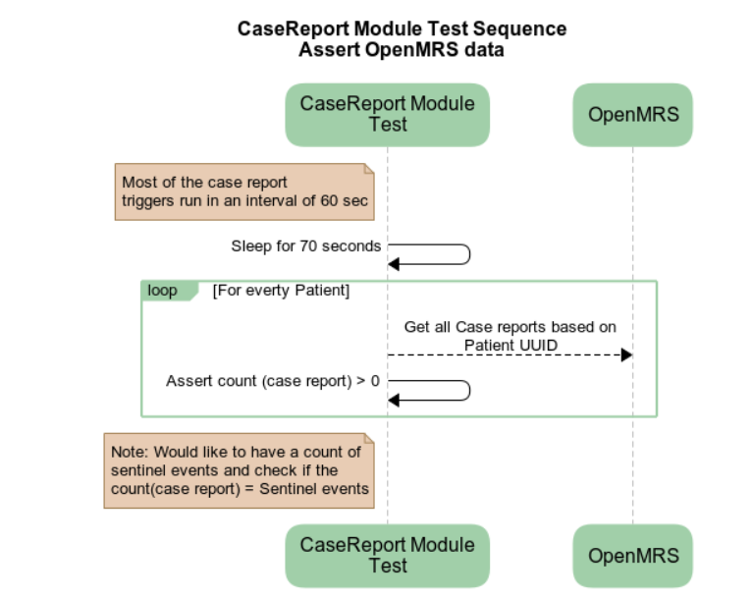

## Assert data in OpenHIM

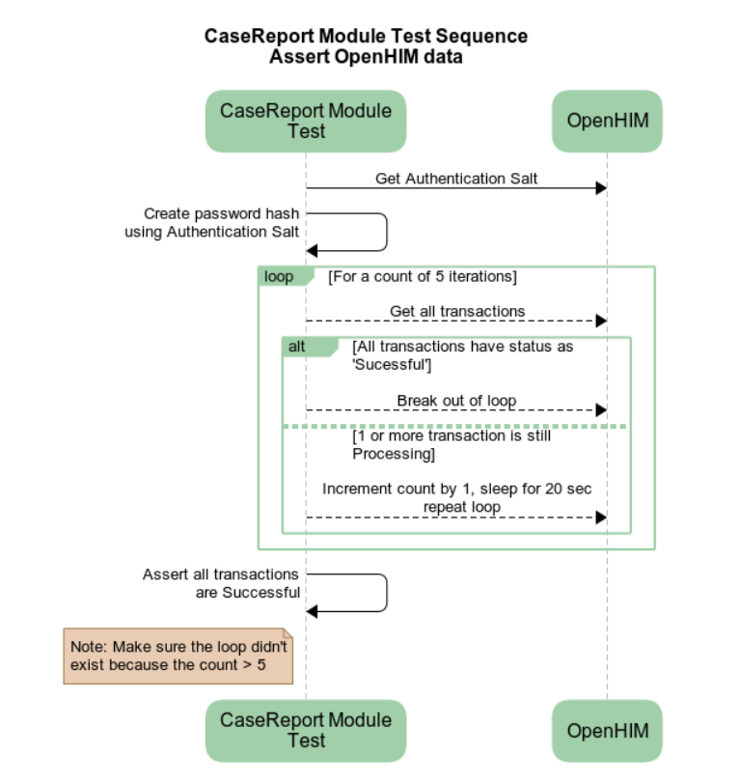

## Assert Data in OpenEMPI

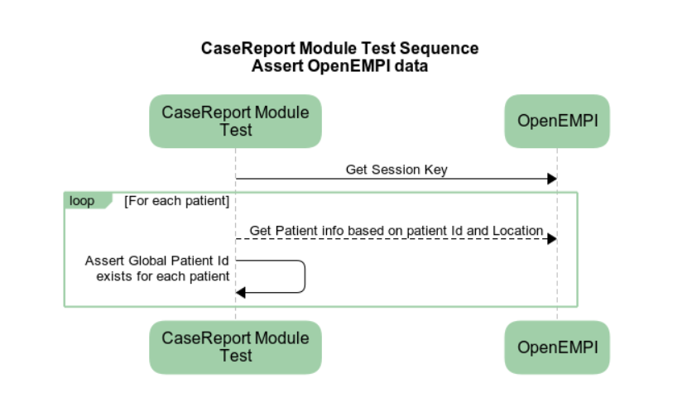

# Assert Data in OpenSHR

