Figure S2 A: The proportion of contacts that involved physical contact, by a) duration, b) frequency and c) location of contact in BE; d) correlation between duration and frequency of contact. Contacts were weighted by country-specific sampling weights.
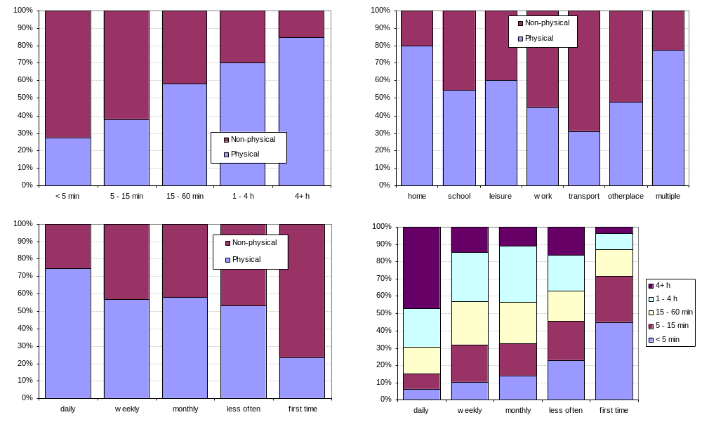

Figure S2 B. The proportion of contacts that involved physical contact, by a) duration, b) frequency and c) location of contact in DE; d) correlation between duration and frequency of contact. Contacts were weighted by country-specific sampling weights.
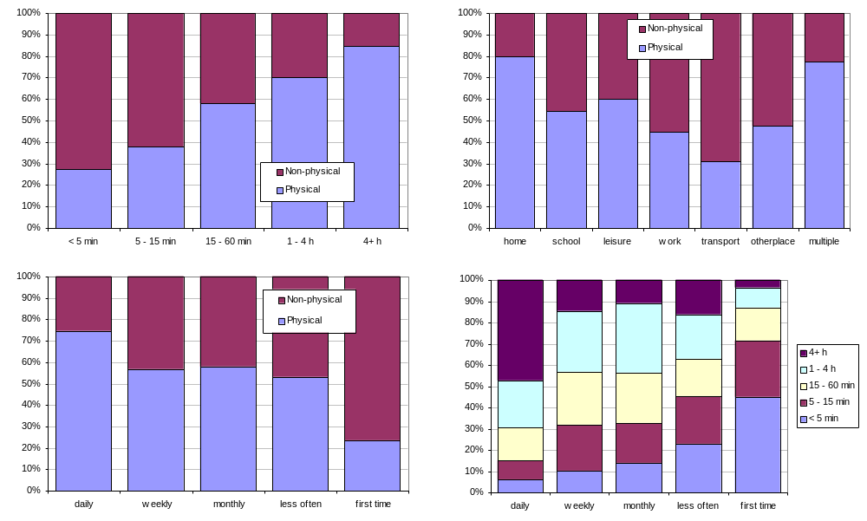

Figure S2 C: The proportion of contacts that involved physical contact, by a) duration, b) frequency and c) location of contact in FI; d) correlation between duration and frequency of contact. Contacts were weighted by country-specific sampling weights.
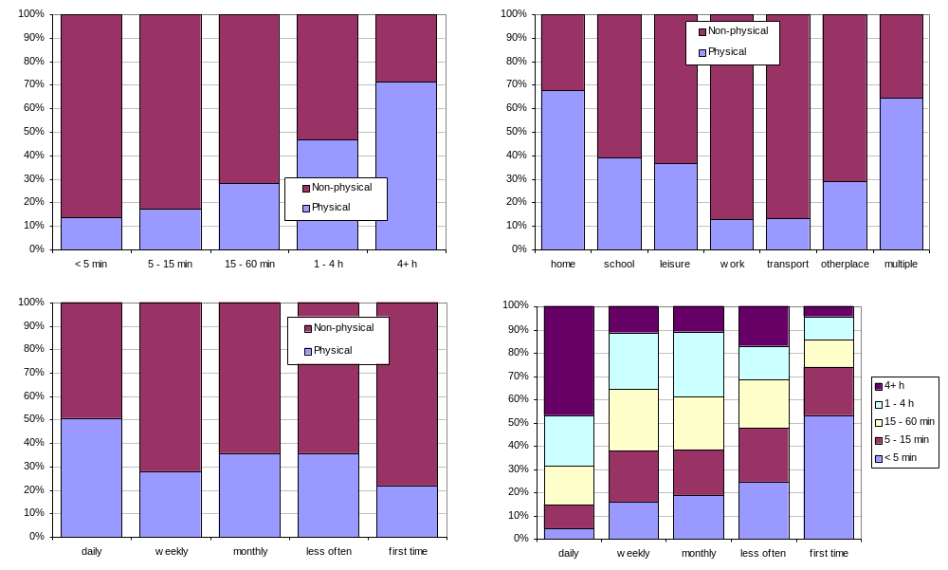

Figure S2 D: The proportion of contacts that involved physical contact, by a) duration, b) frequency and c) location of contact in GB; d) correlation between duration and frequency of contact. Contacts were weighted by country-specific sampling weights.
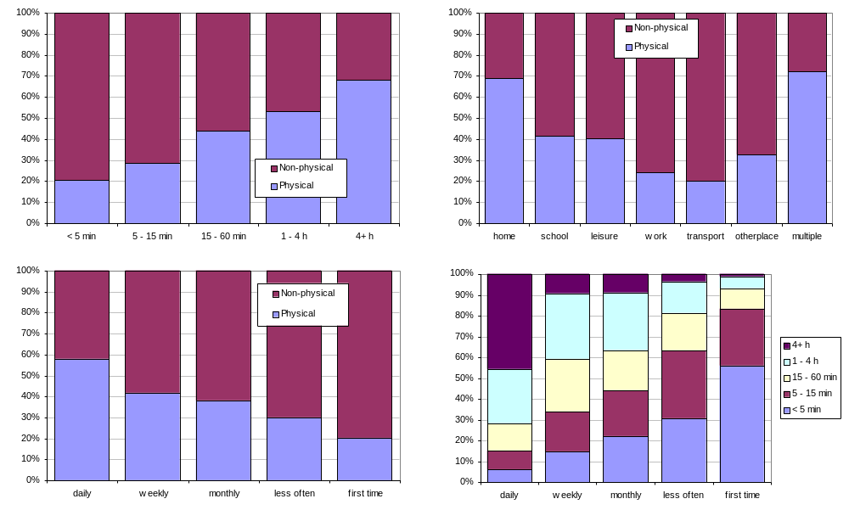

Figure S2 E: The proportion of contacts that involved physical contact, by a) duration, b) frequency and c) location of contact in IT; d) correlation between duration and frequency of contact. Contacts were weighted by country-specific sampling weights.
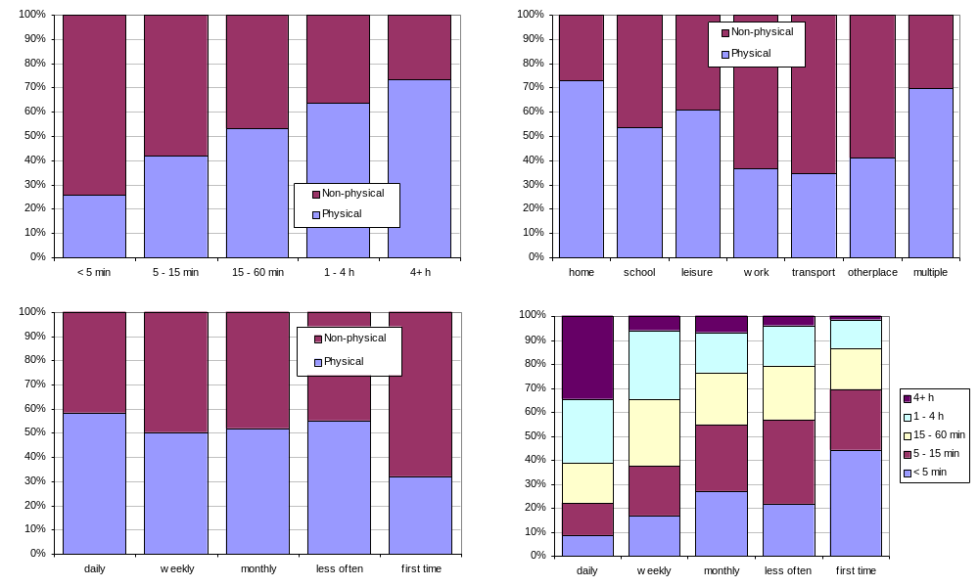

Figure S2 F: The proportion of contacts that involved physical contact, by a) duration, b) frequency and c) location of contact in LU; d) correlation between duration and frequency of contact. Contacts were weighted by country-specific sampling weights.
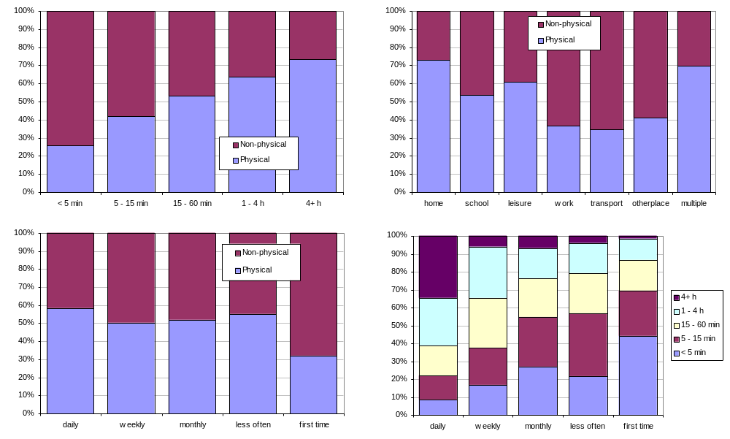

Figure S2 G: The proportion of contacts that involved physical contact, by a) duration, b) frequency and c) location of contact in NL; d) correlation between duration and frequency of contact. Contacts were weighted by country-specific sampling weights.
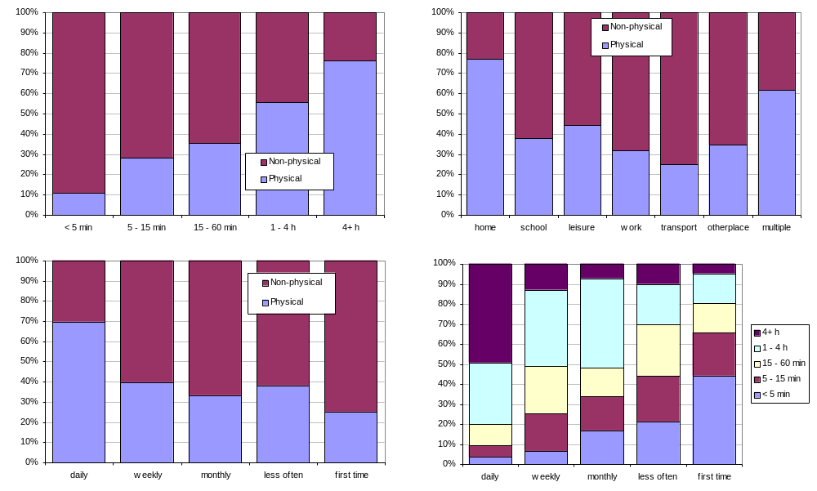

Figure S2 H: The proportion of contacts that involved physical contact, by a) duration, b) frequency and c) location of contact in PL; d) correlation between duration and frequency of contact. Contacts were weighted by country-specific sampling weights

