MEDICAL COST PREDICTION
Using Machine Learning on the Kaggle Insurance Dataset
Project Report
IBM SkillsBuild Data Analytics with AI – Academic Internship Program
BharatCares in association with AICTE
Submitted by: Shivam Chauhan
College : M.I.T Moradabad
October 2026

1. Abstract
Health insurers need to estimate how much a customer is likely to cost so that premiums can be set fairly. This project builds a machine-learning model that predicts individual medical insurance charges from six personal attributes: age, sex, body mass index (BMI), number of children, smoking status and region. Using the Kaggle "Medical Cost Personal Datasets" (1,338 records), the data was cleaned, explored, enriched with two engineered features, and used to train four regression models. The best model, Linear Regression with engineered features, achieved a test R² of 0.907 with a mean absolute error of about $2,369. The analysis shows that smoking is the dominant cost driver: smokers are billed about 3.8 times more than non-smokers on average.

2. Introduction
Medical costs vary widely between individuals. Insurance companies use historical data to understand which characteristics are associated with higher claims. Data analytics and machine learning allow this relationship to be learned automatically from data, giving a transparent and repeatable way to estimate expected cost.

3. Problem Statement
Given the demographic and lifestyle details of a person, predict the medical charges billed by the health insurer. This is a supervised regression problem where the target variable is charges (in US dollars).

4. Objectives
- Load, clean and validate the insurance dataset.
- Explore the data visually to understand which factors influence medical charges.
- Engineer features that capture important interactions such as obesity combined with smoking.
- Train and compare several regression models using standard metrics.
- Identify the most important factors and save the final model for reuse.

5. Dataset Description
The dataset was downloaded from Kaggle: https://www.kaggle.com/datasets/mirichoi0218/insurance. It contains 1,338 rows and 7 columns. There are no missing values and one duplicate row, which was removed, leaving 1,337 records.
Column | Type | Description
age | Numeric | Age of primary beneficiary (18 – 64)
sex | Categorical | Gender of insurance contractor (female / male)
bmi | Numeric | Body Mass Index (15.96 – 53.13)
children | Numeric | Number of children / dependents covered
smoker | Categorical | Smoking status (yes / no)
region | Categorical | Residential area in the US (4 regions)
charges | Numeric (target) | Individual medical costs billed by insurance (USD)

6. Tools and Technologies
- Language: Python 3
- Libraries: Pandas, NumPy (data handling); Matplotlib, Seaborn (visualisation); Scikit-learn (modelling and evaluation); Joblib (saving the model)
- Environment: Jupyter Notebook

7. Methodology

7.1 Data Cleaning
The dataset was checked for missing values (none found) and duplicates (one found and removed). Data types were verified: numeric columns were read as numbers and categorical columns as text.

7.2 Exploratory Data Analysis
The target variable is right-skewed: most people have charges below $15,000, while a small group has charges above $40,000. The average charge is about $13,270 with a median of about $9,382.
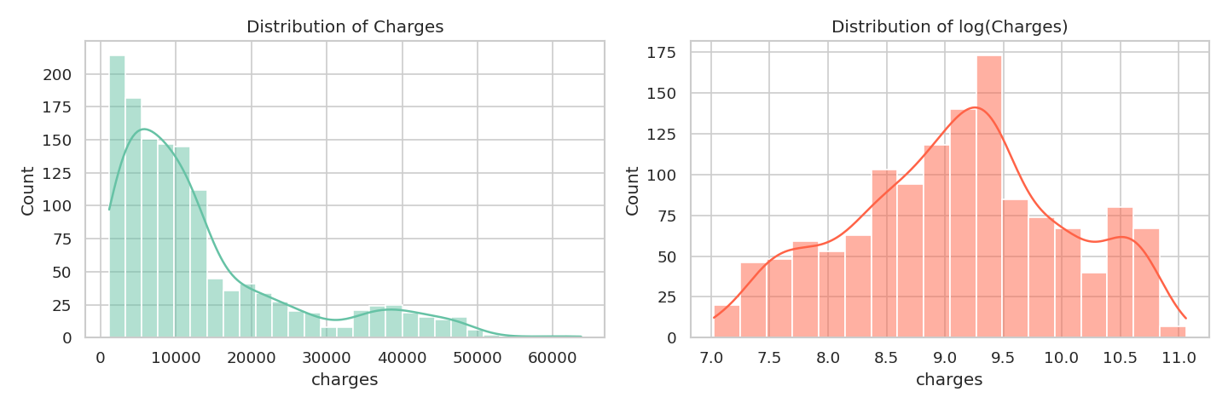
Figure 1: Distribution of charges and log(charges)
Box plots show that smoking status has by far the largest effect on charges. Smokers pay an average of about $32,050 compared with $8,441 for non-smokers. Sex, region and number of children show only small differences.
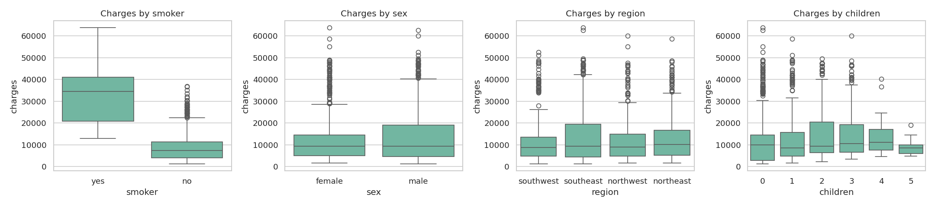
Figure 2: Charges by smoker, sex, region and children
The scatter plots show that charges rise steadily with age and that the data forms three bands of cost. BMI has a strong effect mainly for smokers: smokers with a BMI of 30 or more have the highest charges.
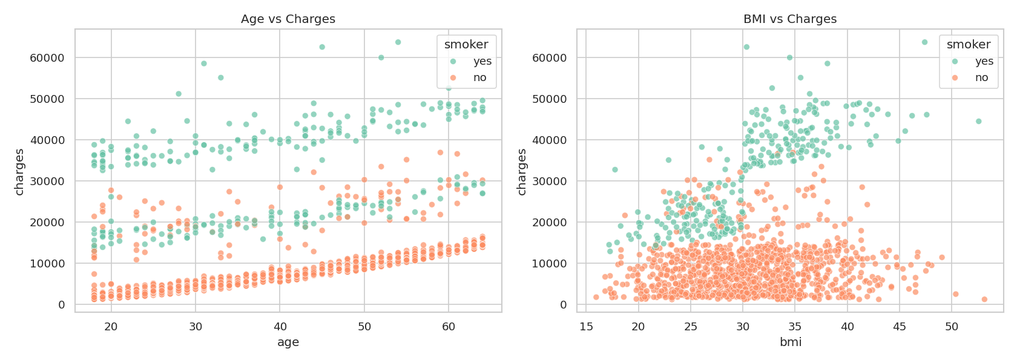
Figure 3: Age and BMI versus charges, coloured by smoking status
The correlation heatmap confirms that smoking has the strongest linear relationship with charges (0.79), followed by age (0.30) and BMI (0.20).
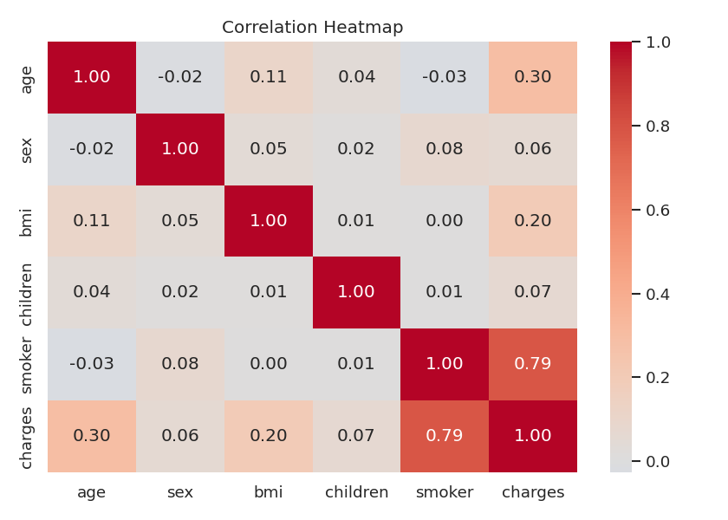
Figure 4: Correlation heatmap

7.3 Feature Engineering
Because obese smokers form a distinct high-cost group, two features were added: obese (BMI ≥ 30) and obese_smoker (BMI ≥ 30 and smoker = yes). This allows even a simple linear model to represent the interaction between BMI and smoking.

7.4 Preprocessing and Split
The data was split into 80% training (1,069 rows) and 20% testing (268 rows) with a fixed random seed of 42. Numeric features were standardised and categorical features were one-hot encoded inside a Scikit-learn Pipeline, so that the same transformations are applied during training, validation and prediction without data leakage.

7.5 Models
Four regression models were trained: Linear Regression, Ridge Regression, Random Forest and Gradient Boosting. Gradient Boosting was additionally tuned using GridSearchCV with 5-fold cross-validation over the number of trees, learning rate, tree depth and subsample ratio. The best settings were learning rate 0.03, max depth 2, 200 trees and subsample 0.8.

7.6 Evaluation Metrics
- R² – share of variance in charges explained by the model (higher is better).
- MAE – average absolute prediction error in dollars.
- RMSE – root mean squared error in dollars; penalises large errors more.
- Cross-validated R² – average R² across 5 folds of the training data, to check stability.

8. Results
Model | Test R² | MAE ($) | RMSE ($) | CV R²
Linear Regression | 0.907 | 2,369 | 4,142 | 0.847
Ridge Regression | 0.906 | 2,378 | 4,146 | 0.847
Gradient Boosting | 0.904 | 2,440 | 4,203 | 0.836
Tuned Gradient Boosting | 0.902 | 2,475 | 4,235 | 0.847
Random Forest | 0.881 | 2,630 | 4,677 | 0.820

Linear Regression gave the best test R² and is also the simplest and most interpretable model. The tuned Gradient Boosting model performed almost identically, which indicates that the engineered features already captured most of the non-linear behaviour in the data. Random Forest scored lowest, likely because of the small dataset.
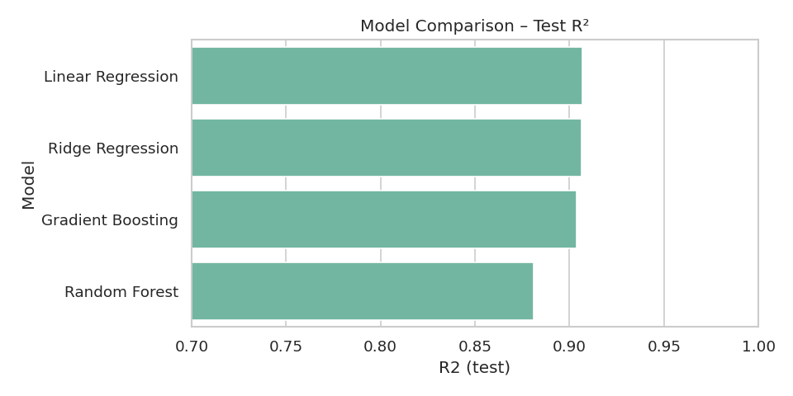
Figure 5: Test R² of the four models
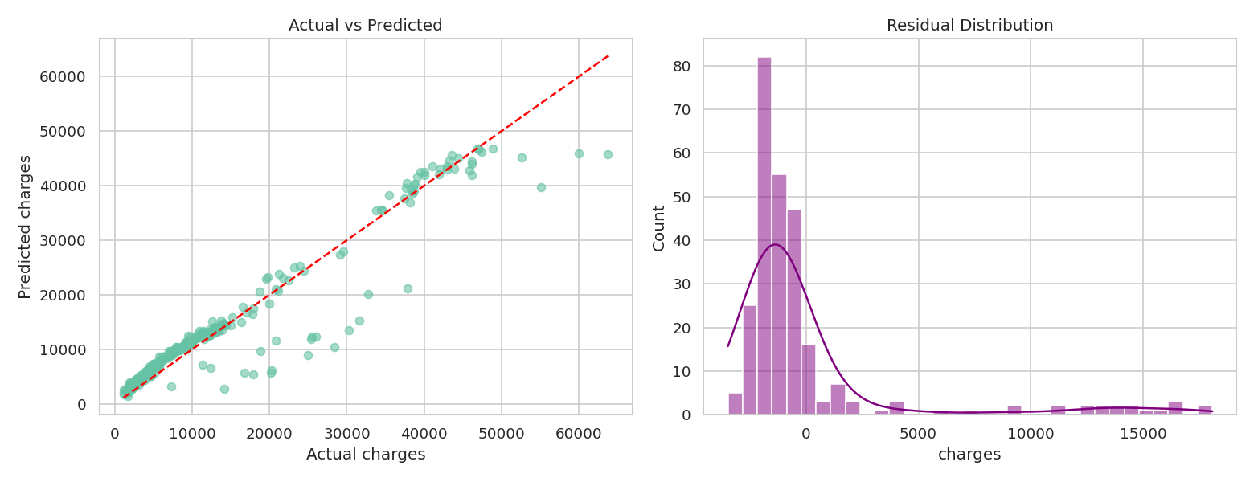
Figure 6: Actual versus predicted charges and residual distribution (final model)
Predictions follow the ideal line closely for most customers. The largest errors occur for a small number of very high-cost smokers, which the available features cannot fully explain.

8.1 Feature Importance
Permutation importance on the test set shows that the obese_smoker flag and smoking status are the most influential inputs, followed by age. BMI on its own adds little once obese_smoker is present, and sex, region and children have almost no effect.
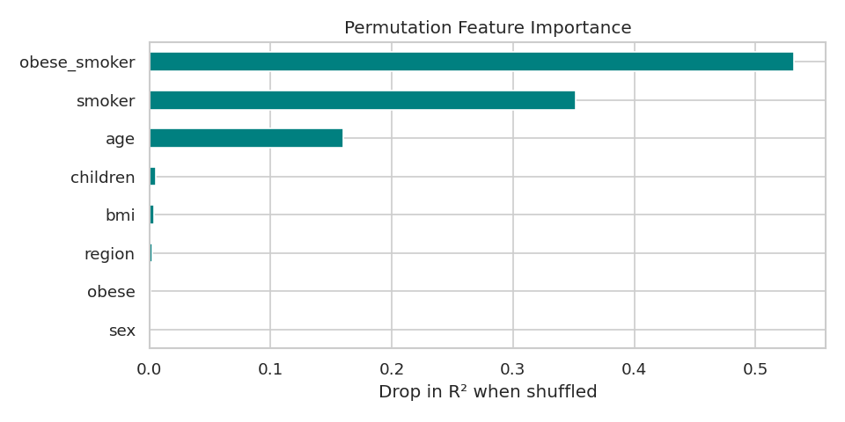
Figure 7: Permutation feature importance

8.2 Sample Predictions
For a 45-year-old male in the southeast with two children, the model predicts about $42,820 per year if he is a smoker with BMI 32, and about $9,818 if he is a non-smoker with BMI 24. This illustrates the very large effect of smoking and obesity on expected cost.

9. Conclusion
The project shows that medical insurance charges can be predicted with good accuracy (R² ≈ 0.91) from just six basic attributes. Smoking status is the most important factor, with age and the combination of obesity and smoking also playing major roles. Careful feature engineering allowed a simple linear model to match more complex models, which is valuable because it is easy to explain to non-technical stakeholders.

10. Limitations
- The dataset is small (1,337 records) and contains only six input variables.
- It has no medical history, pre-existing conditions or treatment information.
- The data is US-based and may not generalise to other countries or insurance systems.
- Prediction error is higher for very high-cost customers.

11. Future Scope
- Try advanced models such as XGBoost or LightGBM and model log(charges).
- Collect richer data such as medical history and lifestyle details.
- Deploy the model as a web application (for example with Streamlit) so users can enter their details and get an estimate.

12. References
- Kaggle – Medical Cost Personal Datasets: https://www.kaggle.com/datasets/mirichoi0218/insurance
- Scikit-learn documentation: https://scikit-learn.org
- Pandas documentation: https://pandas.pydata.org
- IBM SkillsBuild Data Analytics with AI – course material

