**AWS CI/CD**

Day-71:

Created instances using RDS service

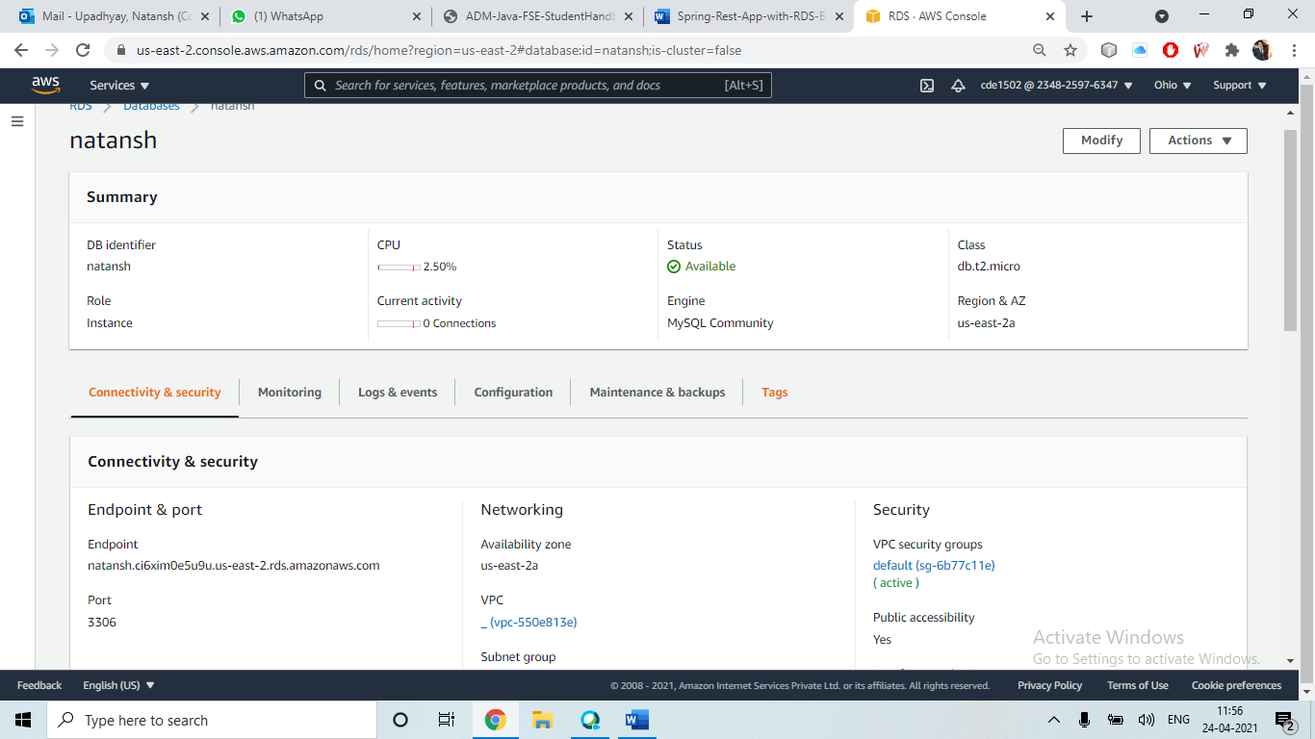

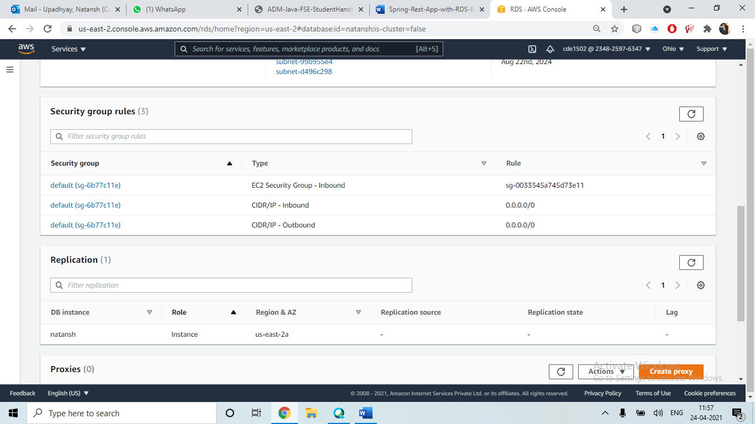

Created database and tables in mysql workbench:

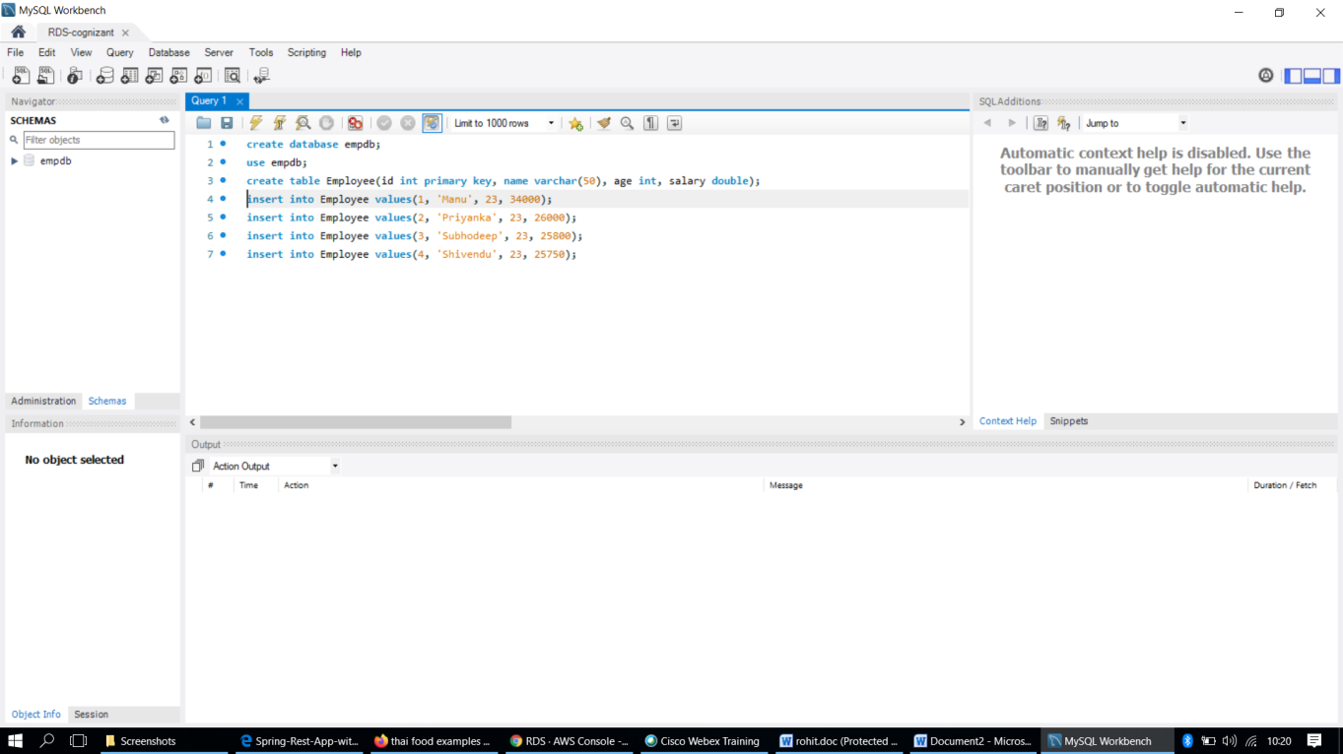

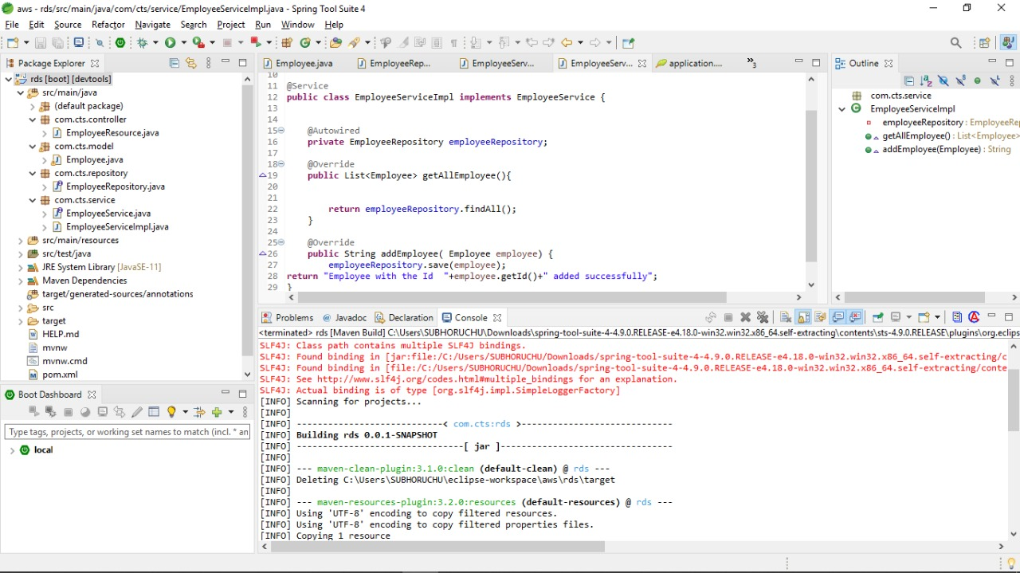

Created an app using Elastic Beanstalk service:

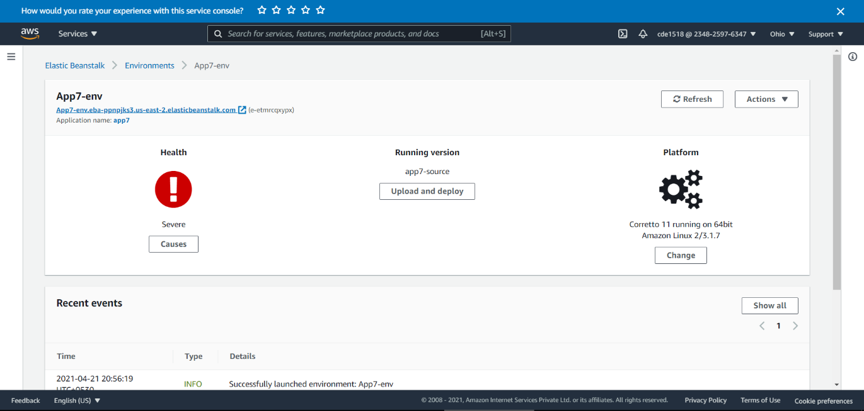

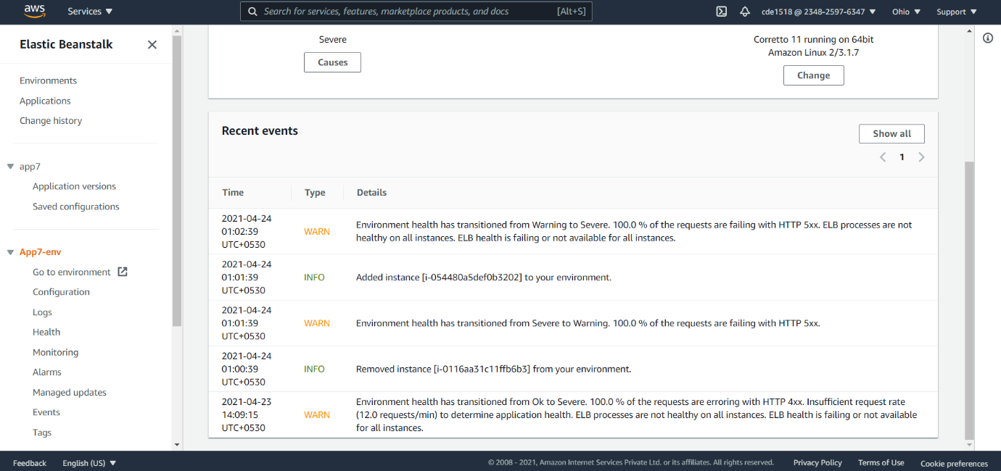

Then copied the URL and run it on the local host:

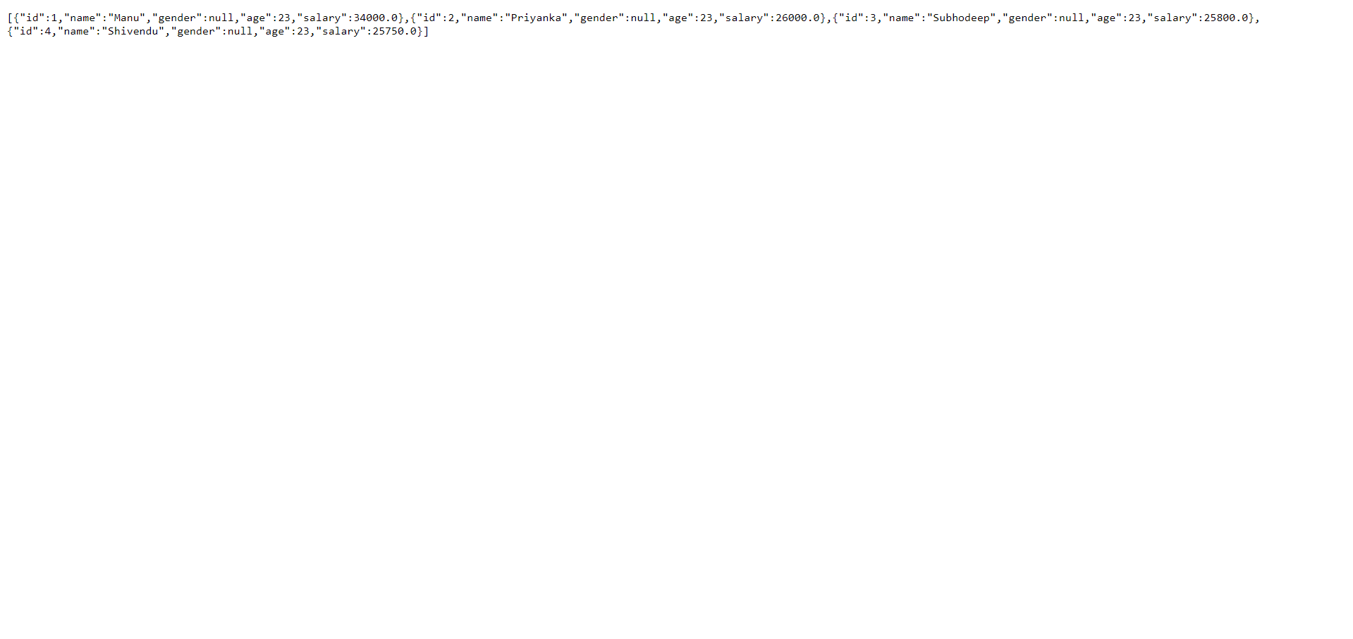

Posted the operation on postman:

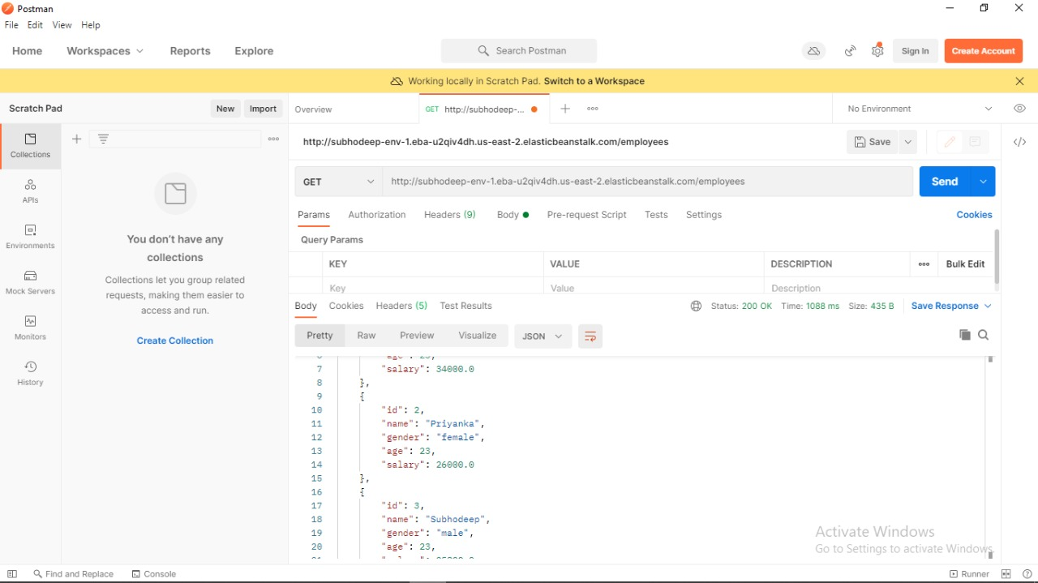

Day 72:

Created a simple restful service using Spring boot and added swagger dependencies. Visited api endpoint.

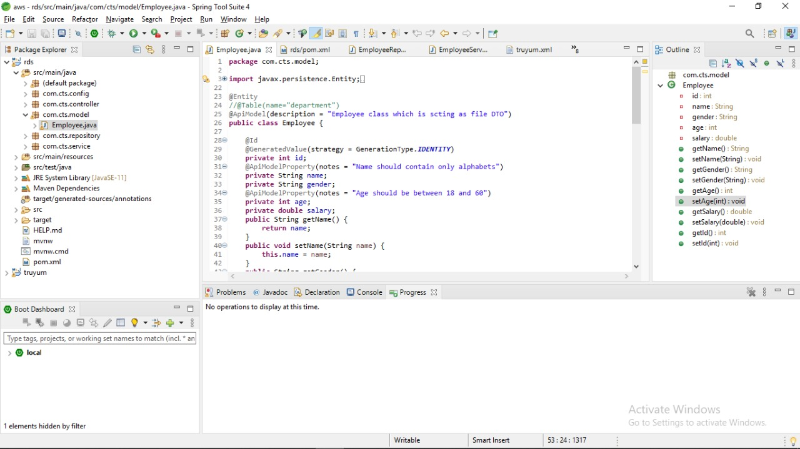

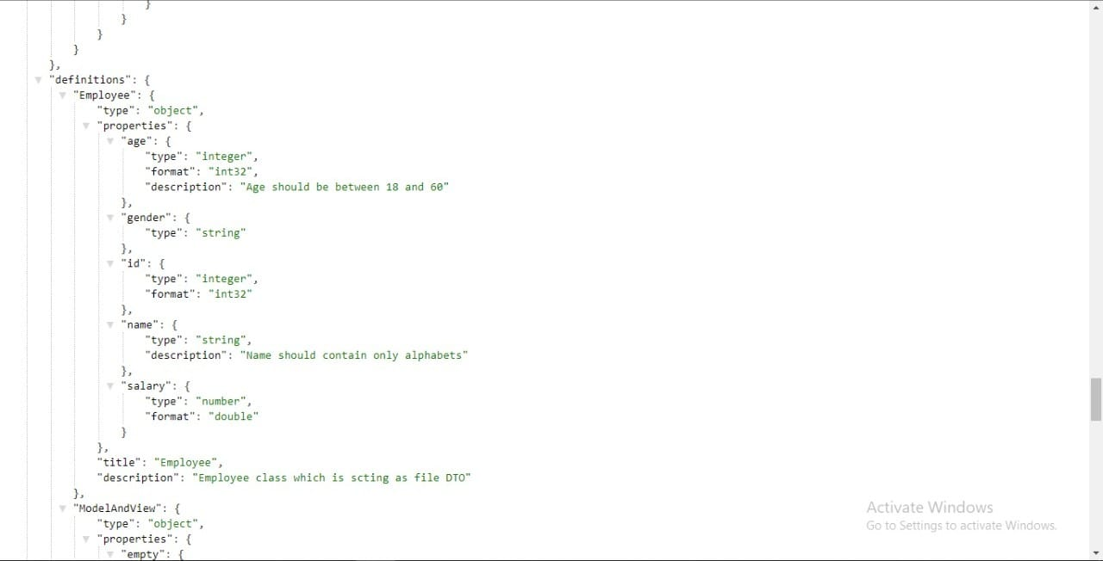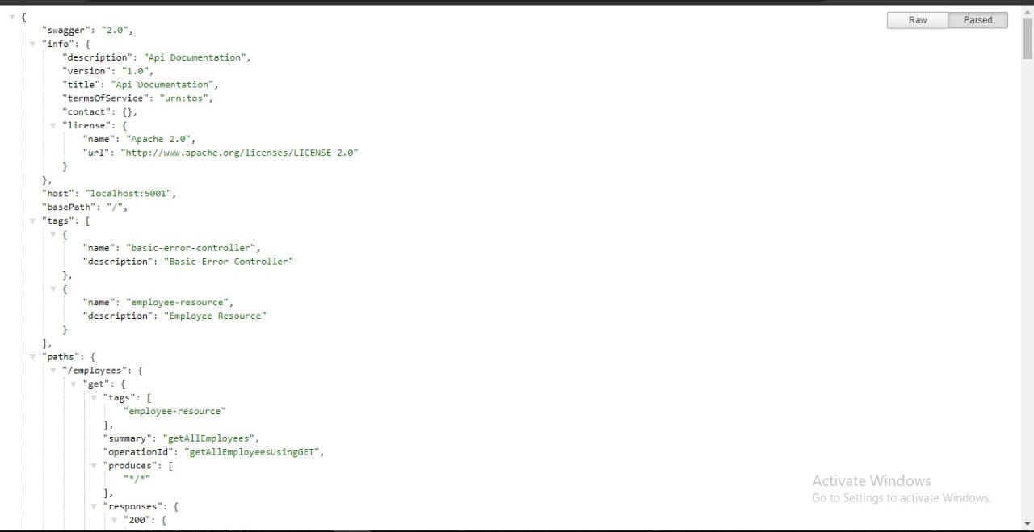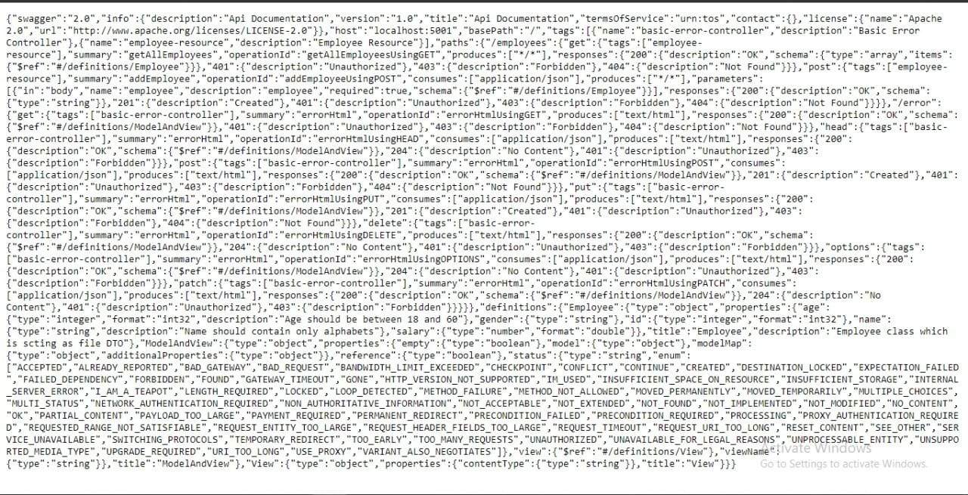

Day 73:

Created a client application using Spring MVC and Spring Boot and consume the REST service created earlier from the client application.

First I added “openfeign” dependency

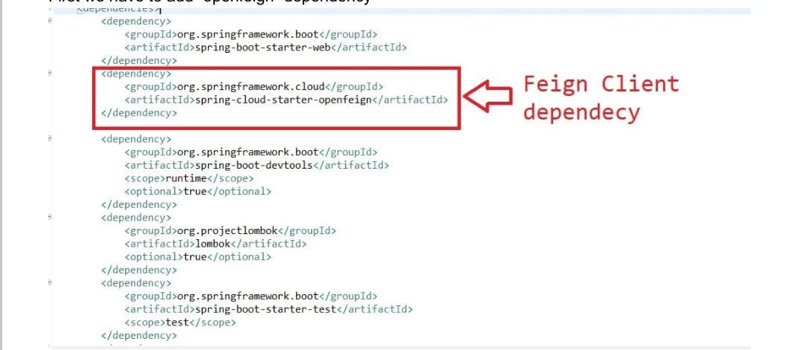

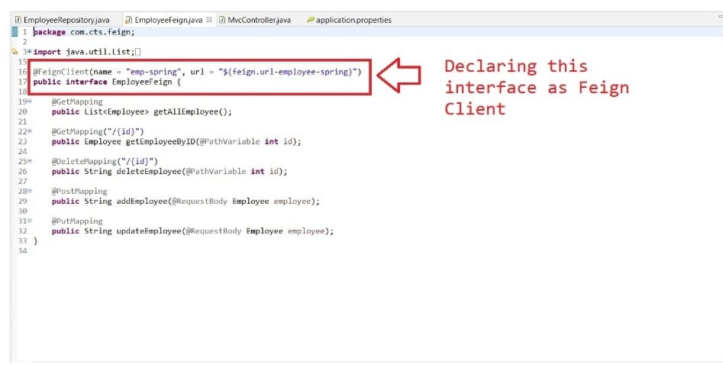

Note: The value argument passed in the @FeignClient annotation is a mandatory, arbitrary client name, while with url argument, we specify the API base URL.

Furthermore, since this interface is a Feign client, we can use the Spring Web annotations to declare the APIs that we want to reach out to.

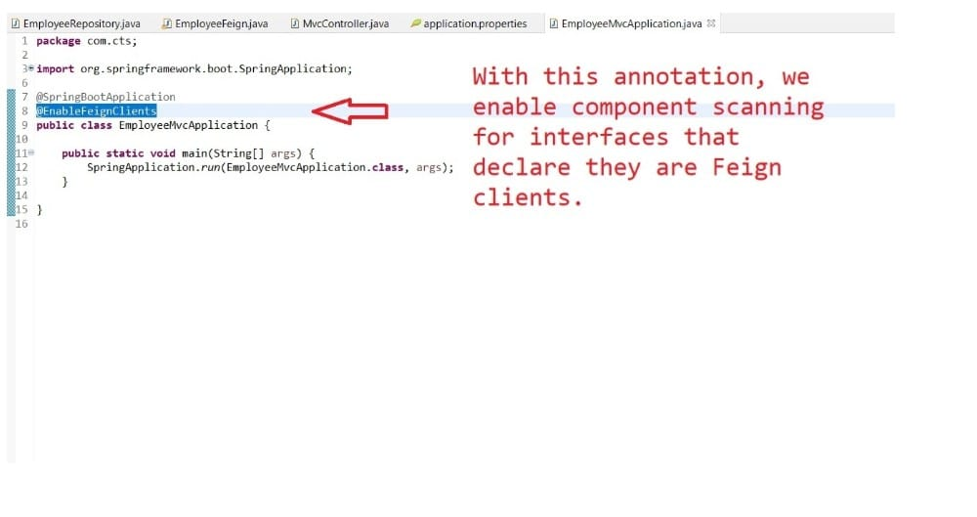

The ui looks like the following.

