**AWS Hands-On**

**Note**: - I have deleted the hands-on for day 68. This docx contains after day 68.

**RDS HandsOn**

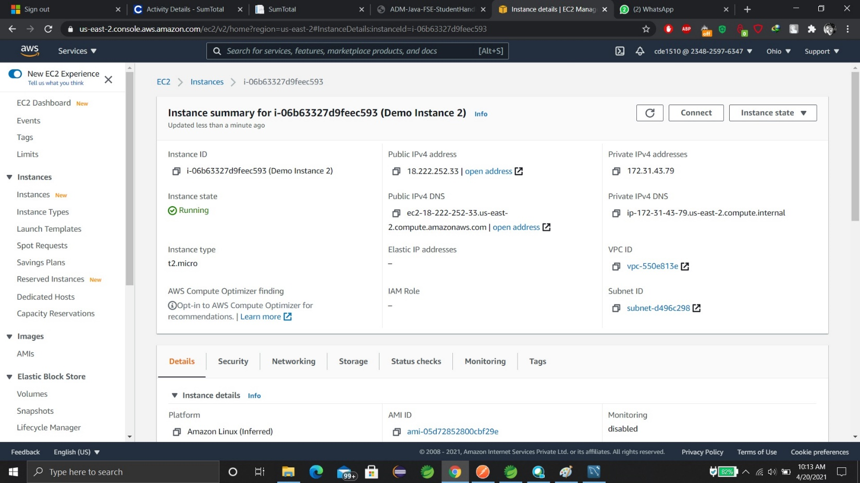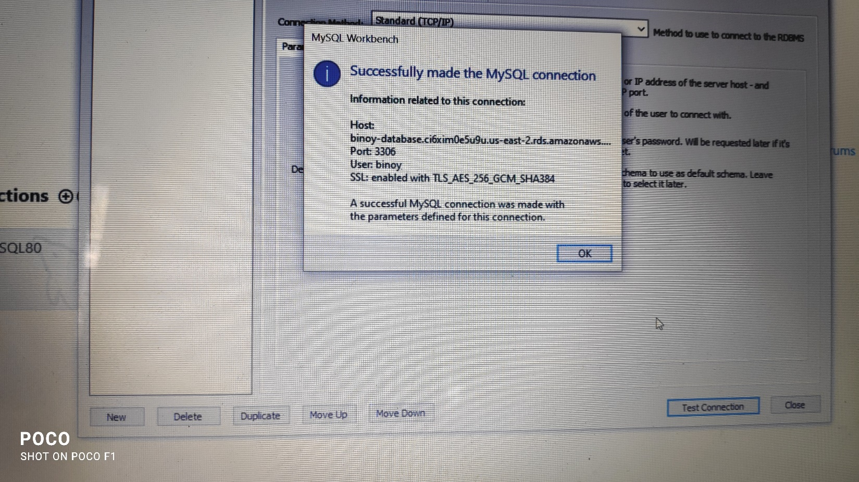

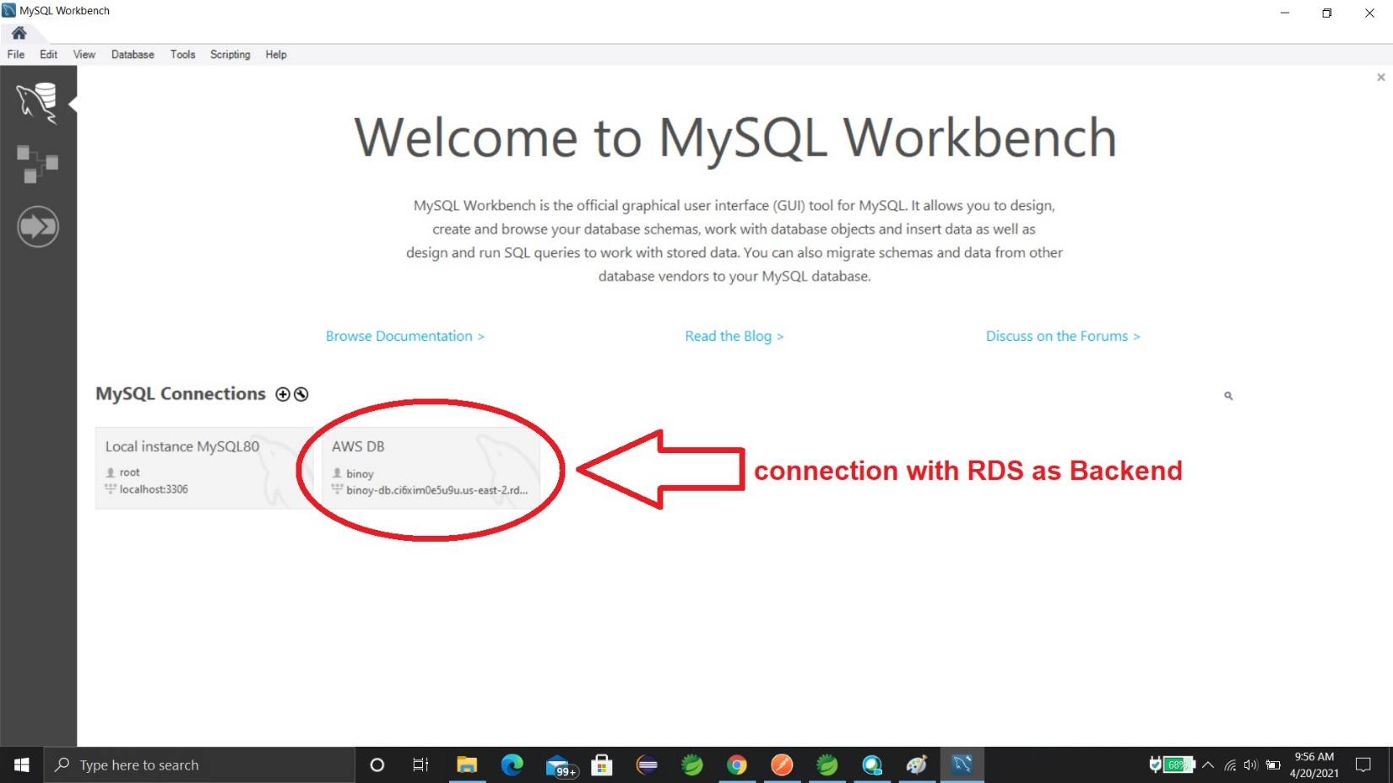

Data in RDS

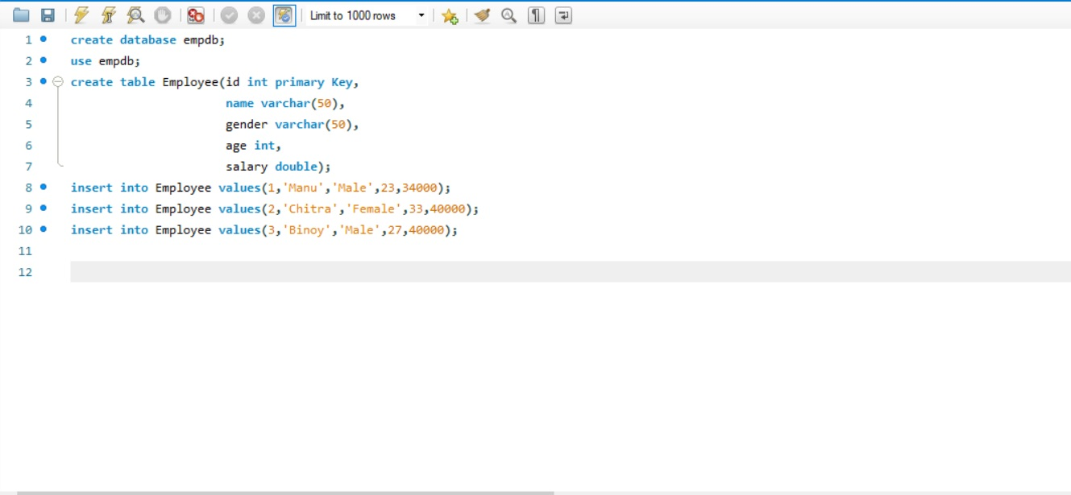

**CI/CD HandsOn**

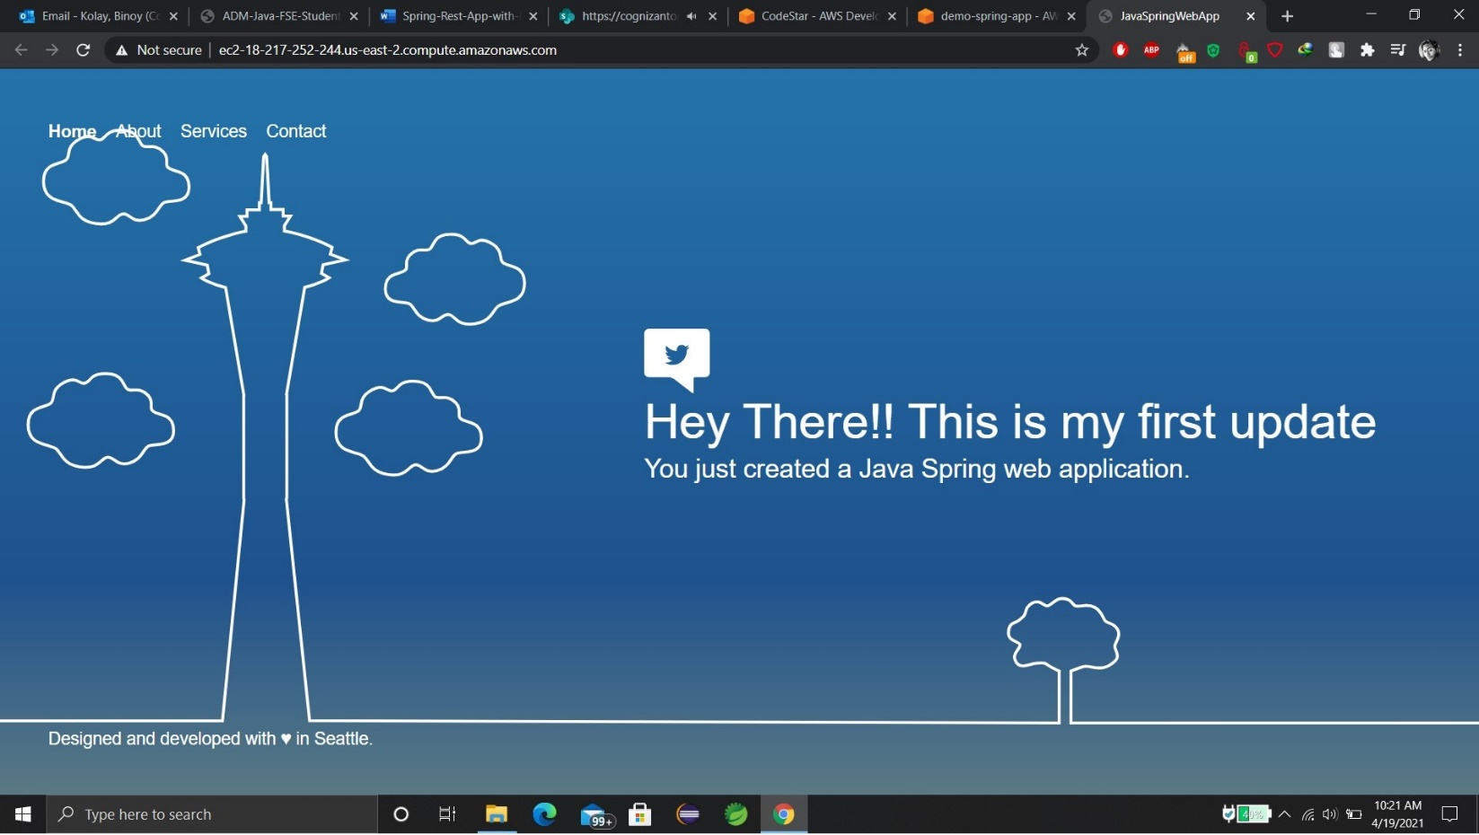**Output:-**

**Spring-Rest-with-RDS-Backend HandsOn**

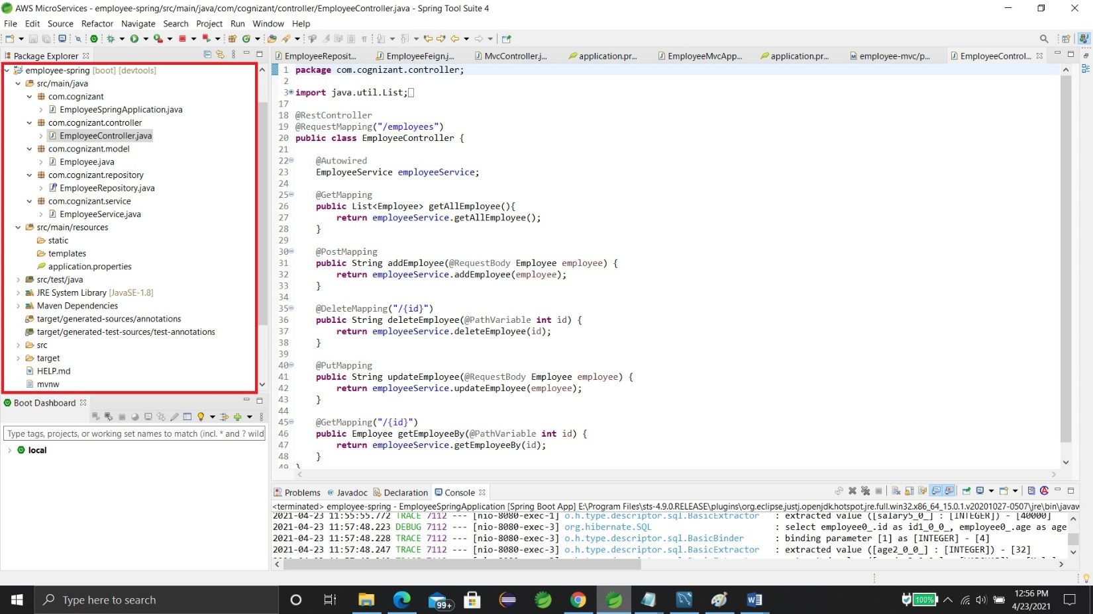

We have created a “employee” microservice to test the RDS Database.

**Swagger HandsOn**

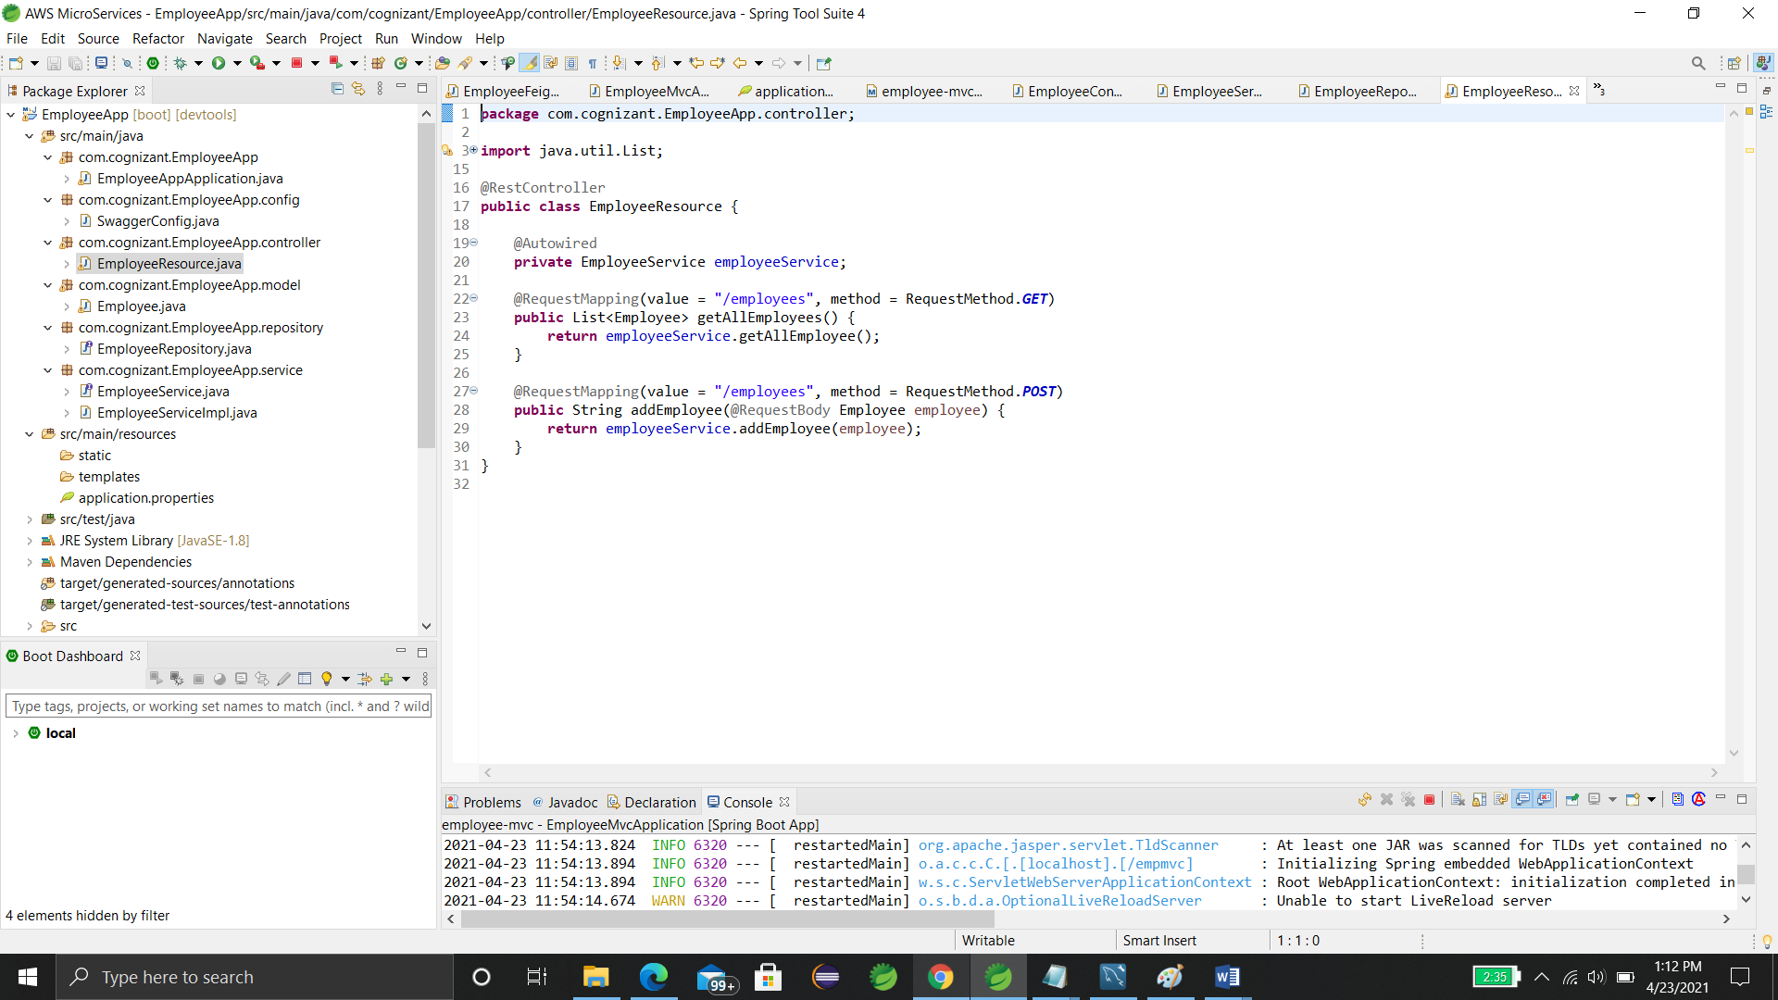Step 1:- Create a simple RESTful service using Spring BOOT

Step-2:- Add Dependencies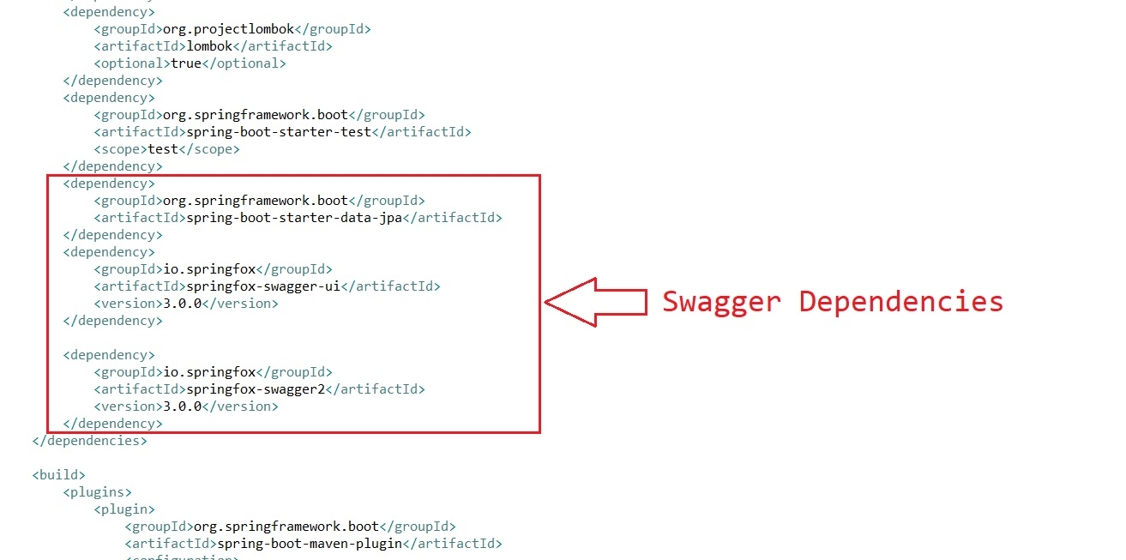

Step 3:- Create a Swagger configuration class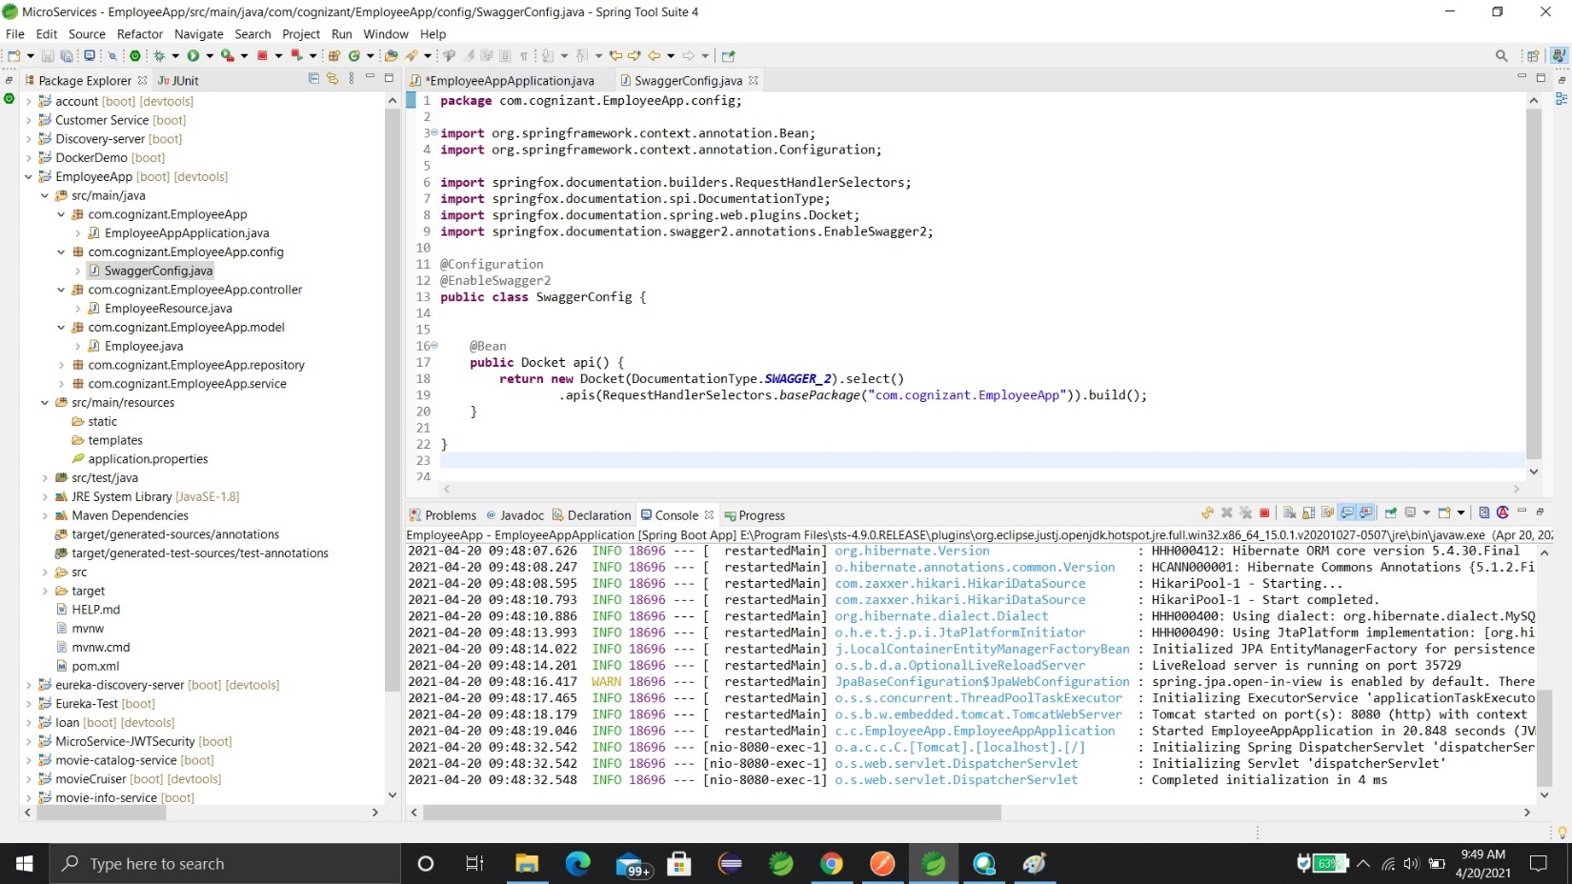

Step 4:- use Swagger specific annotations to customize the descriptions of model class and the properties.

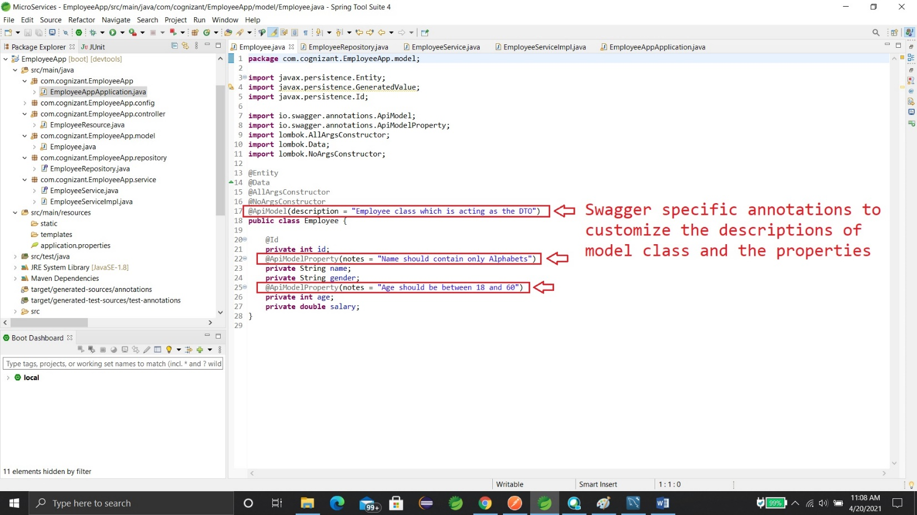

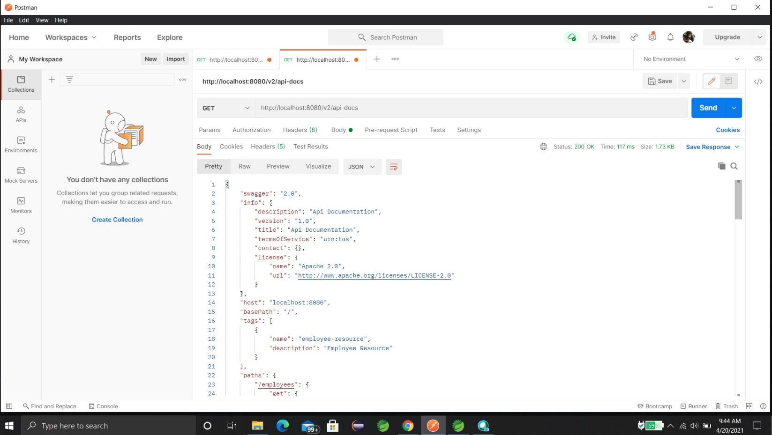“**localhost:8080/v2/api-docs**” and you can see the complete API documentation of your service.

Now, hit the URL in your web browser and see the Swagger API functionalities.

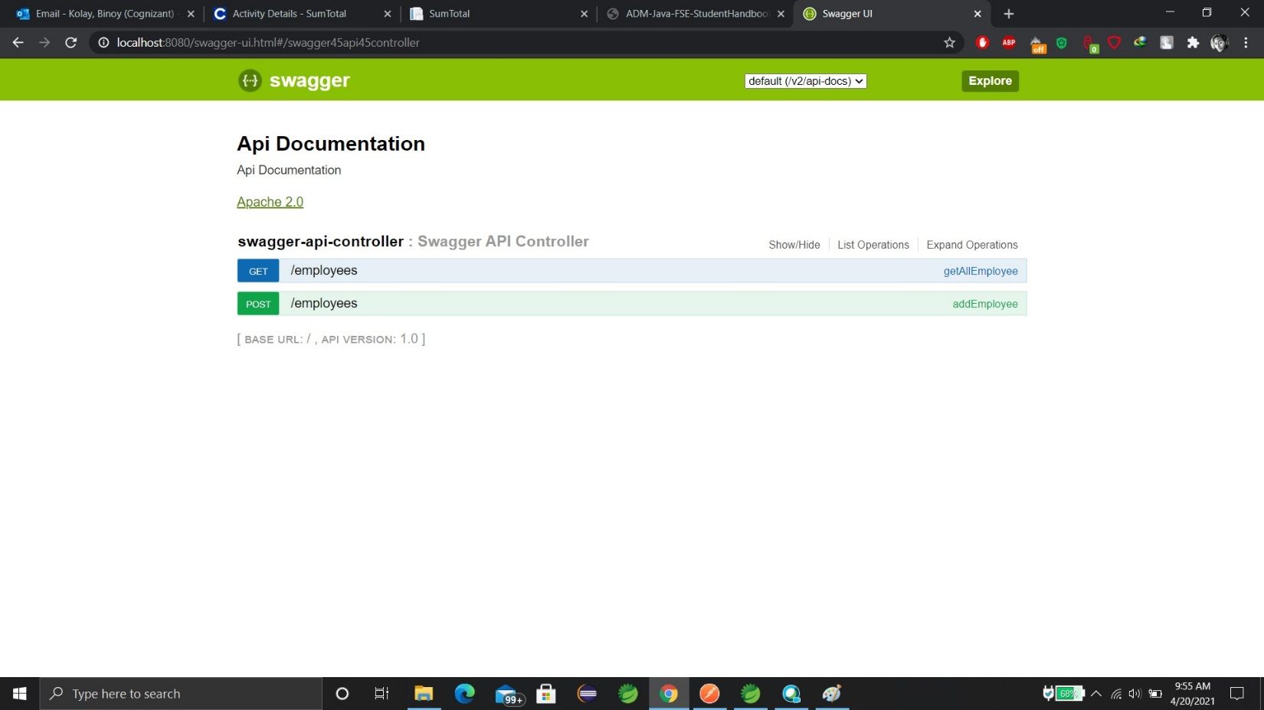**http://localhost:8080/swagger-ui.html**

**Spring MVC Client For Spring REST Service**

**Note:-** We have already created a microservice(employee) in our local System. Now, we are just creating another microservice which will consume the rest service of our previous employee microservice.

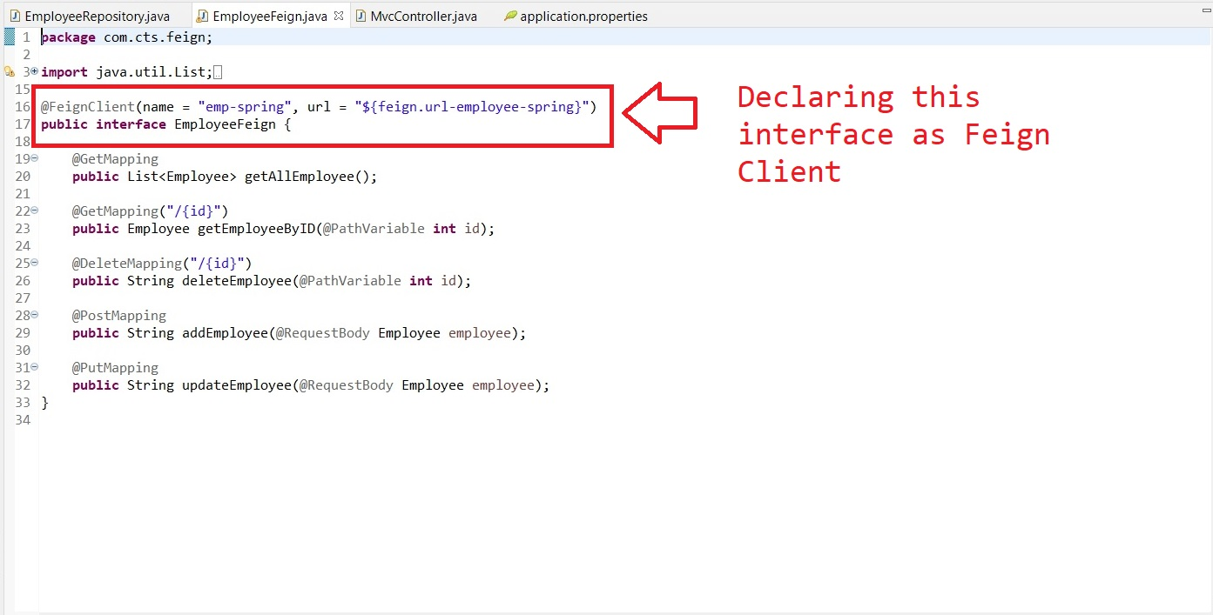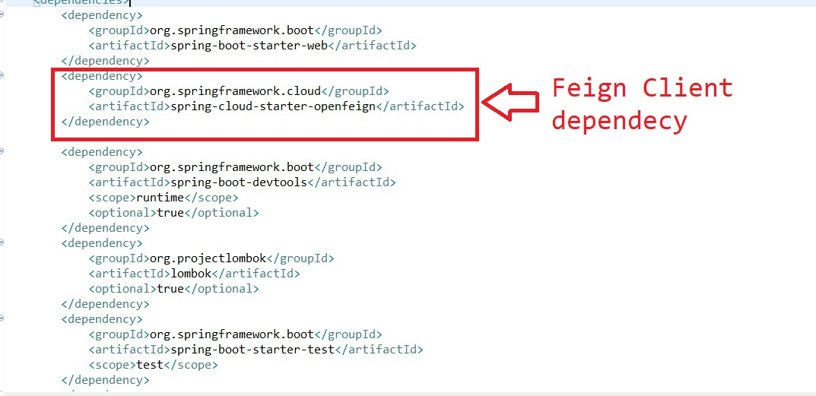First we have to add “openfeign” dependency

**Note:-**The *value* argument passed in the ***@FeignClient***annotation is a mandatory, arbitrary client name, while with the *url* argument, we specify the API base URL.

Furthermore, since this interface is a Feign client, we can use the Spring Web annotations to declare the APIs that we want to reach out to.

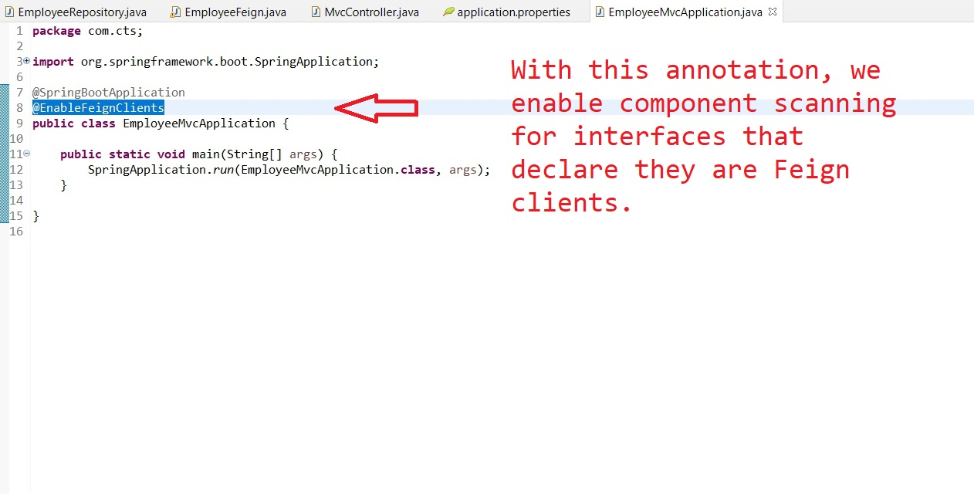

With this annotation, we enable component scanning for interfaces that declare they are Feign clients.

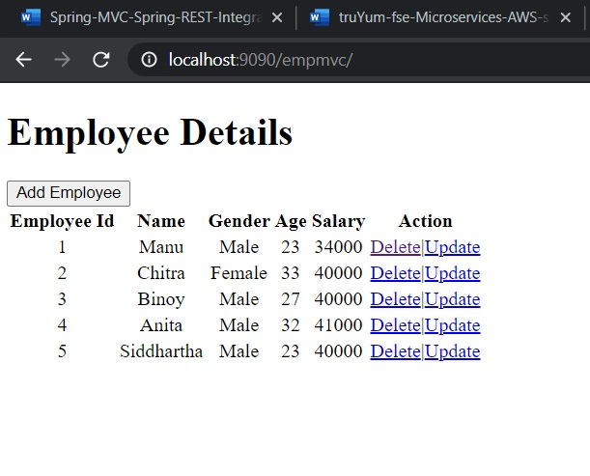Output:-

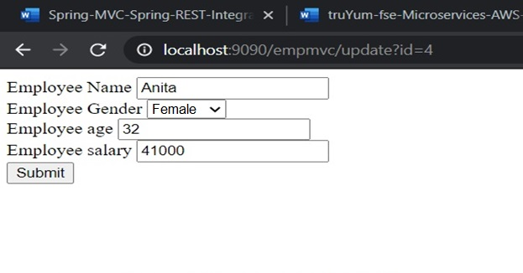output:-