9. UAV-UGV-based communication
ARGUS UAV and HUNTER UGV are designed to work collaboratively for FOD detection and removal. ARGUS searches the runway for FOD. HUNTER receives the detected object locations and navigates to collect them. A communication system is required to transmit the accurate FOD position from ARGUS to HUNTER. The transmitted message includes object classification, detection confidence score and target coordinates. This allows ARGUS to scan while HUNTER handles object retrieval.

The communication subsystem was initially developed and tested using ROS 2 over a local WI-FI network. This provides a preliminary communication framework that’s needed before integration with the actual hardware and choosing a suitable communication method.

Add software Architecture
9.2 Requirements and consideration
The operational range must be up to 5 km, as that’s the runway length. Based on IMDA under the Telecommunications Act, the frequency restriction is from 917-925MHz. The hardware must be small and light due to ARGUS’s payload constraints. We also need a small telemetry payload since video transmission isn't required. This also consumes less network capacity and lower bandwidth.

9.3 Interim Communication
For interim communication, I implemented ROS 2 Jazzy to establish communication between ARGUS and HUNTER. ROS 2 provides a publisher-subscriber communication architecture that sends information between systems. I implemented communication using Python 3 and the ROS 2 Python client library.

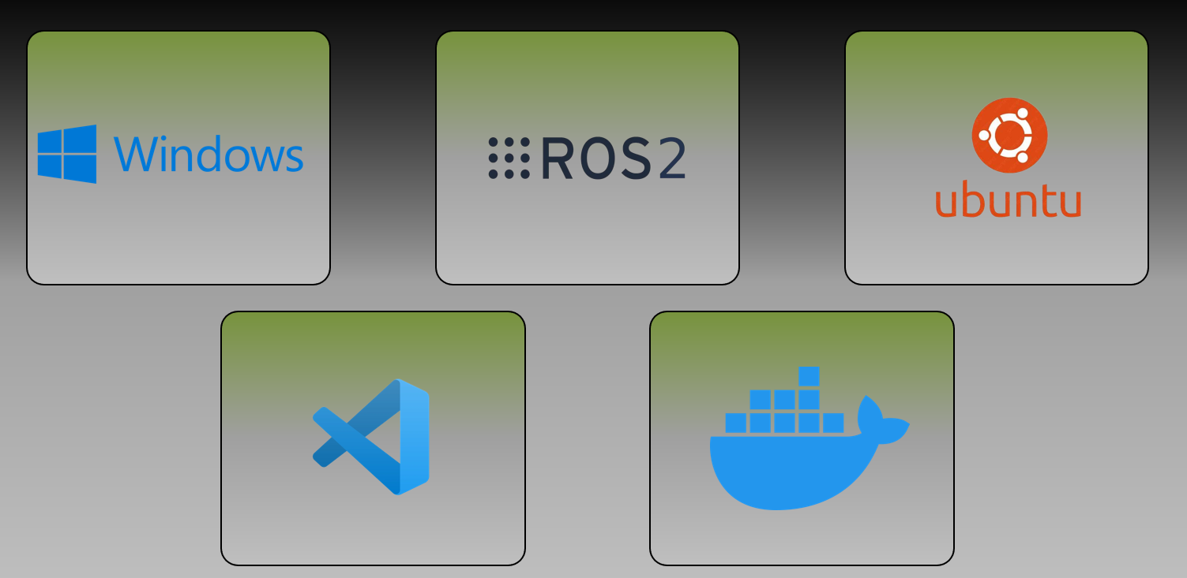

9.5 UAV Communication Architecture
Suggested diagram to add using AI:
ARGUS (Laptop)
↓
Python C2 Alert Publisher
↓
ROS 2 Jazzy / DDS
↓
UDP/IP over Local Wi-Fi
↓
ROS 2 Jazzy / DDS
↓
Python C2 Alert Subscriber
↓
HUNTER (Raspberry Pi 5)
This architecture enables communication between the two systems without requiring the Python scripts to establish direct network socket connections manually.

9.6 C2 Alert Message Structure
The communication system uses structured command and control (C2) alert messages to send the detected object. It is formatted as a JSON and sent using ROS 2 std_msgs/String messages.

The message format is as follows:
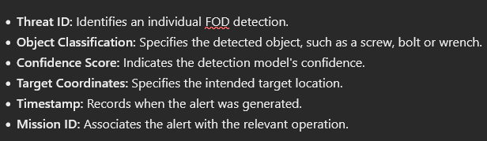

9.7 DDS & QoS

ROS 2 uses DDS (Data Distribution Service) middleware to exchange messages between ARGUS and HUNTER. DDS handles automatic device discovery and message delivery using the RTPS protocol over UDP/IP, allowing data to be transmitted through a local Wi-Fi network. ROS 2 provides DDS Security, which offers additional security features not yet implemented but planned for future setup. Currently, access protection depends on the network’s security configuration.

ROS 2 quality of service (QoS) settings improve FOD alert transmission reliability and are configured in the UAV publisher. The reliable policy enables message retransmission when necessary and reduces the likelihood of message loss during operation.
TRANSIENT_LOCAL durability allows the subscribers to retrieve the last retained alert.
The KEEP_LAST history policy with a depth of 1 holds the most recent alert. These settings improve communication reliability while maintaining a lightweight message-transmission system.

9.8 Multiple FOD Transmission
The ARGUS publisher sends the FOD alerts in sequence. The threat ID would be as follows:
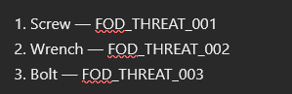
This is reset after every run. This is also particularly useful in detecting communication loss. For example, if the HUNTER is supposed to receive _005 but receives _007 instead, it indicates a communication loss or error. Currently, no measures are implemented, but future work will have ARGUS resend those coordinates. If the problem continues, it alerts the base station.

9.9 Communication and Vision System Workflow
The vision system continuously requests drone centre coordinates from the navigation system. If an FOD is detected, the drone coordinates goes through the coordinate extraction method to get the precise FOD coordinate, then through the communication system, where it is published to HUNTER.

Give work flow

9.10 Communication Performance Evaluation
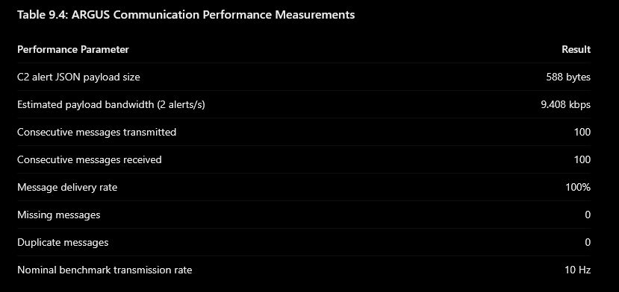
A communication performance evaluation was done using ROS 2 Jazzy. The C2 alert payload size was measured at 588 bytes, and the estimated application-level bandwidth was 9408 kbps at two alerts per second. Additionally, a ROS 2 test was conducted using 100 consecutive alerts simulating the C2 alerts at a nominal rate of 10Hz sent from publisher to subscriber. All 100 messages were received successfully hence attaining the 100% delivery rate with no missing or duplicate messages. These results shows that the message transmission using ROS 2 environment is a success.
9.11 Long-Range Communication Hardware for final implementation
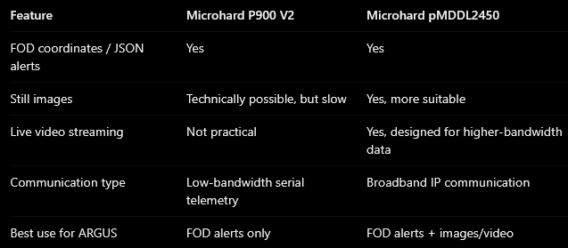

Two radio communication methods were explored for future ARGUS – HUNTER communication. The microhard P900 V2 and the microhard pMDDL2450. The P900 provides serial RF communication suitable for transmitting small C2 alert messages. The pMDDL2450 supports higher-bandwidth IP communication. Since ARGUS must send crack images to the base station for inspection, the PMDDL2450 is chosen, though it's heavier and consumes more power than the P900. Hence, the PMDDL2450 was identified as the suitable communication device for this system.

9.12 Communication test
Stage 1: The test was done on a laptop running Ubuntu 24.04 with WSL to simulate ARGUS’s onboard computer, while a Raspberry Pi 5 running ROS 2 Jazzy in a Docker container simulated HUNTER’s communication system. In this test, both devices must share the same local Wi-Fi network. A simple test message, “Hello World was sent from one device to another, as shown in the video below.

Video:

Stage 2: In this demo, ARGUS detects the FOD and, at the backend, asks the Navigation system to send the drone centre coordinates. The Vision system performs precise coordinate extraction of the actual FOD and sends it to the communication system. The Gazebo simulation extracts the new FOD coordinate and queues it. The Queue system was designed so that, when multiple FODs are sent, it can queue them all. This prevents missed detections by storing the FODs' coordinates instead of overwriting them with newer detections. It allows sequential collection where the UGV completes its current target before proceeding to the next. This also supports continuous identification and transmission of FOD locations while the UGV is occupied. The UGV can also manage multiple targets without interruption in this system.

Video:

Overall, the vision system tracks FOD and extracts coordinates from the navigation system. Once it extracts coordinates, the communication system sends the updated message to HUNTER as a C2 alert, as shown below. A Python script (DemoComs_C2.py) served as a ROS 2 publisher, sending FOD detection information to the Raspberry Pi 5(simulated HUNTER) through the /c2/target alert communication channel. It sends the FOD detection data in JSON format.
On the Raspberry Pi 5, the receiver successfully receives and decodes the messages. It then displays the FOD classification, confidence score and the target coordinates in the terminal. In the background, it converts the received coordinates into a ROS 2 PoseStamped navigation goal and publishes it to the goal_pose topic.

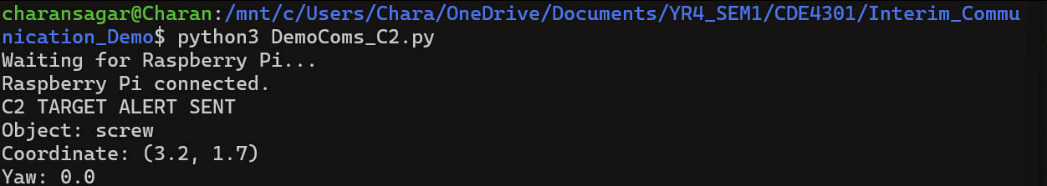
From ARGUS (simulated laptop)

⬇️
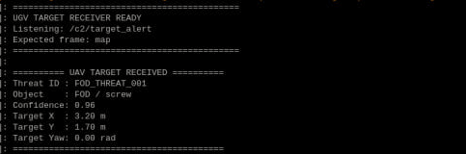
To HUNTER (simulated Raspberry Pi 5)

These tests were successful (shown in the figure above), proving that the ARGUS and HUNTER can exchange structured data over a local wireless network. This served as the baseline foundation for integrating the real-time FOD detection from the vision system with the HUNTER’s autonomous navigation system.

9.11 Limitations and Future Works
Although the interim tests demonstrated successful message transmission, several limitations remain. Firstly, the current communication relies on a local Wi-Fi network, which has not been tested for the full runway. Further research led to the decision to use long-range RF communication hardware that meets IMDA regulations within the operating range. ARGUS communications scripts are still not linked to the vision system, so the next stage is to integrate with the onboard vision system to automate C2 alerts. Additional reliable communication methods will be explored, including application-level acknowledgement, sequence-number tracking, and communication-loss detection. Finally, security enhancements such as authenticated messages and encryption will improve the protection of transmitted FOD information. The final objective is to establish a reliable communication system that allows ARGUS to detect and send coordinates to HUNTER, supporting timely FOD removal.

