**What did you do today?**

Peter, Brandon, Erin – developed the wireframes for the “Public” site (see a couple examples below).

Daniel – Created a useable “transparent” logo (see below)

Jason – Web Detail notes, wireframe review



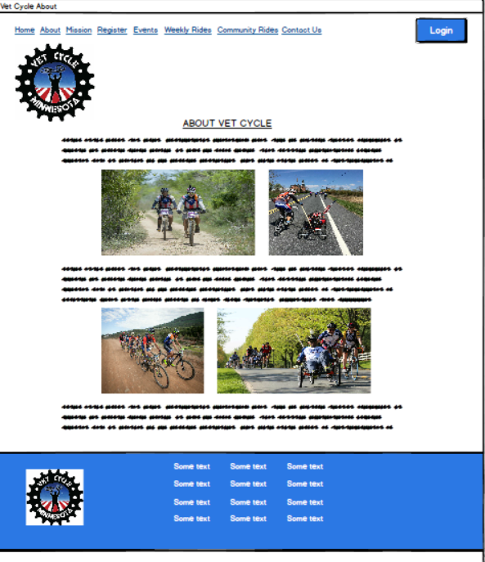

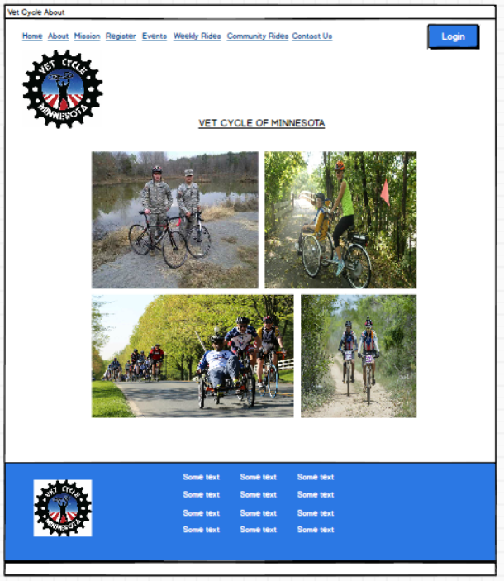

**What will you do tomorrow?**

Daniel – creates the Class Diagrams

Koua – creates the Use Case Diagram

**Any impediments?**

Time and getting together as a group. Our group chat helps, but it’s just a bit more difficult to give feedback that way. Trying to find times to meet.