Predator phylogenetic diversity decreases predation rate via antagonistic interactions

A. Andrew M. MacDonald, Diane S. Srivastava, Gustavo Q. Romero

## treatment## andro control elong elong + andro elong + leech ## 5 5 5 5 5 ## elong + tab leech tabanid ## 5 5 5

## eu Id wt name N X15N d15N emerged fine n15.leaves## 1 1 EU1 5.8 B1 46.9 0.3653 -2.8 0 0.5783 31## 2 2 EU2 6.2 B6 82.2 0.3713 13.6 0 0.6755 26## 3 3 EU3 6.2 B7 46.8 0.3694 8.4 0 0.1966 6## 4 4 EU4 6.2 D6 34.4 0.3714 13.9 1 1.3413 4## 5 5 EU5 5.9 Romero_Tray1_A1 51.4 0.3700 10.1 4 0.8255 11## 6 6 EU6 5.8 D7 59.6 0.3733 19.1 2 0.4996 40## leaf.mass bromeliad growth treatment fine.detritus mass.g. decomp## 1 0.9677 6 5.06 andro 1 1.514 0.3608## 2 0.9127 9 5.58 tabanid 10 1.498 0.3908## 3 1.0063 12 6.48 tabanid 18 1.506 0.3319## 4 1.0193 3 3.50 elong + andro 33 1.504 0.3221## 5 0.9035 10 3.34 control 20 1.502 0.3985## 6 0.9469 8 -1.12 elong + andro 8 1.514 0.3748## Culicidae Chironomidae Tipulidae Psychodidae Scirtidae total.surv leech## 1 0 1 1 0 0 2 0## 2 0 0 0 0 5 5 0## 3 1 1 0 0 3 5 0## 4 0 2 1 1 3 7 0## 5 3 13 1 1 2 20 0## 6 0 0 1 0 0 1 0## andro tab elong## 1 1 0 0## 2 0 1 0## 3 0 1 0## 4 1 0 1## 5 0 0 0## 6 1 0 1

## Introduction

We test three related hypotheses:

1. *species co-occurance*: closely-related predators occur together more frequently than less-related predators, due to their similar habitat requirements. Additionally, very closely related species never co-occur because they are too similar.
2. *diet similarity*: similarity in diet (as measured by feeding trials) decreases with phylogenetic distance.
3. *ecosystem-level effects*: similarity in the effect of predators on whole ecosystems declines with phylogenetic distance. Additionally, the non-additive effect of predators will have a greater absolute value when their phylogenetic diversity is larger.

## Methods

## Results

### metabolic capacity and phylogenetic distance

Predators which are closer in the phylogeny are more likely to occur in the same bromeliads, and to do so with a similar overall metabolic capacity.(F1,89=3.9381,P=0.0503).

### diet similarity and phylogenetic distance

Phylogenetic distance was not correlated with similarity in diet (F1,4=0.2807,P=0.6243). Indeed, all predators in this system appeared to feed readily on a wide range of prey species.

### Ecosystem-level effects and phylogenetic distance

All increases in predator phylogenetic diversity beyond damselflies resulted in a reduction of prey mortality.

### Figures

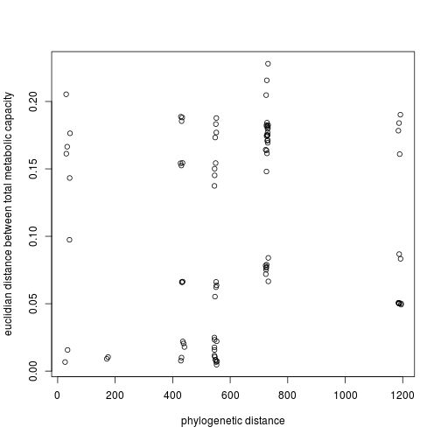

FALSE

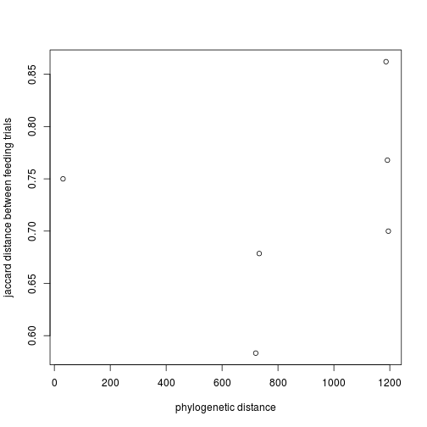

FALSE

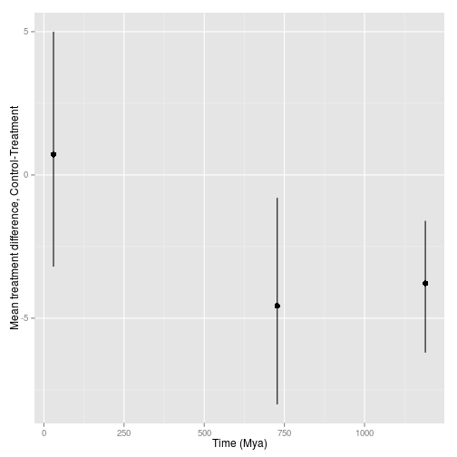

FALSE

## Discussion

## Works Cited