Predator phylogenetic diversity decreases predation rate via antagonistic interactions

A. Andrew M. MacDonaldDiane S. SrivastavaGustavo Q. Romero

## Introduction

We test three related hypotheses:

1. *species co-occurance*: closely-related predators occur together more frequently than less-related predators, due to their similar habitat requirements. Additionally, very closely related species never co-occur because they are too similar.
2. *diet similarity*: similarity in diet (as measured by feeding trials) decreases with phylogenetic distance.
3. *ecosystem-level effects*: similarity in the effect of predators on whole ecosystems declines with phylogenetic distance. Additionally, the non-additive effect of predators will have a greater absolute value when their phylogenetic diversity is larger.

## Methods

## Results

### metabolic capacity and phylogenetic distance

Within the 2008 observational dataset, we identified 14 species as predators. These predators vary in taxonomic relatedness: from congeners -- *Bezzia* sp. (Diptera:Ceratopogonidae) with two species and *Leptagrion* sp. (Odonata:Coenagrionidae) with three -- to confamilials (three species of Tabanidae and two of Empididae, all Diptera). Three families of Diptera are represented by a single species each: Dolichopodidae, Corethrellidae and Chironomidae. The deepest taxonomic divide is between all insects present and a species of leech (Annelida:Hirudinidae). Node age data was available for all but the shallowest nodes of the tree, where either a lack of taxonomic information (e.g. Tabanidae) or a lack of phylogenetic study (e.g. *Leptagrion*) prevented more information from being included. These branches were left as polytomies, and were all assigned identical, arbitrary and short branch lengths (15 Mya).

We obtained node age estimates for all 7 internal nodes of the tree. These were usually provided by only a single study, with more studies available for deeper nodes: Insecta--Hirudina (543 to 700 Mya, n=5 studies), Odonata--Tabanidae (151 to 543 Mya, n=4 studies) and Tabanidae--Diptera (151 to 543 Mya, n=7 studies). We used the median estimate of age for these nodes.

In 2008, insects were counted and measured in an observational study of 25 bromeliads. Across all bromeliads, predator species differed widely in metabolic capacity, from 0.0062 for a species of Empididae, to 0.4804 for the abundant predator *Leptagrion andromache*. Predators often co-occured in bromeliads ( $3.52±3.11$ species per plant). However, the euclidian distance between the total metabolic capacity of two predators did not show any relationship with phylogenetic distance between them (F1,89=1.5558, p=0.22).

### diet similarity and phylogenetic distance

We conducted 237 feeding trials of 8 predator taxa fed 14 prey taxa. However, due to the rarity of some taxa many predator-prey pairs were not possible; we tested 46 pairwise combinations. Most trials were replicated at least 5 times, but the number of replicates for various combinations ranged from 1 to 11. Two damselflies, *Leptagrion andromache* and *Leptagrion elongatum*, showed the higest rates of prey consumption (prey consumed in 94% and 67% of trials, respectively).

All predators showed a very generalist diet breadth, consuming nearly all species offered to them. However, more phylogenetically distant predators preferred slightly different diets, as measured by euclidian distance between feeding trial outcomes (F1,19=5.16, p=0.035) Regression was weighted by the number of trials conducted.

### Ecosystem-level effects and phylogenetic distance

In our manipulative experiment, we placed a standardized prey community into bromeliads and measured five response variables: the total survivorship (both emerged during experiment and found as larvae at the end) of all prey, the %N15 which was transferred into bromeliad tissue, bromeliad growth, coarse detritus decomposition and fine organic matter production. Predators had a large effect on prey survivorship: on average all predator treatments showed 51% lower prey emerging or surviving as larvae relative to the predator-free control. Nitrogen transport to bromeliad leaves was slightly decreased relative to controls (-11%), and was only higher than the control in treatments including Tabanid predators. We found a similar pattern for plant growth: on average, predators had a -18% effect on growth of bromeliad leaves (mm), though Tabanids seemed to create a slight increase. The decomposition of coarse detritus and production of fine organic matter showed no obvious pattern related to the mere presence of predators.

Predator combinations tended to have an increased effect on our response variables relative to predators alone. Approximately 14% more prey survived in polyculture, on average, compared to all monocultures. Effects were smaller for Nitrogen (8%) and bromeliad growth (11%). Fine particulate organic matter was produced 29% more when predators were present in combination.

Our experimental design allows us to estimate the non-additive effect of predator species pairs on whole communities of prey, and the functioning of the bromeliad ecosystem. We used randomization tests to test the hypothesis that increased phylogenetic distance between members of a predator pair results in a greater magnitude of nonadditive effect. We contrasted the differences of the mean individual predator treatments from the control with the mean difference of their pairwise combination from the control. We found the greatest effect for prey survival: while effects of *L. andromache* and *L. elongatum* in combination were quite similar to the effect of either alone, when *L. elongatum* was placed in the same plant as either a Tabanid larva or leeches, on average 5 more prey (18% of total prey community) survived till the end of the experiment (Fig 3). This effect was smaller among the other variables, most of which showed confidence intervals from the randomization test which overlap 0.

### Figures

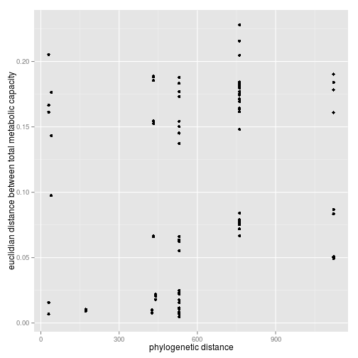

FALSE

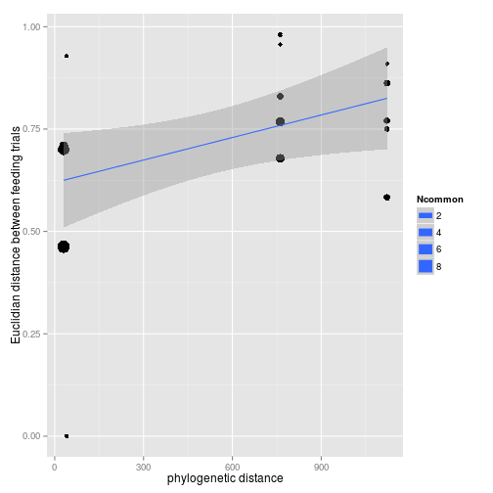

FALSE

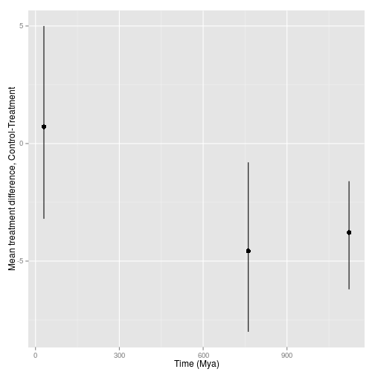

FALSE

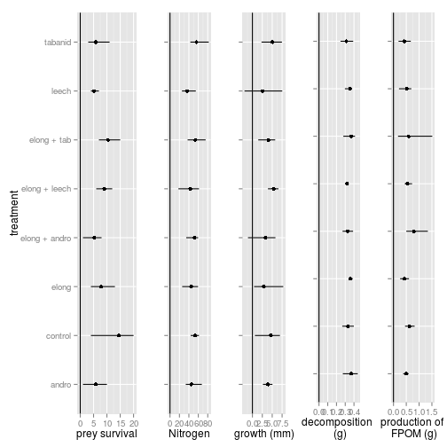

FALSE

## Discussion

## References