 |  | Grade/s: | 5
Enduring Idea: | Alienation
Integrated Discipline: | English
Unit Title: | Altered Self
Unit Designer: | Sara McGregor
Unit Description: | Introduction  What is an “altered book?” One definition defines it as, “any book, old or new that has been recycled by creative means into a work of art. They can be rebound, painted, cut, burned, folded, added to, collaged in, gold-leafed, rubber stamped, drilled or otherwise adorned.”  Other techniques for pages include: pierced, and torn pages can be painted, collaged, stamped, and written on. Elements in pages can be manipulated and popped out in all directions. Objects can be glued, stapled, sewed, or tucked into various folds and pockets, and blocks of pages can be glued or wired together to make carved windows, niches, and boxes, and even small drawers made out of matchboxes.  One separation between altered books from scrapbooks and collages is the relationship of the visual elements to the text of the original book. Text can be hidden, isolated, or highlighted and even painted except for hidden elements. One or more lines of text can provide the inspiration for an entire finished page. Even the page can become an interpretation of a poem or passage. Sometimes even new text is added, such as selected pieces cut out of magazine or newspapers.  Due to the labor-intensity of materials used in book making, many of the earliest books are altered books. When Greek scribes washed, scraped, and resurfaced pieces of parchment to recycle the expensive animal hides, traces of previous text often bled through, creating what we call a palimpsest.  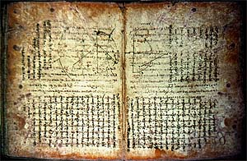  Palimpsest example  Several diverse traditions merged in the Victorian period to lay the foundation for the modern altered book. Since the 17th century, commonplace books or collections became popular. These were popular books of favorite sayings and drawings inscribed by friends and acquaintances.  Victorians continued the range of this idea by creating scrapbook albums of pictures, sometimes cut from store catalogues. “Clip art” was not an invention of the computer age because Victorian stationers sold “scraps,” sheets of pictures to be cut out and put in albums, similar to stickers today. Sometimes Victorians bought albums, but usually they pasted their scraps in existing books.  The modern altered book has evolved from two movements: the Book Arts and Contemporary Craft. The Book Arts movement began in 1966 when British artist Tom Philips bought the Victorian novel, A Human Document by W. H. Mallock for three pence. He began transforming it page by page into his own by selectively painting over the original text to create his own poetic, gnomic tale, complete with characters. A founding work in the genre now called Artist’s Books. Next, the contemporary craft interest in stamping and scrapbooking has grown in recent years into a major industry. In 2005, a televised tour of the national craft vendors show pronounced altered books the hottest new trend in scrapbooking. Stores selling these craft products include Michaels, Hobby Lobby, Target, and even the local grocery store shelves.  Adapting altered books in the classroom holds the double promise of raising the conceptual level of the genre while also potentially enriching the creative life of the students. It hones the student’s skills in creativity, measurement, recycling and reusing materials, reading, and writing. Materials used will be one donated textbook that would otherwise be discarded. Students will use materials they have laying around their home to further promote recycle and reuse. Parents will be notified of the project in the class schedule and website for clarification and communication.  This lesson is called a round robin altered book because it is shared and passed from one person to another. Students will share responsibility and only one student will be entrusted with the class altered book each weekend. During that time, they will have responsibility and creativity to adorn their own pages and contribute to the collaborative class project. This lesson could be applied to all of the grade levels but will be used for the fifth grade. Targeted due to their advanced skills and ability to make connections between the visual arts and other arts disciplines, content areas, and the world. Plus, this will be a final collaborative project before graduation to promote responsibility and trust as an individual and team member.  Examples of Altered Books  Collage  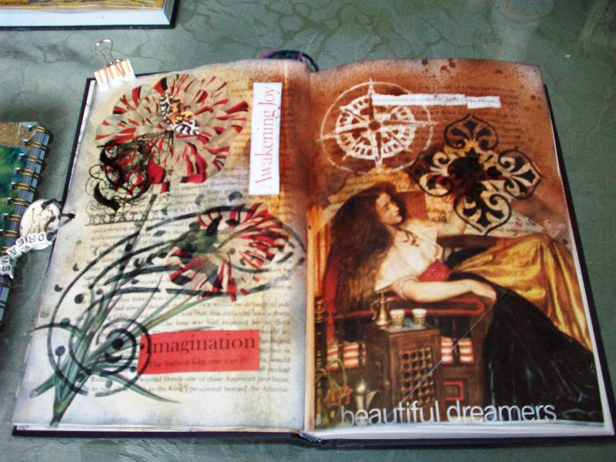  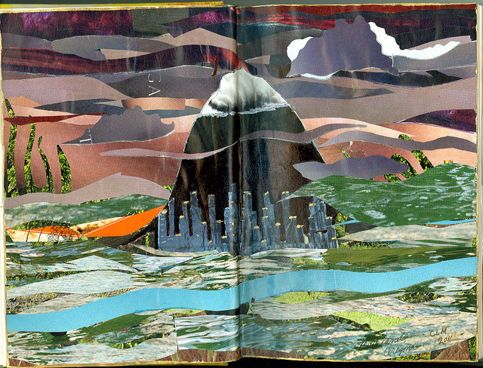  Altered Book – Portland  Imajica Amadoro  "I Left My Heart .."  2011  Paper Collage (magazines)  10 x 8  3D, Cut-Outs, and Fabric  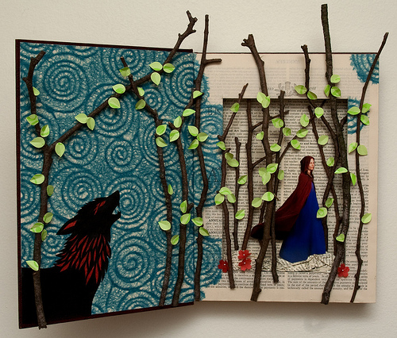  Rachael Ashe  Altered Book: Little Red Riding Hood  Selective Poem  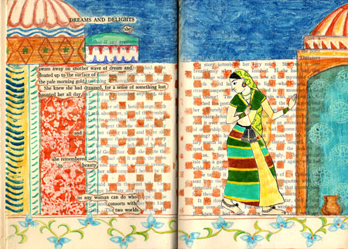  “dreams and delights” – copyright Â© 2004-07 karen hatzigeorgiou  She swam away  on another wave of dream  and floated up to the surface  of the pale morning gold.  She knew she had dreamed,  for a sense of something lost  haunted her all day,  and she remembered its beauty,  as any woman can do  who consorts with two worlds.
Images: | -Lesley Dill, Opening to the Unknown Nourishment, 2001, CMA 2002.11.1  -Roberto De LaMonica, Gravura 52, 1965, CMA 1967.6  -Deborah Muirhead, Nameless (Hands), 2001, CMA 2002.1.1  -Ron Portocarrero, Springtime, 1952, CMA 1955.9
Key Concept: | - An individual’s self-image, self-esteem, and self-worth can be affected by alienation.  - Physical and psychological isolation can impact an individual.  - Individuals and groups with common values can feel alienated in their own environment.
Essential Question: | - What does it mean to alienate one’s self?  - What are the benefits or implications of alienation?  - Can social grouping be alienating?
CCSS Art: | Standard 1: The student will demonstrate competence in the use of ideas, materials, techniques, and processes in the creation of works of visual art.  VA5-1.3 Use a variety of materials, techniques, and processes to create artworks.  VA5-1.5 Use all art materials and tools in a safe and responsible manner.  Standard 4: The student will understand the visual arts in relation to history and world cultures and the technologies, tools, and materials used by artists.  VA5-4.1 Identify specific artworks and styles as belonging to particular artists, cultures, periods, and places.  VA5-4.2 Write an analysis of the ways in which his or her artwork was influenced by another artist and conduct research on that artist to support his or her analysis.  Standard 5: The student will analyze and assess the characteristics and qualities of his or her own works of visual art and those of others.  Indicators  VA5-5.1 Identify and discuss purposes for the creation of works of visual art.  VA5-5.2 Describe, discuss, and evaluate, both orally and in writing, the different qualities and characteristics of his or her own artworks and those of others, including works by South Carolina artists.  Standard 6: The student will make connections between the visual arts and other arts disciplines, other content areas, and the world.  Indicators  VA5-6.1 Identify connections between the visual arts and content areas across the curriculum.  VA5-6.3 Practice the usage of aesthetic terminology when discussing other areas of learning.  VA5-6.4 Discuss and write about the ways that skills from another area of the curriculum might be used in the visual arts.
Integrated CCSS: | Language Arts  Standard 5-5 The student will write for a variety of purposes and audiences.  5-5.3 Create written descriptions using precise language and vivid details.  5-5.4 Create written pieces (for example, picture books, comic books, and graphic novels) to entertain a specific audience.
Learning Outcomes: | The teacher will:  - Discuss the history of altered books and its role in self expression.  - Examine various examples of altered books and discuss its elements as a visual and text.  - Discuss and review the importance and elements of composition.  - Survey and discuss different techniques to alter book pages.  - Analyze the connections of the lesson to English and Science, using text and elements of nature to enhance and inspire your artwork.  Students will:  - Discuss the history of altered books and its elements and purpose.  - Create at least one page in the altered book expressing your inner self.  - Choose at least one technique shown in class and use it in their own pages.  - Write a journal entry about your experience with the altered book and opening up about their alienated self.  - Recall the altered book techniques for a short answer quiz.
Motivator: | Day 1:  The teacher will share either a personal altered book or a past round robin class altered book as an example to the class and pass it around to let students touch and examine the books.  Year:  Each class, the student who was assigned that day will present their two pages in the altered book. Be sure to check to make sure the student wants to present their pages.
Day Breakdown: | Day 1  - Introduction (10 minutes)  - The teacher will introduce the lesson by discussing a brief history of altered books and its elements and purpose.  - Examine various examples of altered books and discuss its elements as a visual and text.  - Discussion (20 minutes)  - The teacher will explain the lesson and show examples to the class.  - The teacher will explain the assessment criteria.  - The teacher will pass around the checklist to the class to reinforce the expectations.  - The class will discuss composition of the altered book examples to create a pleasing artwork.  - Discuss and review the importance and elements of composition.  - Survey and discuss different techniques to alter book pages.  - Analyze the connections of the lesson to English and Science, using text and elements of nature to enhance and inspire your artwork.  - Activity (Outside class)  - Create at least one page in the altered book using materials at home to promote recycling and reuse outside of school.  - Choose at least one technique shown in class and use it in their own pages.  - Write a journal entry about their weekend, experience with the altered book, and opening up about their alienated inner self.  - Clean up (5 minutes)  - The teacher will oversee clean up procedures assigned to the students.  - Short Answer Quiz (10 minutes)  - The student will complete a short answer quiz about the altered book technique.  Day 2- Last Day of Class  - Introduction (5 minutes)  - The teacher will introduce the final altered book to the class.  - Discussion (15 minutes)  - Students will recall their experience taking the altered book home in a class discussion.  - If desired, students will read their journal entries about their altered book experience to the class.  - Optional Activity (30 minutes)  - If available, give each student his or her own textbook to alter at home.  - Paste inside the front cover of the book with a written description and inspirational quote.  - Clean up (5 minutes)  - The teacher will oversee clean up procedures assigned to the students.
Materials: | - Calendar  - Examples of altered book techniques  - Old textbook for altering  - Paper for short answer quiz  - Sign up sheet  Optional Extension:  - Old textbook for each student (ask local library for donations)  - Written description and inspirational quote for inside of each textbook
Resources: | http://www.brittomart.net/WoolfSem/altbookintro.html  http://www.mlahanas.de/Greeks/ArchimedesPal.htm
Assessment: | Day 1:  Quiz- Students will complete a short answer quiz about the texture rubbing technique.  Throughout school year:  Checklist- Students will receive full points if they used at least one technique in their altered book page, promptly returned the book in good condition, and wrote a journal entry about their weekend and experience with the altered book.

