10

Advanced View Techniques

This chapter covers

* Using master pages for crafting site-wide templates
* Applying partials for shared snippets of content
* Leveraging child actions for common widgets
* Building parameter lists to map to routes for links
* Examining a popular alternative view engine, Spark

While the MVC pattern gives us separation of concerns between the model, controller and view, this pattern did not eliminate the need for developers to carefully design their views. With the elimination of code-behind and the addition of a ViewModel object, we can focus strictly on rendering content inside our view. However, without careful attention, our views can still slide into a morass of duplication and spaghetti code. We can no longer lean on custom controls to encapsulate view behavior as we did in WebForms. Instead, ASP.NET MVC provides similar and expanded mechanisms for tackling all levels of duplication in our views. First, we will look at the various forms of duplication we encounter in our views, and various means of tackling duplication as it arises.

10.1 Eliminating duplication in the view

In ASP.NET MVC, the ability to use web controls to encapsulate complex UI elements is all but gone. We can use web controls that do not take advantage of ViewState, but that renders most web controls built for WebForms mostly useless. Instead, we have to turn to other means to eliminate duplication in our views that can grind our ability to build new features to a complete halt. With the release of ASP.NET MVC 2, our choices for tackling view duplication are expanded:

1. Master Pages
2. Partials
3. Child Actions
4. Templates
5. HtmlHelper extensions

Each means of addressing duplication in our views has its sweet spot, while there is some overlap between some. In Chapter 3, we examined using the new templates feature to standardize on displaying and editing data across our entire application. Templates work well for rendering one editor or display template for a single model member or type, but tend to break down in other scenarios. Partials work well with common snippets, but do not scale out to entire sites. In our first example, we will look at establishing site-wide templates with master pages.

10.1.1 Master Pages

When using the WebFormViewEngine, we retain the ability to use master pages as part of our views. Originally added as part of ASP.NET 2.0, master pages allowed developers to create master layouts of common pages. A master page defines a layout, leaving placeholders for derived pages or other master pages to fill in the blanks. In listing 10.1, our master page defines placeholders for both a page title and main content.

Listing 10.1: A master page defined for an MVC view

<%@ Master Language="C#" Inherits="System.Web.Mvc.ViewMasterPage" %>

<!DOCTYPE html PUBLIC "-//W3C//DTD XHTML 1.0 Strict//EN" "http://www.w3.org/TR/xhtml1/DTD/xhtml1-strict.dtd">

<html xmlns="http://www.w3.org/1999/xhtml">

<head runat="server">

<title><asp:ContentPlaceHolder ID="TitleContent" runat="server" /></title>

<link href="../../Content/Site.css" rel="stylesheet" type="text/css" />

</head>

<body>

<div class="page">

<div id="header">

<div id="title">

<h1>My MVC Application</h1>

</div>

<div id="logindisplay">

<%= Html.Action("LogOnWidget", "Account") %>

</div>

<div id="menucontainer">

<ul id="menu">

<li><%= Html.ActionLink("Home", "Index", "Home")%></li>

<li><%= Html.ActionLink("Profiles", "Index", "Profile")%></li>

<li><%= Html.ActionLink("About", "About", "Home")%></li>

</ul>

</div>

</div>

<div id="main">

<asp:ContentPlaceHolder ID="MainContent" runat="server" />

<div id="footer"></div>

</div>

</div>

</body>

</html>

Master pages in ASP.NET MVC are very similar to master pages in WebForms. We can define content placeholders, place common markup in our view, and enforce a site-wide layout. In ASP.NET MVC, our master page now inherits from System.Web.Mvc.ViewMasterPage. This new base class gives us access to the same helper classes and model as our view, including:

* AjaxHelper (in the Ajax property)
* HtmlHelper (in the Html property)
* ViewData and Model
* UrlHelper (in the Url property)
* TempData and ViewContext

In the listing above, we used the HtmlHelper object to generate the common menu links. An alternative strongly-typed master page base class is available, but this is limited to cases where your view structure needs to match an inheritance hierarchy in your ViewModel classes. Master pages can also nest within each other, so that a generic site-wide master page can be defined, for the general layout of the entire site. More specific master pages can then define more specific layout and define new content placeholders. Master pages are best applied when more than one view share common content. This content can then be pulled up to a master page. Each view then only needs to supply the pieces that differ from view to view. While master pages work great for common layouts, we need to use different approaches when we encounter common snippets of markup across disparate views. In the next section, we will examine a common means for rendering content snippets in partials.

10.1.2 Partials

When it comes to rendering common snippets of content, we have many choices for consolidating those snippets into common rendering logic. With the addition of templates in ASP.NET MVC 2, many of the situations when we might use partials are now supplanted by templates. However, we still might run into situations where we would rather not work with the templating infrastructure, and specify exactly which common snippet to render from the view. Templates work well with a strongly-typed view, but still need to work with a specific model to execute. Partials, on the other hand, do not require a model to render. With templates, you will usually render a template for a specific member, while partials have much looser restrictions.

Partials are analogous to user controls in WebForms. They are intended to render snippets of content, when it is most advantageous to develop these snippets in a view page, rather than in code. Since partials cannot contain behavior, they also work best when little to no decisions need to be made inside the partial on how to render the content given. If you find yourself copying and pasting one snippet of HTML from one view to the next, that snippet is a great candidate for a partial.

The mechanism for rendering a partial is quite simple. We can use the RenderPartial method in a parent view, shown in listing 10.2.

Listing 10.2: Rendering a partial from a parent view

<h2>Profiles</h2>

<table>

<tr>

<th>Username</th>

<th>First name</th>

<th>Last name</th>

<th>Email</th>

</tr>

<% foreach (var profile in Model) { %>

<% Html.RenderPartial("Profile", profile); %>

<% } %>

</table>

In the listing above, we render a list of profiles in a table. For each row however, we want to define a partial for rendering a single row. Even if content is not shared with other views, partials can be used to simplify and reduce the amount of markup seen in one view. In our example, it can be seen as similar to extracting a method in a class file. While that method may be only called once, it can be easier to understand the view. The RenderPartial metohd takes a partial name, and an optional model. The partial name is used to locate the partial markup by looking in specific, well-known search locations:

1. <Area>\<Controller>\<PartialName>.aspx & .ascx
2. <Area>\Shared\<PartialName>.aspx & .ascx
3. \<Controller>\<PartialName>.aspx & .ascx
4. \Shared\<PartialName>.aspx & .ascx

These search locations are very similar to searching for views by name, with the exception that we now look for a partial by the name specified in the RenderPartial method. In our example above, the RenderPartial looks for a file named "Profile", found in the controller-specific views folder shown in figure 10.1.

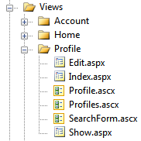

Figure 10.1 - The Profile partial located in our Profile views folder

The Profile partial is an ASCX file, but we could use an ASPX file if need be. Using an ASPX file would allow us to build partials that could use master pages. Otherwise, the ASCX file would inherit from System.Web.Mvc.ViewUserControl (or its generic counterpart). We can develop strongly-typed partials with the same access to the strongly-typed view helpers by inheriting from ViewUserControl<T>, as shown in listing 10.3 below.

Listing 10.3: A partial to display a row for a Profile model

<%@ Control Language="C#" Inherits="System.Web.Mvc.ViewUserControl<Profile>" %>

<tr>

<td><%= Model.Username %></td>

<td><%= Model.FirstName%></td>

<td><%= Model.LastName%></td>

</tr>

With the strongly-typed partial, the Model property now reflects a Profile object. Partials work well for displaying common snippets of content for information already in the main model from the controller action. But for other widgets, we need to look at a new ASP.NET MVC 2 feature called child actions.

10.1.3 Child Actions

While partials work well for displaying information already in the main view's model, they tend to break down when the model displayed needs to come from another source. For example, a logon widget might display the current user's name and email. But the rest of the page likely displays information that has nothing to do with the current user. We could pass this unrelated model through the ViewDataDictionary, but now we are back to magic strings in our action, with problems tracing the model back to its source. For snippets of content that tend to have nothing to do with the main information displayed, we can instead spawn a miniature internal pipeline for a separate, child action, shown in listing 10.4.

Listing 10.4: Displaying a child action for a logon widget

<div id="logindisplay">

<%= Html.Action("LogOnWidget", "Account") %>

</div>

In our master page, we want to display a common logon widget. If the user is not logged in, it should display a "Login" link. Otherwise, it can display common information about the current user such as username and email, as well as a link to the user's profile. However, we do not want to put the burden on every action that might somehow render this master page to also supply this extra information. The profile information might need to be pulled from a persistent store such as a database or Session, so we will not want to use a partial to do all of this. In the example above, we use the RenderAction method to render the LogOnWidget action of the Account controller. RenderAction is similar to other action-based HtmlHelper extensions such as ActionLink, except RenderAction will render the results of that action inline. Because RenderAction will execute another request to ASP.NET MVC, we can encapsulate very complex widgets into a normal MVC pattern.

Authoring a child action is very similar to other normal actions, as shown in listing 10.5.

Listing 10.5: Our logon widget child action

[ChildActionOnly]

public ViewResult LogOnWidget()

{

bool isAuthenticated = Request.IsAuthenticated;

Profile profile = null;

if (isAuthenticated)

{

var username = HttpContext.User.Identity.Name;

profile = _profileRepository.Find(username);

if (profile == null)

{

profile = new Profile(username);

_profileRepository.Add(profile);

}

}

return View(new LogOnWidgetModel(isAuthenticated, profile));

}

Although the logic behind rendering a logon widget is complex, we can encapsulate that complexity behind a normal controller action. In our child action, we check to see if the user is logged in. If so, we pull up their profile using the IProfileRepository. Finally, we render a strongly-typed view by building up a LogOnWidgetModel and calling the View helper method. To ensure that this action can only be rendered as a child action and not through an external request, we decorate our child action with the ChildActionOnly attribute.

The only difference between a normal controller action and a child action is the ChildActionOnly attribute. Otherwise, our controller still gets instantiated through the controller factory, all action filters are executed, and the expected view is displayed using the normal view locating behavior. For child actions, we typically use a ViewUserControl for the view, as master pages usually do not apply in child action scenarios. In the next section, we will examine how we can efficiently build parameter lists without resorting to anonymous objects or ugly dictionary syntax.

10.2 Building querystring parameter lists

Preparing querystring parameters lists happens quite frequently when developing MVC views. In this section, you will learn how to build new URLs complete with querystring parameters. The controller action for this example is very simple with only one parameter as shown in listing 10.6.

Listing 10.6: The Edit profile action

public ViewResult Edit(string username)

{

var profile = _profileRepository.Find(username);

return View(new EditProfileInput(profile));

}

Listing 10.6 shows an action method that accepts a username and send a view model to the default view. Built into ASP.NET MVC, we have two options. We can construct a RouteValueDictionary, or an anonymous object, as shown in listing 10.7 below.

Listing 10.7: Current options for building route-based URLs

<%=Html.ActionLink("Edit", "Edit",

new RouteValueDictionary(new Dictionary<string, object> { {"username", Model.Username } })) %>

<%=Html.ActionLink("Edit", "Edit", new { username = Model.Username }) %>

The first option, using the RouteValueDictionary, is quite ugly. It takes dozens of characters before you find that you are trying to specify the "username" option. The second option is shorter, but much less intuitive. The signature of that ActionLink overload accepts a parameter named "routeValues" but only of type "object". It is up to the end user to determine when these overloads accepting object parameters are actually workarounds for the lack of decent dictionary initializer syntax in C#. Internally, the ActionLink method uses reflection to find the properties and values defined in the anonymous type. From the properties defined, it builds a dictionary from these values. The property names become route value keys, and the property values become the route values.

This works well as long as we already understand that the object overloads are actually using reflection to generate a dictionary. However, this does not address the issue of duplication that this method introduces. For every link to a common action, we need to supply the names of the action parameters. If these values are scattered across many views, it can be difficult or impossible to now change the parameter name in our action method. In our Edit action, we might want to change the parameter name to "name", causing us to search through our views and controllers to find places where we link to that action.

To address this duplication, we have two options. We can create strongly-typed models for every action method that accepts parameters. Another option is to encapsulate the building of parameter lists into a builder object. We can then use this parameter builder to build parameter lists in our views and controller actions. First, we need to create our parameter builder object, shown in listing 10.8

Listing 10.8: The ParamBuilder object

public class ParamBuilder : ExplicitFacadeDictionary<string, object>

{

private readonly IDictionary<string, object> _params = new Dictionary<string, object>();

protected override IDictionary<string, object> Wrapped

{

get { return _params; }

}

public static implicit operator RouteValueDictionary(ParamBuilder paramBuilder)

{

return new RouteValueDictionary(paramBuilder);

}

public ParamBuilder Username(string value)

{

_params.Add("username", value);

return this;

}

}

Our ParamBuilder class inherits from a special dictionary class, ExplicitFacadeDictionary. This class is an implementation of IDictionary<,> where every method is explicitly implemented. This is to ensure that users of the ParamBuilder do not get bombarded with a multitude of dictionary methods. The abstract ExplicitFacadeDictionary class needs implementors to provide the wrapped dictionary object in the Wrapped property. Next, we define an implicit conversion operator from ParamBuilder to a RouteValueDictionary, making it possible for us to pass in a ParamBuilder object directly to methods expecting a RouteValueDictionary. Finally, we define a Username method, meant to encapsulate the "username" action parameter. Because we may want to supply more than one action parameter, the Username method returns the ParamBuilder instance so that the developer can chain multiple parameters together.

To use the ParamBuilder class, we first need an instance of a ParamBuilder. Instead of instantiating a new builder in our views, we can define a new base view page to hold our new helper object. Our new base view page class is shown in listing 10.9.

Listing 10.9: Our shim base view page class

public class ViewPageBase<TModel> : ViewPage<TModel>

{

public ParamBuilder Param { get { return new ParamBuilder(); } }

}

To use our new base view page class, we modify our views to inherit from this new class. Creating a base view page class is generally a good idea, as it allows us to build in site-wide view helper methods, similar to creating a site-wide controller layer supertype. With our view now inheriting from ViewPageBase<T>, we can now use the Param property to build up parameter lists, shown in listing 10.10.

Listing 10.10: Using the parameter builder in our view

<p>

<%

bool hasPermission = (bool)ViewData["hasPermission"];

if (hasPermission) { %>

<%=Html.ActionLink("Edit", "Edit", Param.Username(Model.Username)) %> |

<%=Html.ActionLink("Back to List", "Index") %>

<% } %>

</p>

In the Edit action link, we use the Param property to specify the username member. Because we now control our parameters through a ParamBuilder object defined in our codebase, we can build overloads to parameter methods to take a variety of types. All conversions from model objects to parameter values can be encapsulated in our ParamBuilder, cleaning up our views.

The default view engine in ASP.NET MVC is the WebFormViewEngine, but it is definitely not the only view engine available. In the next section, we will examine the popular Spark view engine.

10.3 Exploring the Spark View Engine

By default, an ASP.NET MVC application uses the WebFormViewEngine to locate and render views. But we are not forced to use Web Forms to design and render our views. One of the extension points of ASP.NET MVC is the ability to swap out the default IViewEngine for a different implementation. With a different view engine, we get a different experience in defining and developing views. Popular alternative view engines supported in ASP.NET MVC through various open source efforts include:

* Brail
* NHaml
* NVelocity
* Spark

But why would we want to investigate other view engines? One issue with the WebFormViewEngine is that you do not have many options for server-side coding except with complex languages such as C# and VB.NET. Although these languages are quite powerful, seeing code interspersed with markup is ugly. Creating a simple loop of HTML requires a foreach loop and curly braces mixed with our HTML tags. For more complex view logic, it becomes nearly impossible to understand what is going on. The WebFormViewEngine suffices in many situations, but it’s obvious that it was not built with MVC-style applications in mind, where we are almost guaranteed to need code in our views. Although this code is strictly view-centric, it’s still unavoidable.

These alternative view engines are designed to be view engines, rather than holdovers from the Web Forms days. Each is optimized for designing an MVC view, and many are ported versions of other, established view engines for other, established MVC frameworks. For example, NHaml is a port of the popular (and extremely terse) Haml view engine. Another view engine, designed for both ASP.NET MVC and MonoRail, is Spark (<http://sparkviewengine.com/>). Spark provides a unique blend of C# code in line with HTML, disguised as XML elements and attributes. There are disadvantages to some view engines, such as the lack of IntelliSense and a slightly less integrated feel in Visual Studio. Spark provides integration with Visual Studio, including IntelliSense and a view compiler. The view compiler ensures that at least we do not have to wait for runtime exceptions to expose typos and bugs in our views. In this section, we examine the major features of Spark to see the advantages it has over the default view engine. But first, we’ll walk through the installation and configuration process.

10.4.1 Installing and configuring Spark

The latest release can be found at Spark’s CodePlex site, at <http://sparkviewengine.codeplex.com/>. The release includes:

* The Spark assemblies we need in our MVC project
* Documentation
* Samples
* Installer for Visual Studio IntelliSense

To get Spark running in our MVC project, we need only the binaries. However, the IntelliSense is quite helpful, so we’ll run the installer before launching Visual Studio. Next, we add references to both the Spark and Spark.Web.Mvc assemblies, shown in figure 10.2.

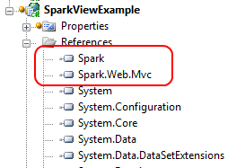

Figure 10.2 Adding the Spark assembly references to our project

With our Spark assembly references added to our project, we can configure ASP.NET MVC to use Spark as our view engine. Spark has additional configuration, which we can either place in our Web.config file or in code. For this example, we’ll configure Spark in code, but the Spark documentation has full examples of both options. Our Spark configuration is shown in listing 10.11.

Listing 10.11 Spark configuration code

var settings = new SparkSettings()

.SetDebug(true)

.AddAssembly("SparkViewExample")

.AddNamespace("System")

.AddNamespace("System.Collections.Generic")

.AddNamespace("System.Linq")

.AddNamespace("System.Web.Mvc")

.AddNamespace("System.Web.Mvc.Html");

ViewEngines.Engines.Add(new SparkViewFactory(settings));

We place the code into the Application_Start method in our Global.asax.cs file, as the Spark configuration and MVC view engine configuration only need to happen once per application domain. In the first section, we create a SparkSettings object, configuring the compilation mode, and adding our project assembly and various assemblies for compilation. This section should look similar to configuring the WebFormViewEngine in our Web.config file. Next, we add a new SparkViewFactory instance to the System.Web.Mvc.ViewEngines.Engines collection. The ViewEngines class allows additional view engines to be configured for our application. To the SparkViewFactory instance we pass our SparkSettings object created earlier. That is all it takes to configure Spark! Now that Spark is configured, we can move on to creating views for our example.

10.4.2 Simple Spark view example

On the controller and model pieces of our MVC application, we won't see any changes with our new view engine. We want to show a list of Product model objects, shown in listing 10.12.

Listing 10.12 Simple Product model

public class Product

{

public string Name { get; set; }

public string Description { get; set; }

public decimal Price { get; set; }

}

Again, the Spark view engine places no specific constraints on our model, nor our controller action, shown in listing 10.13.

Listing 10.13 A ProductController for displaying Product objects

public class ProductController : Controller

{

public ViewResult Index()

{

var products = new[] #A

{

new Product {

Name = "Toothbrush",

Description = "Cleans your teeth",

Price = 2.49m

},

new Product {

Name = "Hairbrush",

Description = "Styles your hair",

Price = 10.29m

},

new Product {

Name = "Shoes",

Description = "Protects your feet",

Price = 55.99m

},

};

return View(products); #B

}

}

#A Create dummy products

#B Send products to the view

We show only a dummy list of products for our Spark views to display. To create our Spark views, the folder structure is similar to our structure for other view engines. In the root Views folder, we create a Product folder to correspond to our ProductController. Additionally, we create a Layouts and Shared folder, as shown in figure 10.3.

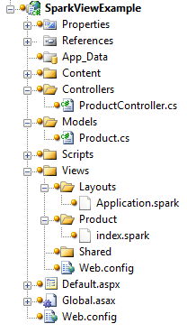

Figure 10.3 Complete folder structure for our Spark views

In Spark, view files use the.spark file extension. This is mainly so that the file extension doesn’t conflict with other view engines in the IDE or at runtime.

Spark supports the concept of layouts, which are similar in nature to the Web Forms Master Pages. By convention, the default layout name is Application.spark, found in either the Layouts or Shared folder. To start, we’ll create just a text file in Visual Studio named Application.spark (instead of a Web Form or other template). This is shown in figure 10.4.

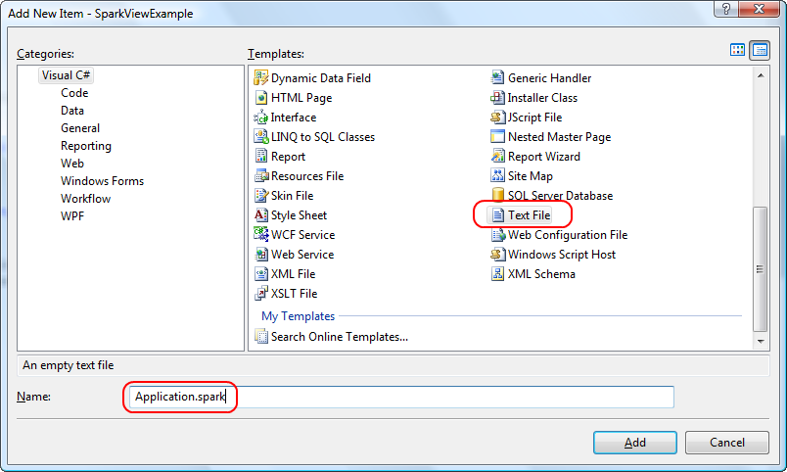

Figure 10.4 Adding an Application.spark layout for our views

We choose the Text File template as we don't want any of the built-in functionality with something like a Web Form template; we need only a blank file. Inside our base layout, we need to place a couple of links as well as provide a placeholder for the actual child content. Our entire layout is shown in listing 10.14.

Listing 10.14 Entire Application.spark layout template

<!DOCTYPE html PUBLIC "-//W3C//DTD XHTML 1.0 Strict//EN" "http://www.w3.org/TR/xhtml1/DTD/xhtml1-strict.dtd">

<html xmlns="http://www.w3.org/1999/xhtml">

<head>

<title>Spark View Example</title>

<link href="~/Content/Site.css" rel="stylesheet" type="text/css" />

</head>

<body>

<div class="page">

<div id="header">

<div id="title">

<h1>My MVC Application</h1>

</div>

<div id="logindisplay">

Welcome!

</div>

<div id="menucontainer">

<ul id="menu">

<li>${Html.ActionLink("Home", "Index", "Home")}</li>

<li>${Html.ActionLink("About", "About", "Home")}</li>

</ul>

</div>

</div>

<div id="main">

<use content="view"/>

<div id="footer">

</div>

</div>

</div>

</body>

</html>

The first interesting item is the “link” element linking to our CSS file. It uses the familiar tilde (“~”) notation to note the base directory of our website, instead of relative path notation (“..\..\”). We can rebase our website and redefine what the tilde means in our Spark configuration if need be. This method is helpful in web farm or Content-Delivery Network (CDN) scenarios. The next interesting item is our familiar Html.ActionLink calls, but this time, we enclose the code in the ${} syntax. This syntax is synonymous with the <%= %> syntax of Web Forms. However, if we place an exclamation point after the dollar sign, using $!{} instead, any NullReferenceExceptions will have empty content, instead of an error screen. This is one advantage of Spark over Web Forms, where a null results in an error for the end user, even though missing values are normal. The last interesting piece of our layout is the <use content="view"/> element. The named content section, “view,” defaults to the view name from our action. In our example, this would be an Index.spark file in a Product folder. We can create other named content sections, for a header, footer, sidebar, and anything else we might need in our base layout. Like master pages, we can nest our layouts as much as our application demands.

With the layout in place, we can create our action-specific view, shown in listing 10.15.

Listing 10.15 Spark view for the Index action

<viewdata model="SparkViewExample.Models.Product[]" />

<var styles="new [] {'even', 'odd'}" isCurrent="false" />

<h2>Products</h2>

<table>

<tr>

<th>Name</th>

<th>Price</th>

<th>Description</th>

</tr>

<var i="0">

<tr each="var product in ViewData.Model" class="${styles[i%2]}">

<td>${product.Name}</td>

<td>${product.Price}</td>

<td>${product.Description}</td>

<set i="i+1" />

</tr>

</var>

</table>

In the Index view, we want to loop through all of the Products in the model, displaying a row for each Product. With Web Forms, we would need to put in <% %> code blocks for our for loop. With Spark, we have cleaner options. First, we use the <viewdata /> element to tell Spark that we are using a strongly typed view, and our model type is an array of Products. Spark also supports the key-based ViewData dictionary. Next, we create local styles and isCurrent variables with the <var /> element. Each attribute name becomes a new local variable, and the attribute value is the value assigned. These two variables will help us create alternating row styles.

Next, we put normal HTML in our view, including a header, table, and header row. With Spark, special Spark XML elements are interspersed with HTML elements, making our view look cleaner without C#’s distracting angle brackets. After the header row, we create a counter variable to help in the alternating row styles. We need to iterate through all the Products in our model, creating a row for each item. In Web Forms, this is accomplished through a foreach loop. In Spark, we need only to add an each attribute to the HTML element we want to repeat, giving the snippet of C# code to iterate in each attribute’s value. The class element in our row element is set to an alternating style, using a counter to switch between odd and even styles.

Inside our row, we use the ${} syntax to display each individual product. Because we installed the Spark Visual Studio integration, we get IntelliSense in our views, as demonstrated in figure 10.5.

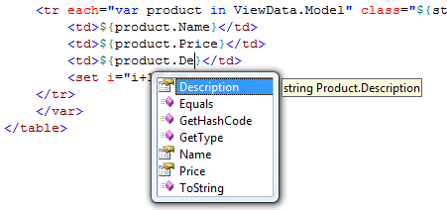

Figure 10.5 IntelliSense in our Spark views is possible because of the Visual Studio add-in.

To complete the alternating row styles, we increment the count using the <set /> element. This element lets us assign values to variables we created earlier in our view. In addition to the each attribute and <set /> element, Spark provides complex expressions for conditional operators (if…else), macros, and more. With our Spark view complete, our view renders as expected in the browser, as shown in figure 10.6.

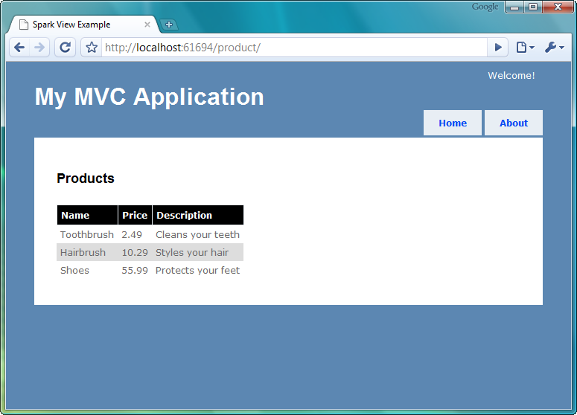

Figure 10.6 Our running Spark application

Because of the ASP.NET MVC architecture, we can swap out view engines without needing to change our controllers or actions. As we saw in this section with the Spark view engine, many view engines provide a cleaner way to create views in our MVC application. The Spark view engine gives us a terser, more readable markup, blending code and HTML seamlessly. Because Spark supports compiling views and IntelliSense, we do not need to give up all the nice integration that Web Forms offers. The decision to choose a different view engine is still quite important, as it has long-term technical and non-technical ramifications. Alternative view engines should be another option to investigate for MVC applications, as they offer compelling alternatives to the default WebFormViewEngine.

10.4 Summary

With the release of ASP.NET MVC 2 came several more options for organizing content in our views. Child actions moved from the MVC Futures assembly to a first-class citizen, and the addition of templates has allowed us to build standardized content in our views. With master pages, partials, child actions, templates and HtmlHelper extensions, we have many options for rendering our views outside just a single page. While each has their sweet spot, we can be assured that any duplication we encounter in our views can be easily addressed. The only question is how we want to address it. Because of the extensibility of ASP.NET MVC, we can also swap out our view engine without affecting our controllers. The Spark view engine, optimized for code in markup, is a viable alternative to some of the ugliness that comes with mixing C# and markup in the traditional web forms view engine. In the next chapter, we take a look at securing our MVC applications.