

Unified Digital Format Registry (UDFR)

Export Use Cases

Version 0.4

Revision History

|  |  |  |  |
| --- | --- | --- | --- |
| Date | Version | Description | Author |
| 2010-02-08 | 0.1 | Original Document | Anne Ward |
| 2010-02-09 | 0.2 | Updated for the following missing information:   * Business rules for mandatory attributes (data elements) to be provided by the interfaces; * Corrected UDFR-UC Request Records via a Web Service. | Anne Ward |
| 2010-02-09 | 0.3 | Updated as follows:   * Incorporated feedback from development team; * Renumbered use cases to match document provided by A. Goethals in draft functional specification. | Anne Ward |
| 2010-02-10 | 0.4 | Added compliance quality requirement for web service interface | Anne Ward |
|  |  |  |  |

Table of Contents

1 Introduction 1

1.1 Purpose 1

1.2 Overview 1

1.3 Notes 1

2 Package Description 2

2.1 Use Case Package Context Diagram 2

2.2 Actors 2

2.3 Workflows 2

2.4 Domain Object Model(s) 2

2.5 Quality (Non-functional) Requirements 3

2.6 Business Rules 3

2.7 Overview of Use Cases 4

3 Use Cases 5

3.1 UDFR-UC10. Export Records via a Web Interface 5

3.1.1 Diagram 5

3.1.2 Description 5

3.2 UDFR-UC11. Export Records via a Web Service 8

3.2.1 Diagram 8

3.2.2 Description 8

3.3 UDFR-UC Request Records via a Web Service 11

3.3.1 Diagram 11

3.3.2 Description 11

Introduction

* 1. Purpose

The purpose of this document is to document Library and Archive Canada’s (LAC) requirements for export services from the Unified Digital Format Registry (UDFR) to provide digital format information in support of LAC’s Trusted Digital Repository (TDR) Local Digital Format Registry (LDFR).

* 1. Overview

LAC’s current requirements can be broken down into two areas:

* information required to identify digital formats and their risks (of obsolescence); and
* information on the migration paths/tools adopted/recommended by the preservation community at large.

In the future, as the UDFR evolves to cover hardware, software, digital format specifications, that LAC will expand its use of UDFR services in its own preservation activities.

* 1. Notes

The following summarizes deviations from the terminology used by the UDFR and the rationale for these deviations:

* For the purposes of these use cases, the actor that represents a system accessing the UDFR has been renamed to “Registry Service Consumer (System)” in order to avoid possible confusion with the actual Registry System;
* For the export use case, the LAC TDR team has identified that the service would be all inclusive (combined request/response): there is no separation between the request for relevant UDFR records to be exported and the exporting of these records;
* A “request records via web service” use case has been introduced to document the functionality foreseen to be required as LAC proceeds with the implementation of its preservation workflows: these requirements may be merged with use cases being developed by other partners in the UDFR community (for example: UDFR-UC4 Search Records via a Web Service, and UDFR-UC7 Retrieve a Record via a Web Service).

Package Description

The export use cases address the actions taken by a Registry User (human actor) or a Registry Service Consumer (system actor) when accessing the UDFR for the purpose of exporting information for us in LAC’s TDR.

* 1. Use Case Package Context Diagram

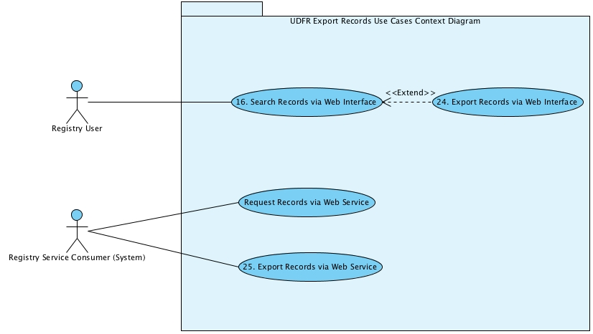

* 1. Actors
* Registry User: an actor that represents a person using the registry via a web interface for searching, displaying or exporting information;
* Registry Service Consumer (System): an actor that represents a system requesting information from the registry, or requesting an export from the registry, using web services.
  1. Workflows

Not Applicable.

* 1. Domain Object Model(s)
* UDFR Domain Model: Format Descriptive Information (including identification, signatures, risk factors), and Format Migration Paths/Tools.
  1. Quality (Non-functional) Requirements

The following represents a list of key quality requirements (such as standards compliance) that will constrain the export solution:

* QUAL-1 (Compliance) SOAP/WSDL Document Literal/Wrapped.
  1. Business Rules

| Identifier | Title |
| --- | --- |
| BR-1 | Format Descriptive Information Export via Web Interface  Where the user requests an export of format descriptive information from the registry and selects the CSV export format, all mandatory descriptive data elements (see BR-2) will be retrieved / exported with the exception of the digital signatures for the formats.  Where the user requests an export of format description information from the registry and selects the XML export format, all mandatory descriptive data elements (see BR-2) will be retrieved / exported.  Where a user requests an export of format migration information in either of the CSV/XML formats, all mandatory format migration data elements will be retrieved / exported (see BR-3). |
| BR-2 | Mandatory Format Descriptive Information  The following format descriptive information is mandatory when exporting the information for a Registry Service Consumer (System):   * Unique format identifier; * Name of the format; * Version of the format; * Signatures for the format; * Description; * Orientation; * Byte order; * Related format(s) (unique format identifier(s)); * Format risk; * Created date; * Last updated date. |
| BR-3 | Mandatory Format Migration Information  The following format migration information is mandatory when exporting the information for a Registry Service Consumer (System):   * Name of the migration path; * Unique format identifier of source (as requested); * Name of source format; * Unique format identifier of target; * Name of target format; * Version of target format; * Approved uses of target (e.g., approved for preservation, presentation); * Tool(s) supporting the migration path; * Created date; * Last updated date. |

* 1. Overview of Use Cases

The following provides an overview of the purpose of each use case.

**UDFR-UC10. Export Records via a Web Interface**

Following a search of the registry, a Registry User may elect to export the records found. The user may export:

* A single record;
* A set of records;
* All records.

The information exported may be:

* Format descriptive information; or
* Format migration information.

The user may export the records in one of two formats:

* Comma separated value (csv); or
* XML.

**UDFR-UC11. Export Records via a Web Service**

A system (Registry Service Consumer) requests that format descriptive information be retrieved and returned using a web service interface. The Registry Service Consumer will request that:

* All records be retrieved and returned; or
* Only those records updated after a given date be retrieved and returned.

**UDFR-UC Request Records via a Web Service**

A system (Registry Service Consumer) requests that format migration paths/tools for a specific digital format be retrieved and returned using a web service interface.

Use Cases

This section provides detailed documentation for each of the use cases in the package.

* 1. UDFR-UC10. Export Records via a Web Interface
     1. Diagram

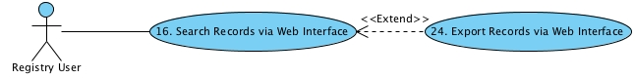

* + 1. Description

| Use Case Name | UDFR-UC10. Export Records via a Web Interface |
| --- | --- |
| Description | Following a search of the registry, a Registry User may elect to export the records found. The user may export:   * A single record; * A set of records; * All records.   The information exported may be:   * Format descriptive information; or * Format migration information.   The user may export the records in one of two formats:   * Comma separated value (csv); or * XML.   The use case **begins** when a user elects to export records from the registry.  The use case **ends** when the records have been exported. |
| Actor(s) | Registry User  Goal(s):   1. To export format description records from the UDFR;   or   1. To export format migration records from the UDFR. |
| Trigger(s) | The use case **begins** when the user elects to export records from the registry. |
| Pre-conditions | 1. One or more records have been selected for export;   or   1. The user has requested that all records be exported. |
| Post-conditions | (Success)   1. The requested format description records or format migration records are exported.   (Failure)   1. An error message is displayed. 2. The error is logged and an administrator is notified. |
| Invariant(s) | 1. Logging of error events. |
| Object(s) | * UDFR Domain Model: Format Descriptive Information, Format Migration Paths/Tools. |
| Activity Diagram | Not applicable. |
| Basic Flow | 1. The system presents a list of the available export formats and prompts the user to select one. 2. The system retrieves the records and data elements in accordance with BR-2 (format descriptive information), or BR-3 (format migration information). 3. The system generates the export format in accordance with BR-1 for the selected export format. 4. The system prompts the user for the location to save the exported records. 5. The user selects the location. 6. The system saves the exported records in the area specified by the user. 7. The use case ends. |
| Alternate Flow(s) | Not applicable |
| Exception Flow(s) | 1. An error is encountered   Condition: The system encounters an error as follows:   * At , the system encounters an error retrieving the requested records / data elements; * At , the system encounters an error when generating the requested export format; * At , the system encounters an error when saving the exported records in the user selected location.   1. The system displays a message informing the user of the error encountered.   2. The system records the event in a log.   3. The system notifies the administrator of the error.   4. The use resumes at the step prior to the point where the error occurred. |
| Use Case Inclusion(s) | Not applicable. |
| Use Case Extension(s) | * Use case for logging exception events. |
| Business Rule(s) | | Identifier  Title  BR-1  Format Descriptive Information Export via Web Interface  BR-2  Mandatory Format Descriptive Information  BR-3  Mandatory Format Migration Information |  | | | --- | --- | --- | |  | |  | |  | |  | |  | |  | |
| Supplementary / Quality Requirements | Not applicable. |
| User Interface Elements | Not applicable. |

* 1. UDFR-UC11. Export Records via a Web Service
     1. Diagram

.

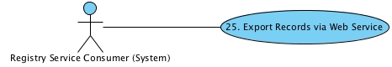

* + 1. Description

| Use Case Name | UDFR-UC11. Export Records via a Web Service |
| --- | --- |
| Description | A system (Registry Service Consumer) requests that format descriptive information be retrieved and returned using a web service interface. The Registry Service Consumer will request that:   * All records be retrieved and returned; or * Only those records updated after a given date be retrieved and returned.   The use case **begins** when the user invokes the export web service.  The use case **ends** when the system responds with the requested records. |
| Actor(s) | Registry Service Consumer (System)  Goal(s): To request and receive format descriptive information from the registry. |
| Trigger(s) | The use case **begins** when the user invokes the export web service. |
| Pre-conditions | 1. None. |
| Post-conditions | (Success)   1. The requested records are returned;   or   1. A message indicating that no records meeting the request criteria were found.   (Failure)   1. The error event is logged and an administrator notified. |
| Invariant(s) | 1. Logging of error events. |
| Object(s) | * UDFR Domain Model: Format Descriptive Information. |
| Activity Diagram | Not applicable. |
| Basic Flow | 1. The system validates the export service request. 2. The system determines that all records have been requested. 3. The system retrieves the requested records and attributes (in accordance with BR-2). 4. The system formats the records according to the web service specifications. 5. The system sends the response. 6. The use case ends. |
| Alternate Flow(s) | 1. A validation error has occurred   Condition: At , the system determines that the web service request is not valid, that is, it does not conform to the web service specifications.   * 1. The system sends a response identifying that the request does not conform to the web service specifications, and provides the specifications.   2. The use case resumes at .  1. Updated records have been requested   Condition: At , the system determines that the request is for updated records.   * 1. The system queries the registry for records that have been updated after the date provided in the request.   2. The system determines that records have been updated.   3. The use case resumes at .  1. No records have been updated   Condition: At , the system determines that no records have been updated after the date specified in the request.   * 1. The system sends a response indicating that no records have been updated.   2. The use case resumes at . |
| Exception Flow(s) | 1. An error has occurred   Condition: The system encounters an error as follows:   * At , the system encounters an error when retrieving the records from the registry; * At , the system encounters an error when querying the registry.   1. The system records the event in a log.   2. The system notifies the administrator of the error.   3. The use case ends. |
| Use Case Inclusion(s) | Not applicable. |
| Use Case Extension(s) | * Use case for logging exception events. |
| Business Rule(s) | | Identifier  Title  BR-2  Mandatory Format Descriptive Information |  | | | --- | --- | --- | |  | |  | |
| Supplementary / Quality Requirements | | Identifier  Title  QUAL-1  (Compliance) SOAP/WSDL Document Literal/Wrapped |  | | | --- | --- | --- | |  | |  | |
| User Interface Elements | Not applicable. |

* 1. UDFR-UC Request Records via a Web Service
     1. Diagram

.

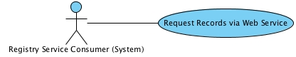

* + 1. Description

| Use Case Name | UDFR-UC Request Records via a Web Service |
| --- | --- |
| Description | A system (Registry Service Consumer) requests that format migration paths/tools for a specific digital format be retrieved and returned using a web service interface.  The use case **begins** when the user invokes the web service.  The use case **ends** when the requested records are returned. |
| Actor(s) | Registry Service Consumer (System)  Goal(s): To request and receive format migration information from the registry. |
| Trigger(s) | The use case **begins** when the user invokes the request records web service. |
| Pre-conditions | 1. None. |
| Post-conditions | (Success)   1. The requested records are returned;   or   1. A message indicating that no records meeting the request criteria were found.   (Failure)   1. The error event is logged and an administrator notified. |
| Invariant(s) | 1. Logging of error events. |
| Object(s) | * UDFR Domain Model: Format Migration Pathways/Tools. |
| Activity Diagram | Not applicable. |
| Basic Flow | 1. The system validates the service request. 2. The system queries the registry for migration information for the requested format. 3. The system retrieves the requested records and attributes (in accordance with BR-3). 4. The system formats the records according to the web service specifications. 5. The system sends the response. 6. The use case ends. |
| Alternate Flow(s) | 1. A validation error has occurred   Condition: At , the system determines that the web service request is not valid, that is, it does not conform to the web service specifications.   * 1. The system sends a response identifying that the request does not conform to the web service specifications, and provides the specifications.   2. The use case resumes at .  1. No records found   Condition: At , the system determines that no migration records exist for the requested format.   * 1. The system sends a response indicating that no migration records were found for the requested format.   2. The use case resumes at . |
| Exception Flow(s) | 1. An error has occurred   Condition: The system encounters an error as follows:   * At , the system encounters an error when retrieving the records from the registry.   1. The system records the event in a log.   2. The system notifies the administrator of the error.   3. The use case ends. |
| Use Case Inclusion(s) | Not applicable. |
| Use Case Extension(s) | * Use case for logging exception events. |
| Business Rule(s) | | Identifier  Title  BR-3  Mandatory Format Migration Information |  | | | --- | --- | --- | |  | |  | |
| Supplementary / Quality Requirements | | Identifier  Title  QUAL-1  (Compliance) SOAP/WSDL Document Literal/Wrapped |  | | | --- | --- | --- | |  | |  | |
| User Interface Elements | Not applicable. |