Configuring OpenDS LDAP for use with Merritt Sample Database

OpenDS Install
- Download a compressed archive of OpenDS (current URL http://opends.java.net/public/downloads_index.html).
- Extract OpenDS to the directory of your choice.
- Copy the file 99-user.ldif to the config/schema/ directory inside extracted OpenDS files.

OpenDS Setup
- Execute the script setup inside your extracted OpenDS files. (Note, be sure to keep track of the settings you use in this setup since you'll need the settings later.)
- Click Next > at the welcome screen.
- Click the Configure. . . for LDAP Secure Access.
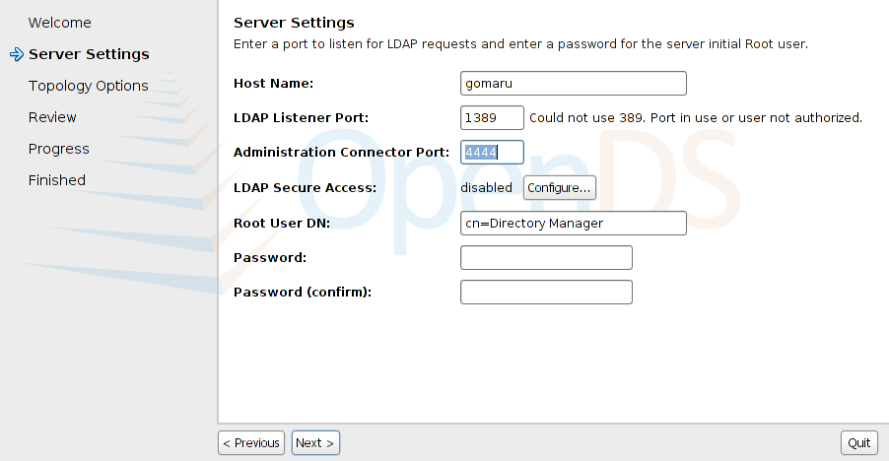
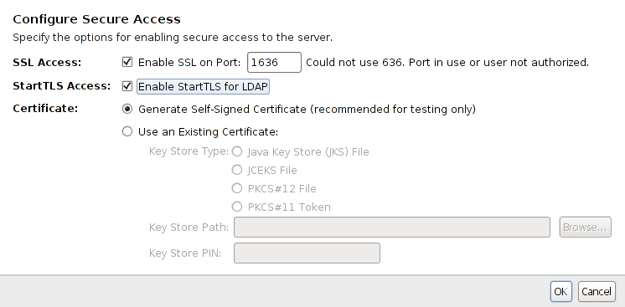
- Enable SSL and set the other options according to your certificate choices. Click Ok.
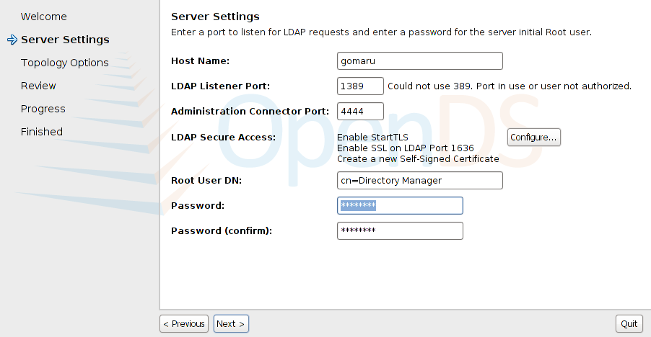
- Finish configuring the server settings such as your password and click Next >.
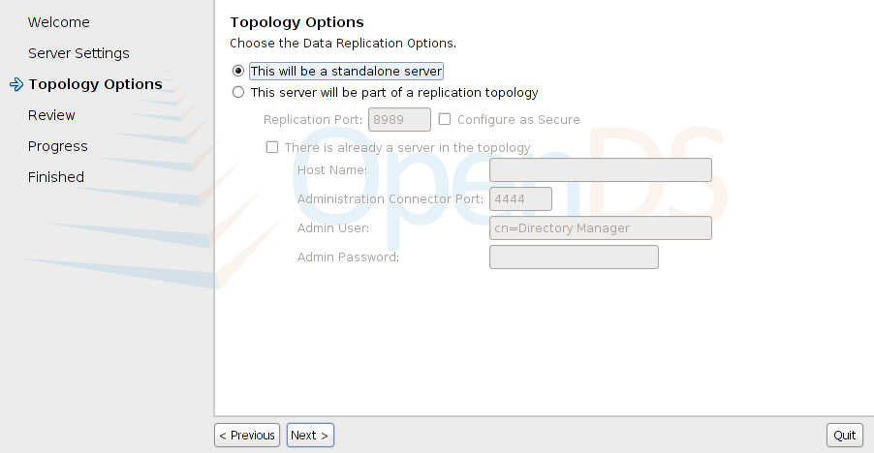
- Choose your LDAP replication options and click Next >.
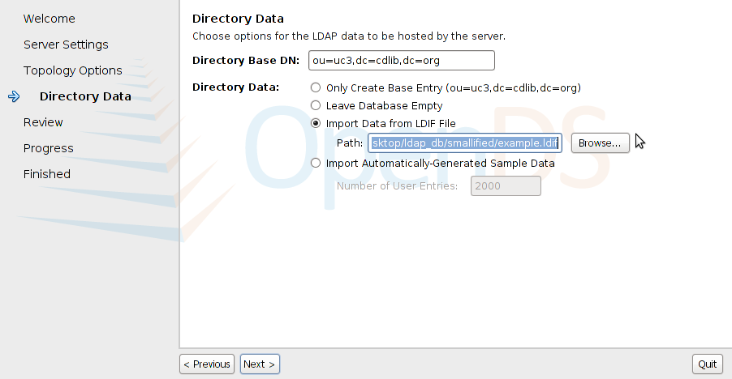
- Change the value for the Directory Base DN to ou=uc3,dc=cdlib,dc=org. Choose the option to Import Data from LDIF File. Browse or enter the path to the example.ldif file. Click Next >.
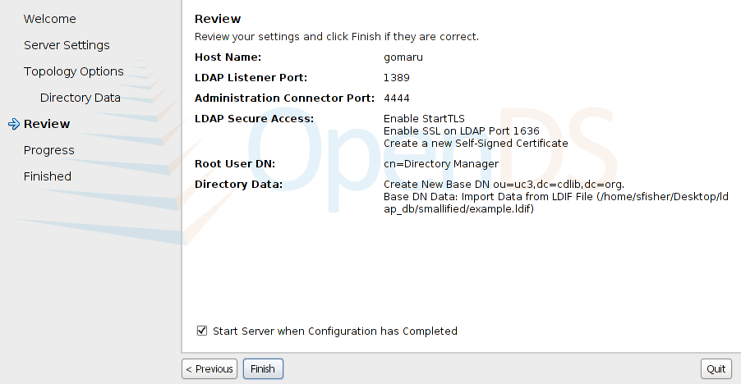
- Review your settings and click Finish.
- You will see a progress bar and text that show that all items were completed successfully.
- You will see a final summary screen from which you can launch the OpenDS control panel if you wish. Click Close.

Starting, Stopping, Using the OpenDS Control Panel
- You may start the OpenDS server with the bin/start-ds script.
- You may stop the OpenDS server with the bin/stop-ds script.
- You may open the Control Panel with the bin/control-panel script.

