Bleap!

By Doug Moses
Christ Games
Table of Contents
Overview 3
Christian Theme 3
Game Play 3
Why Bleap? 3
Screen Layout 4
Splash Screen 4
Main Menu 4
HUD 4
Game Screen 4
Game Controls 5
Movement 5
Jumping 5
Physics 5
Falling 5
Platforms 5
Triggers 5

Overview

This is a simple 3rd person 3D puzzle jumping game. It was created during a two week game jam contest from 8/30/2017 to 9/16/2017, hosted by the Christian Developer Network (CDN) http://christiandevs.com, and sponsored by the Christian Game Developer Conference http://cgdc.org. The game is licensed under the MIT open source model. Game assets are licensed under CC0. The theme of the game is based on a bible verse.

Christian Theme

Three verses we were picked for the contest. Here is the verse that is used to represent Bleap!

Zechariah 4:6 ~ So he said to me, “This is the word of the Lord to Zerubbabel: ‘Not by might nor by power, but by my Spirit,’ says the Lord Almighty.

Commentary – Zerubbabel was the governor of the Persian Province. He was given the task by God to rebuild the temple in Jerusalem. These passages in Zachariah reference mans weakness and how we can overcome any obstacles in our way, even problems the size of mountains can be solved if we put our trust in him. Zerubbabel had many obstacles in his path, political, resources, and his own confidence. He trusted God and completed the temple build after 20 years ~ 516BC.

Game Play

The objective is to travel from your starting point to the Temple area. You are carrying the capstone. By placing the capstone on the Temple, you complete the objective. You are judged on how fast you complete the level. You have a maximum of 5 minutes to complete the task. If you fall, you start over from the beginning of the last level that you were playing on. There are several different objects to jump on in the game. Some are stationary and stable. Others move in patterns, or are unstable. You will need to time some jumps just right by landing on moving objects, travel with them a bit, and then jump again to progress. Some of the jumps are high and require precession to land on them. Some objects may be far away, increasing your chance of failing. Pendulums and other traps can swing across your path and block your way, or knock you off your feet. Besides jumping, the player also needs to walk on small narrow pathways without falling, travel up steep angled ramps, and carefully navigate their way around in the environment.

Why Bleap?

Bleap is a combined word between bleep and leap. Jumping puzzles can be frustrating and hard to complete. Instead of using colorful metaphors when you fail, just remember you are playing a game called Bleap! Try to channel your frustrations into more positive and uplifting language. This is a family friendly game. No cursing is allowed. Bleap! :)

Screen Layout

Splash Screen

A quick splash screen showing the Bleap logo will be displayed when you first start the application.

Main Menu

The main menu will have three buttons. “Start New Game”, “Continue Saved Game”, “Exit”. If you press the Start New Game button, the game is reset and you begin from level 1 with scores cleared. If you press “Continue Saved Game”, you will continue from the last saved game session and your scores are restored. There is only one saved game per install. The Exit button closes the game.

HUD
There are two items on the top of the screen for the heads-up-display. A clock timer will show how long it took for you to reach the Temple. It will count up until 5:00 (5 minutes) is reached. The score will contain a value based on time. Score = ((300 - # of seconds) * 10). If you go past 5 minutes, your score is 0. Scores are cumulative from one level to the next.

Game Screen

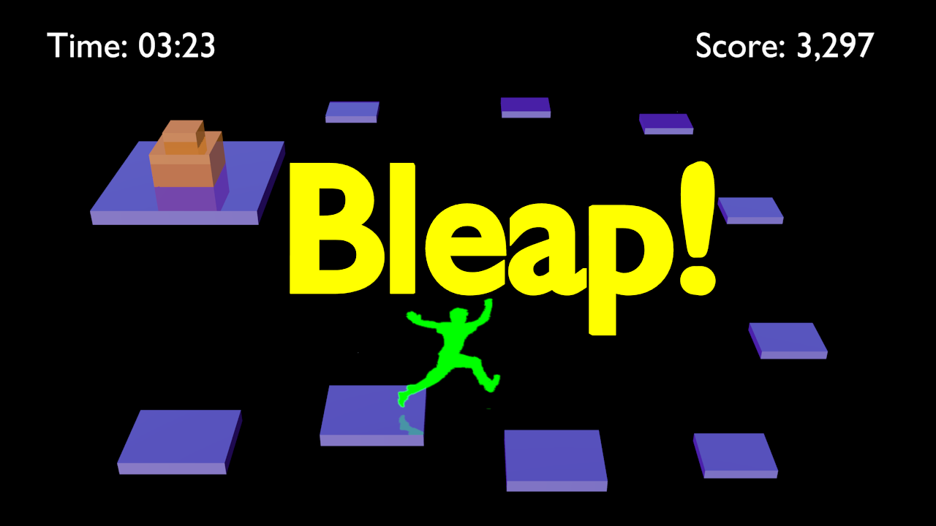
The player starts on a stable platform. You are looking down at the character from behind. Ahead of you is a series of floating platforms and traps to overcome. The Temple area is on another floating platform at the end of the path. Each level has different platforms and paths to follow to the finish area. The number of levels will depend on how many we can create within two weeks.
Here is a 2D art concept of the idea.

Game Controls

Movement

WASD or arrow keys = Standard keyboard and controller key binds for 3rd person movement. Forward = W(up arrow), Turn Left = A(left arrow), Backward = S(down arrow), Turn Right = D(right arrow).

Jumping

Space Bar or Enter = All jumps are consistent. No power jumps or other key combination influence distance.

Physics

Falling

Not landing on a platform or being knocked off. Several seconds of free fall before reset.

Platforms

Moving platforms travel in a specific path. Some platforms are stationary.

Triggers

Touch the Temple to finish the level. Fall if you get hit by a trap or moving object.

