ASSIGNMENT 2

OSYS1200 – Introduction to Windows Administration

NSCC

Ricardo Oliveira

W0428722

Index

Introduction 2

Assignment questions 2

Screenshots taken during the assignment 2

PDF of Change management 4

Works Cited 7

# Introduction

The purpose of this document is to answer any questions asked in the assignment as well as a means to display your change management log and any attachments or screenshots as required.

# Question or Research Section

## Assignment questions TASK 1

**Part 2 (submit on Brightspace):**

1. For the task configured in Part 1, what are three (3) reasons it important that the task starts only when the computer is idle?

A: There will be no interference caused by the user; It won`t relocate resources in use; Faster execution of the task, as it`s on demand

1. In addition to setting “On a schedule” task weekly, what other time setting options are available?

A: One day; Daily; Monthly.

1. In addition to triggering Begin the task: “on a schedule”, what are the other options available to trigger a task to begin?

A: At log on; At startup; On idle; On an event; At task creation/modification; On connection to user session; On disconnect from user session; On workstation lock; On workstation unlock.

## Assignment questions TASK2

**Part 5 (submit on Brightspace):**

In your Professional Document, answer the following review questions for Part 3 & 4

1. Where are custom MMC consoles stored by default, as documented earlier? Please include the **FULL** **path**.

A: “C:\Users\ROliveira\AppData\Roaming\Microsoft\Windows\Start Menu\Programs\Administrative Tools”

1. What are the 4 console **modes** available in the options of an MMC console and what does each mode do (make sure to explain in your own words)?

A: Author mode – You can create custom console, add and remove snap-ins.

User mode – full access – You can have full access to the pre-installed snap-ins, but can’t add or remove anything.

User mode – limited access, multiple window – The user can’t see the content of the left tree that doesn’t show on console window.

User mode – limited access, single window – It just open the console window, and that`s all the user can see.

1. What certificates types are different (exist in one but not the other) for the Local Computer and Local User.

A: Local User – Active Directory User Object; Local Computer – Preview Build Roots, Test Roots, eSIM Certification Authorities, Homegroup Machine Certificates, Trusted Devices and Windows Live ID Token Issuers

1. In what mode can I open my Custom Console to be able to add or remove snapins?

A: Author mode

# No - Case Study

# Screenshots taken during the assignment - For the Marking

## Task 1

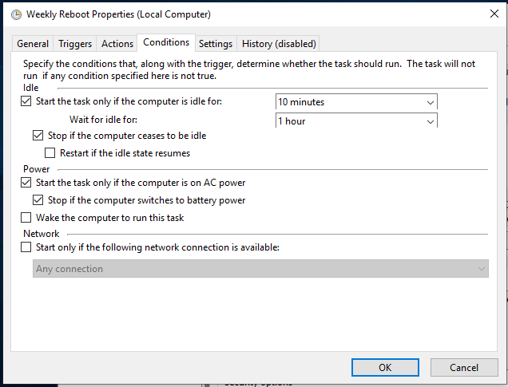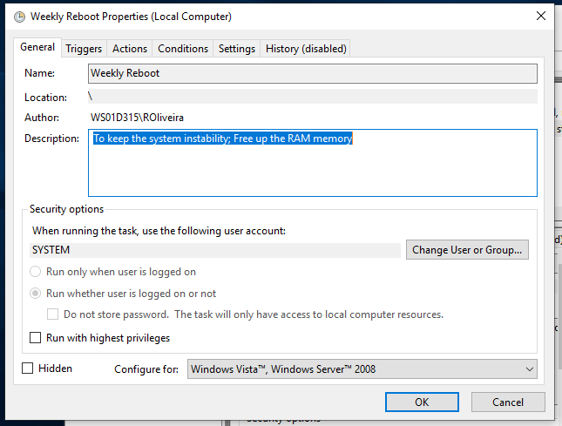

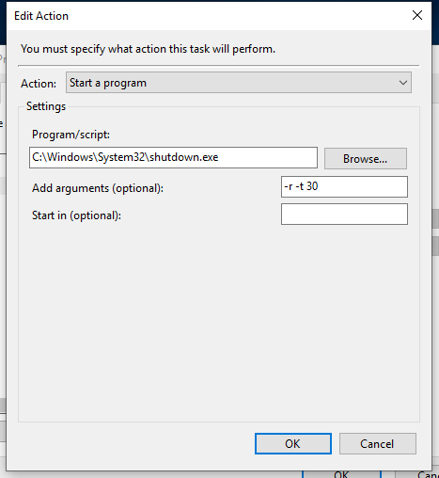

## Task 2

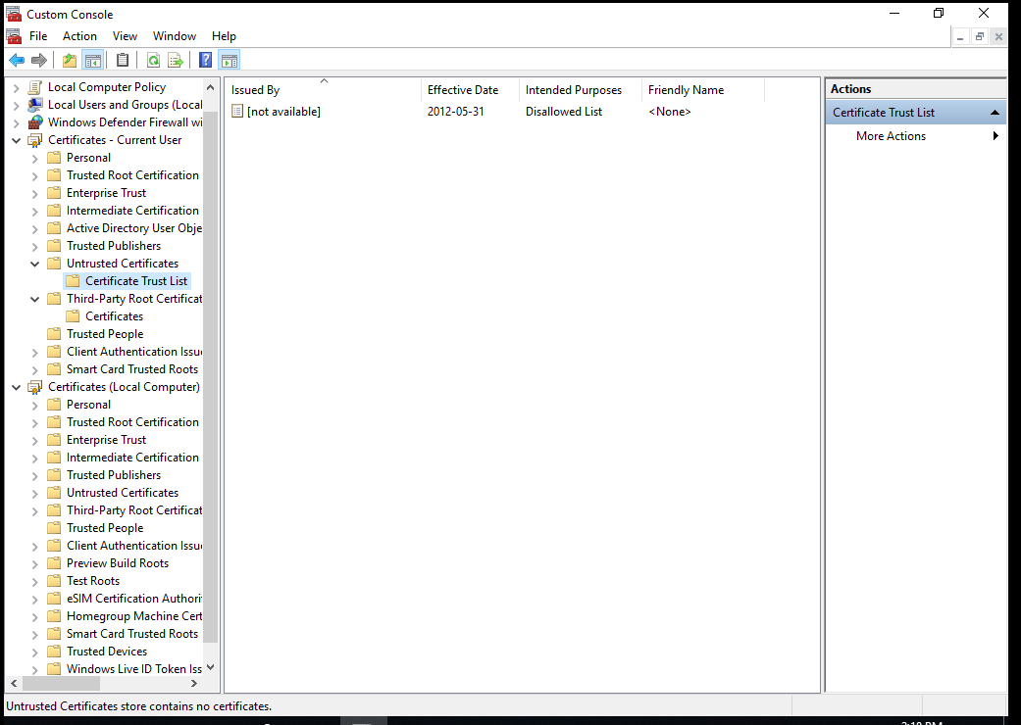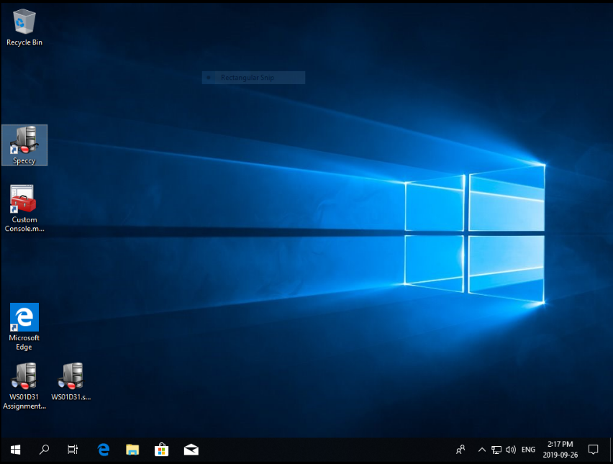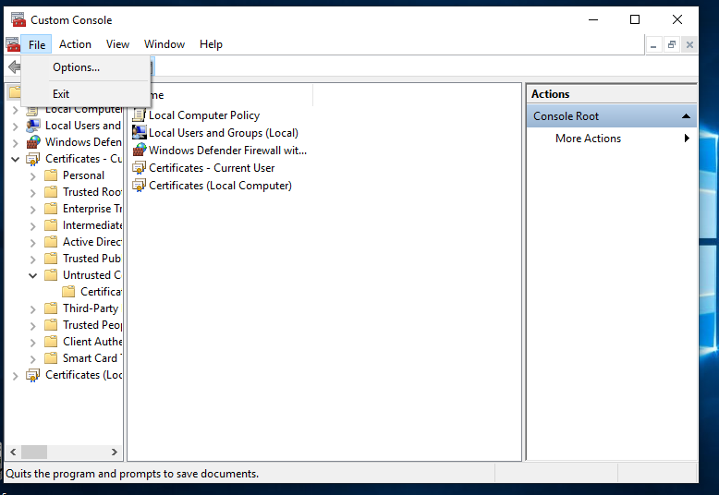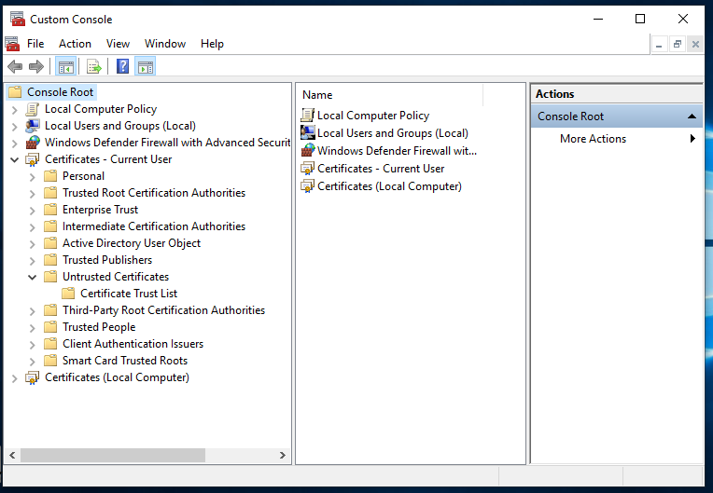

# Script used in assignment

No scripts

# PDF of Change management

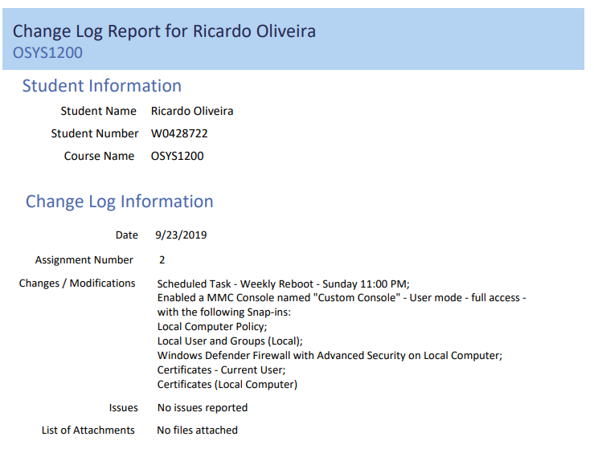

# Attachments in Change management

No attachments

# Works Cited/ References

NSCC. (2019, 09 23). *NSCC Brightspace*. Retrieved from NSCC Online Learning: https://nscconline.desire2learn.com/d2l/home

Wright & Plesniarski(2017) *Microsoft Windows 10 Configuring Windows Devices*, pp. 75-120