ASSIGNMENT 6

OSYS1200 – Introduction to Windows Administration

NSCC

Ricardo Oliveira

W0428722

# Introduction

The purpose of this document is to answer any questions asked in the assignment as well as a means to display your change management log and any attachments or screenshots as required.

# Task 1 (submit on Brightspace) - The Registry

**Part 1** – Create a professional style document (details on page 1). Copy or create the following Registry Summary Table and complete.

|  |  |  |
| --- | --- | --- |
| **Registry Key** | **Applies to** | **Contains what type of information** |
| HKEY_CLASSES_ROOT | Program files | Contains the information about the registered applications, file associations overall. |
| HKEY_CURRENT_USER | Current logged user | The root of the configuration information for the logged user, such as user`s folders, screen colors and Control Panel settings |
| HKEY_LOCAL_MACHINE | Local computer | Contains the configuration information particular to the computer (to any user) |
| HKEY_USERS | All actively loaded user profiles | The information regarding all the actively loaded user profiles on the computer |
| HKEY_CURRENT_CONFIG | Hardware profile | Information about the hardware specs that is used by the computer at the startup |

**Part 2**– Before attempting any registry navigation it is always good practice to do a complete backup of the registry.

* **Question 1:** What arethe value ‘base’ options for the “Start” DWord key in wuauserv subkey and what do they mean?
* **A:** The base options are 2, for automatic; 3 to manual, 4 to disabled, 1 when changing to Automatic(Delayed), and 0 when changing from Automatic(Delayed) to Automatic.
* **Question 2:** What are the keys named ‘S-I-5…’ shown under HKEY_USERS in regedit? What do they represent?

**A**: They`re the security identifiers, and they represent a unique identifier that corresponds to the respective information addressed.

* **Question 3:** What are the steps you would use to import your wuauserv subkey back into your registry (Do **NOT** actually import).
* **A:** At regedit, the first step is to backup the current registry. Then, click on file, import, select the file and import it to the registry.

**Task 2 (submit on Brightspace) – System Events**

* Use the **Event ID** from your Errors.txt to research your error and answer the following questions. *Remember to cite your resources.
  + What is a symptom of this error? My phone didn`t got recognized by the VM/Computer.
  + What is a possible cause? Connectivity problems.
  + What is a possible solution? Changed the cables, problem solved.
* **Record** the details for one of the problems, issues or events noted. Your research MUST include:
* Research the Reliability Monitor and **Record** the 5 areas for which reliability data is collected (eg. Application Failures).

**(Information)**

* + Source 9NBLGGH4LS1F-Microsoft.StorePurchaseApp
  + Summary Successful Windows Update
  + Date 2019-11-07
  + Action Install Update
  + Description Installation Successful: Windows Successfully installed the update

**(Warnings)**

* + Source 9NMPJ99VJBWV-Microsoft.YourPhone
  + Summary Failed Windows Update
  + Date 2019-10-17
  + Action Installation Failure
  + Description Windows failed to install the following update with error 0x80073d02

**(Windows failures - Critical Events)**

* + Source Windows
  + Summary Windows was not properly shut down
  + Date 2019-11-04
  + Action Shut down
  + Description The previous system shutdown at 9:55:11AM on 2019-11-04 was unexpected.

**(Miscellaneous failures)**

* + Source N/A
  + Summary N/A
  + Date N/A
  + Action N/A
  + Description N/A

**(Application failures)**

* + Source N/A
  + Summary N/A
  + Date N/A
  + Action N/A
  + Description N/A

# Errors.TXT

#Created On: 10/24/2019

#Author: Ricardo Oliveira

- <Event xmlns="http://schemas.microsoft.com/win/2004/08/events/event">

- <System>

<Provider Name="Microsoft-Windows-DeviceSetupManager" Guid="{fcbb06bb-6a2a-46e3-abaa-246cb4e508b2}" />

<EventID>131</EventID>

<Version>0</Version>

<Level>2</Level>

<Task>0</Task>

<Opcode>0</Opcode>

<Keywords>0x4000000000000000</Keywords>

<TimeCreated SystemTime="2019-11-07T20:14:00.066111800Z" />

<EventRecordID>686</EventRecordID>

<Correlation />

<Execution ProcessID="1396" ThreadID="1552" />

<Channel>Microsoft-Windows-DeviceSetupManager/Admin</Channel>

<Computer>WS01D315</Computer>

<Security UserID="S-1-5-18" />

</System>

- <EventData>

<Data Name="Prop_ContainerId">{00000000-0000-0000-FFFF-FFFFFFFFFFFF}</Data>

<Data Name="HRESULT">2147942413</Data>

</EventData>

</Event>

# Screenshots

**Event Viewer**

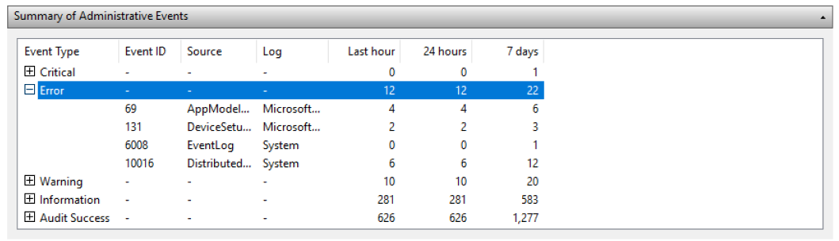

File

**History**

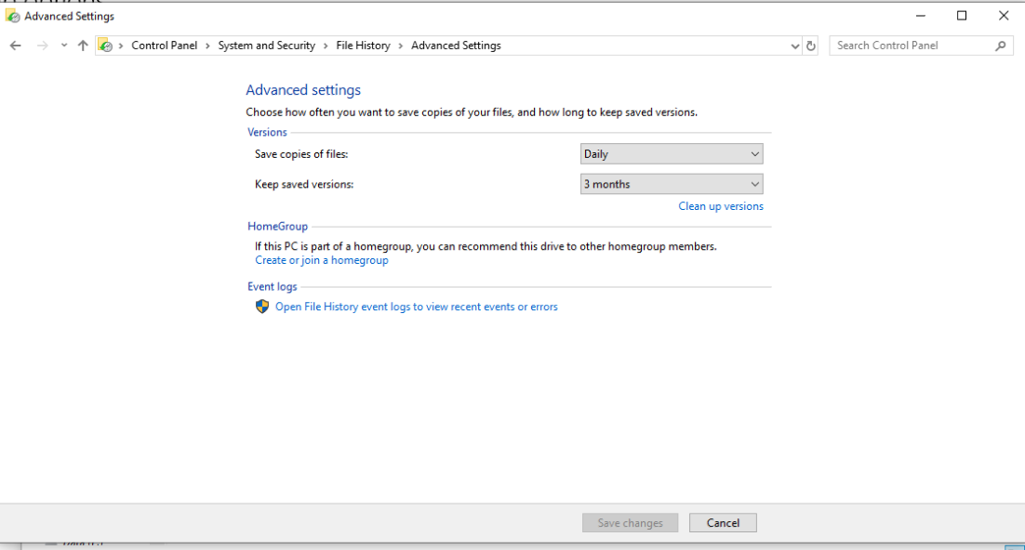

**Automatic Maintenance**

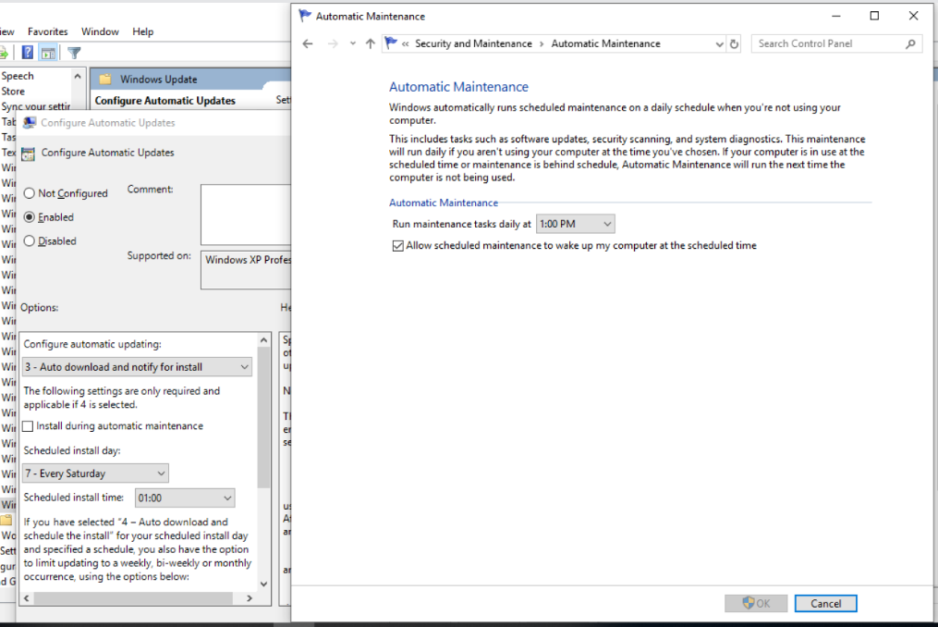

# Change management

