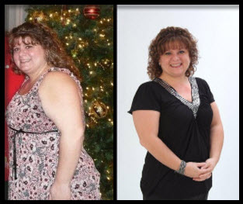 **Kristina**

Adjustable Gastric Band Surgery with Dr Tiffany Jessee 1/19/2011 Pre op weight 223

I am the most recent banded staff member, still in my weight loss progress, currently down 35 lbs.

The realization I was obese came during a seminar that I was attending for “moral support” for a friend who was getting ready to have gastric band surgery. I knew at that time I was overweight and struggled with the 15 pound up and 10 pound down dieting, but never really thought I was “that” heavy. I read the BMI circle they give out at the seminar and could not believe what I was reading….Morbidly Obese! MORBIDLY! I was MORBIDLY OBESE!

After that I began the dieting and for every 5 pounds I lost I gained 10 back. At one point I started to accept the fact that for the rest of my life, I was just going to be fat.

I starting working with Dr Jessee in 2009, seeing the weight loss success of her patients inspired me. I had been obese my entire life, missing out on activities because of my weight, depressed because I did not have nice clothes to wear or nothing fit so I stayed home all weekend and missed out on activities not only as a child but as an adult as well.

I had been diagnosed with P.C.O.S. (Polycystic Ovarian Syndrome) at age 25. P.C.O.S. causes weight gain, diabetes, heart disease, infertility, excessive hair growth and acne. I was also diagnosed with Psoriatic Arthritis and the onset of Rheumatoid Arthritis. I couldn’t walk long distances because my legs would hurt, I was out of breath just trying to put my shoes on and don’t even think about stairs!

The day I decided to have surgery, my brother who is thin and healthy, ended up in the emergency room with chest pain and had to have 2 stents put in. I was in shock! Here I am the MORBIDLY OBESE sibling and he, the thin, in great shape and healthy one, in the E.R. I decided at that moment I needed to make a change in my life if I wanted to live. I’m young, I want children, not only do I have the P.C.O.S. making that difficult but if I do have children I want to LIVE with them, I don’t want to come home tired and exerted and miss out on their lives like I had mine for so many years.

Today I FEEL 100lbs lighter. I’m not tired all the time, I have a ton of energy, a lot of my P.C.O.S. symptoms are gone, my body doesn’t ache all day like it did before and it’s actually nice to walk into a clothing store and not have to shop in the “plus size” section. I have gone from a size 20 to a 14 and even lost a shoe size!

I am so happy I made the decision to have surgery, I think of a quote I saw “The longest journey began with one single step”. I have made the first step and I know my “tool” isn’t a quick fix, it’s a lifelong partnership. Thank you Dr Jessee.

**Tricia**

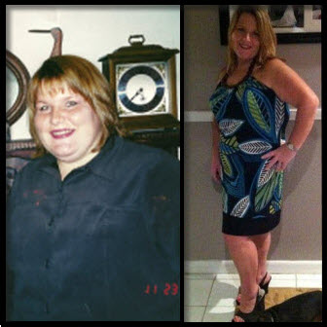 As we know, adult obesity poses many problems to our physical and mental health. For a child that’s still growing and developing, obesity becomes more detrimental to its well-being. I can remember as far back as six years old, my other classmates calling me cruel nicknames and teasing throughout my school days. Physicians ran every test on me that they possibly could to find a diagnosis for my obesity, with all results being normal; I ended up on my first diet at age nine. After over twenty years of dieting, I came to the conclusion that I needed weight loss surgery. In my years of dieting I lost a significant amount of weight on several occasions, but I ended up gaining it all back in addition to what I originally lost. I knew I could lose the weight. The problem was keeping it off. My decision to have bariatric surgery at age thirty was the best decision I’ve ever made. I suffered from hypertension, borderline diabetes, sleep apnea, and severe back pain. I can’t imagine what my health would be like now if I never had weight loss surgery. Bariatric surgery has given me a tool to lose 107 pounds over the past six years, and I have kept it off the whole time. When I made my decision, I preferred to have the adjustable gastric band versus gastric bypass surgery. At that time, insurance companies were not approving the band, even though it’s much less invasive and you have an adjustable tool for the rest of your life. I’ve been asked on several occasions if I would do it all over again if I had a chance. My answer is yes one hundred times over. I think if patients have a chance in life to get healthy they should make the most of the opportunity and embrace it.

**Michelle**

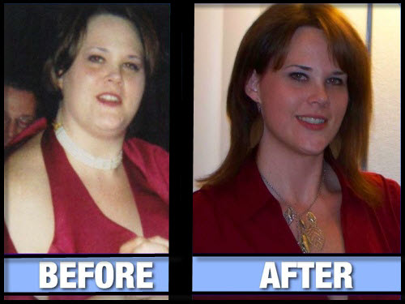 A life of being heavy is all I knew, despite my desires and efforts to get healthy numerous times. Every year all through my childhood I wanted to be thinner so I would not be picked on as much; it never worked. I underwent gastric bypass in 2005. It took me three years to decide on surgery, deciding it was time to take my life and health into my own hands but, I needed help. I remember getting the call from my surgeon’s office stating that my surgery was approved by insurance. The emotions I felt were many but, above all of them I pictured what could become of my health with surgery.

The back and joint pain was severe enough to convince me I must be older than twenty five. Fear of other diseases associated with obesity and heart attacks lingered daily in my mind as I was experiencing chest pains when exerted. I expressed to my surgeon that I would be an example of what weight loss surgery can do for a person. He challenged me to show him as the numbers on the scale would be the evidence. Losing 150 pounds not only eased the physical and mental pains but, it opened doors both personally and professionally I never dreamed possible. Surgery gave me the tool to help gain control, even with experiencing complications two years after surgery I know this is not, nor ever was an easy way out. Despite what some may think having Gastric Bypass is not an easy task. Those who are successful with this particular surgery especially long term have changed their way of life, way of eating, and way of thinking. It is not only the portion size consumed that has changed as what a person is able to tolerate. Since a portion of the intestines is bypassed a patient experiences “malabsorption” meaning it is critical for the right foods to be eaten and vitamins to be taken to keep the body healthy. Long term the pouch stretches which reduces a person’s feeling of restriction; there are countless vitamin deficiency risks. There are times to this day six years later that I struggle just like any normal person does because now I am the one in control of my portion size. My restriction is nothing like it was after surgery. I surrounded myself from the start with successful weight loss patients who had changed their lives for the better watching and learning what they did that kept their weight off, how and what they ate, their exercise routines, etc... I educated myself on nutrition and exercise learning new habits which are now my lifestyle. This knowledge made me realize very quickly that if I did not incorporate these life changes permanently that I risk gaining my weight back no matter how far out from surgery I am.

I became certified in Zumba in 2009, something I could not have done at 350 pounds. I’ve led support groups for both Dr. Jessee and a practice in New York. Working with weight loss surgery patients is a passion of mine, as I have walked the walk. There is nothing better than watching someone open up to who they truly are, become healthy, and reach for their goals.