Sciences Po May 2015
Centre d'Études Européennes



EUROPOLIX
----------
USER GUIDE



Romain LALANDE
romain.lalande@gmail.com
Table of Contents
What is Europolix? 3
Overview of the website 4
Welcome page 4
Login page 4
Import page 5
Act ids validation page 7
Ministers' attendance validation page 8
Act data validation page 9
Database management page 10
Export page 11
History page 11
Fields to retrieve 13

What is Europolix?
This section explains what is the project and what it is for.

Europolix is a project started by Sciences Po and Centre d'Études Européennes (CEE) in October 2012. Its aim is to build a database gathering European acts from eurlex (council) and oeil (parliament) - and prelex until the beginning of 2015 (commission).
This project can be seen as a mini website where information is automatically retrieved from the websites above and where experts validate it, act after act.
On top of the creation of a common database, a first goal is to cross validate data between the different European institutions and with an expert to highlight errors. In the end, we wish to have a clean database with no error.
A second goal is to do a statistical analysis of the cleaned acts. To this end, the website allows to extract all the acts of the database into a file readable in a spreadsheet tool.

Overview of the website
This section shows how the website works with screenshots and explanations.
The website is accessible at http://may.cdsp.sciences-po.fr/europolix.

Welcome page
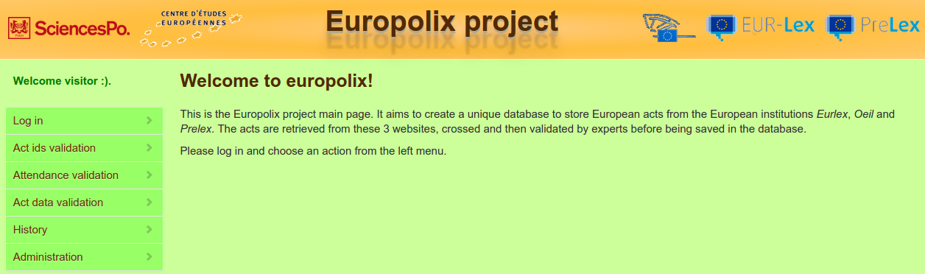
This is the homepage of the website. The left menu shows the available actions on the website. These actions must be performed in order to validate and then export act data.
The following details each of these actions.

Login page
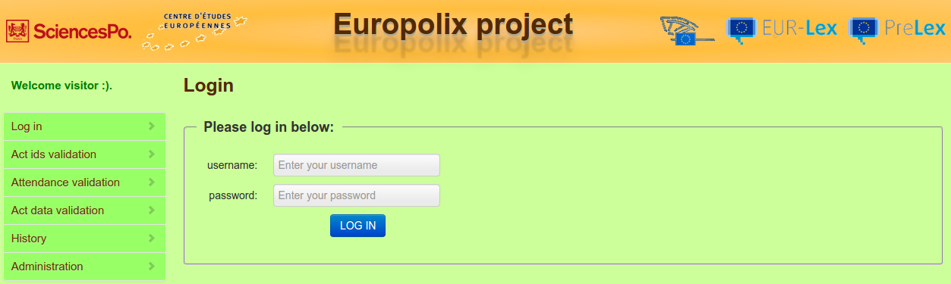
This is the login page (click on “Log in” from the menu). You must log in to get access the other functionalities of the website. If you have no id, you must ask the administrator to use the website.
Enter your username and password. Then click on “Log in”.

Import page
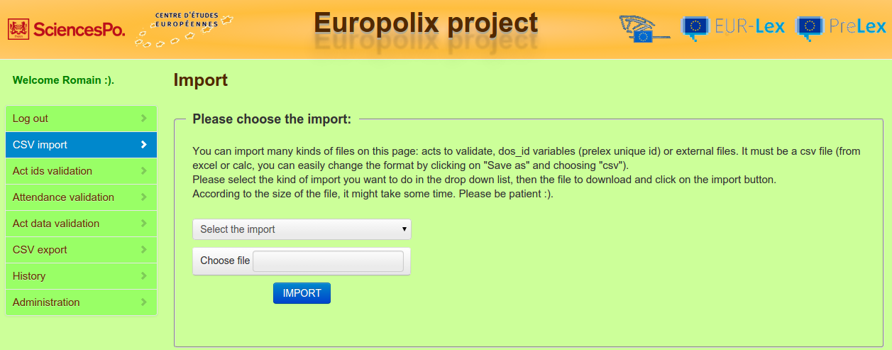
This is the import page. You can import different csv files that are first saved on the server and then processed.
  - Import acts to validate: Import a file containing information on acts (information found in monthly summaries and then gathered in a spreadsheet document). This file is usually called RMC and stands for Relevé Mensuel du Conseil. Two steps:
      - 1/ the content of the file is saved in the database.
      - 2/ for each act saved, we retrieve corresponding data (ids only) from the eurlex or oeil websites and update the database with this new information. A message is displayed if errors are encountered during the import.
  - Import DosId: Import a file containing prelex unique id (called dos_id) and the NoCelex variable to do the mapping ( NoCelex is contained either in the VAL_CHP_SUP_01 or VAL_CHP_SUP_03 column.
  - Import CodeAgenda*: This file is used to do the mapping between the CodeAgenda variables and the CodeSecteur variable.
  - Import RespPropos* and relative data: This file fills the data about each RespPropos variable (eurlex). Each RespPropos has a name, nationality, national party and party family.
  - Import DGProposition* and SiglesDG*: This file associates an act with a DG variable composed of a name and a sigle (and a DG with a number for old dg names, if any).
  - Import ConfigCons: This file is used to do the mapping between ConfigCons variables and CodeSect variables.
  - Import AdoptPCAbs and AdoptPCContre: This file links an act to its AdoptPCContre and AdoptPCAbs variables.
  - Import NationGvtPoliticalComposition: This file contains 3 columns: a start date, and end date and a government composition column. It represents the main political parties of each European nation with their respective dates of appearance and disappearance. The government composition column contains the country and its list of parties and party families for a given period of time (defined by the start date and end date variables). It is used to show the governments in power at the date of adoption of a given act.
  - Import opal file (NP variables): This file links an act to its NP variables through its NoCelex variable. There is a CaseNumber, an ActType and an ActDate variable.
  - Import new Attendance of ministers: This file describes the ministers that attended council meetings. For each council meeting, there is the country of each minister, along with their verbatim and status. Each council meeting is linked to an act through the act ids (releve ids) and / or NoCelex.
  - Import party families of Rapporteurs: link each Rapporteur variable with a PartyFamily. The file contains matchings between Party and PartyFamily variables.
  - Update Attendance of ministers: Same thing than Import new Attendance of ministers but is used to update already existing ministers' attendances (because they were saved with wrong data for instance). In this case, the link with an act is made with the NoCelex.

The web form indicates the variables and their order for each file to import. At the end of the import process, a message is displayed if errors were encountered (in case of already existing record, incorrect data, etc.).

First of all, choose the import to perform in the drop down list. A textual help about the file format to upload appears on the right. Then click on “Choose file” and select the file to import (it must be a csv file). Finally click on “Import” to launch the import. It can take a while...

After the step Import acts to validate, you can validate the ids of the acts you just imported (see Act ids validation page).

Act ids validation page
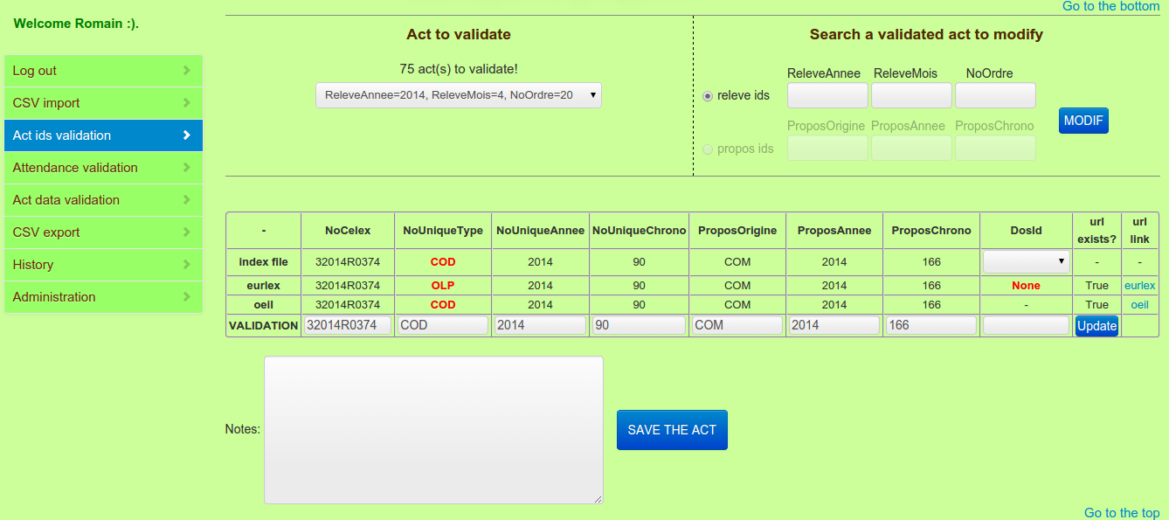
You can perform two actions on this page:
- validate ids of an act that has already been imported through a RMC (releve mensuel du conseil) file (see Import page): select an act in the drop down list to validate it.
- modify ids of an act that has already been validated: select releve ids to find an act with its ReleveAnnee, ReleveMois and NoOrdre variables or select propos ids to find an act with its ProposOrigine, ProposAnnee and ProposChrono variables. Fill the corresponding text boxes and click on the MODIF button to validate the act.

Act ids related to the selected act is then displayed regarding its source in row. The first source (row) corresponds to the RMC file (which can be imported – see previous paragraph), the second row corresponds to the ids retrieved on the eurlex page and the third one on the oeil page. The last raw called “Validation” is used to validate and save the true data of the act. By default, it takes the values of the RMC file.
The DosId variable does not exist in the RMC file. The drop down list in the DosId column displays all the values that match the NoCelex of the selected act, from the imported file containing prelex unique ids (see Import page). The DosId displayed is the one used by default in the validation row.
When information do not match (between sources), data is displayed in red, which means that there is an error and an expert is required to validate the act. If there is an error, the expert can change the value of the field. When everything is checked, the act can be saved.

You can also automatically update the ids of an act if you think they have been updated on eurlex or oeil recently or if one of these sources was not available at the import of the act or if you made a mistake when you first validated it. Click on the Update button at the bottom right corner of the table and wait for the update of the ids of the act.

Select the act to validate in the drop down list (or to modify by entering the corresponding releve ids in the text boxes) and check the corresponding information in the table below. Modify fields if needed in the row “Validation”. You can check or / and add notes regarding the act. Finally, click on “Save” to validate and save the act.

After this step, you can validate the ministers' attendance of any act you have already imported (see below).

Ministers' attendance validation page
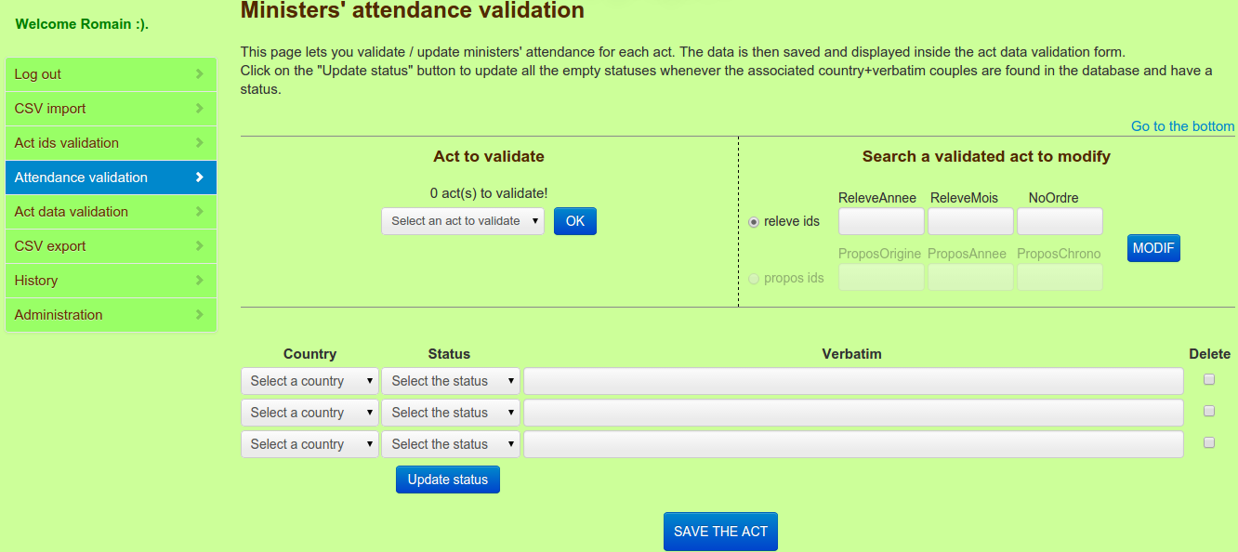
This page displays a list of countries and minister's status and verbatim that attended the council meeting concerning an act to validate. This is possible thanks to the extraction of a pdf whose url is included in RMC files that were imported previously. In order to validate the ministers' attendance of new acts, you must ask the webmaster to import them first.

You can perform two actions on this page:
- validate the ministers' attendance of an act that has already been imported (see Import page): select an act in the drop down list and click on the OK button to validate it.
- modify the ministers' attendance of an act whose ministers' attendance have already been validated: select releve ids to find an act with its ReleveAnnee, ReleveMois and NoOrdre variables or select propos ids to find an act with its ProposOrigine, ProposAnnee and ProposChrono variables. Fill the corresponding text boxes and click on the MODIF button to validate the act.

Information related to the selected act is displayed in 3 columns: country, status and verbatim. For each minister attending the council meeting, we have retrieved his country, verbatim (position title) and status (code created to facilitate the statistical use of the verbatim – see codebook).

You can also update the status by clicking on the Update status button. This will search matches of couples (verbatim+country) and will try to associate the corresponding status to all the same couples (verbatim+country) with no status.

There is the possibility to delete one row by ticking the checkbox Delete in the last column (and clicking on the SAVE button) and adding extra rows using the 3 blank lines at the bottom.

Select the act to validate in the drop down list (or to modify by entering the corresponding releve ids or propos ids in the textboxes) and check the corresponding information in the table below. Modify fields if needed (choose another country or status in the corresponding drop down lists or change the verbatim). Finally, click on “Save” to validate and save the act.

After this step, you can retrieve information of the acts you just validated for the statistical analysis (see below).

Act data validation page
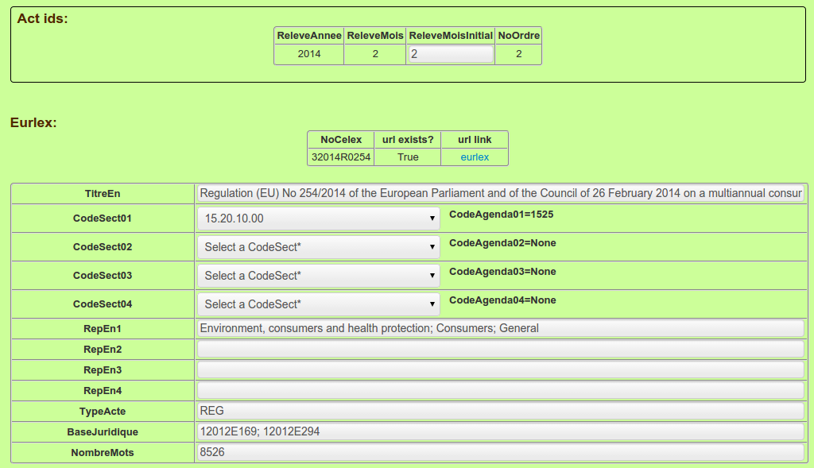
You can perform two actions on this page:
- validate data of an act that has already been imported (see Import page): select an act in the drop down list to validate it.
- modify data of an act that has already been validated: select releve ids to find an act with its ReleveAnnee, ReleveMois and NoOrdre variables or select propos ids to find an act with its ProposOrigine, ProposAnnee and ProposChrono variables. Fill the corresponding text boxes and click on the MODIF button to validate the act.

Acts data can be retrieved and then validated on this page. You can select acts for which ids have been validated only. Data related to one act is displayed. For each source (eurlex and oeil), a first table recalls the ids and the url while a second table displays the corresponding retrieved data. The NationGvtPoliticalComposition variable, at the end of the eurlex table, shows the composition of each national government when the act was adopted. The two other tables show the ministers' attendance data (country and status only) and the opal data with one row per country.
All the retrieved fields are displayed in row. The first column corresponds to labels and the second one corresponds to retrieved data. If there is an error, the expert can change the value of any field. When everything is checked, the act is ready to be saved.

Select the act to validate in the drop down list (or to modify by entering the corresponding releve ids or propos ids in the textboxes) and check the corresponding information in the tables below. Modify fields if needed in the second column of the eurlex or oeil table. NationGvtPoliticalComposition, ministers' attendance and opal data cannot be modified, but ministers' attendance data can actually be modified in another form (see Ministers' attendance validation page). You can check or / and add notes regarding the act. Finally, click on “Save” to validate and save the act.

In fact there is one more action you can perform on this page...

Database management page
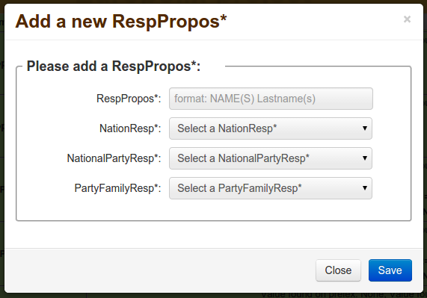

On the Act data validation page, after selecting an act, you can add a new Rapporteur, DG, or RespPropos variable:
- in front of each Rapporteur variable, you can click on “Add a new Rapporteur*” to add a new Rapporteur variable (name, country and party) .
- in front of each DG variable, you can click on “Add a new DGProposition*” to add a new DG variable (dg and dg_sigle) .
- in front of each RespPropos variable, you can click on “Add a new RespPropos*” to add a new RespPropos variable (name, country, party and party_family) .

After this step, the last step is to export the acts you already imported and validated in a csv file (see below).

Export page
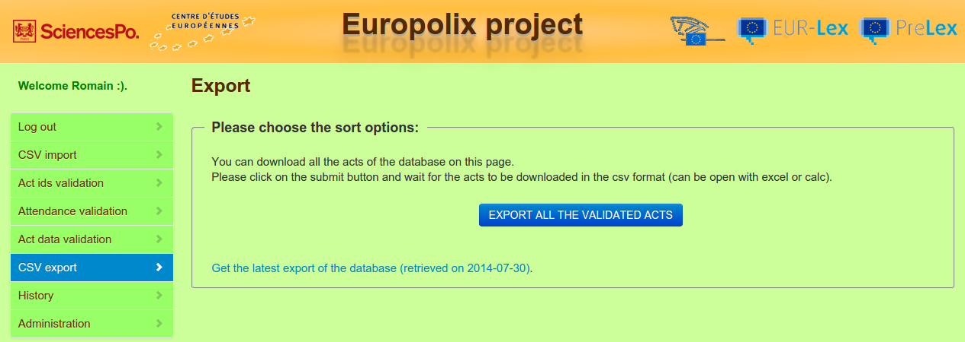
This is the export page. Once acts have been imported, ids validated and data retrieved, you can choose this tool to export them under the csv format. This action exports acts saved and validated only.

To download the validated file, click on the Export button to start the download.

You can also get the latest export of the database by clicking on the link at the bottom of the form. This file is exported on the server automatically, every Sunday. Choose this option if you have problems exporting the acts.

After this step, acts are ready for the statistical analysis :).

History page
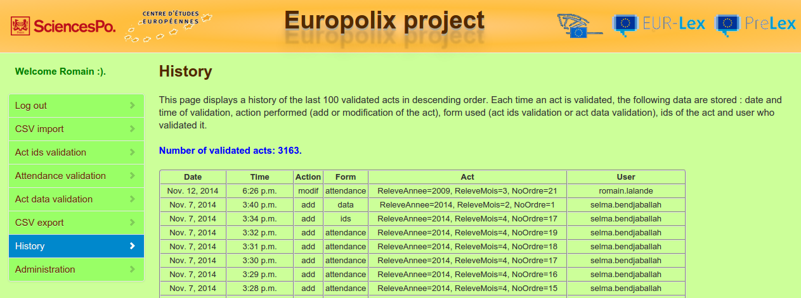
This page shows a history of the last 100 actions performed, useful for validators to help them remember their most recent tasks.
There are 6 columns:
- the date of the performed action
- the time of the performed action
- the action itself: add when an act is added (selection of an act from the drop down list) or modif when an act is modified (after entering its releve ids or propos ids in the textboxes and clicking on the Modif button)
- the form used: ids for the Act ids validation form, data for the Act data validation form and attendance for the Ministers' attendance validation form
- the act column displays the releve ids of the act
- the user column displays the user who has performed the action

Fields to retrieve

The explanation of each field used in the application is given in the codebook.

