Keyphrase Identification Using Minimal Labeled Data with Hierarchical Contexts and Transfer Learning

Rohan Goli, MS¹; Keerthana Komatineni, MS¹; Shailesh Alluri, MS¹; Nina Hubig, PhD¹; Hua Min, PhD²; Yang Gong, PhD³; Dean F. Sittig, PhD³; Lior Rennert, PhD⁴; David Robinson, MD⁵; Paul Biondich, MD⁶; Adam Wright, PhD⁷; Christian G. Nøhr, PhD⁸; Timothy D. Law, DO⁹; Arild Faxvaag, PhD¹⁰; Aneesa Weaver, BS⁴; Ronald W. Gimbel, PhD⁴; Xia Jing*, PhD⁴
¹School of Computing, College of Engineering, Computing and Applied Science, Clemson University, Clemson, SC, USA; ²Department of Health Administration and Policy, College of Public Health, George Mason University, Fairfax, VA, USA; ³School of Biomedical Informatics, The University of Texas Health Science Center at Houston, Houston, TX, USA; ⁴Department of Public Health Sciences, College of Behavioral, Social, and Health Sciences, Clemson University, Clemson, SC, USA; ⁵General Practitioner/Independent Consultant, Cumbria, UK; ⁶Clem McDonald Biomedical Informatics Center, Regenstrief Institute, Department of Pediatrics, Indiana University School of Medicine, Indianapolis, IN, USA; ⁷Vanderbilt University Medical Center, Nashville, TN, USA; ⁸Department of Planning, Faculty of Engineering, Aalborg University, Aalborg, Denmark; ⁹Ohio Musculoskeletal and Neurologic Institute, Ohio University, Athens, OH, USA; ¹⁰Department of Neuromedicine and Movement Science, Faculty of Medicine and Health Sciences, Norwegian University of Science and Technology, Trondheim, Norway

ABSTRACT
Background: Interoperable clinical decision support system (CDSS) rules can provide a pathway to interoperability, a well-recognized challenge in health information technology. Building an ontology facilitates creating interoperable CDSS rules, and identifying the keyphrases (KP) from the existing literature can be a first step for building an ontology. Ontology construction is traditionally a manual effort by human domain experts, and the newly advanced natural language processing techniques, such as KP identification, can be a critical complementary automatic part of building ontology. However, KP identification requires human expertise, consensus, and contextual understanding for data labeling.
Methods: This paper presents a semi-supervised KP identification framework (long short-term memory-based encoders and the conditional random fields -based decoder models, BiLSTM-CRF) using minimal human-labeled data based on hierarchical attention (i.e., at word, sentence, and abstract levels) over the documents and domain adaptation. We created synthetic labels for initial training and human-labeled data for fine-tuning. We also tested different options during NLP preprocessing and ML training to optimize the ML pipeline.
Results: Our method outperforms the prior neural architectures by learning through synthetic labels for initial training, document-level contextual learning, language modeling, and fine-tuning with limited gold standard label data. After comparison, we found that the BIO encoding schema performed slightly better than BILOU, and domain adaptation techniques can improve the quality of synthetic labels. In addition, document-level context, pre-trained language model, and pre-trained Word Embedding all contributed to better model performance in our tasks. Adding 2 to 4 human-labeled documents for every 100 synthetic labeled documents improves the model performance without exhausting human-labeled documents too quickly.
Conclusions: To the best of our knowledge, this is the first functional framework for the CDSS sub-domain to identify KPs, which is trained on limited human-labeled data. It contributes to the general natural language processing (NLP) architectures in areas such as clinical NLP, where manual data labeling is challenging, and light-weighted deep learning models play an important role in real-time KP identification as a complementary approach to human experts’ effort.
KEYWORDS
Clinical Decision Support System, Minimal human-labeled data, Synthetic labels, Hierarchical context, Semi-supervised learning, Domain adaptation, Natural language processing
Abbreviations:
NLP: Natural language processing
CDSS: Clinical decision support system
HDE: Human domain expert
BiLSTM: Bidirectional long short-term memory
BiLM: Bidirectional language model
CRF: Conditional random field
GS: Gold standard
KP: Keyphrase

Introduction
Interoperability [1,2] is a well-recognized challenge in health informatics. For example, a lack of interoperability can create chaos when transmitting patients’ health records between institutions. Despite good progress in interoperability in healthcare, it is not yet a common reality. Clinical decision support systems (CDSSs), especially rule-based CDSSs have been effective in improving the quality of healthcare and preventive services [3,4]. However, developing and maintaining CDSS rules are resource-demanding, and it is not yet a reality to share such rules across institutions. One way to achieve interoperable CDSS rules is via an ontology [5,6] that uses unambiguous concepts and their relationships.
In a text corpus, such as an article, concepts can be identified as an orderly sequence of words or N-grams, namely, keyphrases (KP). A human domain expert (HDE) identified KPs for a particular purpose are named the gold standards (GSs), such as constructing an ontology, after careful review and with consensus among multiple HDEs [7]. Typically, ontology construction is a manual process with the HDE input and curators’ deep understanding of the domain and application contexts. Automatic KP identification can be a critical complement to the manual construction and curation process.
We aim to build a system using natural language processing (NLP) technique to speed up KP identification in CDSS literature. KPs will be reviewed by HDE before they can be added to a CDSS ontology. NLP neural network architectures [8, 9] can be used to automate identifying possible KPs.
Transformer models [10, 11] have been quite popular in accomplishing such a task using context information with attention, they are computationally intense and require labeled data to fine-tune or to adapt from the biomedical domain to the CDSS domain. To avoid the above-mentioned challenges, inferior neural architectures (compared to the Transformer [10,11] and other [12,13] models) can help us identify the possible N-gram combination of tokens as candidate KPs. For example, long short-term memory (LSTM)-based encoders [14] and the conditional random fields (CRF)-based decoder models [15] (a statistical modeling method for text pattern recognition, where current prediction is affected by neighbors). This encoder-decoder network accommodates the customization of text features and various attention levels over the text while recognizing the candidate KPs from the CDSS literature.
Bidirectional attention for LSTM enhances the prediction of KP [16], focusing more on contextual understanding. Our approach is based on the NLP architectures (attention-based BiLSTM-CRF model) presented by Yang, et al and Gu, et al. [17, 18] to create a hybrid approach by augmenting document-level attention layer, preserving its light-weighted heritage, and adding context awareness.
In this paper, we describe harnessing the power of the newly augmented framework with a minimally labeled dataset for KP identification in CDSS, and the challenges we faced. The main objectives include the following:
- Identifying KPs with long-range contextual dependencies with a hierarchical attention-based encoder (Hier-Attn-BiLSTM) neural network architecture, incorporating document, word, and sentence-level attentions by leveraging a lightweight model.
- Creating high-quality synthetic labels in CDSS to bootstrap a machine learning (ML) model with a pre-trained Bidirectional Encoder Representations from Transformers (BERT) model in the biomedical domain.
- Harnessing and optimizing the fine-tuning process when the ML model with limited HDE labeled data in a semi-supervised approach.

The paper discusses the related research in Section 2; formulates the task and describes the method and architecture in Section 3; outlines the CDSS dataset, training procedure, experiments, and results in Section 4; discusses the significance, strengths, limitations, and challenges identified during this project in Section 5; and concludes in Section 6.

Background

CDSS Ontology

CDSS has been broadly adopted in healthcare settings due to its effectiveness in improving healthcare quality and adherence to prescriptions and other clinical orders [3,4]. CDSS is usually a part of an electronic health record system. For rule-based CDSS, the rules dictate CDSS’ operational behavior. However, creating and maintaining these rules is tedious, resource-demanding, and challenging in resource-constrained settings. A CDSS ontology can facilitate the interoperability of CDSS rules [4,7]. Traditionally, ontology construction has been an expert-driven, manual process. Leveraging the NLP technique to automatically identify KP can be a critical complement to the manual effort of building ontology.

Similarity with other NLP problems

The NLP-based ML approaches use unstructured text to extract information and identify patterns and the KP. Identifying a KP involves (1) extracting N-grams, limiting them to noun phrases only, and (2) ranking the N-grams to find the best and marking them as KP. Some of the popular methods of KP extraction, as given by Zhiyong He et al. [8] will be summarized in the forthcoming sections, as well as the differences between our focus and others.

Statistical and unsupervised methods
For limited labeled data, unsupervised ML can be an ideal solution, as proposed by Kazim et al. [9]. Some statistical features, such as term frequency-inverse document frequency (TF-IDF) [19, 20] and Best Match 25 (BM25) [21], differentiate the KP into good or bad categories. But the approaches fail to deal with the unseen data, as the statistics are drawn from the existing corpus.
In unsupervised methods, KPs are determined based on semantic similarity. A graph using the KP as nodes and their semantic similarity as the relations can be used to rank algorithms, such as Google’s PageRank [22], MultiPartiteRank [23], PositionRank [24], and TopicRank [25] by scoring the terms across the relations drawn. However, the relation is given by the similarity between N-gram tokens without considering the document’s context.

Supervised methods
KP identification can be considered as a classification task, the supervised algorithms, such as Naïve Bayes [26], Decision Trees [27], and Support Vector Machines (SVM) [28], can be used to solve binary classification. However, KPs are not independent entities and are always N-gram combinations, which create chaos in the conceptual formulation of the problem.
Using ranking and marking the top N entities as the KP, Witten Ian et al. [29] developed a Keyword Extraction Algorithm, which uses statistical features like TF-IDF and Word’s First Occurrence Position (WFOP). Chengzhi Zhang et al. [30] included additional features such as the length of the token and linguistic features, such as Part of Speech (POS) [31] tags, to normalize the position and occurrence of the KP. A linear ranking SVM was used to rank the KP [32]. The BiLSTM-CRF model [33] considers KP identification as a sequence tagging problem with superior performance [34]. However, directly implementing supervised methods does not address the problem of limited labeled data.

Named Entity Recognition (NER)
Named entity recognition (NER), a classical NLP task, extracts and classifies N-gram entities into predefined categories, such as name, drug, gene, disease, organization, quantity, numeric values, location, and is known as NER [35]. It can be handled as two problems: entity identification and entity classification. NER can be achieved by grammar-based or statistics-based methods. NER is to identify predetermined categories of entities, while KP identification identifies the primary topics or important concepts within the corpus; it is not necessarily limited to the predetermined categories. Both are critical tasks in NLP, but slightly different (Figure 1).
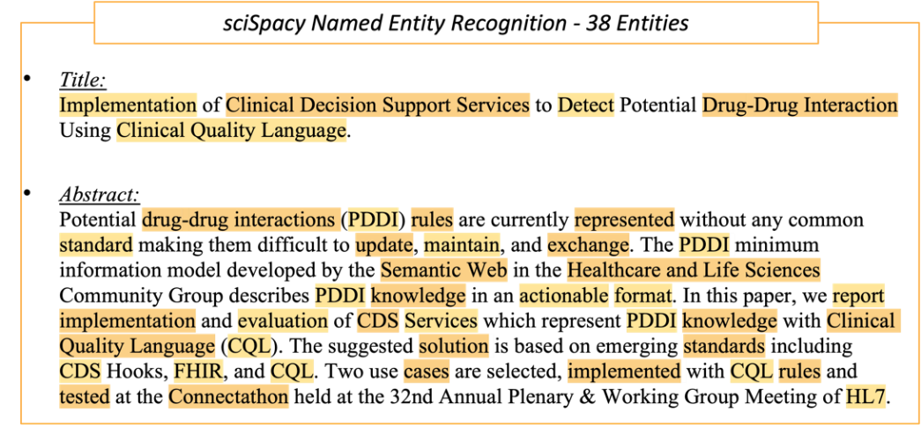
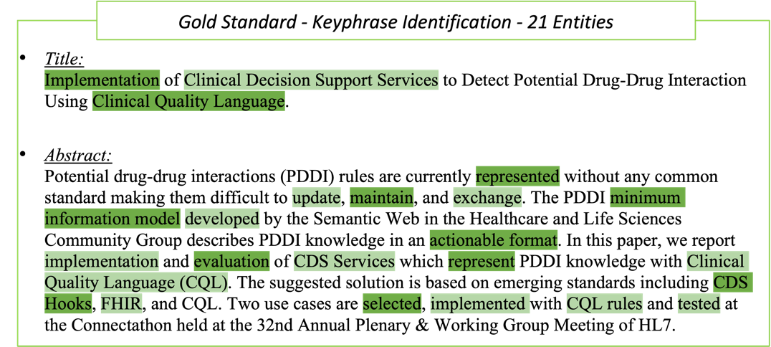

Figure 1. Entities identified on a sample CDSS abstract demonstrate differences between human-labeled Gold Standards and NER by sciSpacy.

Deep learning for KP identification
Deep learning approaches typically use recurrent neural networks (RNN), convolutional neural networks (CNN), generative adversarial networks (GAN), Bi-LSTM-CRF, or transformer-based models, among others, to perform KP identification. BERT is a transformer-based language model that exhibits excellent performance in multiple NLP tasks [36]. However, BERT also requires significant computational resources during both model training and task performance [36-38]. One of our critical technical requirements is a lightweight model that does not demand significant computing resources to operate. Based on the systematic testing results, the BiLSTM-CRF model achieves good results, although it does not set a new state-of-the-art record [36], but it is much more resource-efficient. Our task is not a typical keyphrase extraction about the themes or summaries of the study. The identified keyphrases will be used as ontology candidates, a unique NLP task with specific usage conditions in our use case. Therefore. To be able to fine-tune the model in a non-resource-demanding setting is a critical criterion to meet in our use case. Literature shows excellent results of KP identification by the BiLSTM model with document-level context attention [16-18].

Domain adaptation
Training deep learning models from scratch can facilitate KP identification; however, the process is challenging and needs significant resources, time, and data. Domain adaptation [39,40] adapts the pre-trained ML models to a similar domain and fine-tunes them with minimal use of labeled data. Therefore, it can be a better option for KP identification in our use case.
A popular model in entity identification, Spacy [41], based on BERT [10,11], is trained on OntoNotes5 [42] and WordNet [43] open-source corpora. Although it works very well with English language modeling and text comprehension, it fails to identify the entities in biomedical and clinical informatics sub-domains. Therefore, Spacy, a large language model (LLM), has been domain-adapted with a 785 K vocabulary and 600-word vectors into sciSpacy, specializing in the identification of biomedical entities [45]. We further fine-tuned the sciSpacy model to the CDSS sub-domain and strengthened the transfer learning approaches to achieve our goals.

Language Model (LM)

The LM is a critical aspect of NLP architectures [46]. It is a statistical and probabilistic technique to determine the conditional probability of each word’s occurrence in a given sentence based on the hidden Markov model (HMM) [47]. It is often used when the labeled training data is limited. To create such an LM, all the sentences in the document are unified into one, and punctuation is removed. Then, we slide over the word windows to train the LM without using labeled data to provide the context of the words and their characteristics. The LM needs to understand domain-specific language and the distribution of words within the domain, CDSS in our case. We can use this trained LM to transfer its neural network parameters to the actual model; the process helps the model learn the language distribution for the CDSS domain [48].

Methods

We designed a pipeline for the task, which includes a bidirectional long short-term memory (BiLSTM) as the encoder and a CRF layer as the decoder. For a given sentence, it can learn the N-gram entity patterns and their occurrence over the context [16, 17]. We propose a hierarchical attention strategy during model training and learning, including word, sentence, and document-level attentions. The details are presented in the following sections.

Overview

Defining the task
KP identification is a typical sequence labeling task to find the N-gram KP from the document. For a document with m sentences, $d=\left(s_{1},s_{2},…,s_{m}\right):$ each sentence contains n tokens or words, $s_{i}=\left(w_{i1},w_{i2},…,w_{in}\right)$ is the input to the model and output $z_{i}=\left(z_{i1},z_{i2},…,z_{in}\right)$ would be a sequence of tags in BIO token tagging representation [49].
In BIO token tagging [49], the first N-gram word is labeled B-KP, the rest are labeled I-KP, and the non-KP tokens are marked as O. Figure 2 presents a BIO token tagging example with an input document and the sequence tag (B-KP/I-KP/O) output, where the keyphrases can be generated by decoding the output tags.
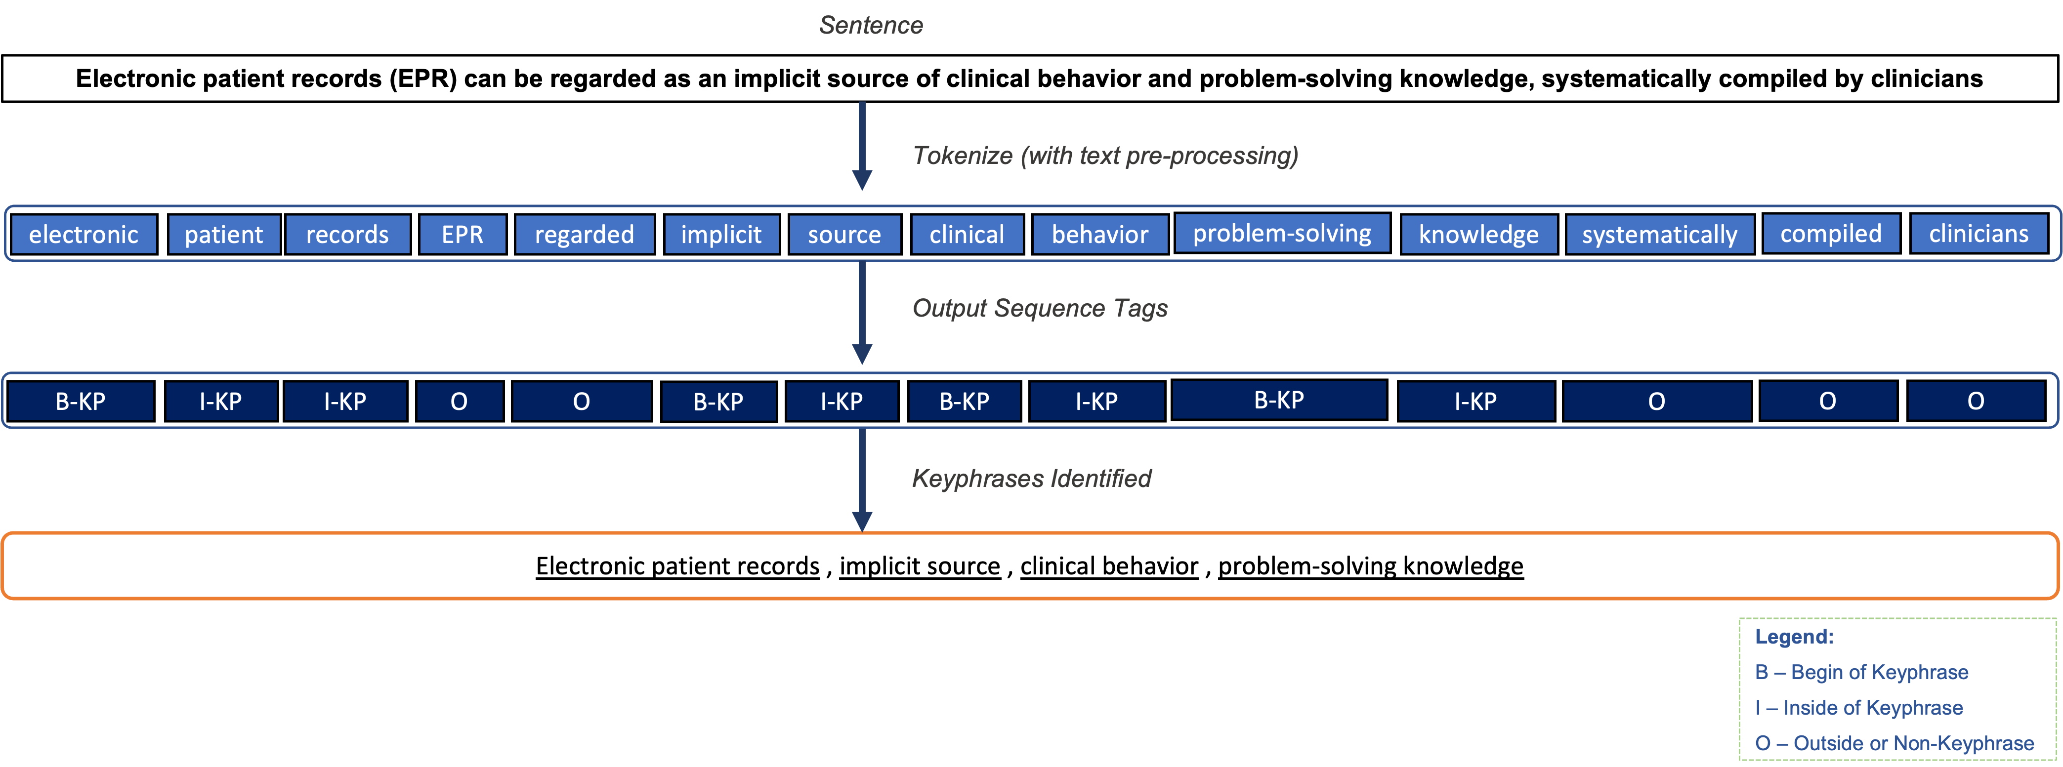
Figure 2. Flow of labeling Keyphrases (KP) from a sentence
We provide the document-level context by combining hierarchical attentions (i.e., adding word-level and sentence-level attentions to create the document vector), to improve the model performance. That is, the input to our model will be all the sentences from a single document.

High-level design
Our ML model architecture includes (1) creating synthetic labels for the corpus, (2) pre-training the model, (3) implementing BiLSTM-CRF model, and (4) fine-tuning with HDE (GS) labeled data (Figure 3). Based on the research of Xu, et al. [18] and Saad, et al. [50], we created synthetic labels using BERT. In parallel, we trained the word embedding (WE, word2vec) model and bidirectional language model (BiLM) without using labels. Then we transferred their parameters into the BiLSTM-CRF model’s initial layers for embedding and LSTM, respectively. Second, all the sentences from a single document are fed into the BiLSTM-CRF model in batches, one document at a time. Each word in the sentence is transformed into a vector via the WE model. Then, we introduced hierarchical attention, i.e., attention at word and sentence levels, to aggregate them into sentence and document vectors, respectively.

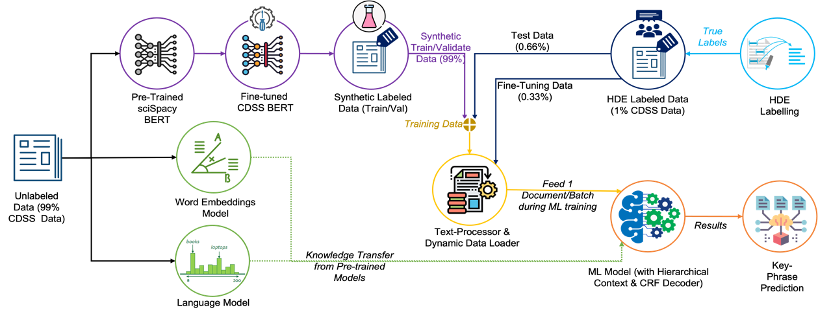
Figure 3. High-level design of the proposed pipeline for KP identification
Using these embedding and attention vectors, we calculated the hierarchical attention for any given word (Appendix A). We then used the encoded information to feed the conditional random fields (CRF) layer, which decodes the best probable sequences to mark the output labels with BIO token tag representations. Later, we fine-tuned the model to enhance its performance using a minimally HDE-labeled dataset.

Synthetic labels
We performed domain adaptation of a sciSpacy BERT model [45] by generating the synthetic KPs (intermediate) on the CDSS dataset and using them to fine-tune the sciSpacy BERT to the CDSS sub-domain BERT. Then, we generated the synthetic KP on the CDSS dataset and marked the labels in the BIO format, namely the synthetic dataset with synthetic labels. We used this dataset to train and test our BiLSTM-CRF model. Synthetic labels can help to bootstrap the ML model’s training process (Figure 3). Then the BiLSTM-CRF model can be fine-tuned with the HDE labels.

Pre-training

Word Embedding (WE) model
Word embedding provides a mathematical vector representation for a given word, which ensures minimal distance between the vectors with similar meaning. These embeddings capture the language semantics and syntactic information using the Word2Vec [51] skip-gram approach. We also tested with fastText [52, 53] and GloVe [54]. Both GloVe and fastText have dynamic and reduced dimensions in the embedding matrix, creating a hiatus for knowledge transfer between them and BiLSTM-CRF. Therefore, we only focused on using a Word2Vec embedding model for our pipeline.

Bi-Directional Language Modeling (BiLM)
To learn the probability distribution over sequences of words, we use a shallow-layered bidirectional RNN [55] (e.g., LSTM and GRU) to learn the joint probabilities represented by WE. A network that learns the word distribution is known as the BiLM [46]. It computes the conditional probability of the occurrence of the next word ($w_{i}$) based on the previous ($w_{1},…,w_{i-1}$) and future words ($w_{i+1}, …,w_{n}$) in a sentence (s) [46], where each sentence (s) is represented by the last word’s context (given by LSTM’s cell state) in both left (${\overset{⃖}{ c }}_{n}^{LM}$) and right (${\vec{ c }}_{n}^{LM}$) directions.

For a given word ($w_{i}$), the forward and backward LSTMs encode the history of previous tokens in each direction into fixed-dimensional vectors (${\overset{⃖}{ h }}_{i-1}^{LM},{\vec{ h }}_{i-1}^{LM}$), where a soft-max layer maximizes the likelihood (p) of the word ($w_{i}$) in the given sentence (s) in the corpus.

Hierarchical-Attention-BiLSTM-CRF Model

Encoder
This architecture is adopted from Zichao Yang, Guohai Xu, and Luo L et al. (Figure 4) [17, 18, 56]. To capture the context of the KP, we encode one document at-a-time to capture document-level context with a stacked BiLSTM [11], which was initiated with weights that were transferred from pre-trained WE and BiLM models. The embedding and first LSTM layers in our encoder share the architecture of the pre-trained models, and can seamlessly transfer the model parameters or weights between the models [18].

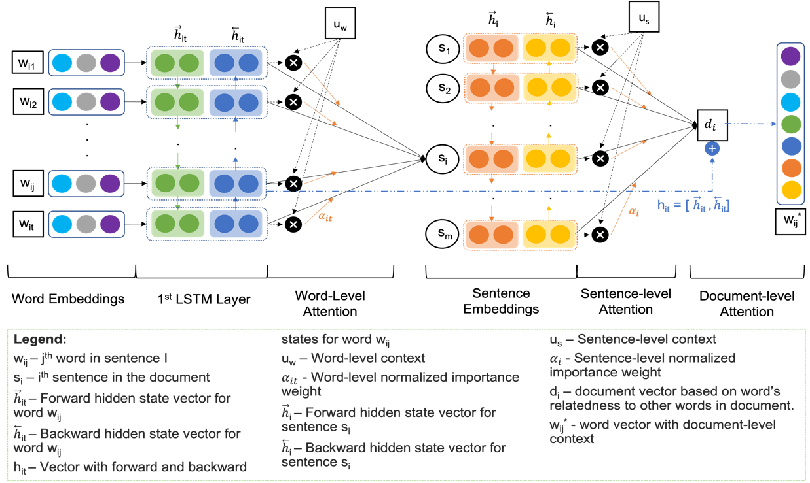
Figure 4. Detailed encoder - word encoding with Hierarchical-Attention-BiLSTM with document-level context.
We used all the sentences in a document, $d=\left(s_{1},s_{2},…,s_{m}\right)$, where each sentence is represented by $s_{i}=\left(w_{i1},w_{i2},…,w_{in}\right)$ and its words by $w_{it}∀t∈\left[1,n\right]$. We embed the words into a vector ($x_{it}$) through an embedding matrix (W_{e}). BiLSTM summarizes the bidirectional context information where each word vector’s hidden state ($h_{it}$) is obtained by concatenating the forward (${\overset{⃖}{ h }}_{it}$) and backward (${\vec{ h }}_{it}$) hidden state vectors, i.e., $h_{it}=\left[{\overset{⃖}{ h }}_{it};{\vec{ h }}_{it}\right]$. The hidden state vector provides sentence-level context to each word [12].

We calculated word similarity ($u_{it}$) using a neural network’s parameter for weighted matrix ($W_{w}$) and word representation ($h_{it}$) given by BiLSTM along with bias ($b_{w}$) [57]. Then we calculated the word-level attention by aggregating the $h_{it}$ and $u_{it}$ using a word-level context vector ($u_{w}$) [19, 20] to get a word-level normalized importance weight ($α_{it}$). Finally, we compute the sentence vector ($s_{i}$) as a weighted sum of word representations as shown in Eq. (A. 1)(A. 2)(A. 3). Initially, $u_{w}$ is the neural network parameter with random initialization, learned during the training process.

$$u_{it}=\tanh\left(W_{w}.h_{it}+b_{w}\right)∀t∈\left[1,n\right]$$
(A. 1)
$$α_{it}=softmax\left(u_{it}^{T}.u_{w}\right)=\frac{exp\left(u_{it}^{T}.u_{w}\right)}{\sum_{t}{exp\left(u_{it}^{T}.u_{w}\right)}}∀t∈\left[1,n\right]$$
(A. 2)

$$s_{i}=\sum_{t}{α_{it}}.h_{it}∀t∈\left[1,n\right]$$
(A 3)

Similarly, a document vector can be computed using sentence-level attention over the sentence vectors ($s_{i}$) [19, 20] and concatenating the forward (${\overset{⃖}{ h }}_{i}$) and backward (${\vec{ h }}_{i}$) states to encode a sentence, $h_{i}=\left[{\overset{⃖}{ h }}_{i};{\vec{ h }}_{i}\right]$ based on neighbor sentences.

To estimate the sentence-level context vector ($u_{s}, B.1, B.2, B.3$), first, we used neural network parameter for weighted matrix ($W_{s}$), sentence representation ($h_{i}$) and bias ($b_{s}$) to calculate sentence similarity ($u_{i}$). Second, we randomly initialize u_{s}, to calculate the sentence-level normalized importance weight ($α_{i}$), which yields a document vector(d_{i}) for each word representing the sentences that are important to consider for a given word while identifying it as a KP as provided [17].

$$u_{i}=\tanh\left(W_{s}.h_{i}+b_{s}\right)∀i∈\left[1,m\right]$$
(B. 1)
$$α_{i}=softmax\left(u_{i}^{T}.u_{s}\right)=\frac{exp\left(u_{i}^{T}.u_{s}\right)}{\sum_{i}{exp\left(u_{i}^{T}.u_{s}\right)}}∀i∈\left[1,m\right]$$
(B. 2)

$$d_{i}=α_{i}.h_{i}∀i∈\left[1,m\right]$$
(B. 3)

Unlike the previous work proposed by Guohai Xu et al. [18], we concatenated the first LSTM’s hidden local state (h_{it}) with the document vector (d_{i}) into a new vector $\left[h_{it};d_{i}\right]∀t∈\left[1,n\right]$, given the word’s relatedness to other words in the document. That is, providing document-level context to each word. Next, the extended representation was further used to identify the labels.

Decoder
As described by Ling Luo et al. [56], we used the CRF [15] layer as the decoder, which produces the confidence scores for the words with each label (B-KP/ I-KP/ O) as the output score of the decoder. Given the transition and network scores, we make tagging decisions independently, considering P, the matrix of scores of the network output.
The score of sentence ($s_{i}$), with a sequence of predictions $y_{i}=\left(y_{i1},…,y_{ij},…,y_{it}\right)$, is given by the sum of transition scores and network scores as shown in Eq.(C. 1). Here each $P_{a,b}$represents the matrix of scores of b^{th} tag of the a^{th} word in the sentence. Furthermore, the tagging transformation matrix (T) is trained as the model parameter. Here $T_{a,b}$ represents the transition score from tag a to tag b through successive words where $T_{0,b}$ is the initial score starting from tag b.
To generate the conditional probability of the path (y), we normalize the score for all possible paths ($\tilde{y}$) using a soft-max function using Eq. (C. 2). Then, we maximize the log probability of valid tag sequences. We obtain the maximum score using the dynamic programming approach of Viterbi decoding [58] for the best tag path given by Eq. (C. 3).
$$score\left(s_{i}, y_{i}\right)=\sum_{k=0}^{n}{\left(T_{y\left(i, k-1\right), y\left(i,k\right)}+P_{\left(k,y\left(i,k\right)\right)}\right)} ∀i∈\left[m,1\right]$$
(C. 1)
$$p\left(y_{i} | s_{i}\right)=\frac{exp\left(score\left(s_{i}, y_{i}\right)\right)}{\sum_{{\tilde{y}}_{i}}{score\left(s_{i}, {\tilde{y}}_{i}\right)}} ∀i∈\left[m,1\right]$$
(C. 2)
$$z_{i} = \underset{{ \tilde{y }}_{i}}{argmax}\left(score\left(s_{i}, {\tilde{y}}_{i}\right)\right) ∀i∈\left[m,1\right]$$
(C. 3)

Experiments and results
This section includes the following content: the profile of the dataset we used in this study (4.1), synthetic label creation (4.2), preparation of the KP identification model (4.3), which includes CDSS domain adaptation, comparing token tagging schemas BIO and BILOU, stemming and non-stemming for our task, and training of the KP identification model. The last part of the Results focuses on strategies to improve the KP identification model performance: i.e., leveraging document-level context and adding HDE labels to synthetic labeled documents (4.4).

Dataset
The text corpus was obtained from PubMed by retrieving the CDSS (as the Medical Subject Headings, MeSH) literature. The articles with a valid PubMed Identifier (PMID) were selected. The corpus profile presents in Tables 1 and 2. Appendix B provides detailed information on the dataset at the various stages during text preprocessing. Of the total dataset retrieved from PubMed (3,545 abstracts), 3,326 abstracts were kept after XML parsing, and 133 of them were labeled by HDE (Table 1, Appendix B ). During preprocessing, we removed articles with abstracts of 3 or fewer sentences, treating the title as a single sentence. The basic statistics about the input sentence lengths: min: 2, max: 81, median: 19, and mean: 21.1.
Table 1. Profiles of the CDSS corpus
 | FC | FC with PMIDs | GS (+8 ACM) | No/little abs. | Final/total dataset
Articles | 3545 | 3326 | 133 | 99 | 3281
FC – Full CDSS dataset
No/little abs. - Abstracts having less than 3 sentences including the title.

Table 2. CDSS Datasets for training, validation, and testing
 | Total | Synthetic KP labeled dataset | Training | Validation | Testing (GS91)* | GS(GS42)*
Articles | 3281 | 3148 | 1049 | 2099 | 91 | 42
* GS91 and GS42 are 2 sets of HDE-labeled datasets.
In addition, we had 2 sets of HDE labeled datasets (GS91 and GS42). GS91 was unseen data to test the model’s performance, and the GS42 was used to fine-tune the ML model. Cohen’s kappa rates for the first 42 (GS42) abstracts were 0.93 (annotators 1 and 2) and 0.73 (annotators 1 and 3) [44]. For the second set of abstracts (GS91), Cohen’s kappa rates were 0.87 (annotators 1 and 2) and 0.97 (annotators 1 and 3). For the remaining 3,148 articles, they were labeled by the synthetic KP, which were split into training and validation data sets in 1:2 ratio (Table 2).

Synthetic label creation
To maximize the quality of the synthetic labels created, we experimented with different unsupervised algorithms (namely, PositionRank, MultiPartiteRank, and TopicRank)[19-25] and NER (i.e., sciSpacy). BERT-based sciSpacy [45] outperformed other unsupervised methods (Table 3).
Table 3. Evaluation of synthetic KP generated with different approaches
Approach | Accuracy | Misclassification | Precision | Recall | Specificity | F1-Score
sciSpacy | 0.69 | 0.31 | 0.36 | 0.81 | 0.66 | 0.50
PositionRank | 0.76 | 0.23 | 0.39 | 0.36 | 0.86 | 0.38
MultiPartiteRank | 0.76 | 0.24 | 0.38 | 0.36 | 0.86 | 0.37
TopicRank | 0.77 | 0.23 | 0.39 | 0.36 | 0.87 | 0.37

Preparation of KP identification model

CDSS domain adaptation for synthetic label generation
To optimize the sciSpacy model for identifying KP in the CDSS context, we performed domain adaptation [39, 40] for the sciSpacy BERT model from the biomedical domain to the CDSS sub-domain [59]. We generated synthetic labels (intermediate) from the base sciSpacy models and thereafter used them to adapt the model iteratively over the CDSS domain. Then the CDSS sciSpacy model (after domain adaptation) was used to generate final syntactic labels. To test the quality of the synthetic labels generated after the domain adaptation, we compared the domain-adapted model with different combinations of training and validation sets to identify the best-performing model. Appendix D contains detailed additional evaluation results. Domain-adapted sciSpacy has better performance as anticipated, and Figure 5 shows an example abstract with results.

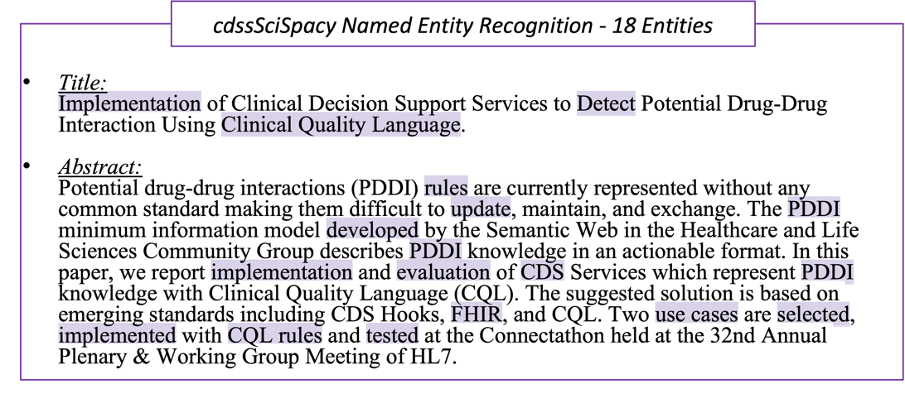
Figure 5. Entities identified on sample CDSS article context with CDSS-domain adapted sciSpacy NER.

Token tagging representation comparison
To identify an N-gram sequence, each token in the text is marked with either the BIO or BILOU encoding schema [49] to represent the KP (Figure 2). We tested both schemas to determine which one fits the CDSS corpus best, and the results are included in Appendix D, Table D2. We chose the BIO token tagging for the label marking as it slightly outperformed BILOU in F1 scores.

Stemming vs. non-stemming
Stemming is a normalization technique used for text pre-processing before feeding it to ML models [60]. To analyze the effect of stemming on CDSS corpora, we experimented with the stemmed and non-stemmed KP on the synthetic and GS-labeled data (Appendix D, Tables D3, D4). The performance of the ML models deteriorated with stemming, so we opted for non-stemming in the text preprocessing steps.

Loading pre-trained models
As discussed in Section 3.4.1, initially, a Word Embedding model and the BiLM were trained separately on the unlabeled corpus (Figures 3 and 4). Then, we transferred the parameter weights into the BiLSTM encoder’s initial layer, to bootstrap the CDSS language distribution before we started training the BiLSTM-CRF model.

KP identification ML model training
We labeled the KP with the BIO token tagging schema [49] to start the ML model training procedure for 30 epochs. Then, we evaluated the sequence-level entity metrics using standard ML metrics (i.e., precision, recall/sensitivity, F1-Score, and accuracy). The parameters and configurations of the Hier-Attn-BiLSTM-CRF neural network model are as follows:
- WE Dimension: 300
- LSTM hidden layer dimension: 256
- Dropout Ratio: 0.2
- Epoch: 30 (number of times every document is shown to the ML model)
- Batch Size: 1 (one document at a time is shown to the model, to calculate the context, with documents having varying sentence numbers, up to a maximum of 52 for an abstract)
- Max sentence length: 128 (For CDSS corpus, the maximum words per sentence is 105)
- WE Type: Word2Vec
- Text pre-processing: remove stop words and punctuation.
- Stemming: no
- Train-validation split: 1:2
- Pre-trained sciSpacy BERT model: en_core_sci_lg

KP identification ML model improvement

Leveraging document-level context
Context is a critical factor to consider during KP identification [16, 61]. To reinforce this philosophy, we experimented with the different encoding combinations at word and character-level embeddings, and CNN-based text features (length, POS tag, text rank, TF-IDF score and Position of First Occurrence [62]). We compared them with our proposed method (BiLSTM-CRF with Hierarchical-Attention and the document-level context). The results are shown in Table 4, Figures 6 and 7. Our method, which included a hierarchical context-driven model, achieved better metrics than the base BiLSTM-CRF model and performed as well as the other models with character embeddings and CNN-based text features, but with lower recall values (Appendix C, Figures 1, 5, and 7).
Table 4. Comparison of evaluations on different contextual levels of attention
Model | Encoder Details | Experiment  Runs | Train Dataset | Test Dataset | Precision | Recall | Accuracy | F1-Score
BiLSTM-CRF | BiLSTM (Word Embd’s) | 1 | 1049  Synthetic | 2099  Synthetic | 0.72 | 0.66 | 0.92 | 0.69
 |  |  |  | 42 GS | 0.54 | 0.46 | 0.86 | 0.49
 |  |  |  | 91 GS | 0.59 | 0.48 | 0.88 | 0.53
BiLSTM-CRF | BiLSTM (Word Embd’s + Char Embd’s) | 1 | 1049  Synthetic | 2099  Synthetic | 0.70 | 0.70 | 0.85 | 0.70
 |  |  |  | 42 GS | 0.52 | 0.56 | 0.78 | 0.54
 |  |  |  | 91 GS | 0.58 | 0.53 | 0.77 | 0.55
BiLSTM-CRF | BiLSTM (Word Embd’s  + Char Embd’s)  + CNN (Text Features) | 1 | 1049  Synthetic | 2099  Synthetic | 0.73 | 0.71 | 0.85 | 0.72
 |  |  |  | 42 GS | 0.56 | 0.55 | 0.78 | 0.55
 |  |  |  | 91 GS | 0.58 | 0.55 | 0.78 | 0.57
Hier-Attn-BiLSTM-CRF (our method) | BiLSTM (Word Embd’s)  + Hierarchical Context  (Word-level sentence-level attentions) | 1 | 1049  Synthetic | 2099  Synthetic | 0.75 | 0.68 | 0.92 | 0.71
 |  |  |  | 42 GS | 0.6 | 0.5 | 0.88 | 0.54
 |  |  |  | 91 GS | 0.61 | 0.5 | 0.88 | 0.55
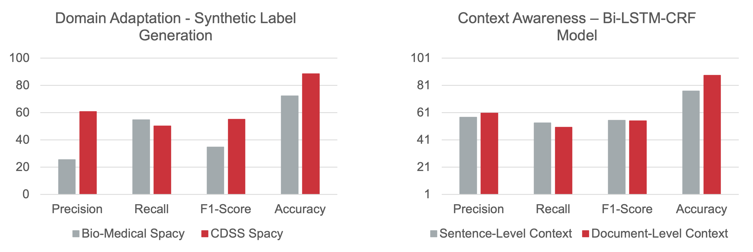
Figure 6. Comparison of results for domain adaptation and hierarchical context (document context through word-level and sentence-level attention).
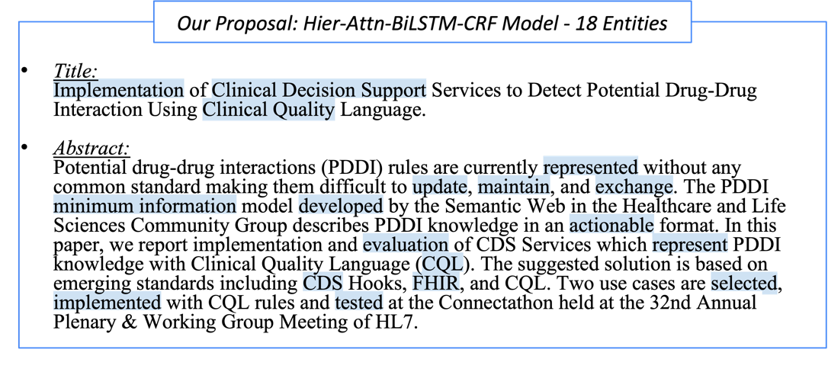
Figure 7. Entities identified in the sample CDSS article context with our Hier-Attn-BiLSTM-CRF model.

Fine-tuning with Gold Standard (GS) labels
To further fine-tune the Hierarchical-Attention based BiLSTM-CRF model to strengthen its predictions [59], we added the HDE-labeled documents to mix with the synthetic labeled documents in different proportions, i.e., 0, 2, 4, 6, and 8 HDE-labeled documents are sampled for every batch of 100 synthetic labeled documents, respectively. It helps us measure learning performance with human feedback across ML training iterations by running independent experiments 10 and 50 times. As shown in Figure 8, exposing the model to 2–4 HDE-labeled documents alongside 100 synthetic labeled documents enabled the model to learn more efficiently from the minimum labeled dataset. The tabulated performance metrics are presented in Appendices E and F.
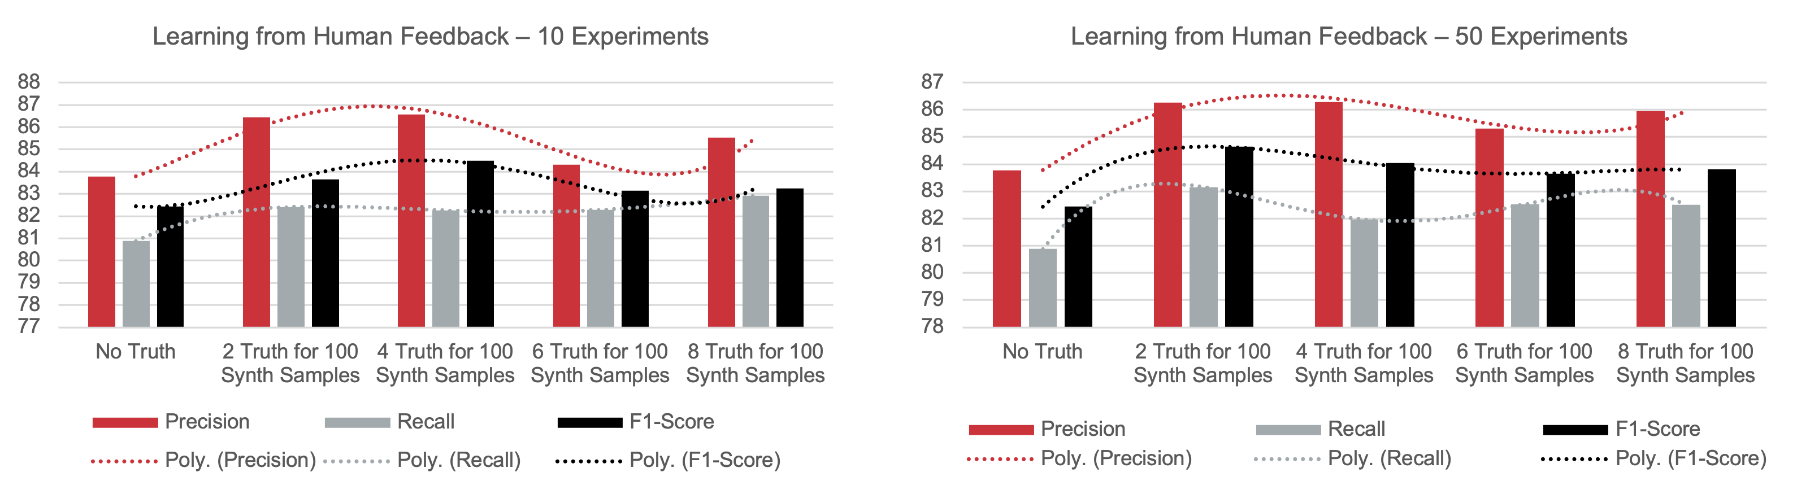
Figure 8. Results for fine-tuning with Gold Standard (GS) labels.

Discussion
Limited HDE-labeled data is a common challenge in clinical NLP and many other fields. In this study, we used synthetic labels to conduct model training. Furthermore, we tested adding a few HDE-labeled documents to the synthetic labeled documents to improve model performance, with successful results. The context is a critical factor to consider because of the long-range dependencies of natural language. To solve this problem, we used hierarchical attention over text to provide a larger, yet still focused, context (one document) to the model while processing each word. Our work demonstrates that an ML model can identify KPs with better performance by adding document-level context. KPs identified by the ML model will be reviewed by human experts before they can be added to the CDSS ontology. Therefore, the ML model facilitates the screening process in narrowing down the scope of candidate terms for an ontology, but does not make the final decisions on which terms will be included in the ontology.

Results interpretation
In this study, we aim to use minimal HDE-labeled data to fine-tune a pre-trained language model to identify candidate KPs for an ontology. The goal is to improve the efficiency of the human curation process during ontology construction and maintenance. Although the task can be presented as a simple yes-or-no labeling of a sequence of words, KP identification is much more complex than a binary task, as the HDE draws on rich background knowledge and expertise to make judgments. We generated synthetic labels and trained our BiLSTM-CRF model with them.
Although the metrics shown in Table 3 (such as F1-Score $≤0.5$) could be improved; we point out that the models compared are trained for different tasks (Figure 1, Appendix C). NER and KP Identification might look like similar tasks on the surface; however, the KP identification for our task was different, with unique requirements. Therefore, we decided to perform domain adaptation on the sciSpacy NER model using CDSS corpora We found that the domain adaptation model provided much better labels than the sciSpacy NER model(Figure 5, Appendix C, and Appendix D, Table D1). The CDSS domain-adapted sciSpacy model has 2-fold improvement in F1-Score from 0.33 to 0.66 on GS133 dataset (Appendix D, Table D1).
We compared fastText and Word2Vec to handle out-of-vocabulary (OOV) words. Literature indicates a 0.5%–1% improvement by fastText, as reported by Benedict et al. [63]. Therefore, we used Word2Vec approach for pre-training the Word Embedding model as it is easier to transfer the embedding matrix weights between pre-trained and actual models. Our method uses index-to-token and token-to-index mapping while encoding the words. The length of the vocabulary(L) is further used as the square matrix dimensions of the WE (W_{e}) matrix, which helps us find the similarity between any two words.
While the visual representation for KPs identified on a sample text (Figure 7, Appendix C) looks closer to the GS labels (Figure 1, Appendix C), most of the entities spanning N-grams do not have an exact match. The evaluation needs to be on the entity level with an exact GS label match, as proposed by Nancy et al. [64]. Therefore, we used the sequence labeling evaluation given by Hiroki et al. [65] to decipher the results. As shown in Figure 6, our model with hierarchical attention and loading document one by one improved accuracy by 10%, from 78% to 88%, compared to the sentence-level attention model. The complete match for GS labels brings down the metrics. Without any character-level and textual features (e.g., character embeddings, document embeddings, phrase embeddings, text rank, TFIDF, topic rank, position rank, word’s first occurrence in text, length of the word) the BiLSTM-CRF model’s results (Table 4) infer an improvement in the overall performance metrics due to the added hierarchical context provided to each word representation. In particular, we noted that it has better precision than the remaining models and maintains the ± 2%) even with a decline in recall (Table 4).
The hierarchical context requires that all sentences of a single document are used to calculate the attention for words and sentences and to create sentence-level and document-level vectors, respectively. Usually, a static batch size (32/64/128) is chosen for the data loader. The sentences of a document could span different batches, which creates complexity in providing focused context. To overcome this, we used a non-conventional technique of dynamic batches for the data loader, i.e., each time a document with a different number of sentences was sent into the encoder-decoder during the ML model training process. This means that the number of iterations for the ML model training equaled the number of documents shown, ultimately increasing the training time, making it 2–3 times slower than models without a hierarchical context. However, the model's performance, especially its accuracy, demonstrated a clear improvement (Figure 6).
To further strengthen the ML model, we fine-tuned the model with the GS labels (42 GS labeled documents from the CDSS corpus) to align the model’s predictions from synthetic labeling to GS labeling. During the training, we varied the number of HDE-labeled documents (0/2/4/6/8 GS) for every 100 synthetic labeled documents during the model’s iteration, marking the essence of minimizing HDE labels . A poly-fit curve over the scores demonstrates that adding 2–4 true samples for every 100 synthetic samples during ML model training demonstrates better performance without exhausting HDE-labeled documents too quickly (Figure 8). The F1-Score improved from 55% to 84%, accuracy from 88% to 96%, precision from 61% to 86% and recall from 50% to 82%.

Challenges
The generation of manually labeled data is an expert-intensive process in fields like medicine. To surmount this problem, HDE can label a small set of samples. During the HDE labeling process, it is important to pick the samples from different areas of the CDSS sub-domain, which helps the model to learn efficiently from the diversified samples. To avoid selection bias, we picked random samples from CDSS corpora for HDE annotation. However, the current data loader randomly picks samples without any diversification, which exposes us to selection bias. The same problem occurs in the selection of data samples or documents for the fine-tuning process. Although randomization can improve model performance by reducing bias, it does not guarantee a diverse selection of samples, as the chosen samples may not cover a wide range of topics.

5.3 Significance of the work
This study has demonstrated our successful exploration of existing lightweight models to address a unique use case: identifying keyphrases for a CDSS ontology with minimal HDE-labeled data. Our study shows these strategies contribute to better performance: domain adaptation helps to create better quality synthetic labels, and hierarchical attention, particularly the document-level context, helps improve the model performance significantly. Meanwhile, pre-trained word embedding models and language models help transfer domain-specific knowledge into the final model, improving its performance. The synthetic labels not only reduce HDE-labeled data use in the task, but the mixing of a small number of HDE-labeled documents with synthetic labeled documents improves the model performance without exhausting HDE-labeled data too quickly, which can be an important strategy to help overcome the limited availability of HDE-labeled data, a common challenge of NLP. The experiment results guide us in optimizing our model and operational settings, and we hope the approach serves as a reference point for others when planning their NLP tasks. Our strategies to improve model performance for our task can provide valuable experience and a beneficial reference for others facing similar challenges in clinical NLP. The work is particularly significant in automating curation of domain-specific ontologies or knowledge bases.

5.4 Limitations of the study
Our study also has several limitations. First, there is no ablation study [66], which is a systematic method for identifying the contribution of different components in a ML pipeline. Although the comparison studies (Table 4, Appendix D) help answer the question, a systematic comparison could yield more accurate results for each component. Second, we used BiLSTM-CRF model instead of BERT or its derivative models (e.g., BioBERT, PubMedBERT) primarily because of the consideration of the computing resources. Our goal is to use a lightweight model and be mindful of the computing resources required. However, it may provide more evidence in comparison side by side if we compare the performance between BiLSTM and BERT. Third, the work was conducted in 2022 before LLM became a primary option. It would be interesting for future study to compare the performance between LLMs and our model on the same task. Finally, for the synthetic label-trained model, we used only HDE-labeled data to evaluate the model's performance, without examining the errors. The error analysis could provide additional insights.

Conclusion
This paper proposes a novel KP identification method using minimal HDE-labeled data and hierarchical attention to retain longer contextual dependencies. It incrementally builds the context at the word level and sentence level within one document. The proposed model (Hier-Attn-BiLSTM-CRF) demonstrated 10% improved accuracy, from 78% to 88%, for KP identification by adding document-level context through document-by-document loading during model training. Further, the domain adaptation in a semi-supervised approach improved the overall performance of the model by creating higher-quality synthetic labels, which helped to solve the challenges of limited HDE-labeled data. When we use a custom batch loader that yields 2-4 samples for a batch of 100 synthetic samples, the model produced optimal performance without exhausting HDE-labeled documents too quickly. Finally, our method contributes to the general architecture of NLP by effectively creating ML models with limited HDE-labeled data by leveraging domain adaptation techniques, document-level context, pre-trained LM, and pre-trained WE, as well as mixed HDE-labeled data and synthetic labeled data during training.

Declarations

Ethics approval and consent to participate
Not applicable to our study. We used publicly available publications in this study.

Consent for publication
All co-authors read and approved the manuscript for publication.

Availability of data and materials
The codes used in this study are available via GitHub: https://github.com/xjing16/cdss4pcp_nlpml_pipeline

Competing interests
None to disclose.

Funding
The work was supported by the National Institute of General Medical Sciences of the National Institutes of Health under Award Number R01GM138589 and partially under P20GM121342. This work has also benefited from research training resources and the intellectual environment enabled by the NIH/NLM T15 South Carolina Biomedical Informatics and Data Science for Health Equity (SC BIDS4Health) research training program (T15LM013977). The content is solely the authors’ responsibility and does not necessarily represent the official views of the National Institutes of Health.

Authors' contributions
RG coded, established the initial pipeline, conducted the initial experiments, wrote the first draft of the manuscript, and revised it; KK and SA continued improving the pipeline, conducted more comprehensive experiments, and significantly revised the manuscript; NH and LR provided valuable input at different stages of the experiments; XJ provided significant feedback in designing, conducting, and revising the study and the manuscript iteratively; all other co-authors participated in the design and revision of the study and the manuscript.

Acknowledgements
We acknowledge Clemson University for the generous allotment of compute time on the Palmetto cluster for our experimentation. Also, we thank the anonymous reviewers for their detailed and insightful comments on earlier drafts of this paper.

7. References
- Marco-Ruiz L, Bellika JG. Semantic Interoperability in Clinical Decision Support Systems: A Systematic Review. Stud Health Technol Inform 2015;216:958.
- Fernández-Breis JT, Vivancos-Vicente PJ, Menárguez-Tortosa M, et al. Using semantic technologies to promote interoperability between electronic healthcare records' information models. Conf Proc IEEE Eng Med Biol Soc 2006;2006:2614-7. doi: 10.1109/iembs.2006.259686.
- Lobach D, Sanders G, Bright T, et al. Enabling Health Care Decision making Through Clinical Decision Support and Knowledge Management. Evidence Report No. 203. (Prepared by the Duke Evidence-based Practice Center under Contract No. 290-2007-10066-I.) AHRQ Publication No. 12-E001-EF.; 2012; Rockville, MD.
- Jing X, Himawan L, Law T. Availability and usage of clinical decision support systems (CDSS) in office-based primary care settings in the United States of America. BMJ Health & Care Informatics (under revision) 2019. https://doi.org/10.1136/bmjhci-2019-100015
- Gruber T. What is an ontology? Knowledge Acquisition 1993;5:199-220.
- Rector A. Foundations of the Semantic Web: Ontology Engineering. 2005;2006
- Jing X, Min H, Gong Y, et al. A systematic review of ontology-based clinical decision support system rules: usage, management, and interoperability. medRxiv; 2022. https://doi.org/10.1101/2022.05.11.22274984.
- He Zhiyong, Wang Zanbo, Wei Wei, Feng Shanshan, Mao Xianling, Jiang Sheng. (2020). A Survey on Recent Advances in Sequence Labeling from Deep Learning Models. https://doi.org/10.48550/arXiv.2011.06727.
- Kazi Saidul Hasan, Vincent Ng. 2014. Automatic Keyphrase Extraction: A Survey of the State of the Art. In Proceedings of the 52nd Annual Meeting of the Association for Computational Linguistics (Volume 1: Long Papers), pages 1262–1273, Baltimore, Maryland. Association for Computational Linguistics. http://dx.doi.org/10.3115/v1/P14-1119.
- Ashish Vaswani, Noam Shazeer, Niki Parmar, Jakob Uszkoreit, Llion Jones, Aidan N. Gomez, L ukasz Kaiser, and Illia Polosukhin. 2017. Attention is all you need. In Proceedings of the 31st International Conference on Neural Information Processing Systems (NIPS’17). Curran Associates Inc., Red Hook, NY, USA, 6000–6010. https://dl.acm.org/doi/10.5555/3295222.3295349.
- Devlin, J., Chang, M.-W., Lee, K. & Toutanova, K. (2018). BERT: Pre-training of Deep Bidirectional Transformers for Language Understanding https://doi.org/10.48550/arXiv.1810.04805.
- Zeyer Albert, Bahar Parnia, Irie Kazuki, Schluter Ralf, Ney Hermann. (2019).
A Comparison of Transformer and LSTM Encoder Decoder Models for ASR. 8-15. https://doi.org/10.1109/ASRU46091.2019.9004025.
- Imran Ahamad Sheikh, Emmanuel Vincent, Irina Illina. Transformer versus LSTM Language Models Trained on Uncertain ASR Hypotheses in Limited Data Scenarios. LREC 2022 - 13th Language Resources and Evaluation Conference, Jun 2022, Marseille, France. hal-03362828v2
- Hochreiter S., Schmidhuber J”urgen. (1997). Long short-term memory. Neural Computation, 9(8), 1735–1780. https://doi.org/10.1162/neco.1997.9.8.1735
- Lafferty J. D., McCallum A., Pereira F. C. N. (2001). Conditional Random Fields:
Probabilistic Models for Segmenting and Labeling Sequence Data. Proceedings of the Eighteenth International Conference on Machine Learning (p./pp. 282–289), San Francisco, CA, USA: Morgan Kaufmann Publishers Inc. ISBN: 1-55860-778-1. https://dl.acm.org/doi/proceedings/10.5555/645530
- Sahrawat, D. et al. (2020). Keyphrase Extraction as Sequence Labeling Using Contextualized Embeddings. In:, et al. Advances in Information Retrieval. ECIR 2020. Lecture Notes in Computer Science (), vol 12036. Springer, Cham. https://doi.org/10.1007/978-3030-45442-5 41.
- Zichao Yang, Diyi Yang, Chris Dyer, Xiaodong He, Alex Smola, and Eduard Hovy. 2016. Hierarchical Attention Networks for Document Classification. In Proceedings of the 2016 Conference of the North American Chapter of the Association for Computational Linguistics: Human Language Technologies, pages 1480–1489, San Diego, California. Association for Computational Linguistics. http://dx.doi.org/10.18653/v1/N16-1174
- Xu, Guohai & Wang, Chengyu & He, Xiaofeng. (2018). Improving Clinical Named Entity Recognition with Global Neural Attention: Second International Joint Conference, APWeb-WAIM 2018, Macau, China, July 23–25, 2018, Proceedings, Part II. 10.1007/9783-319-96893-3 20.
- Salton, G; McGill, M. J. (1986). Introduction to modern information retrieval. McGrawHill. ISBN 978-0-07-054484-0. 10.5555/576628
- Hasan K. S., Ng V. (2010). Conundrums in unsupervised keyphrase extraction: Making sense of the state-of-the-art. In: Proceedings of the 23rd International Conference on Computational Linguistics, Beijing, China, pp. 365–373. https://dl.acm.org/doi/proceedings/10.5555/1944566.
- Amati, G. (2009). BM25. In: LIU, L., OZSU, M.T. (eds) Encyclopedia of Database Sys-¨ tems. Springer, Boston, MA. https://doi.org/10.1007/978-0-387-39940-9 921
- J. Berkhout, "Google's PageRank algorithm for ranking nodes in general networks," 2016 13th International Workshop on Discrete Event Systems (WODES), Xi'an, China, 2016, pp. 153-158, doi: 10.1109/WODES.2016.7497841.
- Florian Boudin. 2018. Unsupervised Keyphrase Extraction with Multipartite Graphs. In Proceedings of the 2018 Conference of the North American Chapter of the Association for Computational Linguistics: Human Language Technologies, Volume 2 (Short Papers), pages 667–672, New Orleans, Louisiana. Association for Computational Linguistics. https://doi.org/10.48550/arXiv.1803.08721
- Corina Florescu and Cornelia Caragea. 2017. PositionRank: An Unsupervised Approach to Keyphrase Extraction from Scholarly Documents. In Proceedings of the 55th Annual Meeting of the Association for Computational Linguistics (Volume 1: Long Papers), pages 1105–1115, Vancouver, Canada. Association for Computational Linguistics. http://dx.doi.org/10.18653/v1/P17-1102
- Adrien Bougouin, Florian Boudin, and B´eatrice Daille. 2013. TopicRank: Graph-Based Topic Ranking for Keyphrase Extraction. In Proceedings of the Sixth International Joint Conference on Natural Language Processing, pages 543–551, Nagoya, Japan. Asian Federation of Natural Language Processing.
- Raschka, S. (2014). Naive Bayes and Text Classification I - Introduction and Theory. ArXiv, abs/1410.5329.
- Quinlan, J.R. Induction of decision trees. Mach Learn 1, 81–106 (1986). https://doi.org/10.1007/BF00116251
- Evgeniou, Theodoros & Pontil, Massimiliano. (2001). Support Vector Machines: Theory and Applications. 2049. 249-257. 10.1007/3-540-44673-7 12.
- Witten, Ian & Paynter, Gordon & Frank, Eibe & Gutwin, Carl & Nevill-Manning, Craig. (1999). KEA: Practical Automatic Keyphrase Extraction. ACM DL. 254-255. 10.1145/313238.313437.
- Chengzhi Zhang, Lei Zhao, Mengyuan Zhao, Yingyi Zhang. Enhancing Keyphrase Extraction from Academic Articles with their Reference Information. Scientometrics, 2022, 127(2): 703–731. https://doi.org/10.48550/arXiv.2111.14106
- Liu F., Pennell D., Liu F., Liu Y. (2009) Unsupervised approaches for automatic keyphrase extraction using meeting transcripts. In: Proceedings of Human Language Technologies: the 2009 Annual Conference of the North American Chapter of the Association for Computational Linguistics, Boulder, Colorado, pp. 620–628. https://dl.acm.org/doi/proceedings/10.5555/1620754
- Xin Jiang, Yunhua Hu, and Hang Li. 2009. A ranking approach to keyphrase extraction. In Proceedings of the 32nd international ACM SIGIR conference on Research and development in information retrieval (SIGIR ’09). Association for Computing Machinery, New York, NY, USA, 756–757. https://doi.org/10.1145/1571941.1572113
- Huang, Z.H., Xu, W., Yu, K.: Bidirectional LSTM-CRF models for sequence tagging. CoRR, abs/1508.01991 (2015)
- Jiang Y, Zhao T, Chai Y, et al. (2020) Bidirectional LSTM-CRF models for keyword extraction in Chinese sport news. In: MIPPR 2019: Pattern Recognition and Computer Vision. International Society for Optics and Photonics, 11430: 114300H. https://doi.org/10.48550/arXiv.1508.01991
- J. Li, A. Sun, J. Han and C. Li,” A Survey on Deep Learning for Named Entity Recognition,” in IEEE Transactions on Knowledge and Data Engineering, vol. 34, no. 1, pp. 50-70, 1 Jan. 2022, doi: 10.1109/TKDE.2020.2981314. https://doi.org/10.1109/TKDE.2020.2981314
- Nikolaos Giarelis and Nikos Karacapilidis. 2024. Deep learning and embeddings-based approaches for keyphrase extraction: a literature review. Knowl. Inf. Syst. 66 (11): 6493–6526 (2024). https://doi.org/10.1007/s10115-024-02164-w
- Muhammad Umair, Tangina Sultana, Young-Koo Lee. Pre-trained language models for keyphrase prediction: A review. ICT Express. 10 (4):871-890 (2024.). https://doi.org/10.1016/j.icte.2024.05.015.
- M. B. Lakshmi, M. D. Padmanabhuni, B. S. P. Katragadda, D. Nakkina and S. J. S. Pusuluri, "Keyword Identification and Summarization in a Text by Using Deep Learning Based Models," 2025 International Conference on Inventive Computation Technologies (ICICT), Kirtipur, Nepal, 2025, pp. 1307-1313, doi: 10.1109/ICICT64420.2025.11005054.
- Mikhailov, Vladislav & Shavrina, Tatiana. (2020). Domain-Transferable Method for Named Entity Recognition Task. 83-92. 10.5121/csit.2020.101407. https://doi.org/10.48550/arXiv.2011.12170
- Kulkarni, Vivek & Mehdad, Yashar & Chevalier, Troy. (2016). Domain Adaptation for Named Entity Recognition in Online Media with Word Embeddings. https://doi.org/10.48550/arXiv.1612.00148
- Honnibal, M., & Montani, I. (2017). spaCy 2: Natural language understanding with Bloom embeddings, convolutional neural networks and incremental parsing.
- Weischedel, Ralph, et al. OntoNotes Release 5.0 LDC2013T19. Web Download. Philadelphia: Linguistic Data Consortium, 2013. https://doi.org/10.35111/xmhb-2b84
- Christiane Fellbaum (1998, ed.) WordNet: An Electronic Lexical Database. Cambridge, MA: MIT Press. https://doi.org/10.7551/mitpress/7287.001.0001
- Jing X, Indani A, Hubig NC, et al. A systematic approach to configuring MetaMap for optimal performance. Methods Inf Med 2022 doi: 10.1055/a-1862-0421
- Neumann, M., King, D., Beltagy, I., & Ammar, W. (2019). ScispaCy: Fast and Robust Models for Biomedical Natural Language Processing. ArXiv, abs/1902.07669.
- Yoshua Bengio, R´ejean Ducharme, Pascal Vincent, and Christian Janvin. 2003. A neural probabilistic language model. J. Mach. Learn. Res. 3, null (3/1/2003), 1137–1155. https://dl.acm.org/toc/jmlr/2003/3/null
- L. Rabiner and B. Juang,” An introduction to hidden Markov models,” in IEEE ASSP Magazine, vol. 3, no. 1, pp. 4-16, Jan 1986, doi: 10.1109/MASSP.1986.1165342.
- Sachan, D.S., Xie, P., Sachan, M., & Xing, E.P. (2017). Effective Use of Bidirectional Language Modeling for Transfer Learning in Biomedical Named Entity Recognition. Machine Learning in Health Care. https://doi.org/10.48550/arXiv.1711.07908
- Lev Ratinov and Dan Roth. 2009. Design Challenges and Misconceptions in Named Entity Recognition. In Proceedings of the Thirteenth Conference on Computational Natural Language Learning (CoNLL-2009), pages 147–155, Boulder, Colorado. Association for Computational Linguistics. https://dl.acm.org/doi/proceedings/10.5555/1596374
- Saad, F., Aras, H., Hackl-Sommer, R. (2020). Improving Named Entity Recognition for Biomedical and Patent Data Using Bi-LSTM Deep Neural Network Models. In: M´etais, E., Meziane, F., Horacek, H., Cimiano, P. (eds) Natural Language Processing and Information Systems. NLDB 2020. Lecture Notes in Computer Science (), vol 12089. Springer, Cham. https://doi.org/10.1007/978-3-030-51310-8 3
- Mikolov, Tomas et al. “Efficient Estimation of Word Representations in Vector Space.” International Conference on Learning Representations (2013). https://doi.org/10.48550/arXiv.1301.3781
- Enriching Word Vectors with Subword Information, Piotr Bojanowski, Edouard Grave, Armand Joulin and Tomas Mikolov, 2016. https://doi.org/10.48550/arXiv.1607.04606
- Bag of Tricks for Efficient Text Classification, Armand Joulin, Edouard Grave, Piotr Bojanowski, Tomas Mikolov, 2016. https://doi.org/10.48550/arXiv.1607.01759
- Jeffrey Pennington, Richard Socher, and Christopher Manning. 2014. GloVe: Global Vectors for Word Representation. In Proceedings of the 2014 Conference on Empirical Methods in Natural Language Processing (EMNLP), pages 1532–1543, Doha, Qatar. Association for Computational Linguistics. http://dx.doi.org/10.3115/v1/D14-1162
- M. Schuster and K. K. Paliwal,” Bidirectional recurrent neural networks,” in IEEE Transactions on Signal Processing, vol. 45, no. 11, pp. 2673-2681, Nov. 1997, doi: 10.1109/78.650093.
- Luo L, Yang Z, Yang P, Zhang Y, Wang L, Lin H, Wang J. An attention-based BiLSTMCRF approach to document-level chemical named entity recognition. Bioinformatics. 2018 Apr 15;34(8):1381-1388. doi: 10.1093/bioinformatics/btx761. PMID: 29186323.
- Sainbayar Sukhbaatar, Arthur Szlam, Jason Weston, and Rob Fergus. 2015. End-to-end memory networks. arXiv preprint arXiv:1503.08895.
- A. Viterbi,” Error bounds for convolutional codes and an asymptotically optimum decoding algorithm,” in IEEE Transactions on Information Theory, vol. 13, no. 2, pp. 260-269, April 1967, doi: 10.1109/TIT.1967.1054010.
- Syed, Muzamil Hussain, and Sun-Tae Chung. 2021.” MenuNER: Domain-Adapted BERT Based NER Approach for a Domain with Limited Dataset and Its Application to Food
Menu Domain” Applied Sciences 11, no. 13: 6007. https://doi.org/10.3390/app11136007
- Alexandra Schofield and David Mimno. 2016. Comparing Apples to Apple: The Effects of Stemmers on Topic Models. Transactions of the Association for Computational Linguistics, 4:287–300. http://dx.doi.org/10.1162/tacl_a_00099
- Benoit Favre. Contextual language understanding Thoughts on Machine Learning in Natural Language Processing. Computation and Language [cs.CL]. Aix-Marseille Universite, 2019. tel-02470185
- Collobert, R., Weston, J., Bottou, L., Karlen, M., Kavukcuoglu, K., Kuksa, P.: Natural language processing (almost) from scratch. J. Mach. Learn. Res. 12, 2493– 2537 (2011). https://doi.org/10.48550/arXiv.1103.0398
- Benedict A. Rabut, Arnel C. Fajardo, and Ruji P. Medina. 2019. Multi-class Document Classification Using Improved Word Embeddings. In Proceedings of the 2nd International Conference on Computing and Big Data (ICCBD 2019). Association for Computing Machinery, New York, NY, USA, 42–46. https://doi.org/10.1145/3366650.3366661
- Nancy Chinchor and Beth Sundheim. 1993. MUC-5 Evaluation Metrics. In Fifth Message Understanding Conference (MUC-5): Proceedings of a Conference Held in Baltimore, Maryland, August 25-27, 1993.
- Hiroki Nakayama.” A Python framework for sequence labeling evaluation” 2018. https: //github.com/chakki − works/seqeval
- N. Sharma and T. K. R. Bollu, "Ablation studies towards interpretable ensemble deep neural networks for mental health classification," 2024 15th International Conference on Computing Communication and Networking Technologies (ICCCNT), Kamand, India, 2024, pp. 1-7, doi: 10.1109/ICCCNT61001.2024.10724733.

