User Story – Select products/services to order

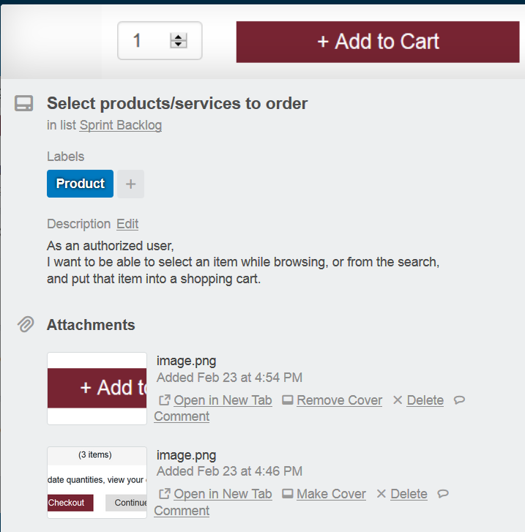

Additional user-centric details added for developers during sprint planning

The original user story