Untitled

# I need a heading 1 in the document

## R Markdown

This is an R Markdown document. Markdown is a simple formatting syntax for authoring HTML, PDF, and MS Word documents. For more details on using R Markdown see <http://rmarkdown.rstudio.com>.

When you click the Knit button a document will be generated that includes both content as well as the output of any embedded R code chunks within the document. You can embed an R code chunk like this:

summary(cars)

## speed dist   
## Min. : 4.0 Min. : 2.00   
## 1st Qu.:12.0 1st Qu.: 26.00   
## Median :15.0 Median : 36.00   
## Mean :15.4 Mean : 42.98   
## 3rd Qu.:19.0 3rd Qu.: 56.00   
## Max. :25.0 Max. :120.00

## Including Plots

You can also embed plots, for example:

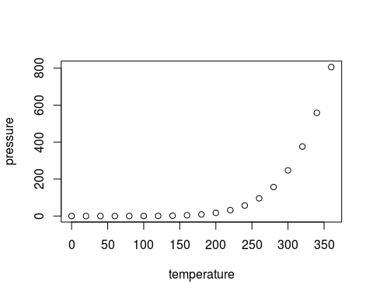

Note that the echo = FALSE parameter was added to the code chunk to prevent printing of the R code that generated the plot.

## Here's me adding a table

pander(mtcars)

|  |  |  |  |  |  |  |  |  |  |  |  |
| --- | --- | --- | --- | --- | --- | --- | --- | --- | --- | --- | --- |
|  | mpg | cyl | disp | hp | drat | wt | qsec | vs | am | gear | carb |
| Mazda RX4 | 21 | 6 | 160 | 110 | 3.9 | 2.62 | 16.46 | 0 | 1 | 4 | 4 |
| Mazda RX4 Wag | 21 | 6 | 160 | 110 | 3.9 | 2.875 | 17.02 | 0 | 1 | 4 | 4 |
| Datsun 710 | 22.8 | 4 | 108 | 93 | 3.85 | 2.32 | 18.61 | 1 | 1 | 4 | 1 |
| Hornet 4 Drive | 21.4 | 6 | 258 | 110 | 3.08 | 3.215 | 19.44 | 1 | 0 | 3 | 1 |
| Hornet Sportabout | 18.7 | 8 | 360 | 175 | 3.15 | 3.44 | 17.02 | 0 | 0 | 3 | 2 |
| Valiant | 18.1 | 6 | 225 | 105 | 2.76 | 3.46 | 20.22 | 1 | 0 | 3 | 1 |
| Duster 360 | 14.3 | 8 | 360 | 245 | 3.21 | 3.57 | 15.84 | 0 | 0 | 3 | 4 |
| Merc 240D | 24.4 | 4 | 146.7 | 62 | 3.69 | 3.19 | 20 | 1 | 0 | 4 | 2 |
| Merc 230 | 22.8 | 4 | 140.8 | 95 | 3.92 | 3.15 | 22.9 | 1 | 0 | 4 | 2 |
| Merc 280 | 19.2 | 6 | 167.6 | 123 | 3.92 | 3.44 | 18.3 | 1 | 0 | 4 | 4 |
| Merc 280C | 17.8 | 6 | 167.6 | 123 | 3.92 | 3.44 | 18.9 | 1 | 0 | 4 | 4 |
| Merc 450SE | 16.4 | 8 | 275.8 | 180 | 3.07 | 4.07 | 17.4 | 0 | 0 | 3 | 3 |
| Merc 450SL | 17.3 | 8 | 275.8 | 180 | 3.07 | 3.73 | 17.6 | 0 | 0 | 3 | 3 |
| Merc 450SLC | 15.2 | 8 | 275.8 | 180 | 3.07 | 3.78 | 18 | 0 | 0 | 3 | 3 |
| Cadillac Fleetwood | 10.4 | 8 | 472 | 205 | 2.93 | 5.25 | 17.98 | 0 | 0 | 3 | 4 |