



[Customer Name]
[Opp Name]

Date: | 00/00/00
Version: | 0.1
Author: | Joe Bloggs
Opp #: | OPP12345

LOW LEVEL DESIGN
Table of Contents

1 ! Read Me First 3
1.1 ! Usage & Examples 3
1.2 ! Headings/Styles 3
1.3 ! Code 4
1.4 ! Tables 4
1.5 ! Mandatory Sections 4
2 Document Control 5
2.1 Revision History 5
2.2 Document Approval 5
3 Design Decisions 6
4 Introduction 6
5 Appendices 8
5.1 Key Terminology 8
5.2 Referenced Documents 9
6 Sign Off, Design 10

! Read Me First
Section 1 and all subsections can be deleted once you’re done with it.
Comments in yellow else where in this document should be deleted prior to using it.

This document template has been created to provide a base from which low level design documentation can be created. The technical content, headings and overall layout are up to the individual team using this document to configure as it is impossible to create a single document which would fulfil all these requirements.

Where sections are included, they should be considered mandatory. We have tried to keep these sections to a minimum as well as keeping them as clear and concise as possible.

Any sections prefixed with a “!”should be deleted prior to use.

Contributors
If you have any questions regarding this document, feel free to reach out to anyone on this list:

- Jamie Rowe – Principal Technical Consultant, Cloud
- Aseem Khan- Principal Technical Consultant, Networking & Security
- Stephen Kirby – Technical Delivery Manager, Integrated Technical Consultancy
- Aleks Zarubica – Senior Technical Consultant – Modern Workspace
- Mark Major – Senior Technical Consultant, Hybrid Platforms
- Neil Walters – Consultancy Manager, Cloud
- Roy Blakemore – Principal Technical Consultant, Hybrid Platforms

! Usage & Examples
- Standard font is Calibri for all headings and text. Size 11
- All text is either black or Grey (Black Text, Lighter 25%)
- All the ‘red’ within the document uses the CDW standard colour (HEX cc0000) or R:80 G:0 B:0

! Headings/Styles
Headings have been configured seven levels deep using the built in styles. All display on the contents page.

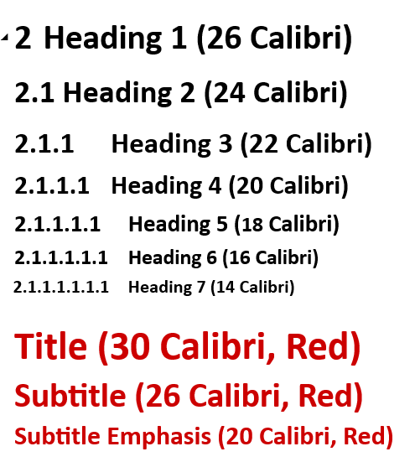

! Code
Code can be represented using the ‘Code’ style however this is not mandatory. Better solutions are available

resource "azurerm_windows_function_app" "monitor" {
# Configuration settings for the resource
attribute1 = value1
attribute2 = value2
# ...
}

! Tables
Vertical and horizontal table styles are available for use. Again, these can be modified to suit but examples are shown below.

Styles are already defined but in summary:
- Outline is dark grey
- Text is Calibri, white, size 11 for headers, Grey (Black Text, Lighter 25%)
- Outline is (Black Text, Lighter 25%)

Table design can be found here:

Name | Organisation | Title | Version | Date | Approval Type
Table 1 Vertical Table
Resource Name | Example
Subscription | Example
Region | Example
Tags | Example
Table 2 Horizontal Table

! Mandatory Sections
Section 2 onwards within this document outlines the mandatory sections required. These sections are considered mandatory from a governance/document management perspective and do not include reference to each teams own ‘mandatory’ design sections which will differ per team.

Examples are given for each of the sections.

Document Control

Revision History
Version | Date | Author | Description
1.0 | 00/00/00 | Joe Bloggs | Example description of document

Document Approval
This is internal approvals/approvers (e.g. peer review)
Approver | Title | Approval Type | Document Version
Joe Bloggs | Consultant | Technical | 1.0

Introduction
This section should introduce the project, how the solution came to be, what it does etc.

Design Decisions
Note: This section was created to consolidate the various types of decision/requirements sections we have had in previous documents as feedback was, they are difficult to fill out as they can be quite ambiguous.

We hope to standardise this section so it follows a similar format in other documentation (e.g. high level design/proposal documents) but this has not been completed yet

Reference | Type | Description
 | Business | System should have an availability SLA of 99.95%
 | Business | The solution should support key business applications as listed in <insert location>
 | Technical | Servers should run Windows Server 2022
 | Technical | SMTP port 25 must be open for email relay within Azure

Design
This section is to be used for design content as per individual team templates/standards

Appendices

Key Terminology
This section should be tweaked to include relevant terminology for your design. Anything irrelevant should be removed. This shouldn’t be 20 pages long and include every technology we currently sell

Acronym | Meaning
VM | Virtual Machine
VNET | Virtual Network
NSG | Network Security Group
SQL DB | SQL Database
AKS | Azure Kubernetes Service
ADF | Azure Data Factory
ADLS | Azure Data Lake Storage
CDN | Content Delivery Network
ARM | Azure Resource Manager
BLOB | Binary Large Object Storage

Referenced Documents
In portrait to allow ease of reading but can be put in landscape if required. Documents can be imbedded here but as most documents end up being converted to PDF it probably is of little benefit to the customer.

Title | Description | Path/URL/Location
What is an Azure landing zone? | Describes Azure Landing zone key terminology. | https://learn.microsoft.com/en-us/azure/cloud-adoption-framework/ready/landing-zone

Approval to Proceed
IMPORTANT: By electronically signing in the box below, you confirm your approval to proceed with the deployment based on the contents of this design document. You understand that this document may be updated as new information becomes available, and all changes will be managed through the agreed change control methods.

Client Company Name: [Customer Name]
Client Registered Company Number: [Client Company No]
Client Registered Address: [Client Address]

Client: | [NAME]
Signature (Authorised Signatory) | {{cby_es_:signer1:signature}}
Name | {{cname_es_:signer1:fullname}}
Title | {{ctitle_es_:signer1:title}}
Date | {{cdate_es_:signer1:date}}

Final Sign Off
IMPORTANT: You acknowledge, agree and accept that by electronically signing in the box below, that: (i) you acknowledge that this is the final version of the design (ii) agree that the configuration is fully complete and tested in accordance with the agreed test plan; and (iii) you affirmatively agree to sign by way of electronic signature, which shall be fully and legally binding.

Client Company Name: [Customer Name]
Client Registered Company Number: [Client Company No]
Client Registered Address: [Client Address]

Client: | [NAME]
Signature (Authorised Signatory) | {{cby_es_:signer1:signature}}
Name | {{cname_es_:signer1:fullname}}
Title | {{ctitle_es_:signer1:title}}
Date | {{cdate_es_:signer1:date}}

