**环境准备 阿里源**

sudo apt update

sudo apt install -y libopencv-dev

sudo apt install -y build-essential cmake git pkg-config

sudo apt install -y libgstreamer1.0-dev libgstreamer-plugins-base1.0-dev gstreamer1.0-rtsp

sudo apt install meson ninja-build

sudo apt-get install libgstreamer-plugins-bad1.0-dev gstreamer1.0-plugins-base gstreamer1.0-plugins-good gstreamer1.0-plugins-bad gstreamer1.0-plugins-ugly gstreamer1.0-libav gstreamer1.0-tools gstreamer1.0-x gstreamer1.0-alsa gstreamer1.0-gl gstreamer1.0-gtk3 gstreamer1.0-qt5 gstreamer1.0-pulseaudio

gst-inspect-1.0 --version gst-inspect-1.0 version 1.20.3 GStreamer 1.20.3

cd gst-plugin/src

创建两个文件：gstundistort.c 和 gstundistort.h

../tools/make_element Undistort gsttransform

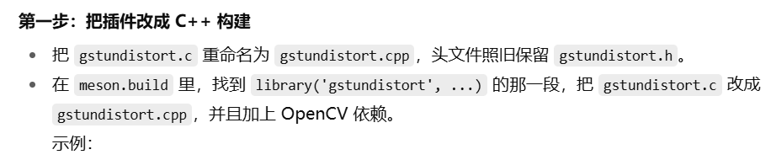

顶层 meson.build 需要把语言从 'c' 扩成 ['c','cpp']

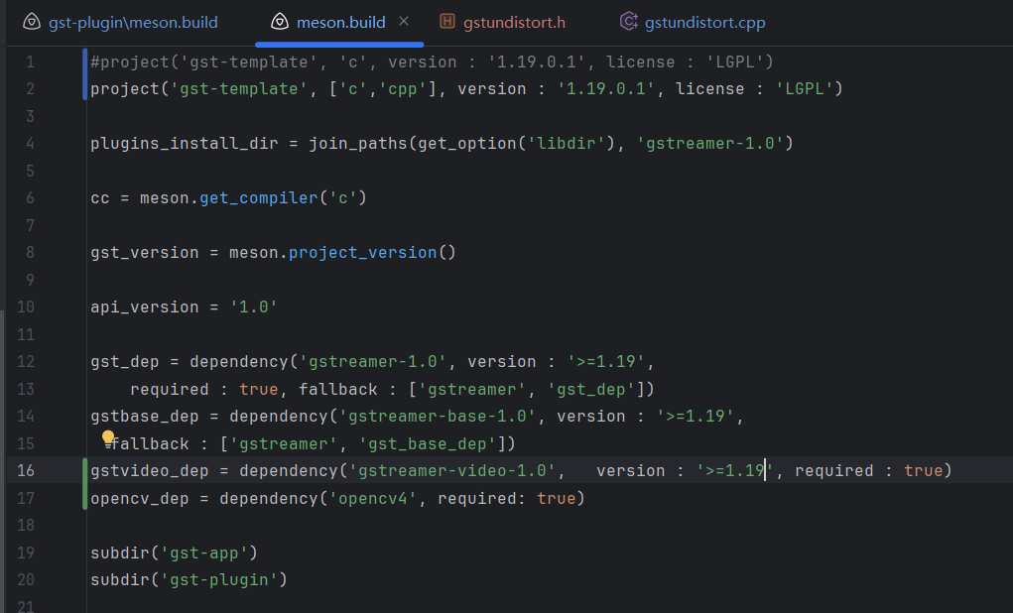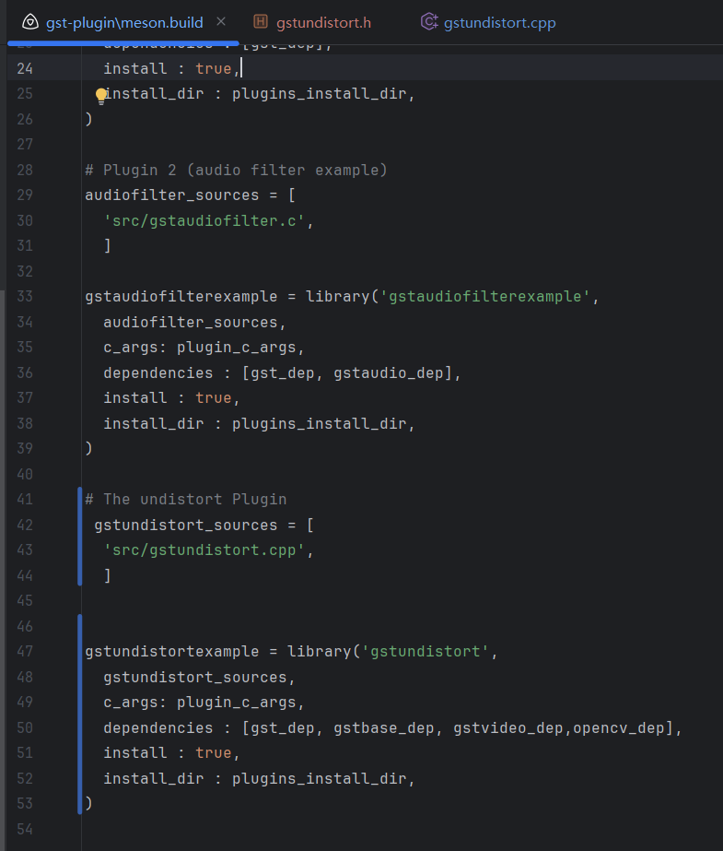

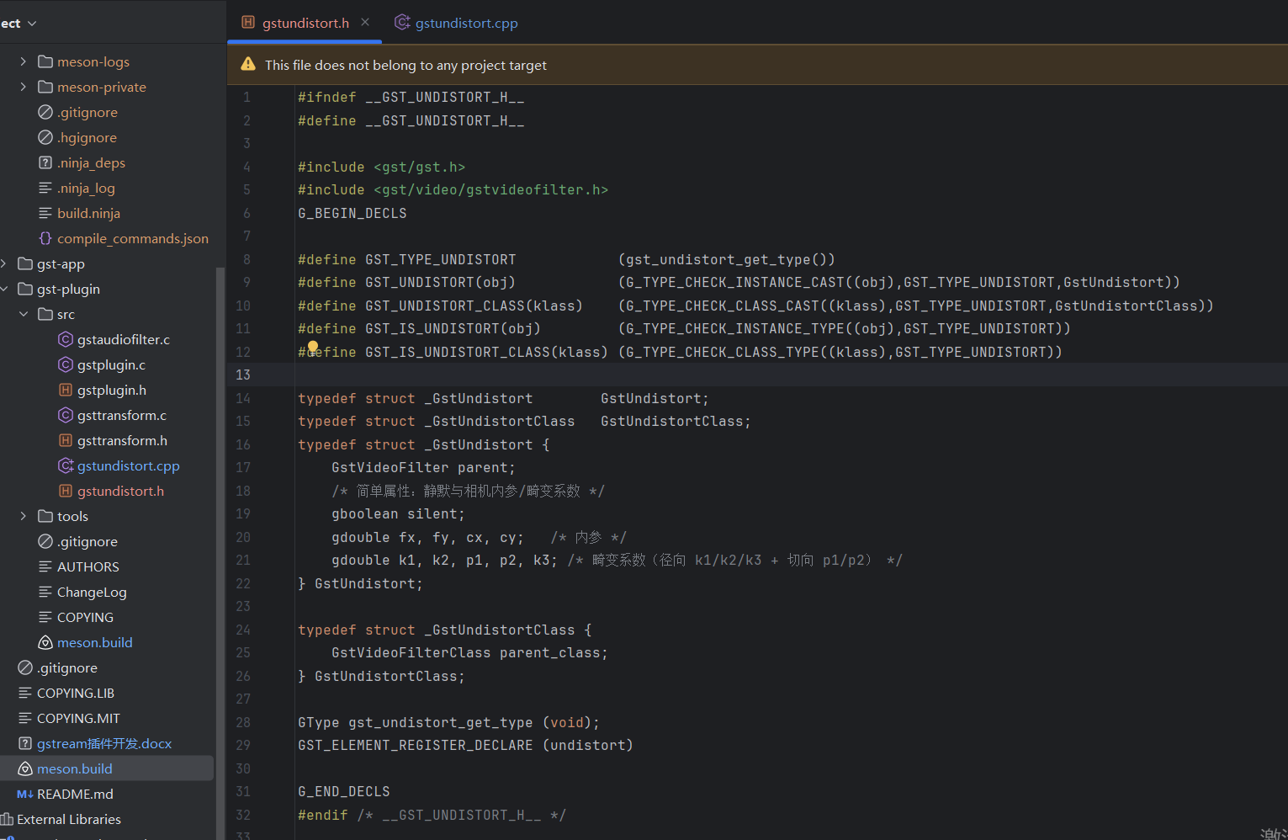

在工程根目录新建构建目录 meson builddir

编译 ninja -C builddir

编译出来的插件 .so 文件 看能不能被 GStreamer 识别：

gst-inspect-1.0 builddir/gst-plugin/libgstundistort.so

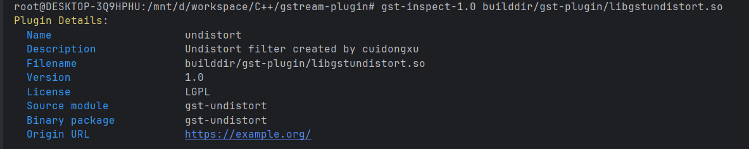

然后转移到到系统目录：

sudo cp builddir/gst-plugin/libgstundistort.so /usr/lib/x86_64-linux-gnu/gstreamer-1.0/

全局可用 gst-inspect-1.0 undistort

实际机器狗推流：

cd /opt/robot/scripts/board_resources/rtsp_service

sudo ./mediamtx &

#!/bin/bash

sleep 3

sudo gst-launch-1.0 v4l2src device=/dev/video0 ! image/jpeg, width=1280, height=720, framerate=30/1 ! jpegdec ! videoconvert ! mpph265enc rc-mode=0 bps=1800000 bps-max=2000000 qp-min=12 qp-max=45 ! rtspclientsink location=rtsp://127.0.0.1:8554/video1 latency=10

笔记本去畸变推流（1、软编码。2、在 undistort 前面加 videoconvert ! video/x-raw,format=BGR，确保输入格式符合 undistort 的要求。3、在 undistort 后面再加一次 videoconvert，把 BGR 转换回编码器能接受的格式（通常 YUV））

sudo gst-launch-1.0 v4l2src device=/dev/video0 ! image/jpeg,width=1280,height=720,framerate=30/1 ! jpegdec ! videoconvert ! video/x-raw,format=BGR ! undistort fx=619.97674 fy=625.27679 cx=586.32027 cy=339.90312 k1=-0.291149 k2=0.057760 p1=-0.006811 p2=0.001601 k3=0.0 ! videoconvert ! x265enc bitrate=1800 speed-preset=ultrafast tune=zerolatency ! rtspclientsink location=rtsp://127.0.0.1:8554/video1 latency=10

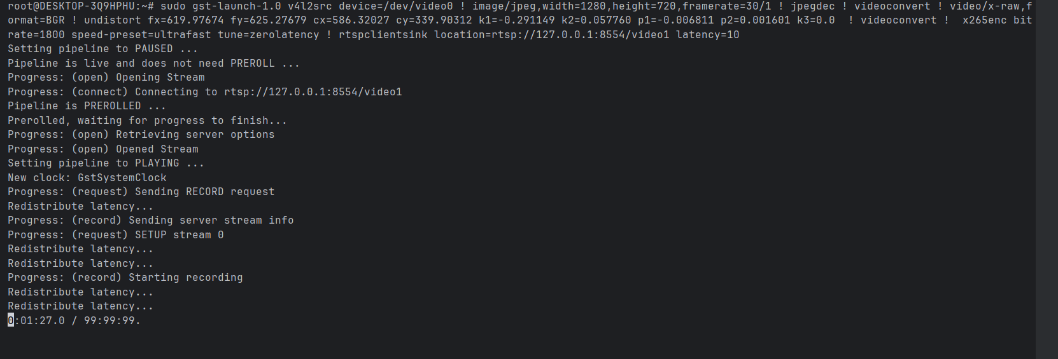

拉流

gst-launch-1.0 -v rtspsrc location=rtsp://172.23.48.48:8554/video1 ! rtph265depay ! h265parse config-interval=1 ! avdec_h265 ! videoconvert ! video/x-raw,format=BGR ! queue max-size-buffers=5 max-size-bytes=0 max-size-time=50000000 leaky=downstream ! autovideosink sync=false

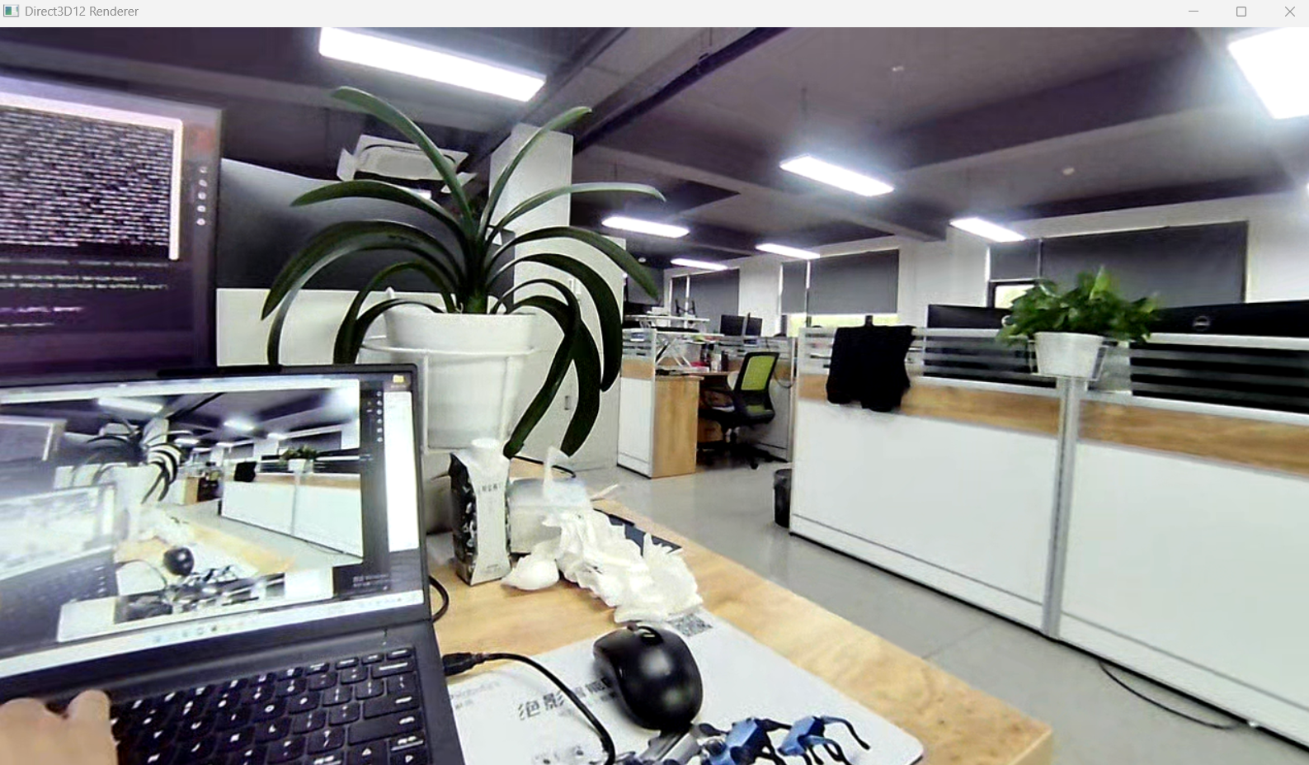

用gstream api代码形式拉流：

