How program count?

First, you should open Disassembly, Memory, Register and Local.

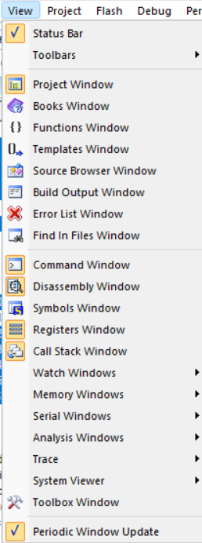

Disassembly: It’s place where you can see your code actually process.

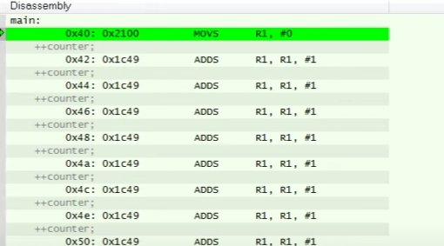

Disassembly and Memory have involved each other.

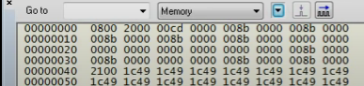

The address 0x04 which in Disassembly table is equivalent 00000040 in Memory table. As you can see, in Memory table the addresses will be separated.

The current green line is displaying for them knowing the program where is it.



The PC is holding locating of instruction when instruction is running in program.

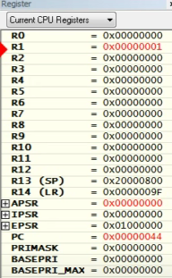

In Stm32, they have 16 registers. It’s equal each register has 32bits data. As you can see, when instruction is running and R1 will be change data. Data will be increment in example.

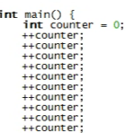

The Table locals will show you seeing the value of variable will be increment with the same position.

