4. Bài tập về this that these those

Bài tập

Bài tập 1: Điền đại từ chỉ định vào ô trống sao cho phù hợp nghĩa nhất
- ………………. shirt looks great. (That, Those)
- ………………. is a beautiful day today. (That, This)
- Look at ………………. man over there. (this, that)
- Do you like ………………. Flowers? (that, those)
- I love ………………. shoes but I don’t like ………………. Shirt. (these, that), (those, that)
- What are the answers to ………………. uestions? (this, these)
- Let’s watch a movie. – ………………. a good idea. (This is, That’s)
- This book isn’t very good , but ………………. book’s great.
- Whose house is ………………. (those, that)

Bài tập 2: Điền vào chỗ trống sử dụng this/that/these/those để hoàn thành các câu bên dưới
- Can you bring me ____magazine, I want to read it before I go to bed.
- My mother likes____ vase, the one over there. She said she bought it at the bazaar.
- ____batteries in my hand are the most powerful.
- I never liked____ silk flowers, the ones they sell on the bridge.
- ____are my children’s toys, I am surprised they are in that basket.
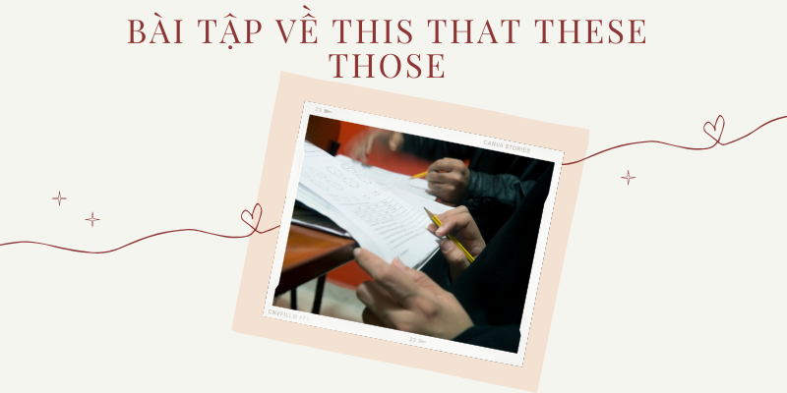Bài tập về this that these those
- Here, take____ pill and you will feel better by the morning.
- It’s very delicious! In fact,__ is the best spaghetti I have had in my life.
- Take the wheel, I am going to take a look at____ noise in the back.
- ____shoes are so old, I didn’t even know they were there.
- I don’t feel comfortable at ____place, I think I will go home.
Xem thêm: Nắm ngay bài tập sắp xếp trật tự từ trong câu tiếng Anh

Bài tập 3: Chuyển đổi từ dạng số ít sang số nhiều hoặc số nhiều sang số ít như trong các ví dụ dưới đây
- Is this bed comfortable?
- Is that Eleni’s English book?
- These are not my toys.
- These boxes are Ana’s.
- Is that jacket Roy’s?
- Are these dictionaries Andre’s?
- Those are mine.
- This building is very old.
- This is a good exercise.
- These are the old dresses.

Bài tập 4: Một số bài tập minh hoạ
- Can you bring me ____magazine, I want to read it before I go to bed.
- My mother likes____ vase, the one over there. She said she bought it at the bazaar.
- ____batteries in my hand are the most powerful.
- I never liked____ silk flowers, the ones they sell on the bridge.
- ____are my children’s toys, I am surprised they are in that basket.
- Here, take____ pill and you will feel better by the morning.
- It’s very delicious! In fact,__ is the best spaghetti I have had in my life.
- Take the wheel, I am going to take a look at____ noise in the back.
- ____shoes are so old, I didn’t even know they were there.
- I don’t feel comfortable at ____place, I think I will go home.

Bài tập 5: Chia động từ thích hợp vào chỗ trống
- Those woman _ (tobe) are professors.
- __ (tobe) that your sister over there?
- Those cherries __ (tobe) very delicious.
- That book _ (not/tobe) very interesting.
- __(tobe) these what you mean?
- __ (belong) to the Shawn?
- Those __ (tobe) my favourite foods.
- That __ (tobe) very cheap clothe.
- Who __ (live) in this house with you?
- Those __ (tobe) my best friends Lin and Frank.

Bài tập 6: Sắp xếp thành các câu hoàn chỉnh
- What/this/is?Is/teacher/that/her?
- Salim/song/this/likes.
- Now/about/that/of/him/new/girlfriend/me/tell.
- If/we/on/hard/to/football/goes/raining/’ll/it/that/play.
- This/ball/his/that/is/ball/over/is/in/over/hand/and/there/his.
- These/Jack’s/those/friends/there/and/are/my/over/are/over.
- That/door/asked/she/windows/knocked/new/guy/the/and/want/on/if.
- is/good/her/idea/this/a/essay/for.
- Sam/bananas/enjoys/with/chocolates/really/these.

Bài tập 7: Tìm và sửa lỗi sai (nếu có)
- This are my best friend Sunny playing tennis in the garden.Is those her notebooks over there on the table?
- Who was these men you talked to last night?
- Do you think that seventeen grammar questions are very easy or difficult?
- This bananas are yellow, but those bananas over here are green.
- Take one of that books from this pile.
- Everyone does it this days.
- She is leaving those Monday.
- Waiter, I think these wine is off.
- Is those restaurant delicious?
- Aren’t this your friend Nicky?
- Gray is right, those is the best thing to do when he has a decision to make.
- Jin is so realistic. These is why she love his drawing.

Bài tập 8: Sắp xếp các từ sau thành câu hoàn chỉnh
- digital/ is/ camera/ that/ Mai’srulers/ those/ my/ are/ new
- my/ paper/ These/ new / are/ books
- black/ These/ are/ shoes
- brother/ there/ Is/ your/ that/? / over
- beautiful/ are/ flowers/ Those
- dog/ intelligent/ Hoa’s / is
- this/ beautiful/ ?/ Is/ picture/ so

Bài tập 9: Hoàn thành với minh chứng phù hợp
- (Talking about a book in your hand) How could you buy something like_____________________?
- (With a bowl of cherries on your lap)_____________________cherries are delicious!
- (During a long walk) I should have worn_____________________shoes I bought in Greece last year;_____________________have never been comfortable.
- Could you bring me_____________________book I left in the garden?
- (From the marriage vows) To have and to hold from_____________________day forward.
- I hate_____________________books which tell you: “_____________________is what you have to do to become rich.”.
- (About a picture hanging on the wall)_____________________are my children.
- (About a picture you’ve just taken from your wallet)_____________________is my wife.

Bài tập 10: Hoàn thành câu với that, those, this or these
- Waiter, I’m sorry to say it but_____________cake you have just served me is awful.
- I met him two five hours ago_____________morning.
- Look at_____________kids playning in the garden over there; they’re so cute.
- Take one of_____________files from that table.
- He was sitting on_____________rocking chair he had bought from the flea market.
- Many parents complain about their children_____________days.
- Are you leaving_____________weekend?
- The jeans you have bought today are better than_____________you bought last month.
- We used to do it differently in_____________days
- You know the books I am carrying are just fantastic. I think_____________books will keep me company during this summer holiday.
Xem thêm: Trọn bộ bài tập thì tương lai hoàn thành

Đáp án

Bài tập 1
1. That | 2. This | 3. That | 4. Those | 5. These/that | 6. These | 7. That | 8. That | 9. That’s

Bài tập 2
1. That | 2. That | 3. These | 4. Those | 5. Those
6. This | 7. This | 8. That | 9. Those | 10. This

Bài tập 3
- Are these beds comfortable
- Are those Eleni’s English books
- This is not my toy
- This box is Ana’s
- Are those jackets Roy’s
- Is this dictionary Andre’s
- That is mine
- Those buildings are very old
- These are good exercises
- This is the old dress

Bài tập 4
1. That | 2. That | 3. These | 4. Those | 5. Those
6. This | 7. This | 8. That | 9. Those | 10. This

Bài tập 5
- are (vì danh từ số nhiều)
- is (vì danh từ số ít)
- are (vì danh từ số nhiều)
- isn’t (vì danh từ số ít)
- are (vì danh từ số nhiều)
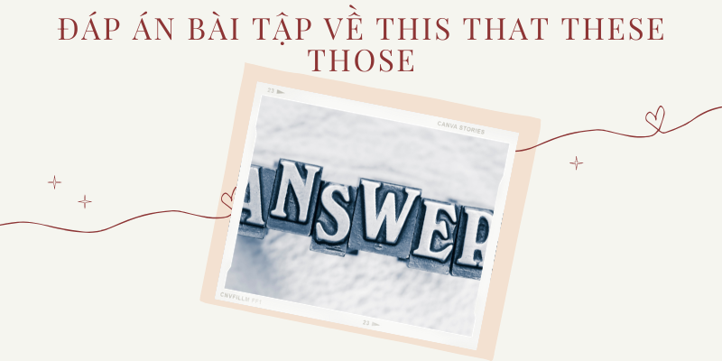Đáp án bài tập về this that these those
- Does…belong (vì danh từ số ít)
- are (vì danh từ số nhiều)
- is (vì danh từ số ít)
- lives (vì danh từ số ít)
- are (vì danh từ số nhiều)

Bài tập 6
- What is this?
- Is that her teacher?
- Salim likes this song.
- Now tell me that new girlfriend of him.
- If it goes on raining that hard, we’ll have to play football.
- This is his ball in his hand and that is my ball over there.
- These are Jack’s friends and those are my friends over there.
- That guy knocked on the door and asked if she want new windows.
- This is a good idea for her essay.
- Sam really enjoys those chocolates with bananas.

Bài tập 7
1. are ➔ is (vì best friend là dnah từ số ít)
Correct: This is my best friend Sunny playing tennis in the garden.
2. Is ➔ Are (vì notebooks là danh từ số nhiều)
Correct: Are those her notebooks over there on the table?
3. these ➔ this (vì men là dnah từ số ít)
Correct: Who was this men you talked to last night?
4. that ➔ those (vì questions là danh từ số nhiều)
Correct: Do you think those seventeen grammar questions are very easy or difficult?
5. This ➔ These (vì bananas là danh từ số nhiều)
Correct: These bananas are yellow, but those bananas over here are green.
6. that ➔ those (vì books là danh từ số nhiều)
Correct: Take one of those books from this pile.
7. this ➔ these (vì days là danh từ số nhiều)
Correct: Everyone does it these days.
8. those ➔ that (vì Monday là danh từ số ít)
Correct: She is leaving that Monday.
9. these ➔ this (vì wine là danh từ số ít)
Correct: Waiter, I think this wine is off.
10. those ➔ that (vì restaurant là danh từ số ít)
Correct: Is that restaurant delicious?
11. Aren’t ➔ isn’t (vì friend là danh từ số ít)
Correct: Isn’t this your friend Nicky?
12. those ➔ that (vì thing là danh từ số ít)
Correct: Gray is right, that is the best thing to do when he has a decision to make.
13. These ➔ this (vì điều được nói đến là số ít)
Correct: Jin is so realistic. This is why she love his drawing.

Bài tập 8
- That is Mai’s digital camera.
- Those are my new rulers.
- These are my new paper books.
- These shoes are black.
Or: Those are black shoes.
- Is that your brother over there?
- Those flowers are beautiful.
Or: Those are beautiful flowers.
- Hoa’s dog is intelligent.
- Is this picture so beautiful?

Bài tập 9
- (Talking about a book in your hand) How could you buy something like this?
- (With a bowl of cherries on your lap) These cherries are delicious!
- (During a long walk) I should have worn those shoes I bought in Greece last year; these have never been comfortable.
- Could you bring me that book I left in the garden?
- (From the marriage vows) To have and to hold from this day forward.
- I hate those books which tell you: ” this is what you have to do to become rich.”.
- (About a picture hanging on the wall) those are my children.
- (About a picture you’ve just taken from your wallet) This is my wife.

Bài tập 10
- Waiter, I’m sorry to say it but this cake you have just served me is awful.
- I met him two five hours ago this morning.
- Look at those kids playning in the garden over there; they’re so cute.
- Take one of those files from that table.
- He was sitting on that rocking chair he had bought from the flea market.
- Many parents complain about their children these days.
- Are you leaving this weekend?
- The jeans you have bought today are better than those you bought last month.
- We used to do it differently in those days
- You know the books I am carrying are just fantastic. I think these books will keep me company during this summer holiday.

Bài 1: Đặt câu hỏi cho phần gạch chân dưới đây
1.My younger sister is five years old.2. Lan often goes to school by bike.3. Lisa is doing her homework at the moment.4. Xuan gave me an interesting book on my birthday.5. Her voice is so beautiful and sweet.6. I won the first prize in a competition last year.7. My mother is in Ha Noi at the moment.8. Lan was absent from school because she was sick.9. The questions in this examination are so difficult.10. They often go to the beach every summer holiday.11. The teacher was so angry because a half of the class didn’t do their homework.12. Jin often plays soccer every afternoon after school with his friends.13. Phuong is the best student in my class.14. There are two books and two pens on the table.15. They are planting some roses in the garden.16. Nam often watch TV 3 hours a day.17. Duc often visits his grandparents on the weekend.18. I stayed in Korean for five months.19. Trang bought a half kilo of cheese yesterday.20. It usually takes us fifteen minutes to get to school on foot.
Bài 2: Chọn đáp án thích hợp điền vào chỗ trống
1.______ school do you go to? -I study at Hai Ba Trung secondary school.
- What
- When
- Which
- Where
2. _____ do you live? -I live in Ha Noi.
- When
- Where
- How
- What
3. ______ is Lan's birthday? -Next Friday.
- When
- What
- Which
- Where
4.______ did you go last night? -I visited my grandfather's house.
- When
- What
- Where
- Which
5. _____ is your favourite subject? -Math.
- What
- How
- Which
- When
6. _____ did she go to the hospital? -Because she was sick.
- When
- How
- What
- Why
7. ______ will you come back to school? -Maybe the 1st of August.
- How
- When
- Where
- What
8. ______ pens are there on the table? -Two
- How
- How many
- How often
- How long
9. ______ is it from your house to school? -About five kilometres.
- How often
- How many
- How far
- How
10. ______ do you feel? -I’m a bit tired.
- How
- What
- When
- Which
11. _____ did Ha fail the exam? -Because she didn’t study the lessons carefully
- What
- Where
- Why
- How
12. _____ do you often go to school? -By bike.
- What
- How
- When
- Which
13. ______ do you usually do in the evenings?
-I often go out with my friends or watch TV at home.
- Which
- When
- How
- What
14. _____ did you buy this lovely dress?
-The shop at 135 Le Hong Phong Street.
- How
- What
- Where
- When
15. ______ does the bank close?
-About 5pm.
- When
- What
- Which
- Where
16. _______ is the test today?
-It is rather difficult. But I did it well.
- What
- Which
- When
- How
17. ______ do you live with?
-I live with my parents.
- What
- When
- Who
- Where
18. ______ are your hobbies?
-I like reading and drawing
- Which
- How
- Where
- What
ĐÁP ÁN
Bài 1:
1.How old is your younger sister?
2. How does Lan often go to school by bike?
Giải thích: Khi muốn hỏi về phương tiện, ta dùng ‘How+ trợ động từ+ chủ ngữ+ động từ’
Ví dụ: Bố bạn đi làm bằng phương tiện gì?
=> How does your father get to work?
3. What is Lisa doing at the moment?
4. What did Xuan give you on your birthday?
5. How is her voice?
6. When did you win the first prize in a competition?
7. Where is your mother at the moment?
8. Why was Lan absent from school?
9. How are the questions in this examination?
10. Where do they often go every summer holiday?
11. Why was the teacher so angry?
12. Who does Jin often play soccer every afternoon after school?
13. Who is the best student in your class?
14. How many books and pens on the table?
15. How many roses are they planting in the garden?
16. How often does Nam often watch TV?
17. Who does Duc often visit on the weekend?
18. How long did you stay in Korea?
19. When did Trang buy a half kilo of cheese?
20. How long does it usually take us to get to school on foot?
Bài 2:
- C
- B
- A
- C
- A
- D => Trong câu trả lời có từ ‘ Because’ nên ta dùng từ để hỏi ‘ Why’ để hỏi lý do, nguyên nhân.
- B
- B
- C
- A
- C
- B
- D
- C
- A
- D
- C
- D

