Enterprise Help Desk Simulation Project
Cornel Davis
A practical portfolio guide for entry level IT support
Practice the full help desk workflow: receive a request, assess its impact, verify the user, troubleshoot with delegated access, validate the result and document a clear resolution or escalation.

Project status
This is a prepared training simulation with fictional worked examples. It has not been executed in a live enterprise environment. The eight workflow snapshots are labeled illustrations, not screenshots from ServiceNow, Microsoft or Okta. Use the screenshot instructions to collect real lab evidence as you complete each procedure.

What you will build
- Eight documented support cases across ticketing, identity, productivity, endpoint and remote support workflows.
- A local Windows domain lab, plus separate cloud exercises where authorized tenant access is available.
- A ticket portfolio, three knowledge base articles and an execution log supported by your own screenshots.

Tools covered
ServiceNow ITSM • Active Directory Users and Computers • Windows 11 • Microsoft Entra ID • Microsoft 365 admin center • Microsoft Intune • Quick Assist or Remote Help • Okta
Read the setup first, complete cases 01 and 02, then add the cloud and remote-support modules. The guide references official vendor documentation checked October 26, 2026. Menus and permissions can vary by version and tenant.

Lab setup and access

Local lab
Use a virtualization host capable of running a Windows Server VM and a Windows 11 Pro or Enterprise client VM. A planning target is 16 GB host RAM and 120 GB free disk, adjusted for your host and VM settings. Allocate resources within vendor minimums. Windows Home cannot join an AD domain.

Network and domain
Create an isolated lab network. Give the server a static lab address such as 192.168.56.10/24 only if that subnet is unused. Install AD DS and DNS, promote a new forest helpdesk.test, and point the client DNS to the server. Join the client to helpdesk.test and restart. Do not expose RDP or domain services to the internet.

Test identities
Create HelpDeskLab OU, a standard user mbrooks and a lab access group. Create a separate technician account; delegate only password reset and related approved OU tasks. Keep administrator credentials separate. Take VM checkpoints before changes.

ServiceNow
Request a free Personal Developer Instance from developer.servicenow.com if available. Use incident management in the available training instance; exact navigation and enabled modules vary. Create only fictional caller and device records. Export your work because the instance is not durable evidence storage.

Cloud tenants
Use separately authorized Microsoft and Okta test environments. Entra, Microsoft 365 and Intune require relevant roles and features; service licenses may be needed. Do not assume school access includes admin rights. Use a cloud test user rather than your only administrator. If access is unavailable, complete that module as documentation only.

Remote support
Quick Assist requires two available endpoints, user consent and internet connectivity. Intune Remote Help is a separate enterprise option with its own setup and licensing. Do not describe Quick Assist as an Intune deployment.

Scope boundary
The AD domain and cloud identities are separate labs. This project does not configure hybrid synchronization, federation, a live ServiceNow integration or a production environment.

Ticket workflow and operating rules
Fictional organization: Bayou Support Services. Cornel Davis practices as a service desk technician supporting fictional users and lab devices. All written outcomes in the case files are examples to test, not completed work.
- Incident: an unplanned interruption such as a failed sign-in. Request: an approved service or access need such as a new application entitlement.
- Priority follows impact and urgency. This exercise assumes one user with no workaround is impact 3 / urgency 2 / priority 3. Actual ServiceNow matrices vary; inspect the configured result.
- New → In Progress → Resolved → Closed is the lab incident sequence. Requests may use different record types, states and approvals. Do not force request records into incident fields.
- Record internal diagnostics as work notes and user-facing updates in the appropriate public communication field. Never log passwords or authentication secrets.
- For access, record identity verification and owner approval. For remote work, record consent and the reversible change.
- Resolve only after evidence and user validation support the result. For this fictional lab, close after user confirmation; otherwise retain the appropriate pending or open state.
- For escalation, include the symptom, timestamps, device, error, checks already performed, evidence location, current owner and next user update.

Example user update
I have recorded your sign-in issue and started checking your account status. One device is affected. I will update you after the account check; if additional investigation is needed, I will route the ticket to our identity team.

Example internal work note
SIMULATED: Caller verification completed through the approved callback exercise. LAB-PC01 reports sign-in failure. No passwords collected. Account status review is next. Cause is unconfirmed. No account change has been made.

Reading the snapshots
Each snapshot shows the initial state and a target or fictional worked outcome. It is a visual explanation, not a replica of the vendor interface. Follow the steps in the actual tool and capture the requested before, action and validation screenshots.

Case 01 Ticket intake and triage
INC0010001 | ServiceNow | Fictional worked example
Maya Brooks cannot sign in to her workstation. One employee is affected and work is blocked.
Navigation: Incident > New; record caller, device, symptoms, impact and urgency.
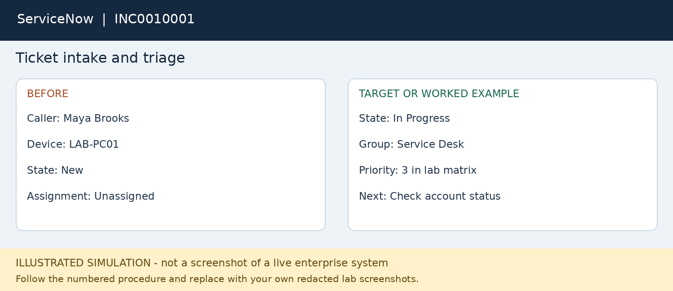
1. Record Maya Brooks, LAB-PC01, start time and exact error without recording passwords.
2. Ask whether another application works, whether coworkers are affected and what changed.
3. Set category to account access. Use impact 3 and urgency 2 for this fictional one-user outage.
4. Use the configured priority matrix; this lab assumes priority 3 for that combination.
5. Assign the Service Desk group and yourself; move the ticket to In Progress.
6. Add private work notes with the diagnostic plan; give the user a plain-language update.
7. Link the account-support procedure in case 02. Resolve only after user validation; close according to the lab closure policy.
Validate: Ticket saved with consistent categorization, ownership and a user update.
Escalate: Reopen if symptoms return. Escalate a multi-user outage to incident coordination.
Capture: Capture the saved incident and work notes; redact names outside this fictional lab.

Case 02 Password reset and account unlock
INC0010002 | Active Directory | Fictional worked example
Maya reports a forgotten domain password. Treat lockout and forgotten password as separate checks.
Navigation: Active Directory Users and Computers > lab OU > user.
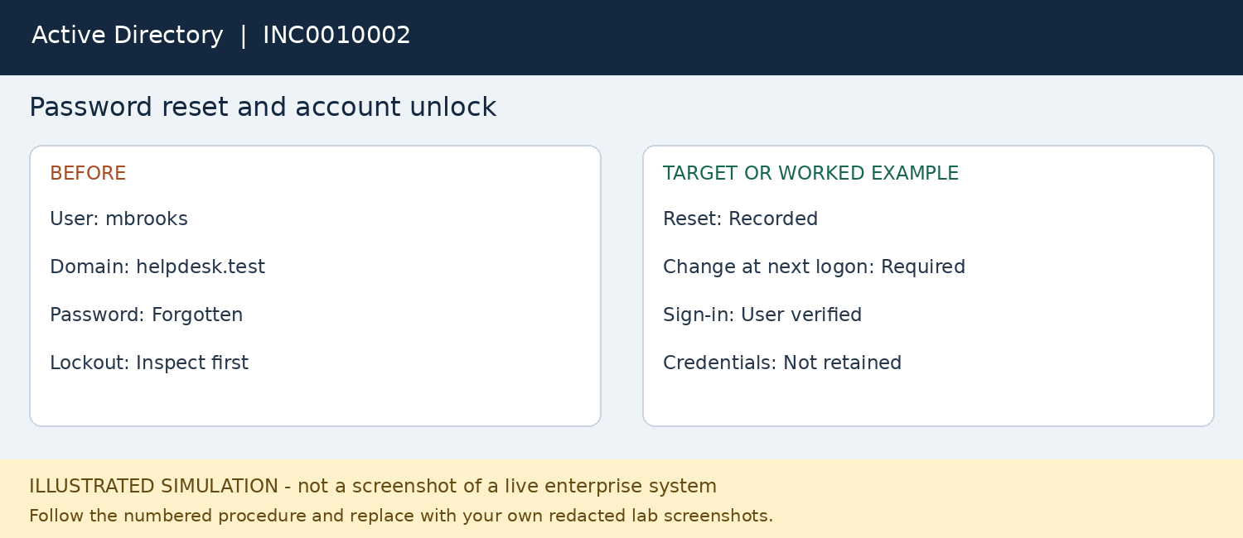
1. Verify the test user through the fictional approved callback process; document verification, not secret answers.
2. Open dsa.msc using the delegated lab support account. Locate mbrooks in the HelpDeskLab organizational unit.
3. Confirm the account identity and inspect Account properties. Unlock only if the account is locked.
4. For the forgotten-password scenario, right-click the test user and choose Reset Password.
5. Set a unique temporary lab password and require a password change at next logon. Never put it in tickets or screenshots.
6. Have the user sign in on the domain-connected client and change the password privately.
7. If repeated lockouts continue, investigate saved credentials and map the source before repeated resets.
Validate: Test user can sign in with the new password and no unnecessary access changes.
Escalate: Persistent lockouts or an unexpected account change go to the identity team.
Capture: Capture the account location, reset options without credentials, and successful test sign-in.

Case 03 MFA recovery for a replaced phone
INC0010003 | Microsoft Entra ID | Fictional worked example
Jordan Ellis has a replacement phone and cannot complete MFA in a separate cloud lab identity.
Navigation: Entra admin center > Entra ID > Users > user > Authentication methods.
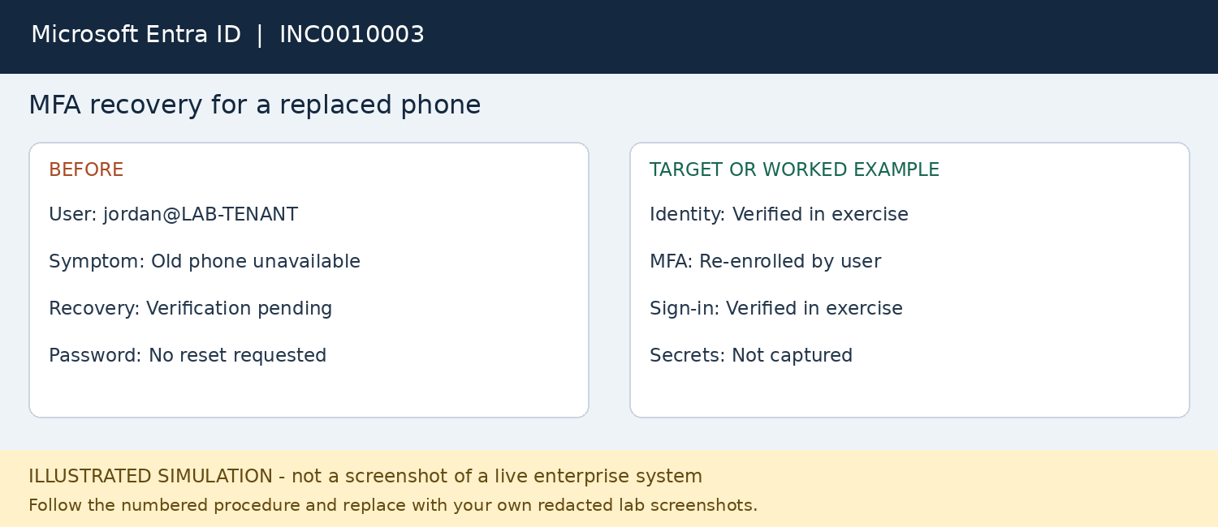
1. Verify Jordan through the approved identity-recovery process; do not accept an unsolicited MFA prompt as verification.
2. Use a delegated Authentication Administrator for an ordinary test user; do not use the tenant owner as the target.
3. Check sign-in failure details and determine whether the factor is unavailable rather than the password being wrong.
4. Review the user authentication methods and follow the tenant recovery procedure.
5. Where approved, select Require re-register MFA. Explain that this removes certain existing methods and forces setup again.
6. Use an approved bootstrap method such as a Temporary Access Pass only if enabled and authorized; do not bypass tenant policy.
7. Have the user register an allowed method, complete a new sign-in and confirm the result in sign-in logs.
Validate: User completes MFA with the new allowed method; record timestamps and relevant error details.
Escalate: Suspicious activity or inability to verify identity requires identity/security escalation.
Capture: Capture method status and sign-in outcome, never QR codes, access passes or recovery secrets.

Case 04 Missing application license
REQ0010004 | Microsoft 365 | Fictional worked example
Avery Chen is approved for Microsoft 365 but cannot open the required service.
Navigation: Microsoft 365 admin center > Users > Active users > user > Licenses and apps.
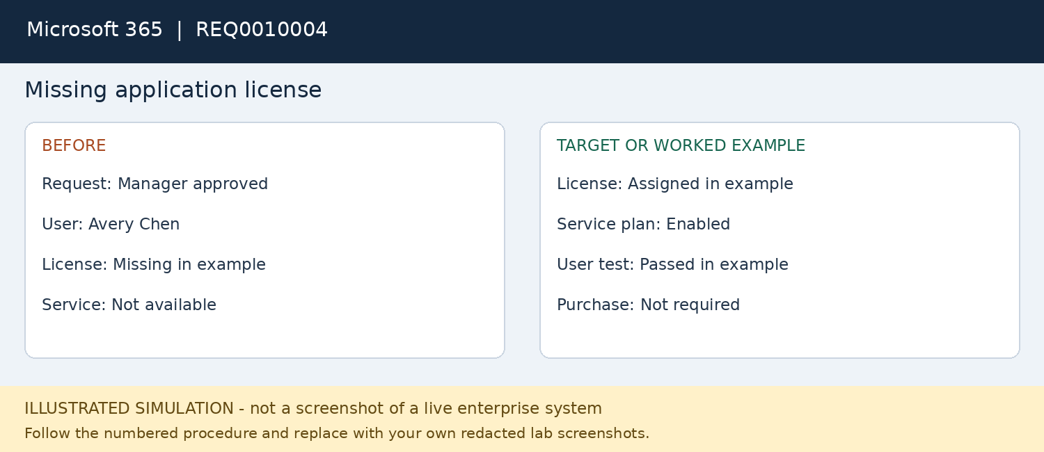
1. Open a service request and record the manager approval and requested application.
2. Verify the target cloud test account, permitted usage location and license availability.
3. Inspect Licenses and apps and distinguish an unassigned license from a disabled service plan.
4. Use an authorized User Administrator or License Administrator to assign an available approved license.
5. Enable only the approved services and save; do not buy subscriptions or add privileged roles.
6. Allow provisioning to complete, then ask the user to sign out and sign back in privately.
7. Validate the licensed service opens; record any remaining provisioning error and escalate if needed.
Validate: The approved service opens and the assignment is visible in the admin center.
Escalate: No available license, billing changes or continued provisioning failure goes to the M365 administrator.
Capture: Capture approval, license assignment without sensitive identifiers, and the user service test.

Case 05 Managed application installation failure
INC0010005 | Microsoft Intune | Fictional worked example
LAB-PC02 is enrolled but an approved required application has not installed.
Navigation: Intune admin center > Troubleshooting and support; select user and device.
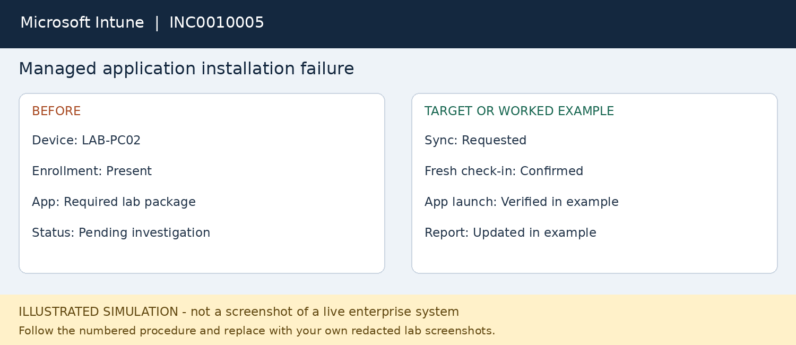
1. Record the device name, application, reported error and last successful use.
2. Check enrollment, last check-in and internet connectivity before changing anything.
3. Review the app installation status and capture the actual error code; do not guess a root cause.
4. Check assignment group, requirements and detection results with the endpoint team if access is limited.
5. For this worked example, connectivity interrupted a check-in. Restore connectivity and trigger an authorized device sync.
6. Retry the installation as applicable and wait for a fresh status; a queued sync is not proof of repair.
7. Have the user launch the app and compare the device result with Intune reporting before resolving.
Validate: Application launches and updated device/app status supports the result.
Escalate: Unclear installation code, missing deployment permissions or fleet-wide failure goes to endpoint management.
Capture: Capture original status/error, sync request, fresh status and successful app launch.

Case 06 Consent based remote troubleshooting
INC0010006 | Quick Assist | Fictional worked example
Taylor Reed needs help diagnosing slow startup on a second Windows lab device.
Navigation: Quick Assist on both devices; helper and user follow the consent prompts.
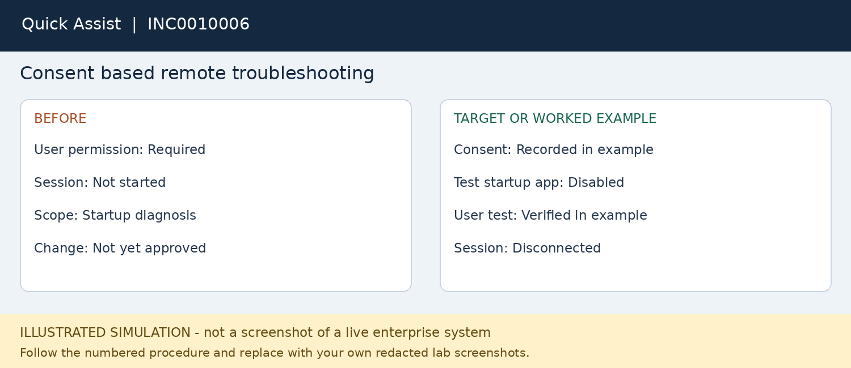
1. Verify the caller and link the remote session to the incident. Ask permission before sharing or taking control.
2. Open Quick Assist on both endpoints. The helper follows the sign-in prompts and shares the session code privately.
3. The user enters the code and approves screen sharing; request control only if needed and wait for approval.
4. Ask the user to close private content. Review Task Manager startup applications and current resource use.
5. In this lab disable only a preselected nonessential test startup application; record its original setting.
6. Have the user restart when convenient and compare the observed startup behavior; restore the setting if no benefit.
7. End the session and confirm it is disconnected. Record the outcome without recording the session code.
Validate: The user confirms the test result and the remote connection is ended.
Escalate: Managed security agents and policy-controlled startup items require endpoint-team review.
Capture: Capture consent status without the code, the changed test setting and the ended session.

Case 07 Single sign on application access request
REQ0010007 | Okta | Fictional worked example
Riley Morgan can sign in to Okta but cannot see an approved test application.
Navigation: Okta Admin Console > Directory > People > user; review groups and applications.
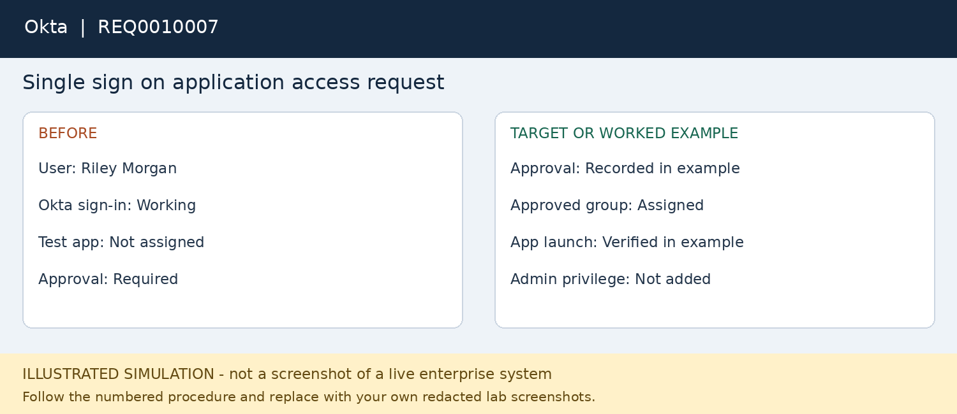
1. Record which application is missing and obtain fictional application-owner approval.
2. Confirm that the user is active and can sign in; a missing app tile is not automatically an MFA issue.
3. Review current assignments and membership of the approved lab access group.
4. Using a role permitted for the task, add the user to the correct lab group only after approval.
5. If assignment is direct, follow the application-owner procedure rather than creating duplicate access paths.
6. Ask the user to start a fresh session and launch the test application. Check assignment and any available relevant events.
7. If SSO succeeds but the app denies authorization, escalate to the application owner with the error and timestamp.
Validate: The authorized application opens with the expected non-admin access.
Escalate: Federation errors or missing downstream application entitlements require application/identity escalation.
Capture: Capture the approval, group or app assignment and successful non-sensitive app landing page.

Case 08 Escalation for repeated account lockouts
INC0010008 | ServiceNow and identity team | Fictional worked example
Maya locks out again after a previous unlock. The source has not been established.
Navigation: ServiceNow incident > Work notes > Assignment group and escalation procedure.
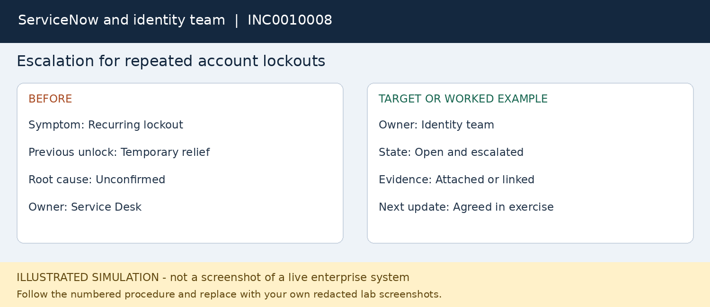
1. Reopen the linked incident or create a linked recurrence according to the lab process.
2. Record the recurrence time, affected device, error and whether the user recently changed a password.
3. Check safe client-side possibilities such as an old mapped-drive credential with user permission; do not delete all credentials blindly.
4. Gather the previous reset timestamp, reproduction steps and available event references without copying tokens or passwords.
5. Route to the identity team when domain event correlation or privileged investigation exceeds service desk access.
6. Use Pending with a clear reason if supported by local workflow, or keep In Progress with explicit new ownership.
7. Tell the user the issue has been escalated and when to expect the next update. Keep the case open until evidence supports resolution.
Validate: A complete handoff is achieved; this case is intentionally not marked resolved.
Escalate: Security indicators go to security operations; do not assert an incident without supporting evidence.
Capture: Capture the recurrence notes, new assignment and user update. Leave the result open until investigated.

Knowledge base procedures

KB01 Account recovery
Verify identity using the approved process. Determine whether the problem is lockout, password or MFA. Reset only the relevant credential or factor with delegated permissions. Deliver temporary secrets privately and require the appropriate user change or re-enrollment. Validate a fresh sign-in; escalate recurring failures.

KB02 Missing application access
Confirm the exact application and obtain owner approval. Check account status, license, assigned group and application entitlement. Grant only approved access through the established assignment path. Have the user launch the service and verify appropriate non-admin permissions. Escalate federation or downstream authorization errors.

KB03 Remote support and safe closure
Confirm the user requested help and record consent. Explain the scope and avoid private content. Inspect the symptom, make one approved reversible change and record the original setting. Verify the result with the user, disconnect the session, and document findings. Keep unresolved issues open with a named owner.

Document an actual result
For each execution, write the actual symptom, observations, action, validation and remaining risk or next step. If the predicted result does not occur, keep the case open and investigate. Replace the example cause with a confirmed cause only when evidence supports it.

Completion criteria
- The selected lab environment is documented and access is authorized.
- Each completed case has before, action and validation evidence linked to its ticket.
- The technician log distinguishes Completed, Escalated, Documentation only and Not executed.
- No sensitive data or authentication secrets appear in public files.
- Case 08 demonstrates a useful escalation; it is not counted as a resolved issue.

Screenshot capture and portfolio presentation
On Windows press Win + Shift + S, select the relevant area, save as PNG, and inspect the file before sharing. Use fictional users and redact real tenant names, identifiers and private data. Never publish passwords, MFA QR codes, access passes, tokens, recovery keys or remote session codes.
- Before: capture the original error, ticket state or assignment.
- Action: capture the relevant setting or operation without secrets.
- After: capture a validated successful test, updated status or a complete escalation.
- Name files with case and step, for example 02-03-reset-options.png; record the date, ticket, environment and observed result in completion-log.csv.
- Keep illustrations in snapshots/ and real lab captures in evidence/. Do not label an illustration as completed hands-on work.

Resume wording before execution
Developed an enterprise help desk simulation documenting ticket triage, account recovery, application access, endpoint troubleshooting and escalation workflows across ServiceNow, Active Directory and cloud administration tools.

Resume wording after verified execution
Use only modules you personally completed. Example: Practiced ServiceNow incident triage and Active Directory password recovery in an isolated Windows lab, documenting troubleshooting steps and user validation with screenshots. Add cloud tools only after you have used them.

Interview explanation
I designed this project around a typical support ticket from intake to validation. The repository separates planned procedures from work I have actually run. I can walk through my captured evidence, explain the permissions required and show when I would escalate instead of making an unsupported change.

Official references and further practice
ServiceNow PDI guide
https://www.servicenow.com/docs/r/application-development/personal_developer_instance_guide.html
ServiceNow incident management
https://www.servicenow.com/products/incident-management.html
Windows Server evaluation
https://www.microsoft.com/en-us/evalcenter/evaluate-windows-server-2025
AD user account management
https://learn.microsoft.com/en-us/windows-server/identity/ad-ds/manage-user-accounts-in-windows-server
Entra authentication method management
https://learn.microsoft.com/en-gb/entra/identity/authentication/howto-mfa-userdevicesettings
Microsoft 365 user and license setup
https://learn.microsoft.com/en-us/microsoft-365/admin/add-users/add-users?view=o365-worldwide
Intune application installation troubleshooting
https://learn.microsoft.com/en-us/troubleshoot/mem/intune/app-management/troubleshoot-app-install
Quick Assist
https://learn.microsoft.com/nl-be/windows/client-management/client-tools/quick-assist
Intune Remote Help
https://learn.microsoft.com/en-us/intune/remote-help?tabs=windows
Okta user management
https://help.okta.com/en-us/Content/topics/users-groups-profiles/usgp-people.htm
Checked October 26, 2026. These references explain product capabilities. All ticket narratives, workflow illustrations, operating assumptions and sample outcomes in this project are original fictional training content.

