**UFOs**

**Overview**

The client request was to display a table organizing UFO data stored as a JavaScript. The client desired the ability to filter by multiple criteria creating a dynamic website. The table was created using JavaScript, while HTML/CSS was used to modify the aesthetics of the website.

**Results:**

**Welcome to UFO Sightings**

[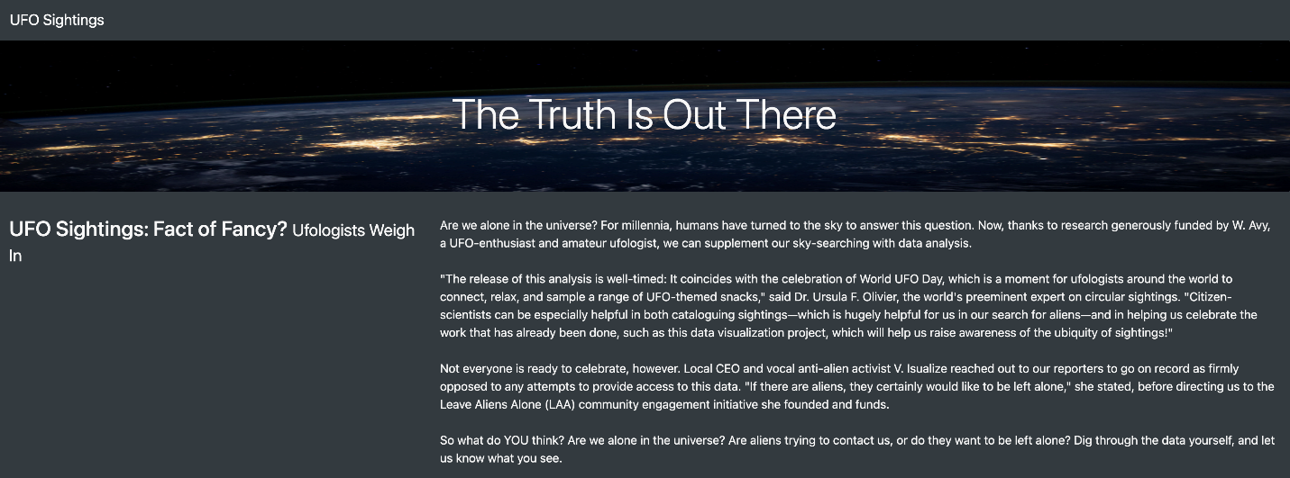](https://user-images.githubusercontent.com/104115586/181342722-9ff59987-4ab5-4e14-a1cb-3e48b91269a4.png)

How the page looks when it’s opened for the first time, filters are left blank.

[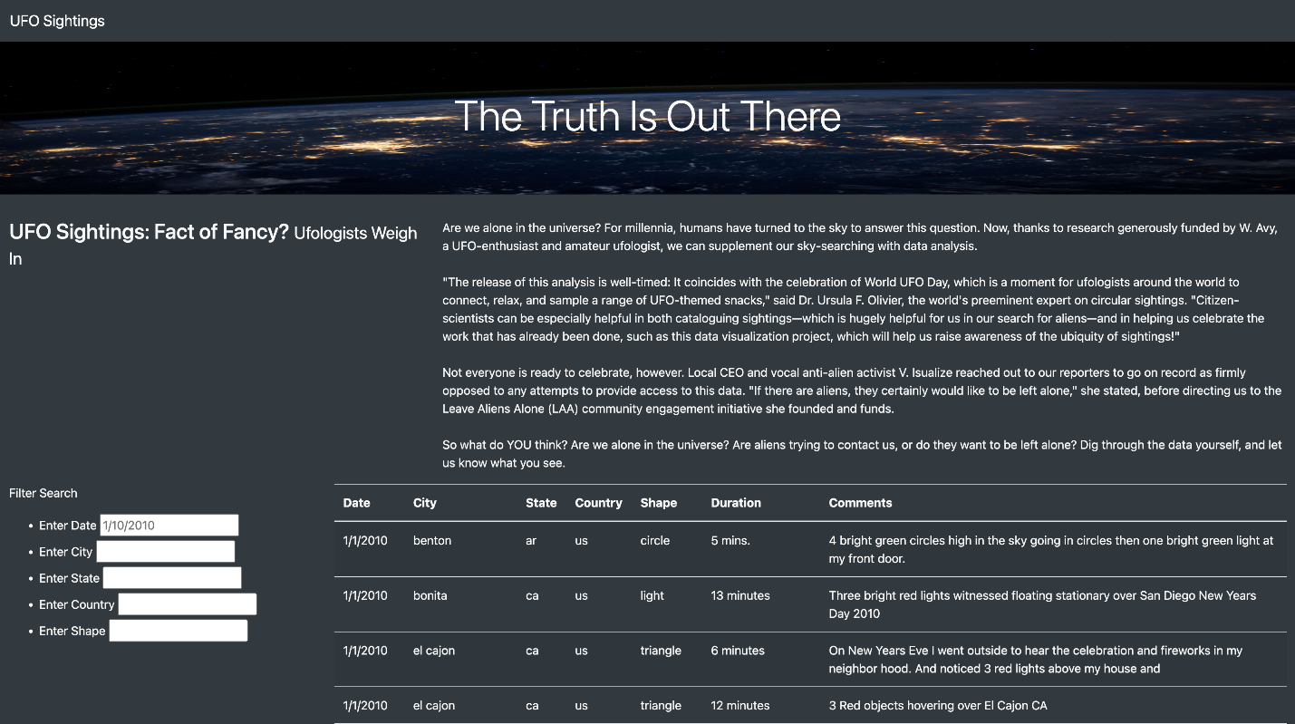](https://user-images.githubusercontent.com/104115586/181342444-df484ca0-8a8b-4a26-9339-30a2ff6159fb.png)

**How the filters appear after being used:**

By typing in the suggested credentials as the filters, the result returns matches. Make sure to type everything in lower case letters and do not have spaces at the end of the text. Click off the input box or press enter to initiate the filter. To reset the filter criteria, click the UFO Sightings at the top left of the website.

**Filtering by city.**

[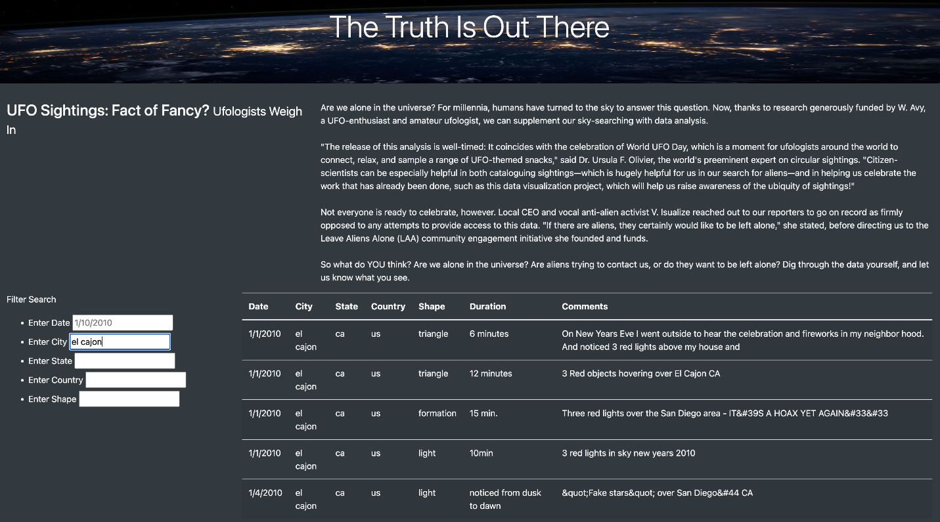](https://user-images.githubusercontent.com/104115586/181342813-73274a47-f2c8-425a-b785-0b1583bda6eb.png)

**Filtering by State**

[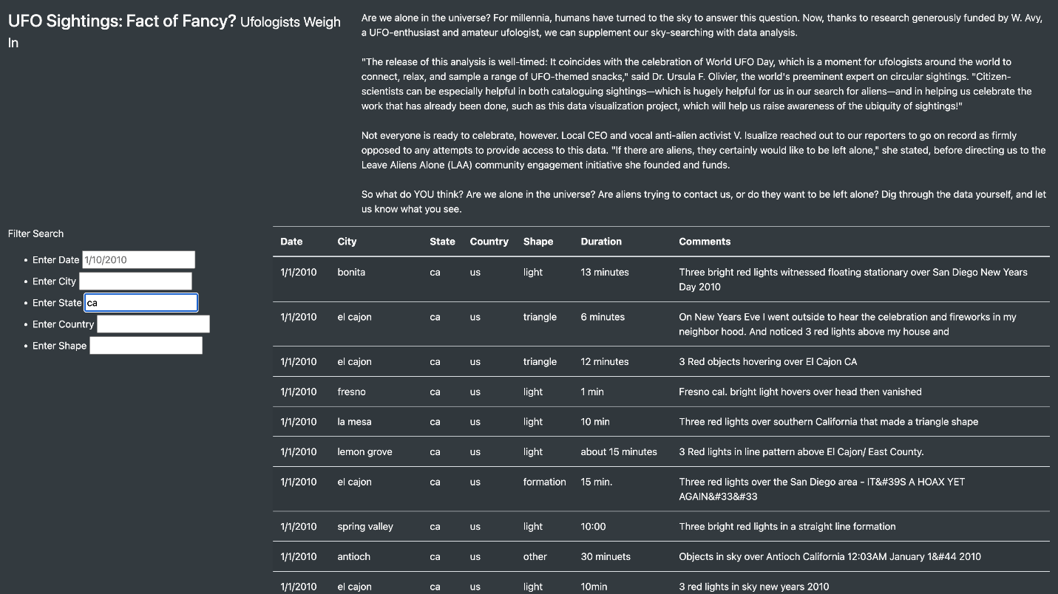](https://user-images.githubusercontent.com/104115586/181342845-58819b03-95bb-4236-b5ca-0e52f89a640b.png)

**Filtering by Country**

[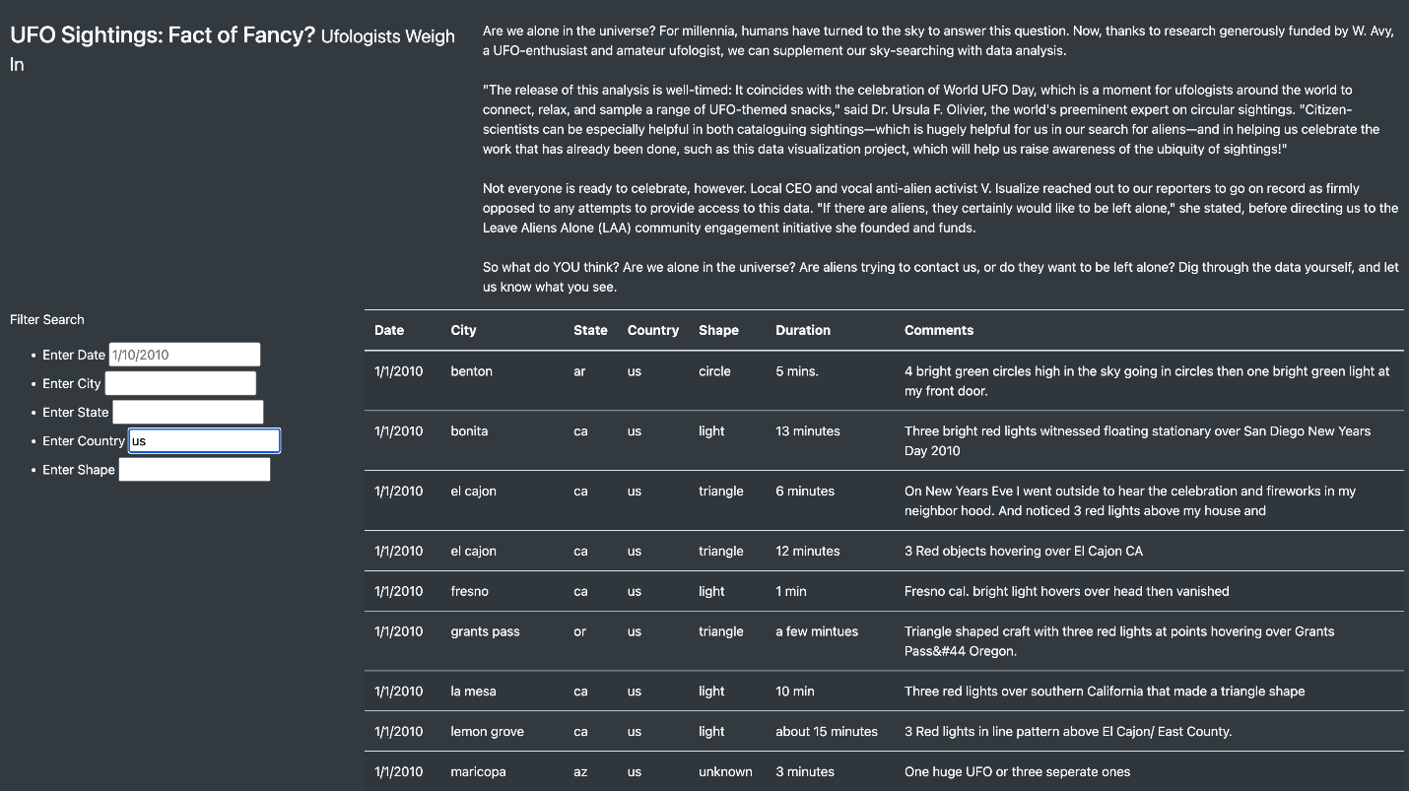](https://user-images.githubusercontent.com/104115586/181342871-9b447f37-5df4-4a69-8483-2454ea726ac5.png)

**Filtering by shape**

[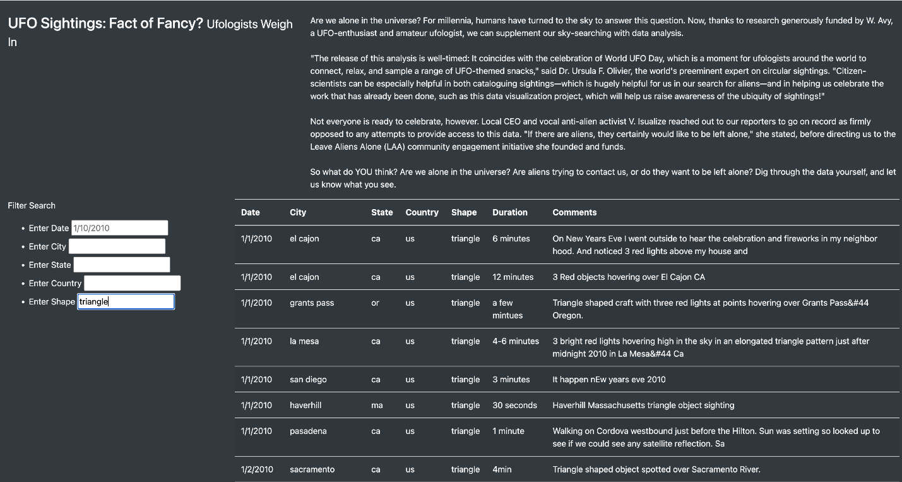](https://user-images.githubusercontent.com/104115586/181342828-23cb5c30-2d76-43df-bb96-59667b8ad80d.png)

**Drawbacks**

The user must know specific dates, cities, or shapes to search. Some shapes like "light" might not be as intuitive. The filters require correct lower-case spellings and cannot include spaces at the end.

**Recommendations**

1. The next addition to the filters should be adding a trim function to catch spaces at the end of words as well as allow for upper and lower cases. [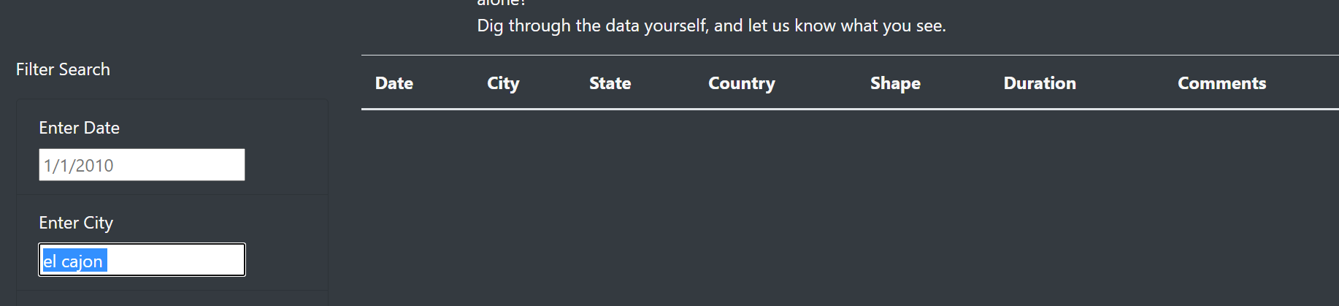](https://github.com/Baylex/UFOs/blob/main/static/images/trim.PNG)
2. A filter on a date range might be preferable than a singular date. Typing 1/2010 did not bring up all the dates from January as hoped. Perhaps, the UFO Sightings occur more frequently in a specific month instead of a specific day within the month. It is recommended to add in a filter function to include a date range as the filter to aid in the investigation of UFO Sightings.