ENGINEERING CASE STUDY / REV A

EdgeLink S3 Cellular —
ESP32-S3 Embedded Hardware Platform
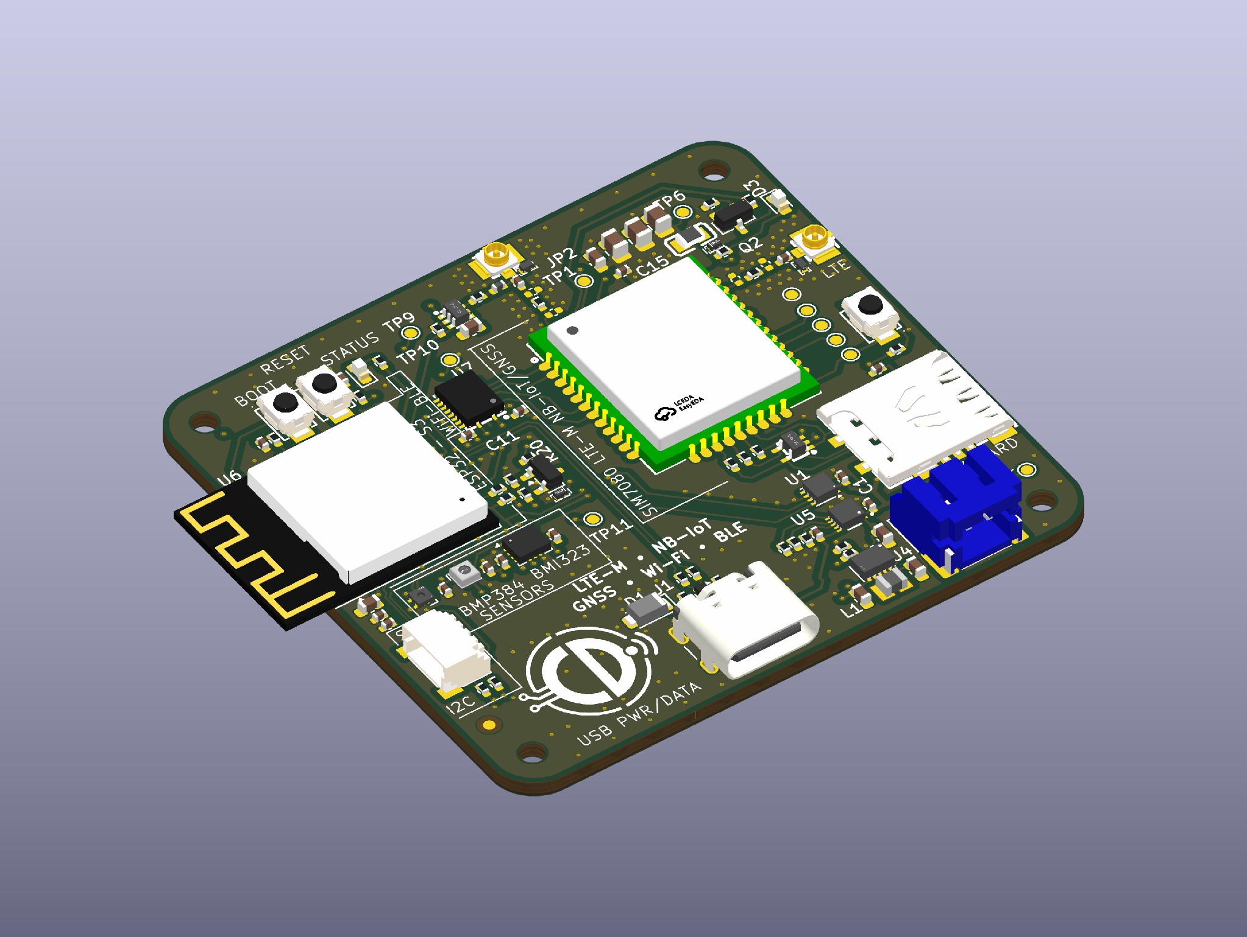
Figure 1 Complete-board isometric CAD render from the Rev A KiCad source. Hardware has not been fabricated or assembled; model appearance is not assembly evidence.
EdgeLink integrates an ESP32-S3 controller, SIM7080G LTE-M/NB-IoT and GNSS modem, USB-C, single-cell battery power management and motion/environmental sensing on a four-layer PCB. The project demonstrates schematic integration, physical layout and preparation of an engineering manufacturing handoff.

Board | Processing and connectivity | Power and interfaces
Four layers  56 × 52 mm CAD outline | ESP32-S3-MINI-1-N8  SIM7080G LTE-M/NB-IoT + GNSS | USB-C + single-cell battery  BQ25185 / TPS63802 / MAX17048

Engineering responsibilities
The design work covers power/interface architecture, controller/modem/sensor integration, local CAD libraries and multilayer placement/routing. The handoff includes BOM, component-placement, Gerber/drill and verification records.

2 System architecture
The power tree separates battery charging, the regulated logic rail and the modem supply. Named sheet interfaces make USB, UART, modem control and the two I2C signal pairs traceable through the hierarchy.

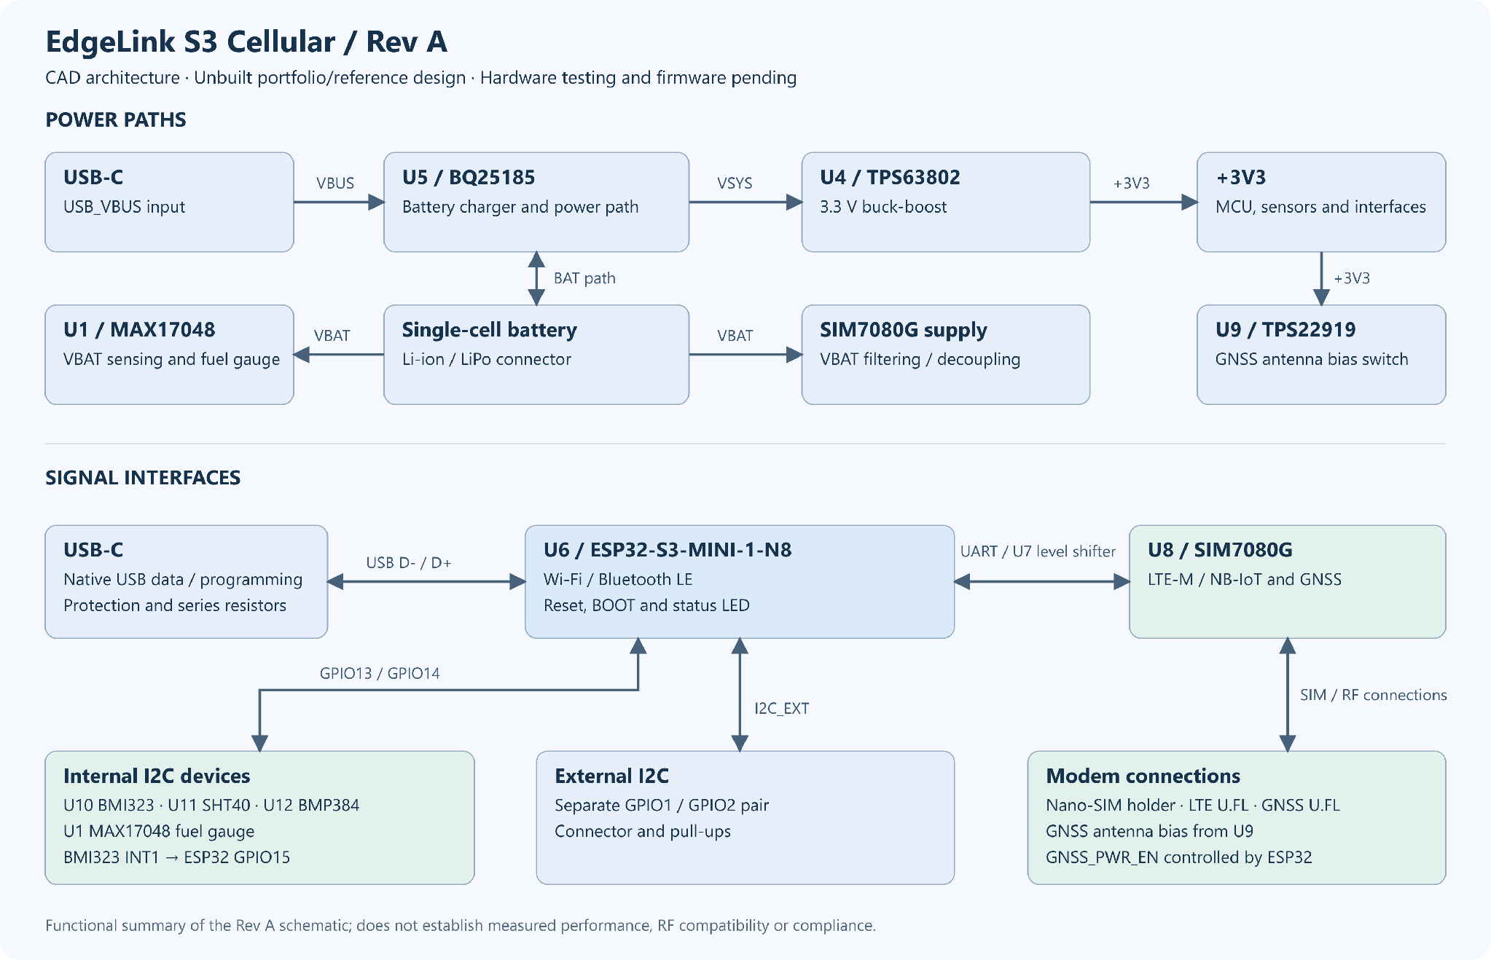
Figure 2 Existing Rev A architecture diagram. Supply paths and interfaces describe the CAD design, not measured hardware behaviour.

Power distribution
Path | Source implementation
USB_VBUS → BQ25185 | USB-C feeds the charger/power-path input. The battery connects to the BAT/VBAT path.
VSYS → TPS63802 → +3V3 | The buck-boost stage supplies the controller and logic/sensor circuitry.
VBAT → SIM_BAT | Filtering and local decoupling support the modem supply.
+3V3 → TPS22919 | The switched output feeds the GNSS antenna-bias network.
VBAT → MAX17048 | Battery monitoring reports through the internal I2C pair.

Controller and peripheral interfaces
Native USB reaches the ESP32-S3 through protection and series components. U7 TXB0108 links the controller and modem UART/control signals. The SIM7080G connects to a Nano-SIM holder and separate LTE/GNSS U.FL connectors.
GPIO13/GPIO14 serve the fuel gauge, BMI323, SHT40 and BMP384 on internal I2C. GPIO1/GPIO2 provide a separate external I2C pair; BMI323 INT1 reaches GPIO15. Firmware and interface validation remain pending.

3 Schematic design
Hierarchical sheets separate power/USB, the controller, cellular/GNSS and sensors. Controller nets distinguish native USB, modem UART/control, two I2C pairs and the motion-sensor interrupt.

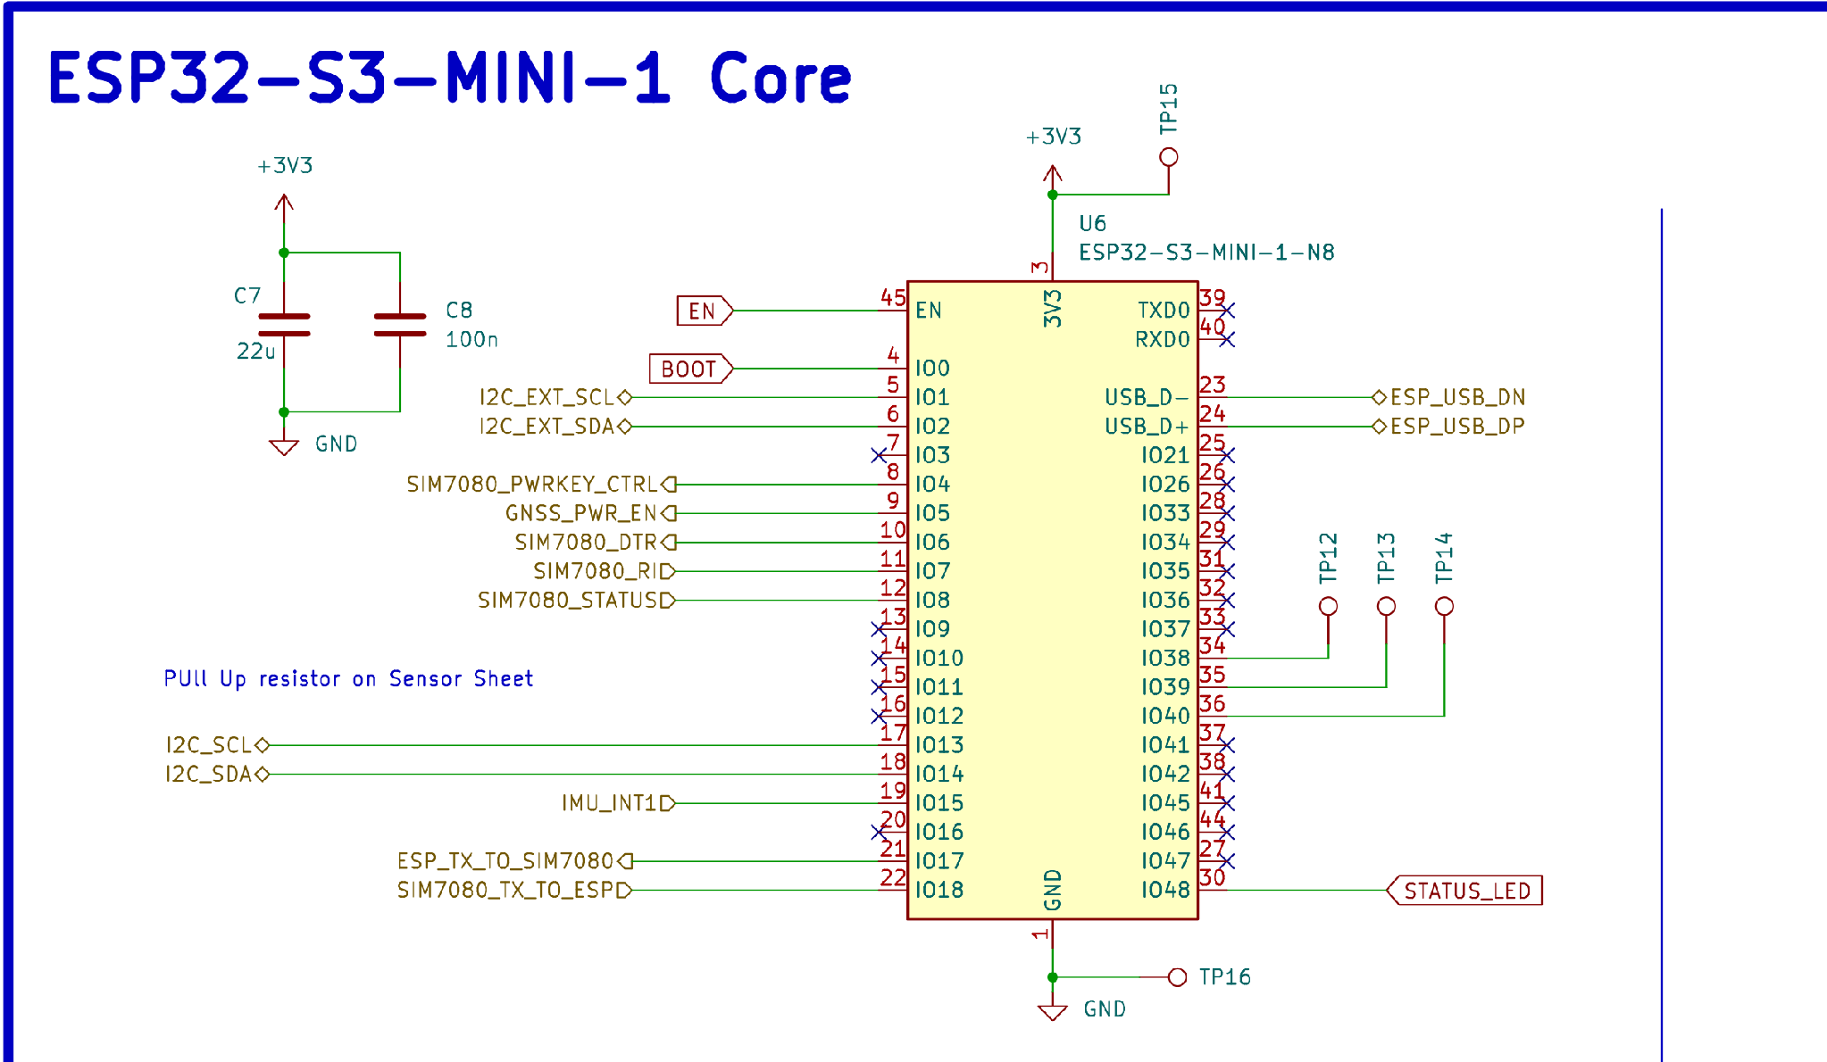
Figure 3 ESP32-S3 integration with local decoupling, native USB, modem UART/control, distinct I2C signal pairs and the IMU interrupt.
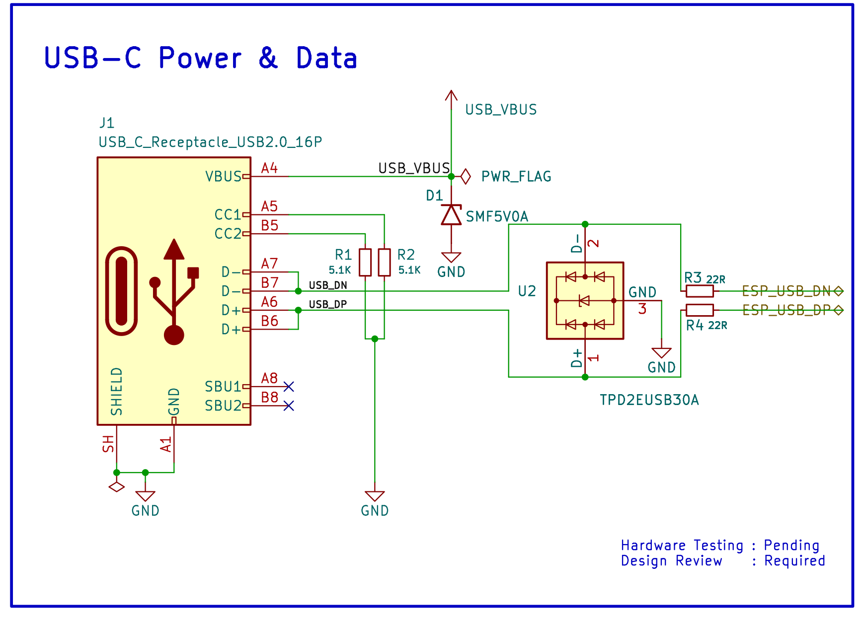
Figure 4 USB-C input with CC resistors, TPD2EUSB30A protection and 22 ohm data-series resistors. These are source design choices; no USB compliance test is claimed.

4 PCB layout
The nominal 56 × 52 mm outline accommodates the controller, modem, RF connectors, sensors and edge interfaces. The exported views retain the original placement, routing, outline and filled zones.
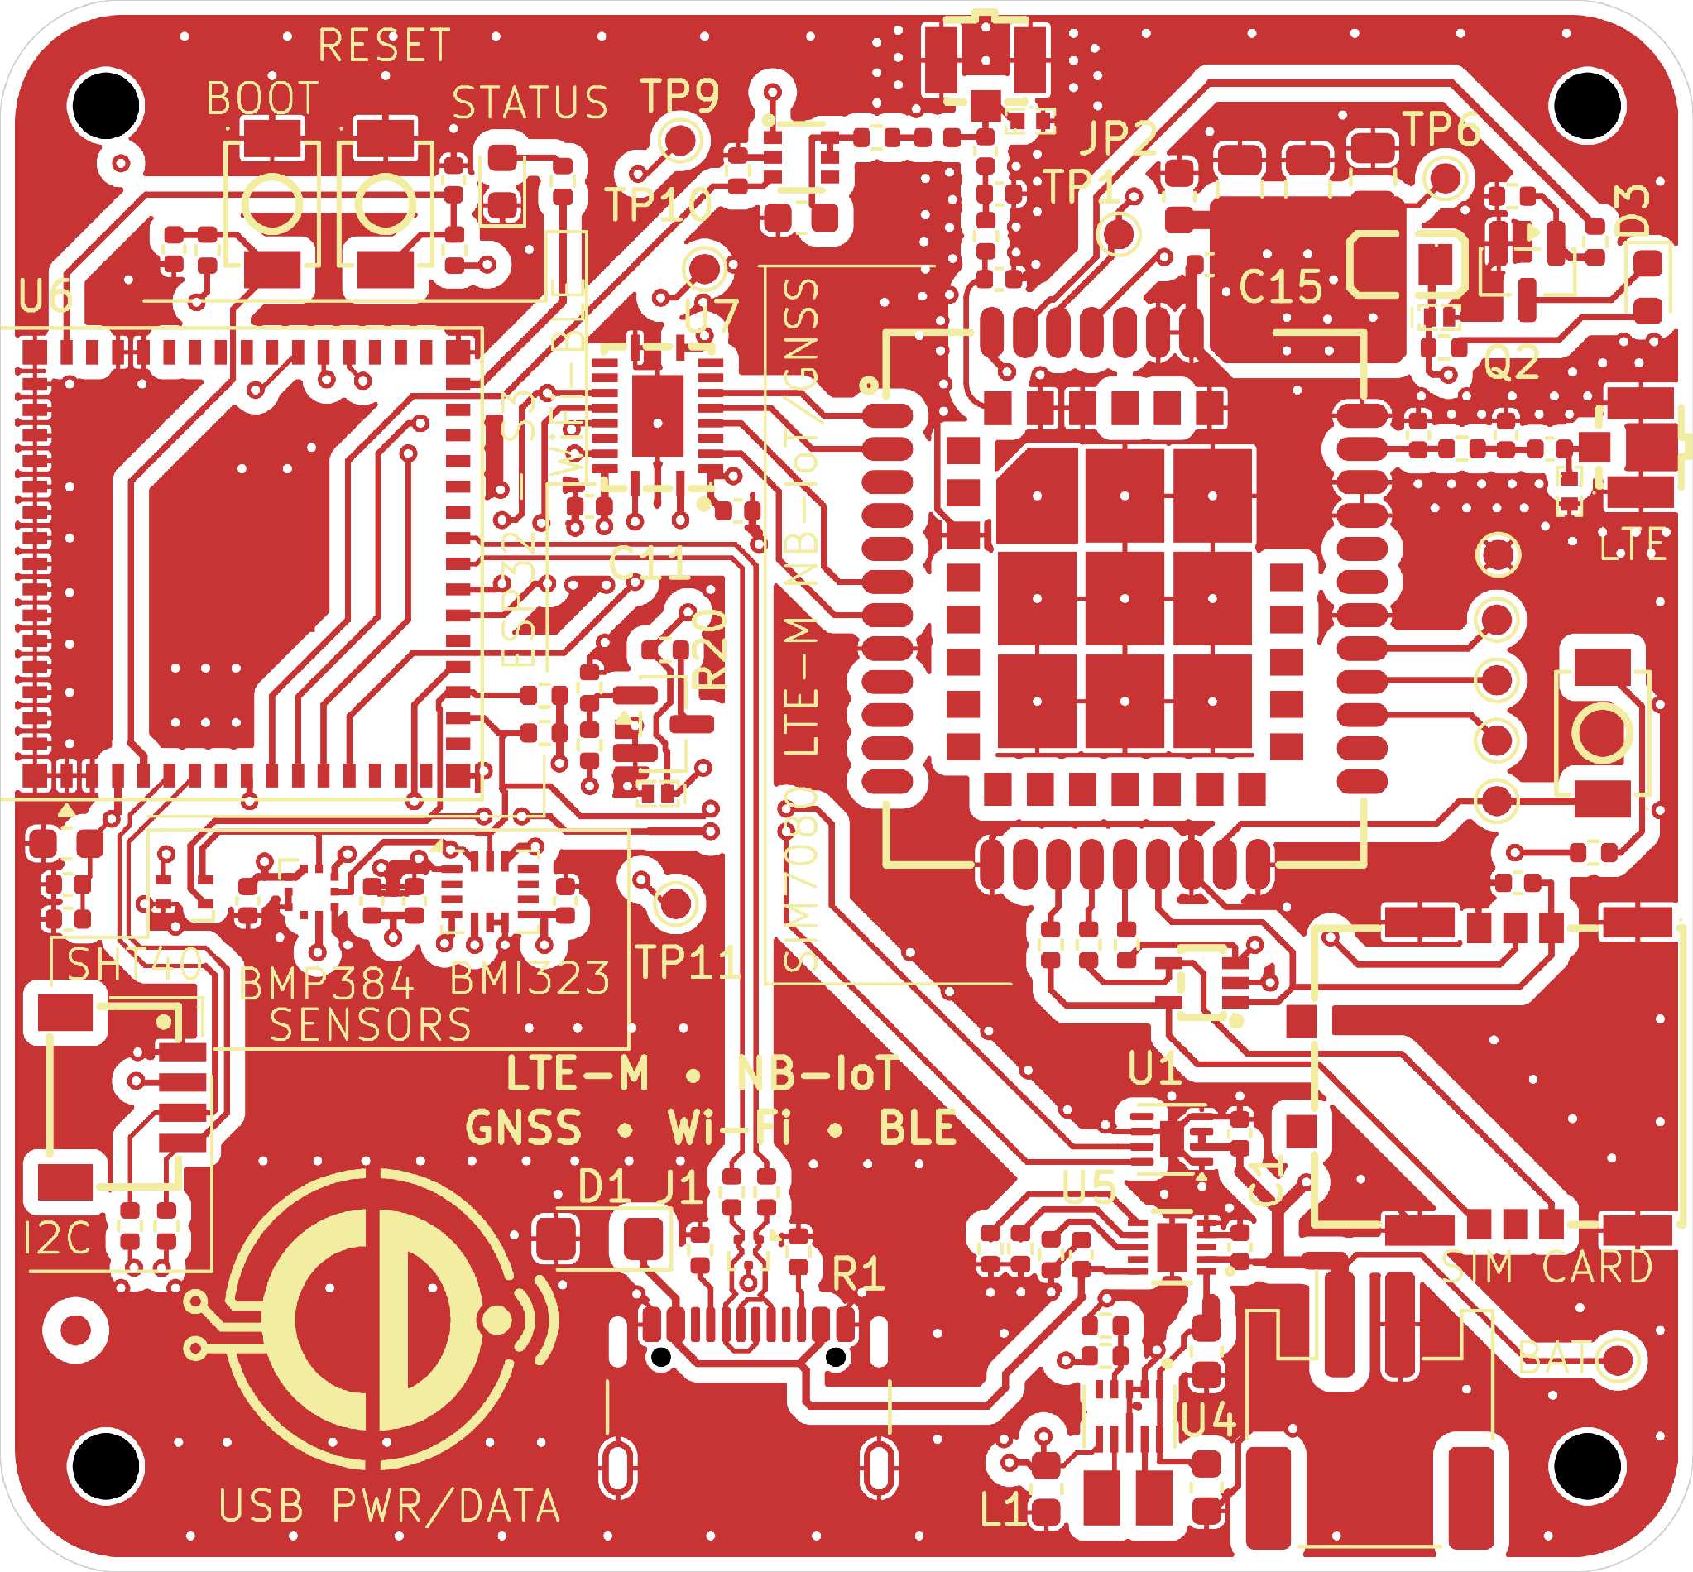 | 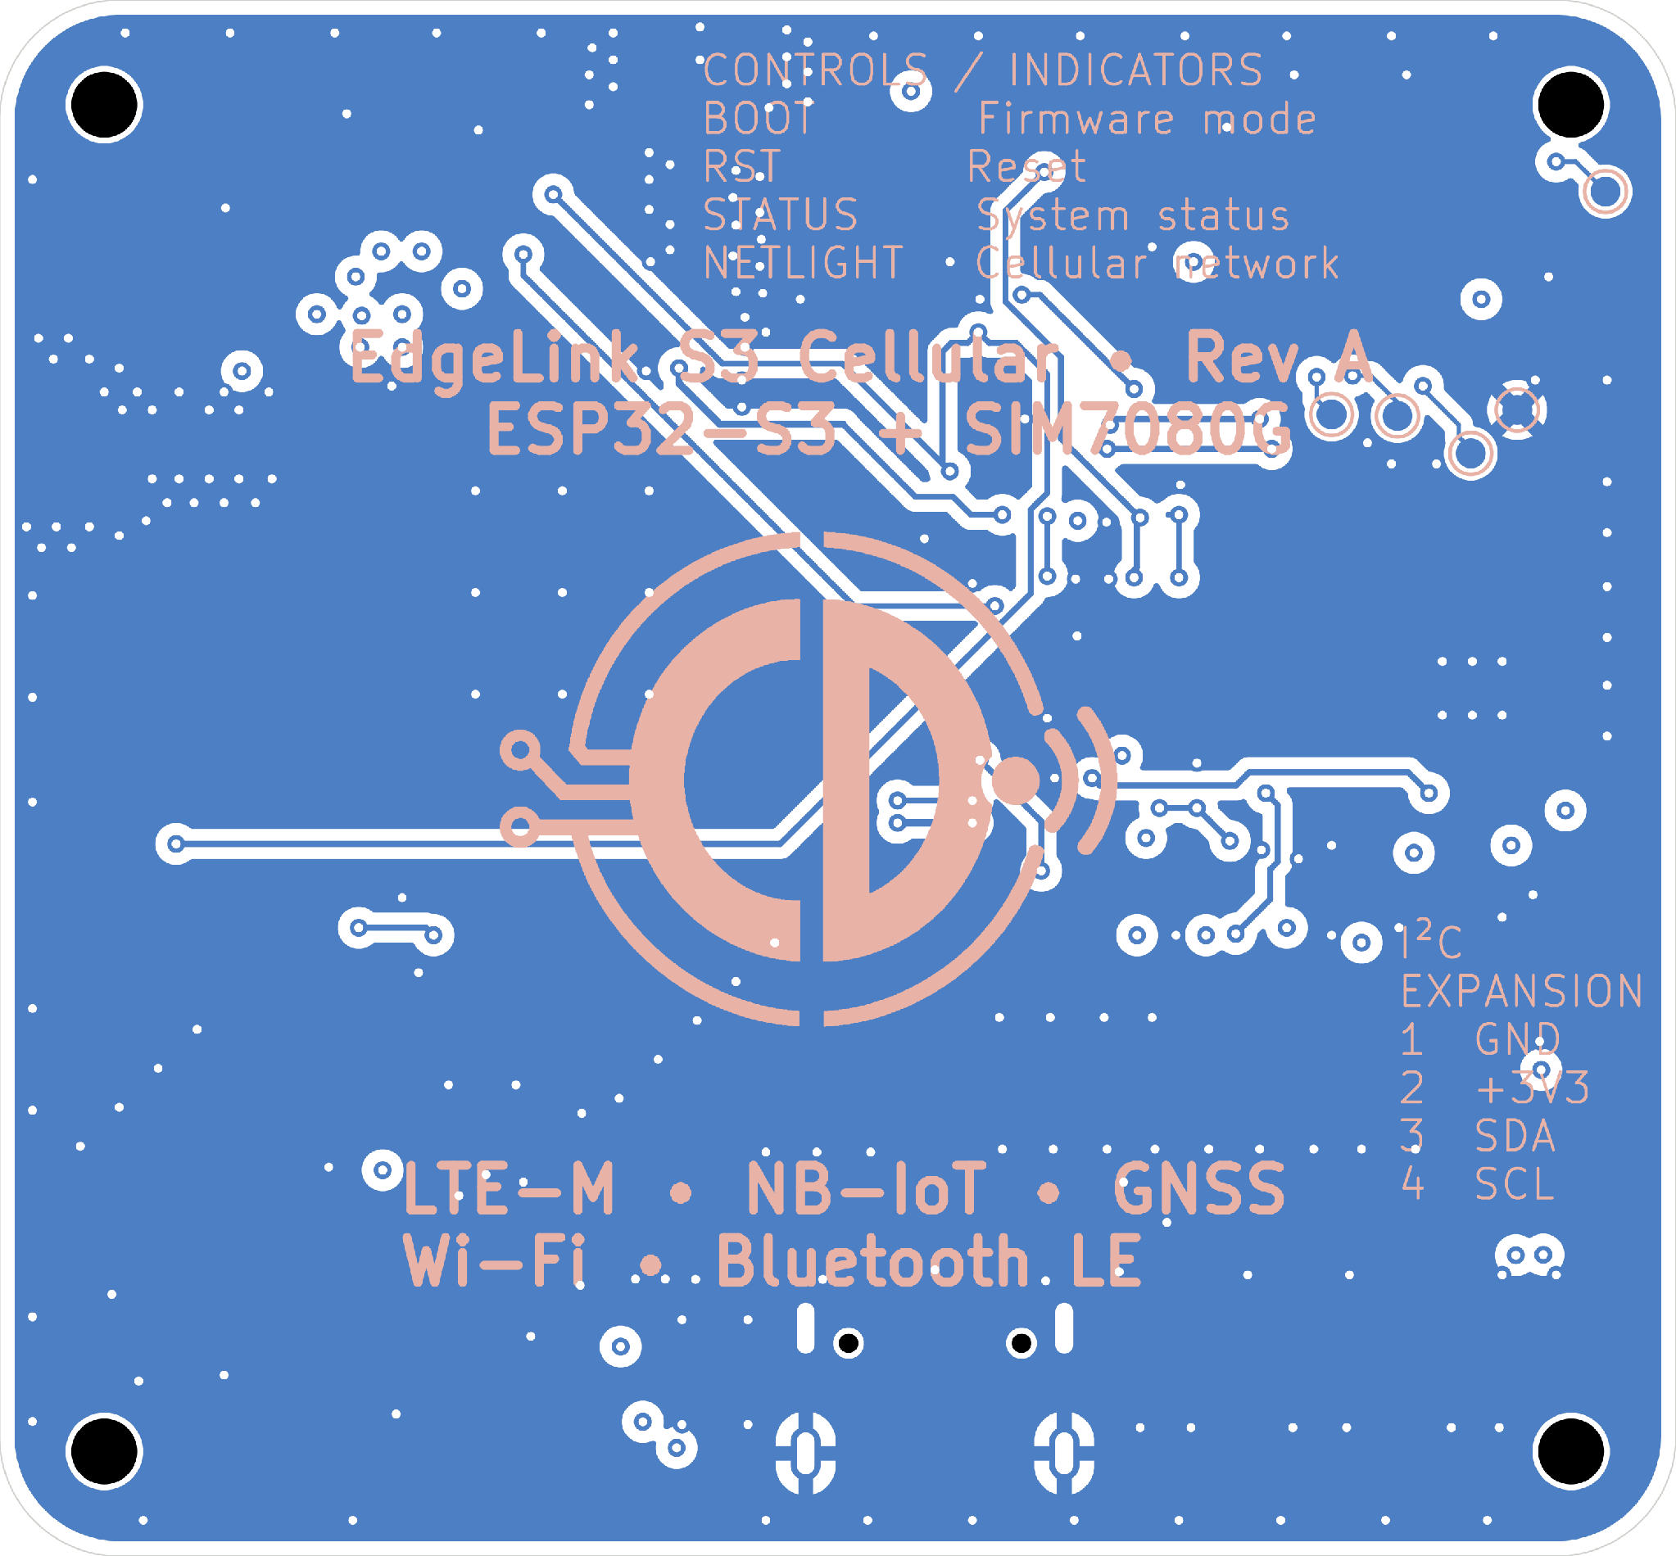
Figure 5 Top copper/silkscreen (left) and bottom copper/silkscreen (right). The bottom view is intentionally mirrored for underside inspection; plots are CAD evidence, not bare-board photographs.
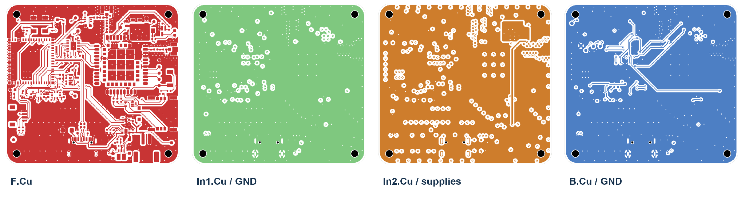
Figure 6 Four copper layers in a common top-view orientation. In1 contains a GND zone; In2 contains +3V3 and SIM_BAT supply zones. Bottom comparison view is unmirrored.

Layout evidence and constraints
The module/RF region, supply circuitry and external connectors occupy distinct areas. Source copper includes GND zones on F.Cu, In1.Cu and B.Cu, with signal routing and via connections visible in the plots. Return-path and power-integrity performance have not been measured.
USB and RF routes receive dedicated placement/routing attention, but the portfolio does not establish verified impedance or RF/EMC performance. Four 2.2 mm NPTH mounting holes and edge-accessible connectors provide mechanical integration points.
CAD stack-up record | Intended supplier configuration
Four-layer FR4; approximately 1.558 mm total  1.238 mm core; finish recorded as None | Nominal 1.6 mm; ENIG; JLC04161H-3313  Supplier reconciliation remains pending

5 Manufacturing and verification
The JLCPCB-oriented package contains an upload BOM, upload CPL, enriched supporting BOM and fabrication ZIP with matching loose outputs. Manufacturing preparation is complete as documentation; fabrication and assembly remain pending.
Comment | Designator | Footprint | LCSC Part #
ESP32-S3-MINI-1-N8 | U6 | RF_Module:ESP32-S2-MINI-1 | C2913206
BMP384 | U12 | Sensor_Footprints:BMP390_LGA10_2x2mm | C5577555
10K | R8,R12,R14,R25 | Resistor_SMD:R_0402_1005Metric | C2906861
Table 1 Actual upload-BOM rows. The existing LCSC Part # header and retained ESP32-S2/BMP390 footprint identifiers are shown exactly; fitted devices are ESP32-S3 and BMP384.
CPL designator | Mid X / Mid Y mm | Rotation | Layer
U6 | 49.600000 / -66.650000 | 90 degrees | Top
Table 2 Original U6 placement data, retained without a counter-offset. Assembler placement must be confirmed against pads and pin orientation.
The BOM has 46 rows and 89 unique fitted references; the CPL has the same 89 references, all Top. Supplier codes are nonblank. TP1–TP16 and C19–C22 are excluded. The readable 12-file ZIP matches its loose outputs byte-for-byte.

Fabrication deliverables
Release output group | Supplied filename suffixes
Copper layers | F_Cu.gbr / In1_Cu.gbr / In2_Cu.gbr / B_Cu.gbr
Solder mask | F_Mask.gbr / B_Mask.gbr
Silkscreen | F_Silkscreen.gbr / B_Silkscreen.gbr
Board outline | Edge_Cuts.gbr
Drill files | PTH.drl / NPTH.drl
Gerber job | job.gbrjob
Table 3 All 12 release outputs. Filenames share the EdgeLink_S3_Cellular- prefix; the ZIP and loose files are preserved.

Recorded checks and open warnings
KiCad 10.0.6 checks on 11–12 October 2026 | Recorded result
ERC | 0 violations
Layout DRC / unconnected items | 0 errors; 0 warnings / 0 unconnected
Additional schematic parity | 0 warnings
The six layout warnings comprise two silkscreen/edge, three silkscreen/mask and one D5 library-footprint mismatch. Parity warnings comprise 109 custom-field, 21 value/exclusion, five extra mechanical/graphic, four duplicate mechanical-reference and two footprint-filter warnings.

Release limitations
The ZIP includes four copper layers, front/back mask and silkscreen, outline, PTH/NPTH drills and a job file. Solder-paste Gerbers are absent: confirm stencil/assembly requirements before ordering. Supplier placement review, stack-up reconciliation and full DFM qualification remain open.

6 Embedded hardware engineering capabilities
The project demonstrates a traceable progression from hardware architecture and circuit integration to physical layout and a manufacturing handoff. Its value as a portfolio example lies in the editable source and documented engineering evidence.
Transferable capability | Evidence in EdgeLink Rev A
ESP32-S3 hardware integration | Module supply/decoupling, native USB, reset/BOOT controls, UART and named GPIO interfaces.
Power-tree architecture | BQ25185 charge/power path, TPS63802 regulation and MAX17048 battery monitoring.
Multilayer PCB layout | Four copper layers, component placement, ground/supply zones and mechanical mounting features.
USB-C and digital interfaces | Connector/protection circuitry, separate internal/external I2C and modem UART level shifting.
RF module integration | SIM7080G, Nano-SIM, LTE/GNSS U.FL interfaces and controlled GNSS antenna bias.
KiCad project organisation | Hierarchical sheets, project-local symbols/footprints/models and relative paths.
Manufacturing documentation | LCSC-coded BOM, matching CPL, Gerber/drill package, supplier notes and explicit release caveats.
Verification documentation | Recorded ERC/DRC results, warning-category triage and a clear distinction between CAD checks and hardware tests.

Source and evidence
Repository CDonohoe-Designs/EdgeLink_S3_Cellular
Revision 8bded932abc2eb7f814c76b664655bd760522112
Primary records README.md; docs/architecture/README.md; docs/verification.md; docs/references.md; manufacturing/REV_A/README.md.
Figures derive from the KiCad source and the approved portfolio image library; the accompanying evidence manifest maps images to source files.

