CONNECTED EMBEDDED SYSTEM
ExitLight Health Checker  ESP32 cellular IoT retrofit for automated emergency-light health testing  I designed and developed a retrofit controller that adds remote test control, light-level sensing and cloud connectivity to an existing emergency exit light. The prototype can interrupt mains power, allow the fitting to operate from its own battery, measure illumination and return the result remotely. | 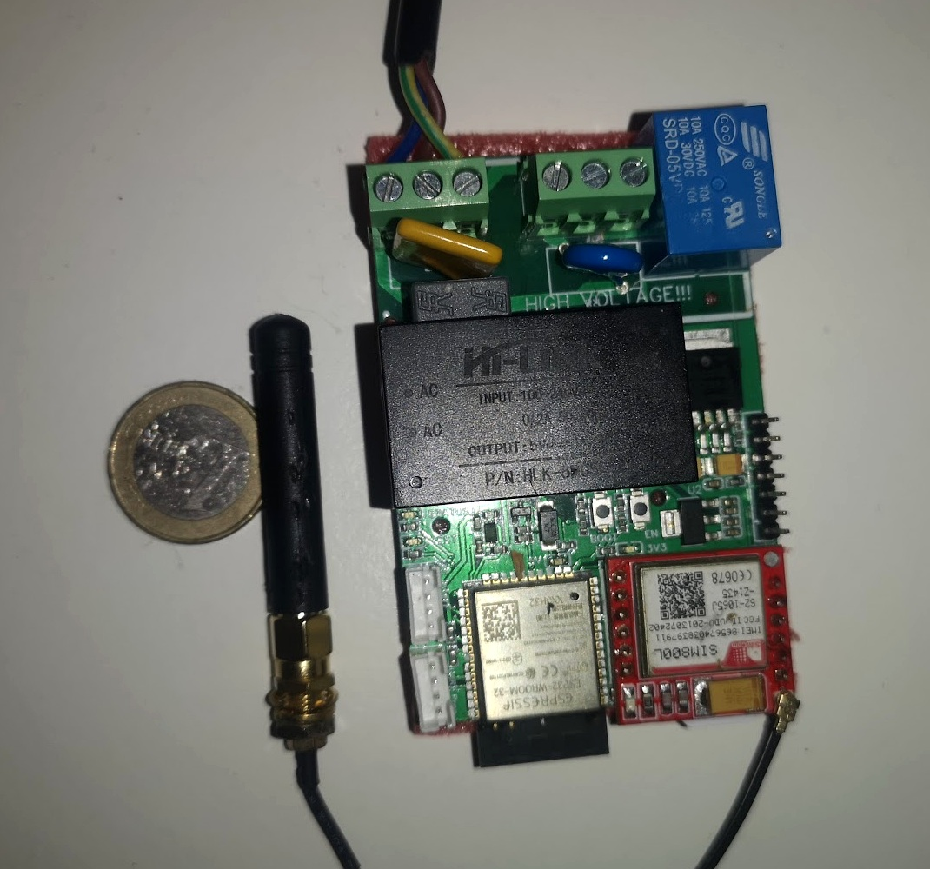  Working controller prototype; €1 coin shown for scale.
  ESP32-WROOM  Embedded controller | SIM800L  Cellular / GPRS
  BH1750  I²C light sensing | AWS IoT + MQTT  Remote connectivity
  230 VAC relay  Automated test control | External I²C / GPIO  Expandable sensing

Working retrofit prototype
The controller was physically integrated into an OEM emergency-light fitting, demonstrating the complete retrofit concept rather than only a schematic or bench circuit.
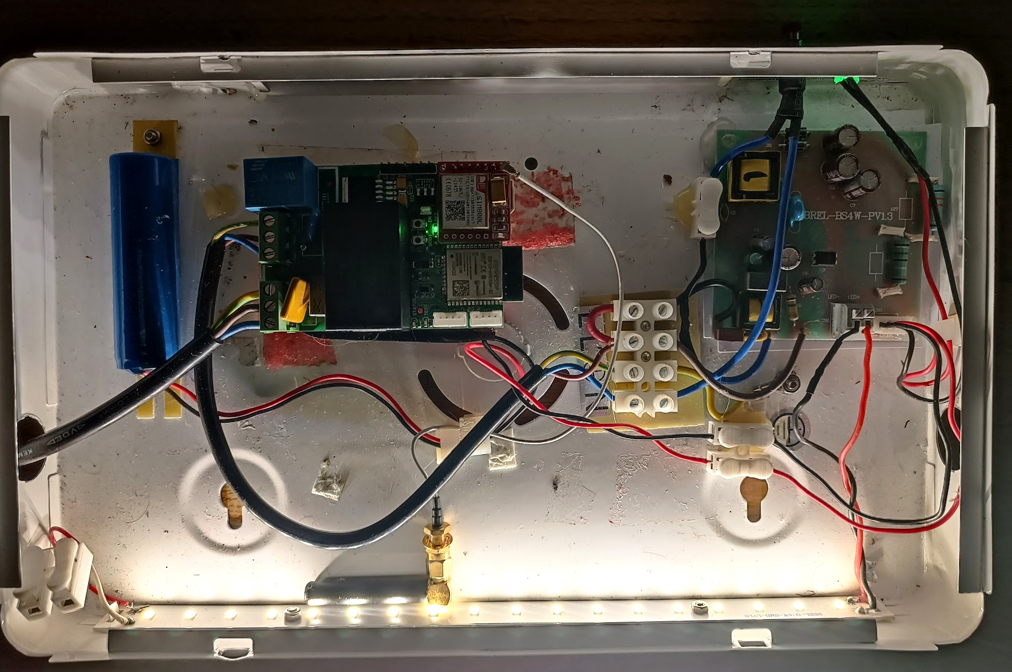  Prototype installed alongside the original emergency-light electronics. | 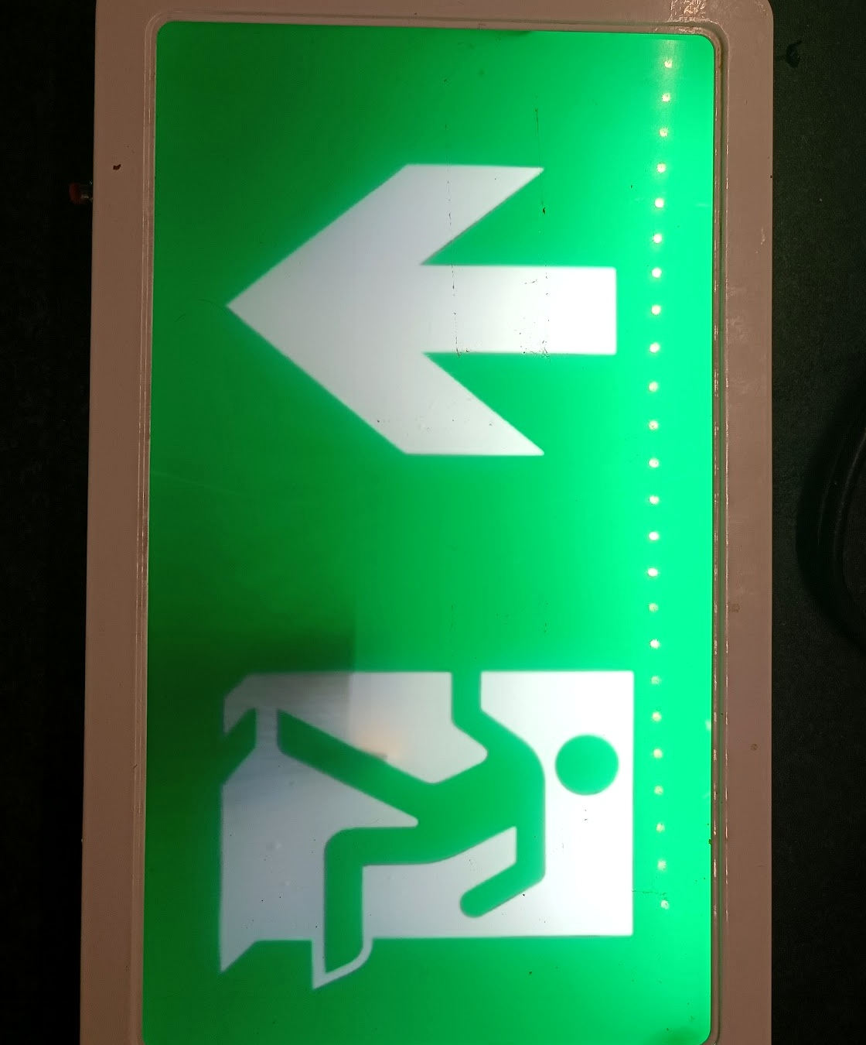  OEM fitting operating in emergency-light mode.

Hardware architecture
The design combines mains-side control, dedicated power rails, an ESP32 controller, local light sensing and cellular communication. The external interface leaves room for additional sensors or peripherals.
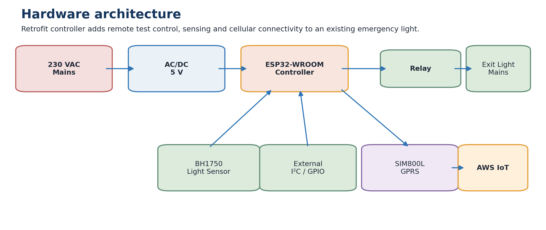

Controller & sensing  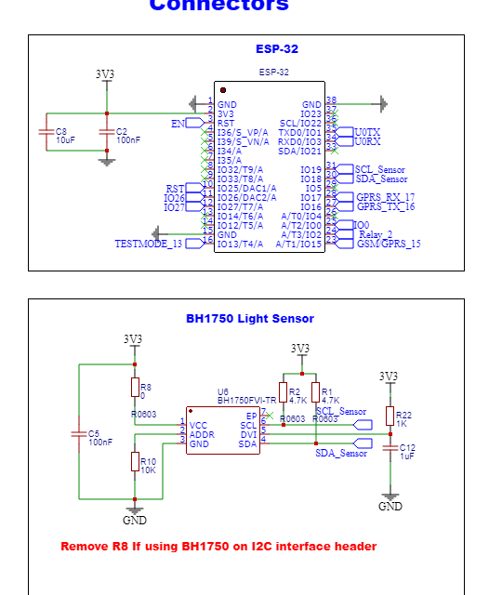  ESP32 controller and BH1750 I²C light-sensor section from the original schematic.  - ESP32-WROOM provides the main control and communication functions.  - BH1750 measures light output during the battery test.  - I²C / GPIO plus UART support expansion and programming. | Power, relay & cellular  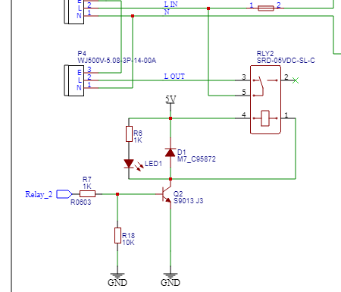  Mains relay / AC-DC conversion and supporting power circuitry.  - AC/DC conversion generates a 5 V rail from the mains input.  - Separate regulation supports the ESP32 and SIM800L rails.  - The relay disconnects the OEM fitting; SIM800L provides GPRS connectivity.
Design intent: add monitoring and automated test capability without replacing the existing emergency-light electronics.

Embedded control & cloud workflow
The system-level design closes the loop between remote scheduling, embedded control and a physical light measurement. The original architecture uses MQTT and AWS IoT services for the remote communications path.
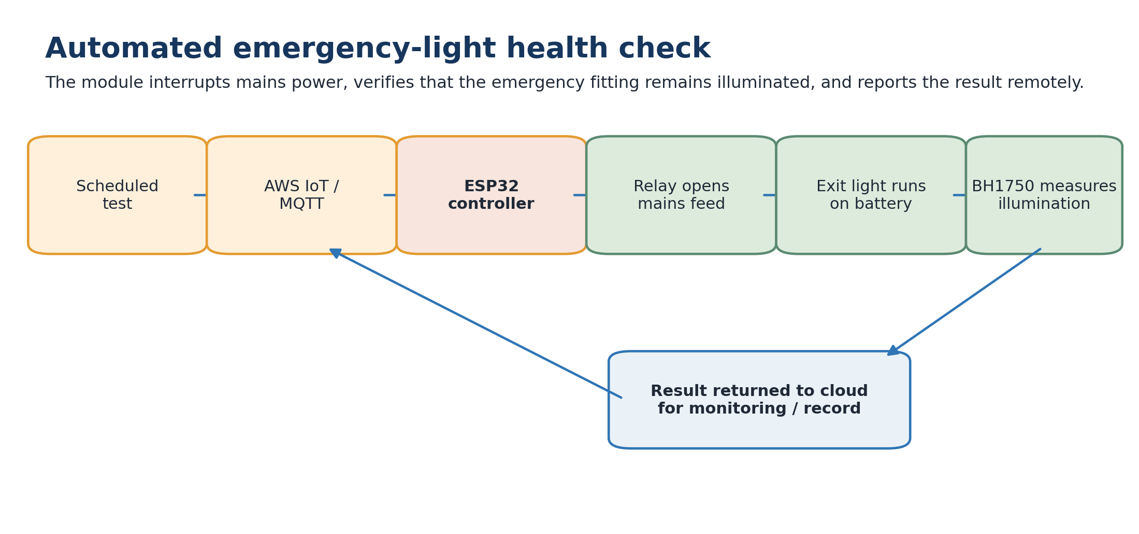

Cloud-side architecture  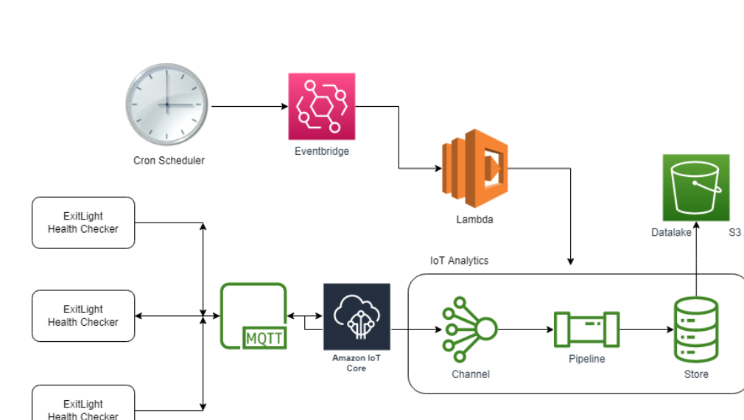  Original AWS architecture: EventBridge / Lambda scheduling, MQTT through AWS IoT Core, IoT Analytics and S3 data storage. | What this project demonstrates  - End-to-end embedded product architecture  - ESP32 hardware integration  - Cellular IoT connectivity  - I²C sensor integration  - Mains switching and multi-rail power design  - Cloud-connected control and data flow  - Working retrofit installation and system test  Relevant experience  This project is a useful example of taking an embedded connected-device concept through hardware design, physical integration and an end-to-end IoT workflow.
Original prototype documentation dated 2021.

