FOUR-LAYER PCB / ESP32-S3 / CELLULAR + GNSS / USB-C

EdgeLink S3 Cellular
An ESP32-S3 embedded hardware platform
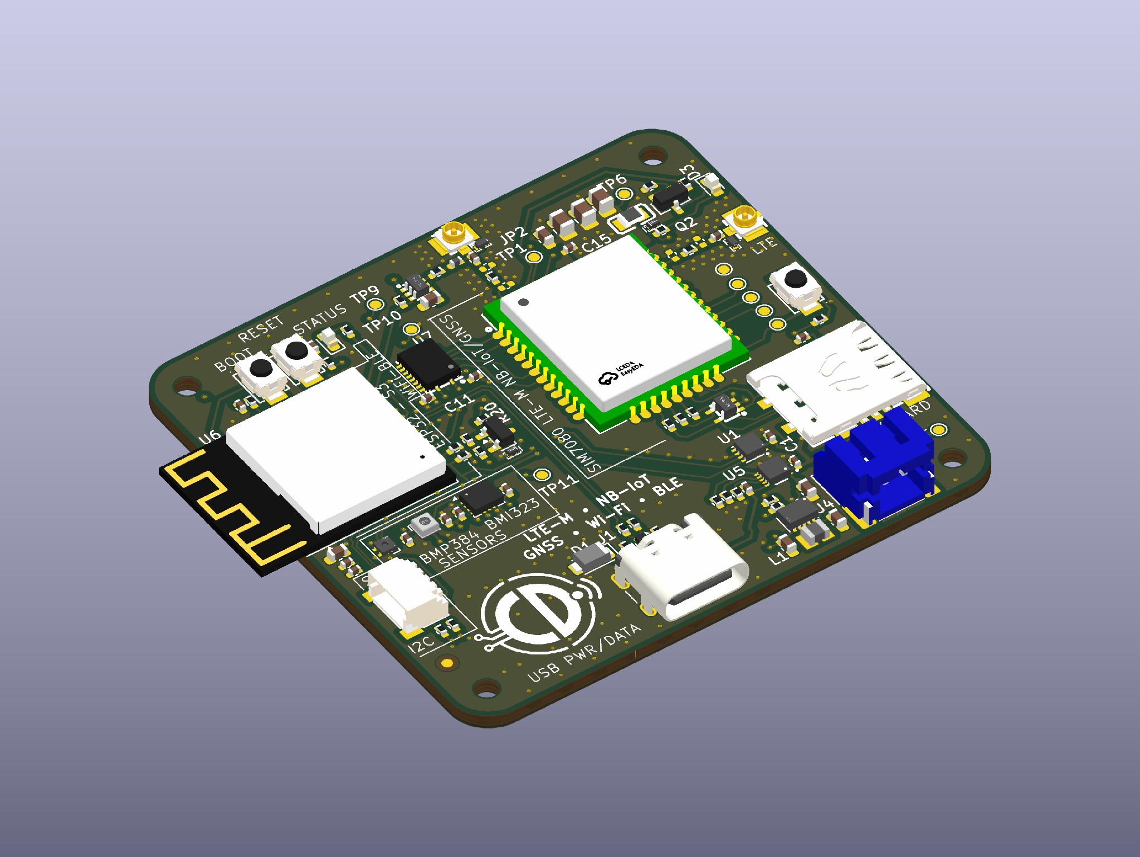
Rev A board visualised using the actual KiCad PCB and 3D models.
EdgeLink S3 Cellular brings together an ESP32-S3, a SIM7080G cellular/GNSS modem, USB-C, battery power management and environmental sensing on a compact four-layer PCB. I developed the schematic and board layout to explore how these subsystems fit together in a practical, manufacturable embedded platform.

At a glance
PCB | Controller & wireless | Power & sensors
4 layers · 56 × 52 mm | ESP32-S3-MINI-1-N8 · SIM7080G | USB-C · Li-ion · BQ25185 · TPS63802 · BMI323 · SHT40 · BMP384
The project includes editable KiCad files, a complete schematic and a JLCPCB-oriented fabrication/assembly package. Rev A is a completed CAD design, not a fabricated or tested prototype.

1 System architecture
The starting point was to make power, communications and sensing work together without treating them as separate boards. The ESP32-S3 handles processing, USB and local peripherals, while the SIM7080G provides LTE-M/NB-IoT and GNSS connectivity.
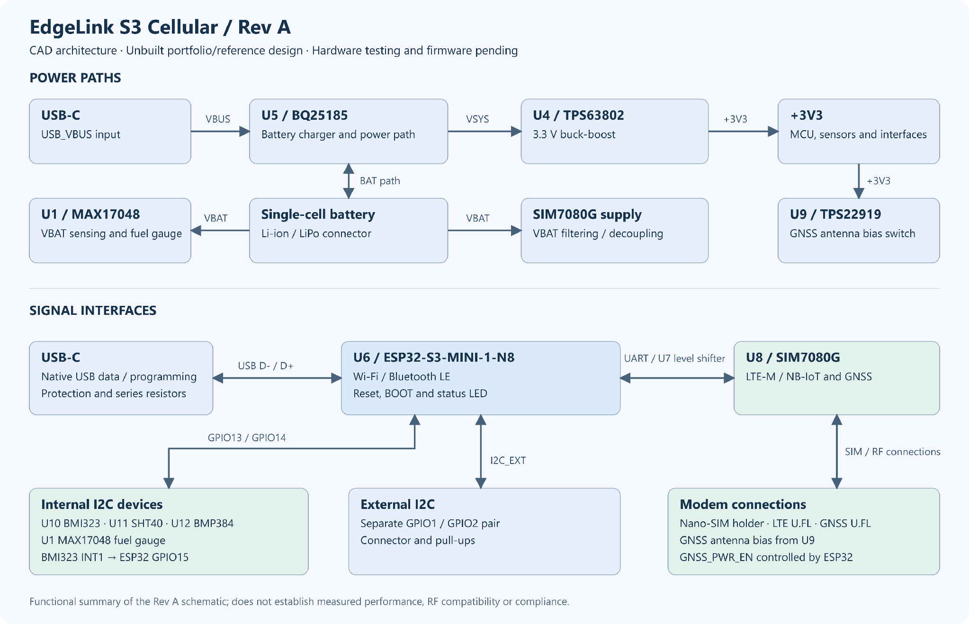
Power and signal flow across the ESP32-S3, modem, battery system and sensors.

Power that works from USB or battery
USB-C feeds the BQ25185 charger and power-path circuit. Its system output supplies a TPS63802 buck-boost regulator for the 3.3 V logic rail. The modem uses a filtered battery supply, while a MAX17048 tracks battery state. A switched supply controls GNSS antenna bias.

Keeping interfaces organised
The design uses native ESP32-S3 USB, a level-shifted UART to the modem, an internal I²C bus for the sensors and fuel gauge, and a separate external I²C connection. The BMI323 also provides an interrupt to the controller.

2 Schematic design
I split the schematic into functional sheets for power/USB, the ESP32-S3, cellular/GNSS and sensors. This makes it easier to follow the power tree and check the interfaces without searching through one oversized circuit.
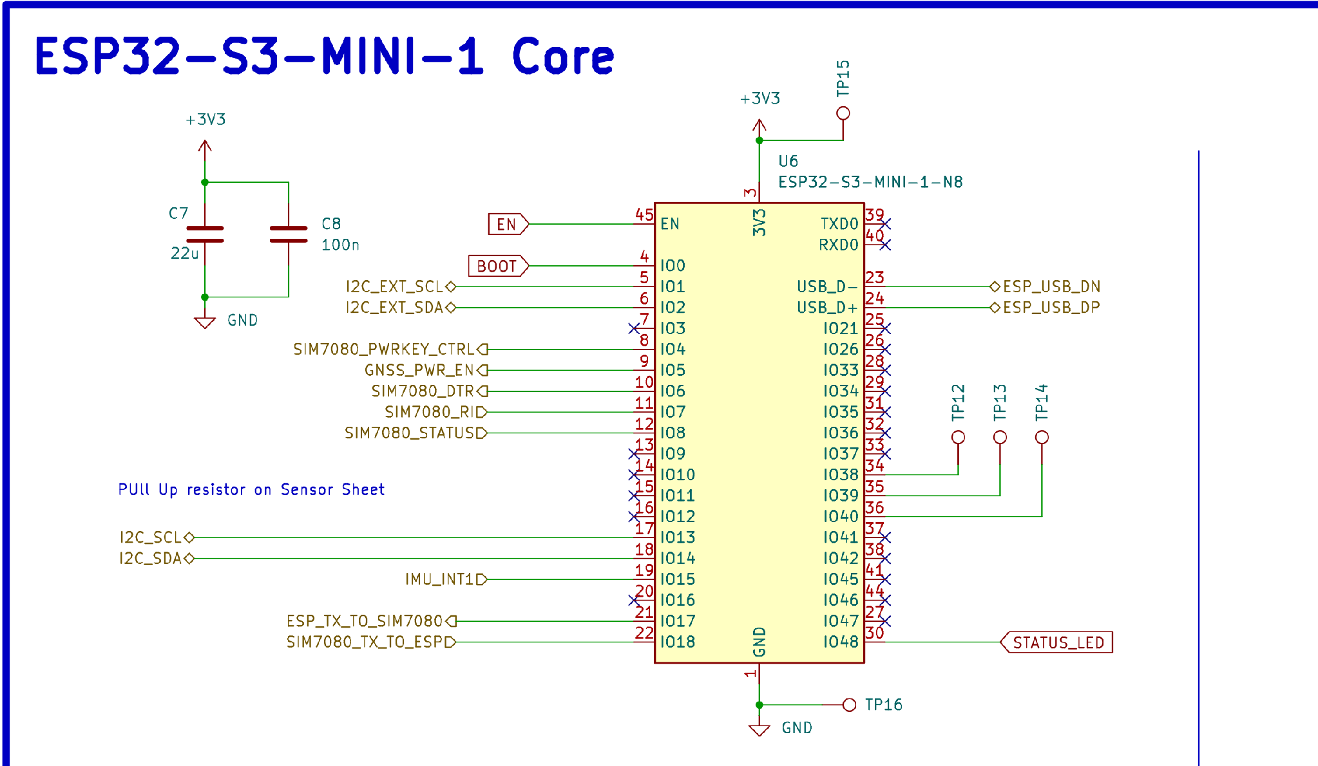
ESP32-S3 module connections, local decoupling and named USB, UART and I²C signals.
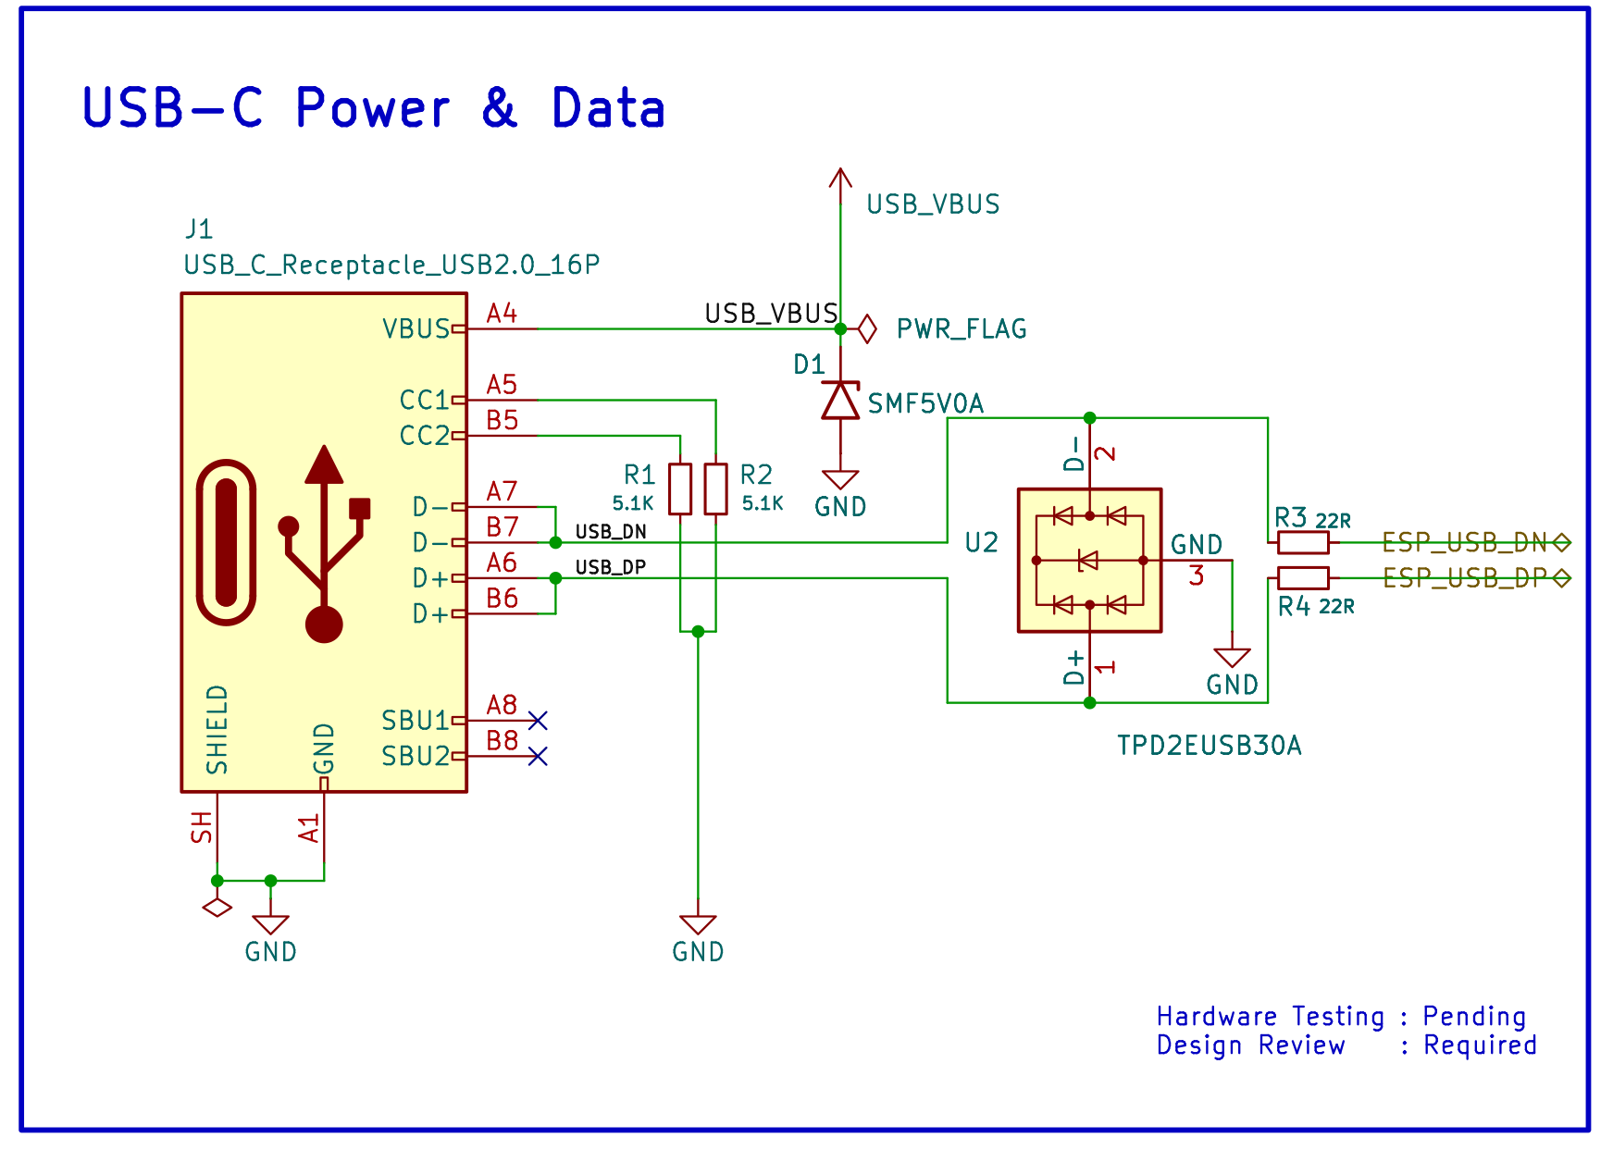
USB-C power/data connection, CC resistors, ESD protection and series resistors.
Other implemented circuits include the BQ25185 charging stage, TPS63802 regulation, SIM7080G interface, Nano-SIM and LTE/GNSS antenna connections, and the BMI323/SHT40/BMP384 sensor subsystem.

3 Four-layer PCB layout
The 56 × 52 mm board brings wireless modules, power conversion, sensors and external connectors into a single layout. I grouped related circuitry, kept decoupling close to its devices and considered return paths and the routing needs of USB and RF connections.
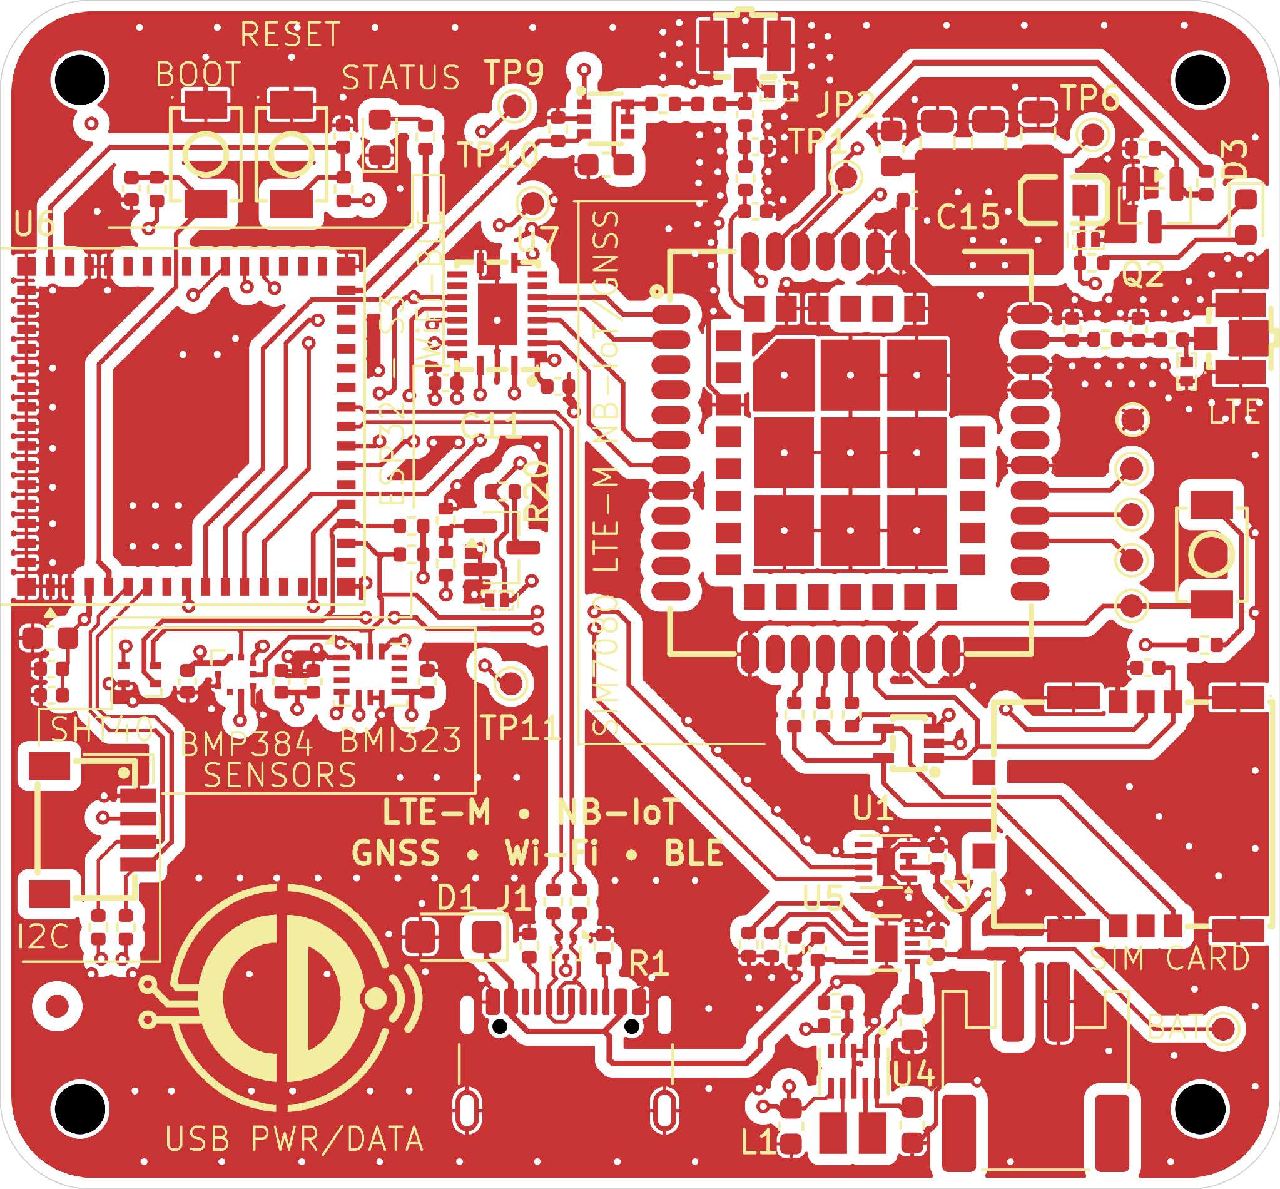
Top-side copper and silkscreen from the Rev A PCB.
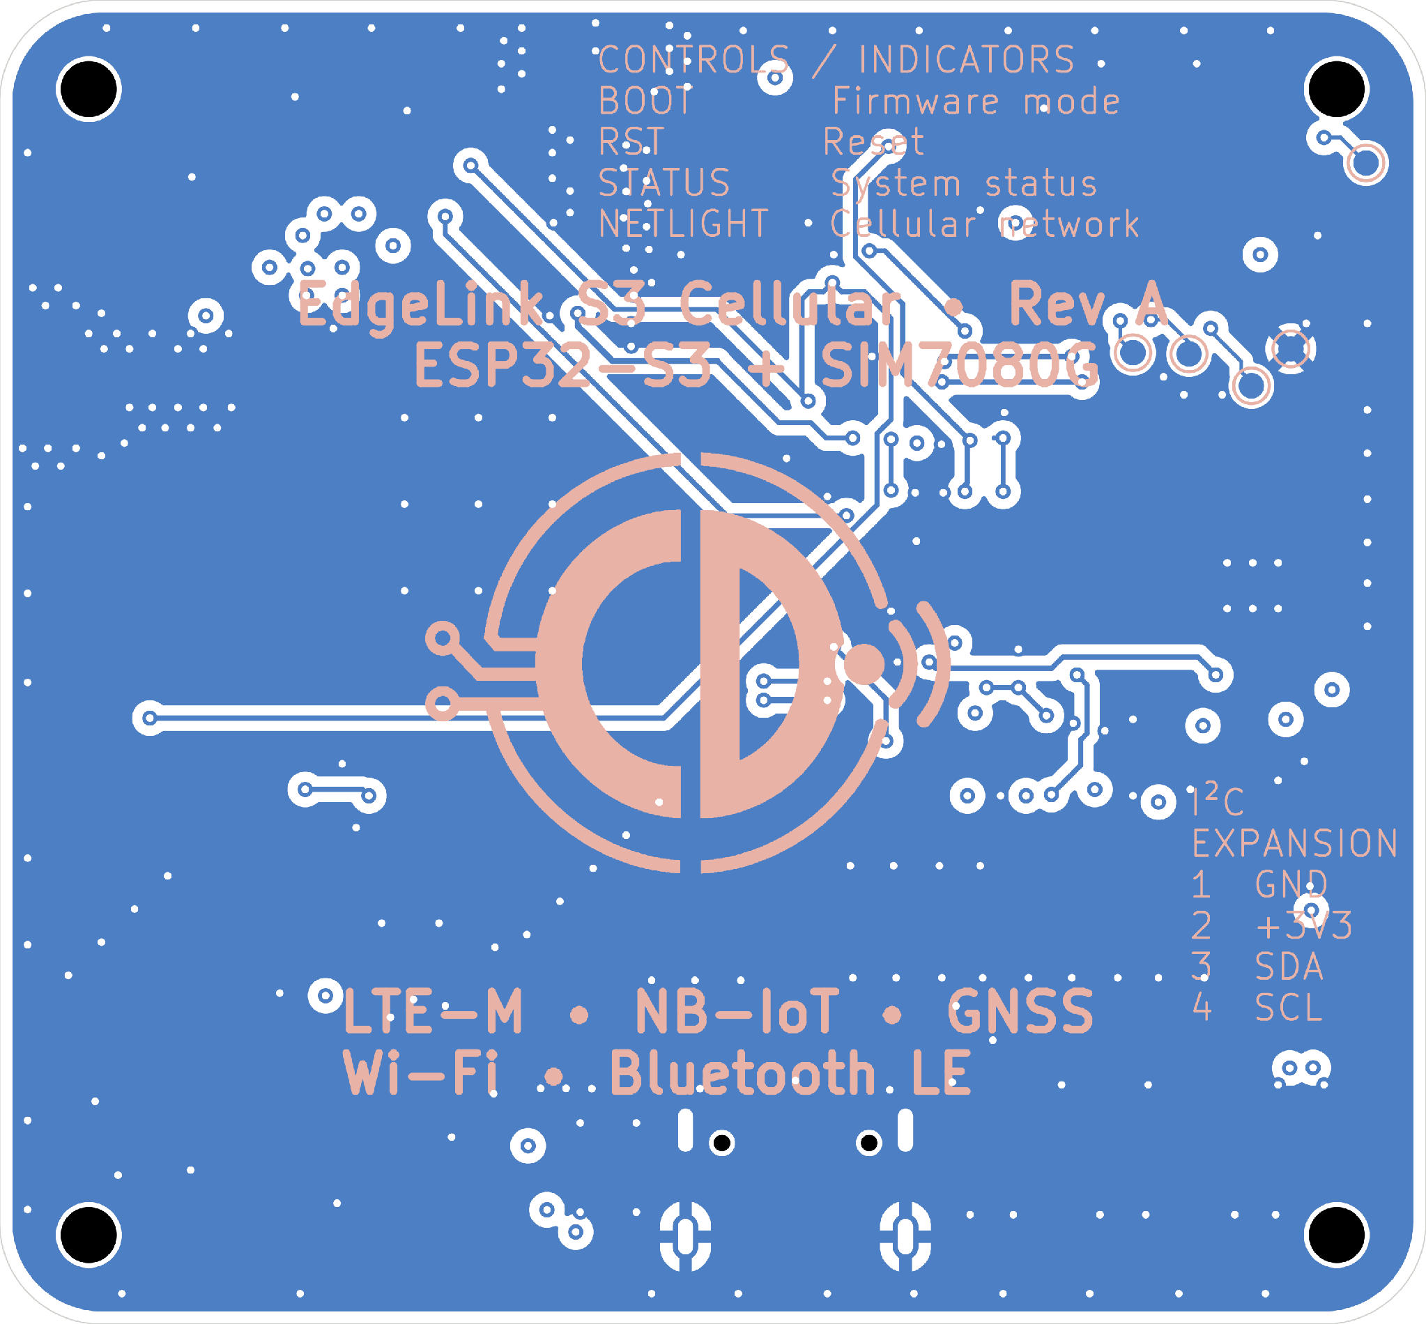
Bottom-side layout viewed from underneath.
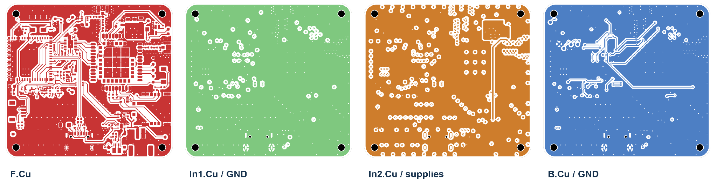
Four copper layers: top routing, internal ground, internal supplies and bottom routing.
The inner layers provide ground and supply zones, including +3V3 and the modem battery supply. The board includes four mounting holes and edge-accessible interfaces. The routing has not yet been validated by physical RF or signal-integrity measurements.

4 Manufacturing preparation
A useful hardware design needs to be understandable beyond the CAD editor. I prepared a JLCPCB-oriented manufacturing package alongside the PCB source, with the files an assembler would use to review fabrication and component placement.

What is included
Deliverable | Purpose
Four-layer Gerbers and drill files | Fabrication data for copper, masks, silkscreen, outline and holes
Assembly BOM | 46 component groups with LCSC sourcing references
Component placement (CPL) | 89 fitted component references, all on the top side
KiCad source project | Editable schematic, PCB and supporting local libraries
Architecture and schematic PDFs | Readable technical handover and circuit reference

Design-to-manufacturing workflow
The manufacturing outputs are organised under manufacturing/REV_A, separate from the editable KiCad project. Keeping these deliverables together makes it easier to inspect the design, compare the BOM against placement data and prepare for an assembly quotation.
This is a manufacturing-preparation package, not evidence of an assembled board. Final supplier review, stencil/assembly arrangements and prototype validation would follow before a production order.

Why this matters
The same approach transfers directly to client projects: clear design hierarchy, source-controlled CAD, sourcing information and a practical handoff that another engineer or assembler can follow.

5 Engineering skills demonstrated
EdgeLink is intended to show how I approach a complete embedded hardware design—from system architecture through circuit implementation, PCB layout and manufacturing documentation.
Area | Evidence from EdgeLink
Embedded controller design | ESP32-S3 integration, native USB, boot/reset and peripheral interfaces
Power management | Single-cell charging, power-path control, 3.3 V buck-boost and fuel gauge
Wireless hardware | SIM7080G, Nano-SIM, LTE/GNSS antenna interfaces and bias control
Digital sensing | IMU, temperature/humidity and pressure sensors on I²C
Multilayer PCB | Four copper layers, ground/supply zones, placement and routing
Manufacturing handoff | Gerbers, drills, supplier BOM and CPL
The Rev A schematic, PCB and manufacturing documents are available for inspection. The board has not been fabricated or brought up, and firmware, electrical measurements, RF testing and compliance evaluation are not presented as completed work.
GitHub: https://github.com/CDonohoe-Designs/EdgeLink_S3_Cellular
The repository contains the editable KiCad project, schematic PDF, architecture diagram and manufacturing package. It is a practical example of my embedded hardware design and documentation workflow.

