**PiCam_BoxDetector — README (with Images)**

I built this Raspberry Pi presence detector with a live MJPEG stream. Next I added debounced state changes and CSV logging so I can measure real “in/out” events. This document mirrors the README, but includes all images inline so it can be shared as a portfolio artifact.

## 1) Landing / Demo

**Show:** My browser on http://192.168.1.49:8000 /video and /snapshot).

**Setup:** I start my app (python3 scripts/box_stream.py or systemd service).

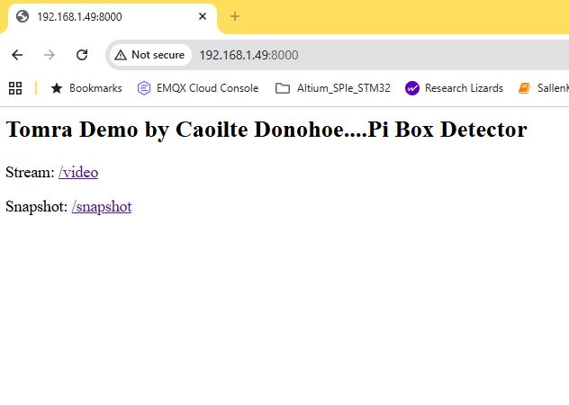

Figure 1. 1) Landing / Demo.

## 2) System Architecture

Shows: Camera → OpenCV presence → Debounce & CSV → Flask MJPEG → Browser.

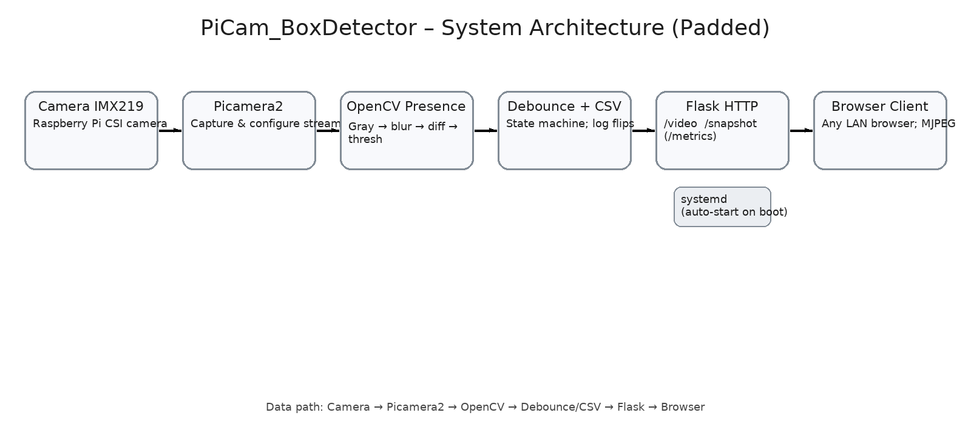

Figure 2. 2) System Architecture.

## 3) Stream UI (Detail)

**Shows:** The /video page (live MJPEG) and the URL visible.

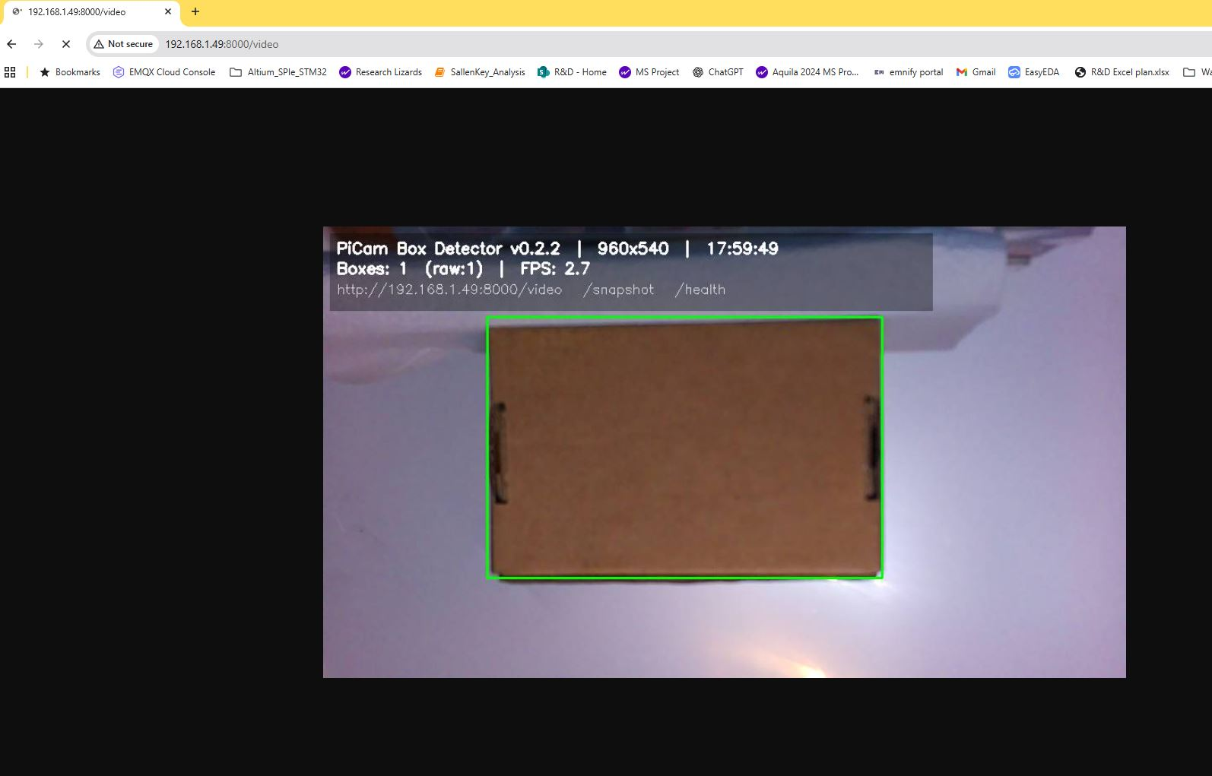

Figure 3. 3) Stream UI (Detail).

## 4) Detection Sequence

Three frames to demonstrate debounce: 1. No subject → 2. Subject enters → 3. Stable PRESENT.

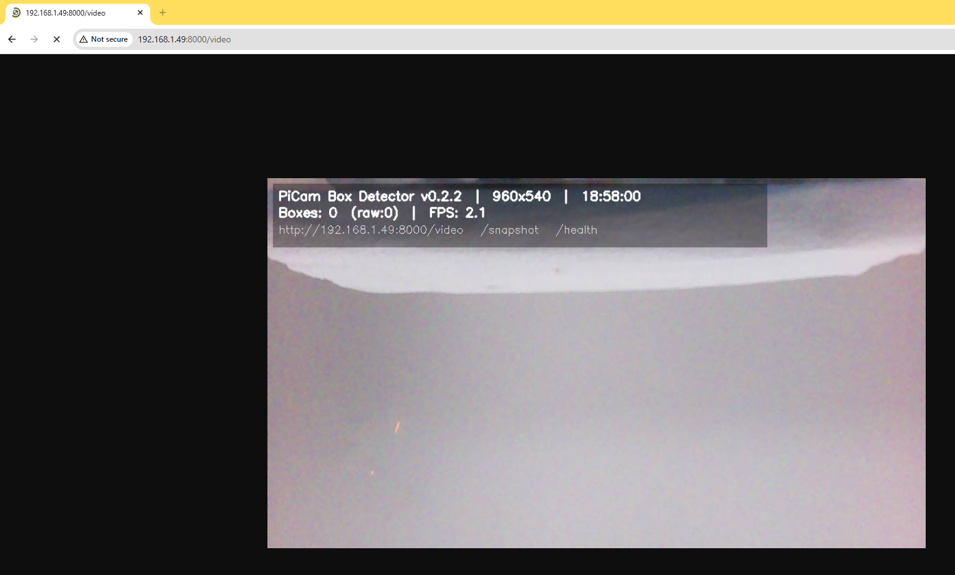

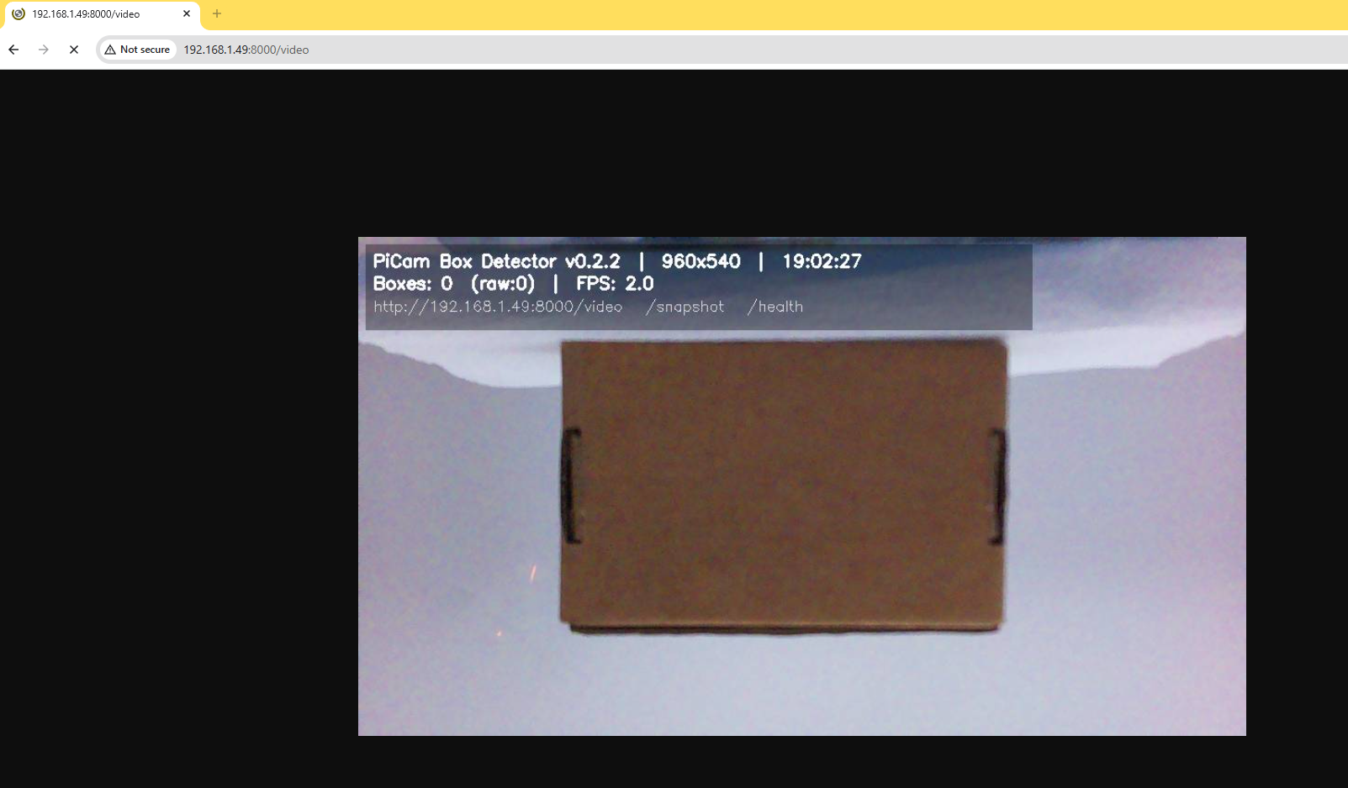

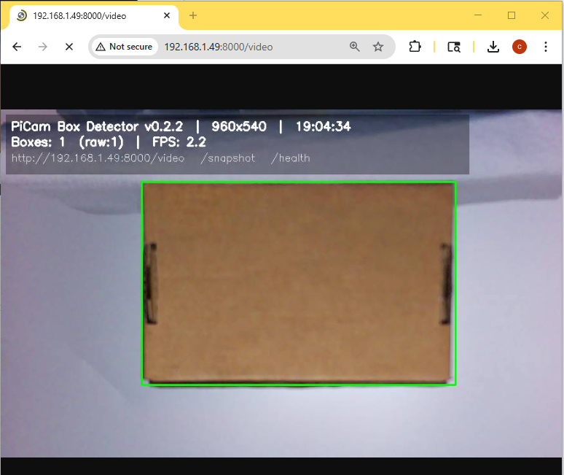

Figure 4. 4) Detection Sequence.

## 5) ROI / Overlay (Optional)

Region-of-interest rectangle/mask for focused detection.

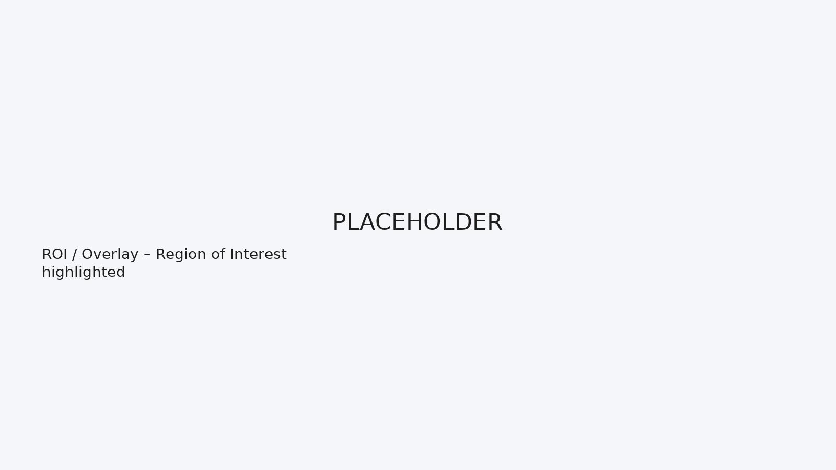

Figure 5. 5) ROI / Overlay (Optional).

## 6) Metrics

Raw CSV transition log (epoch, present) and a small timeline/step chart.

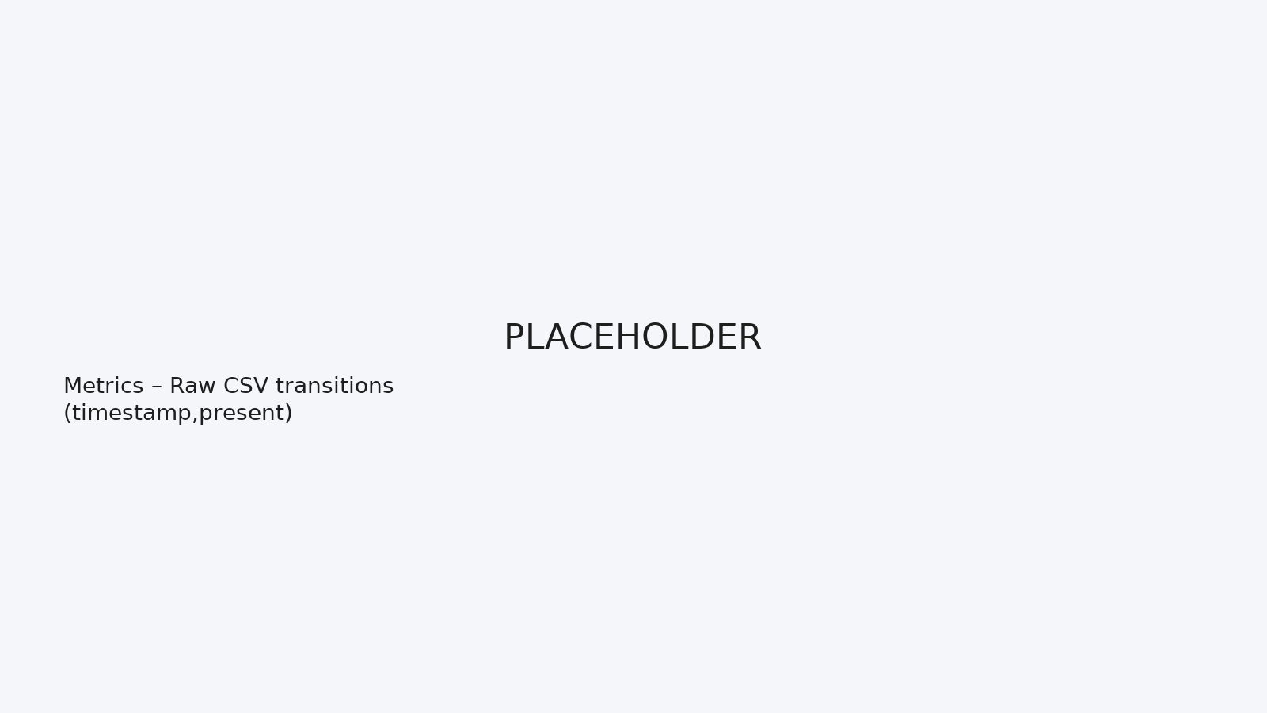

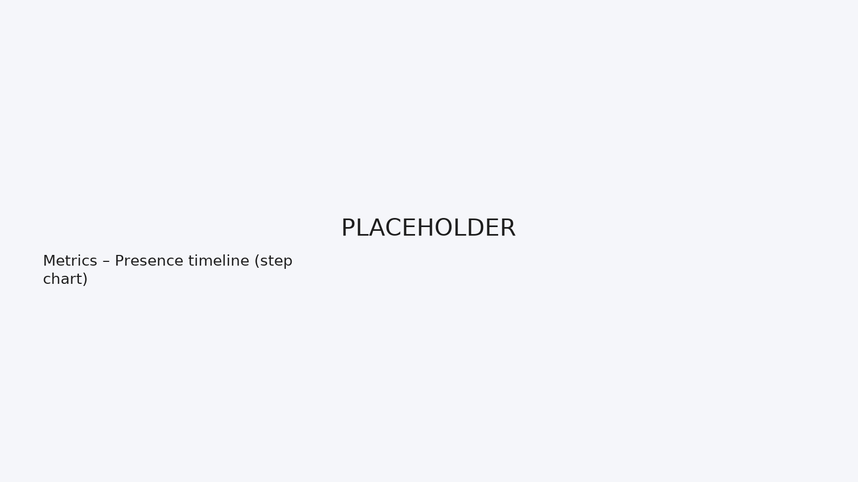

Figure 6. 6) Metrics.

## 7) Hardware

Assembly top view and typical placement/angle for the camera.

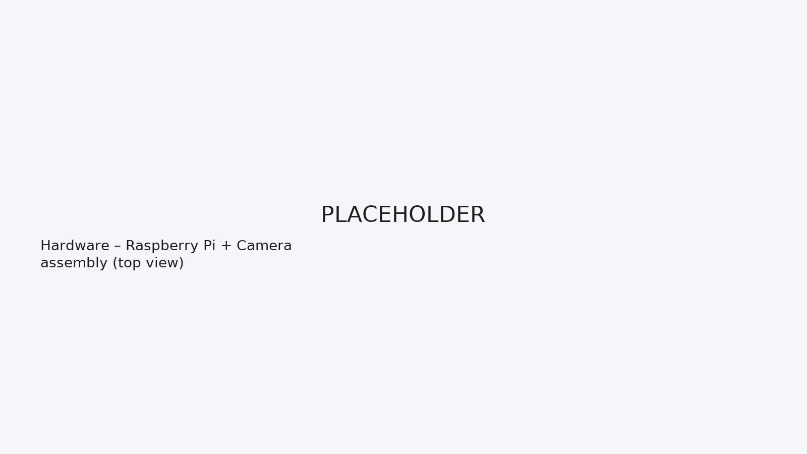

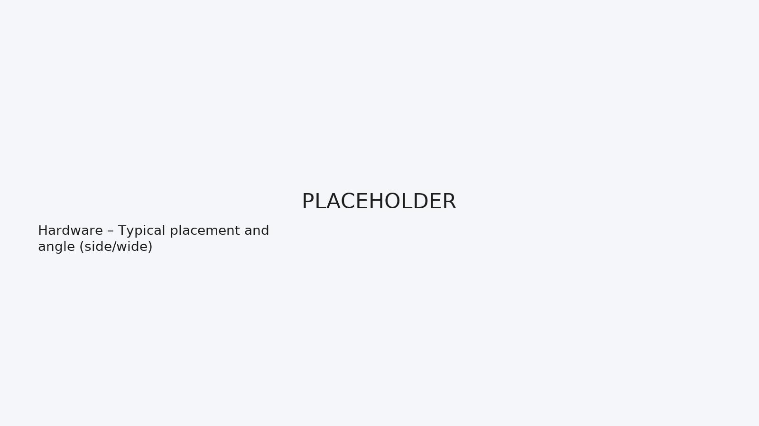

Figure 7. 7) Hardware.

## 8) Ops Proof

Show boot stability and reachability: systemd status and LAN access.

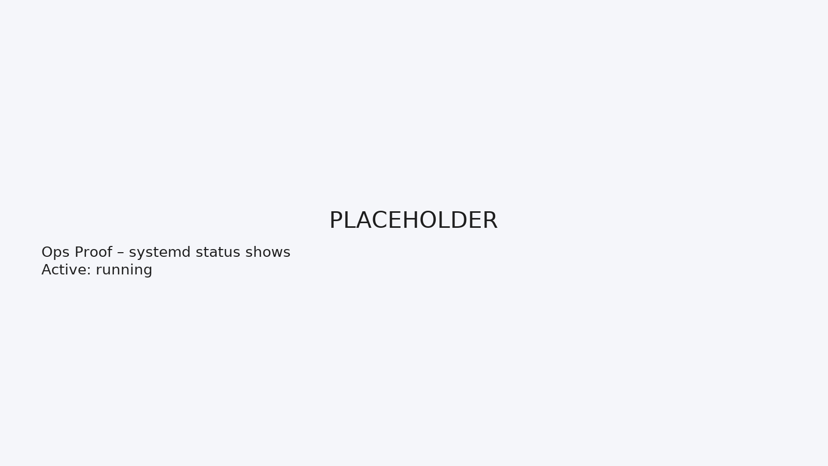

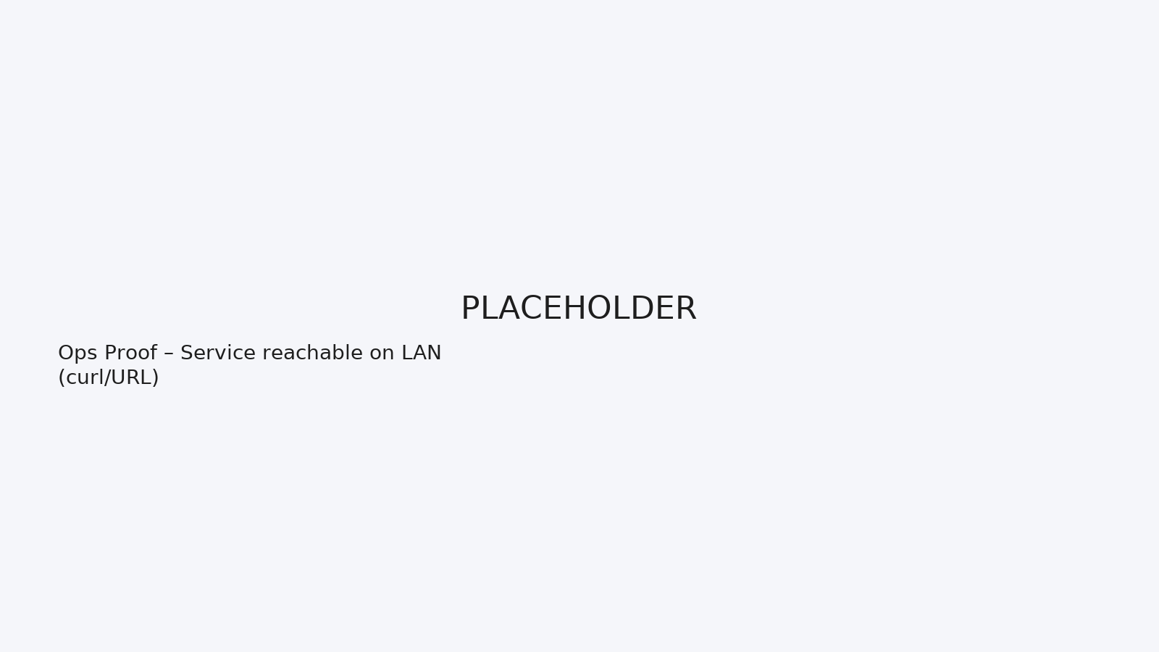

Figure 8. 8) Ops Proof.

## 9) Tuning & Edge Conditions

Threshold sensitivity comparison and behavior across varied lighting/backgrounds.

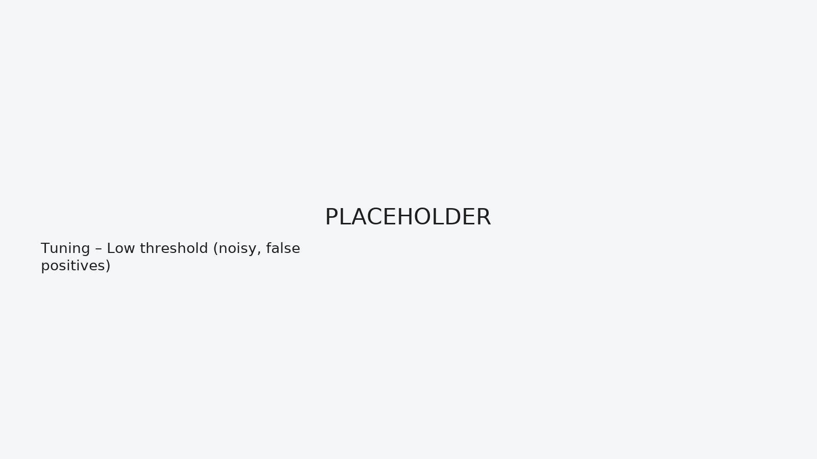

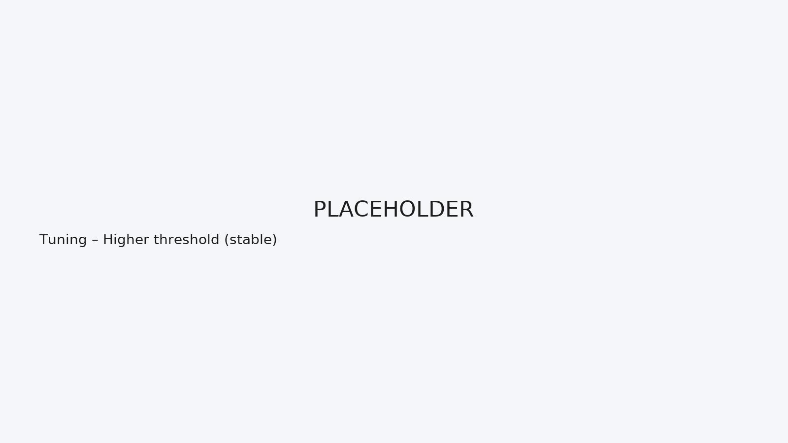

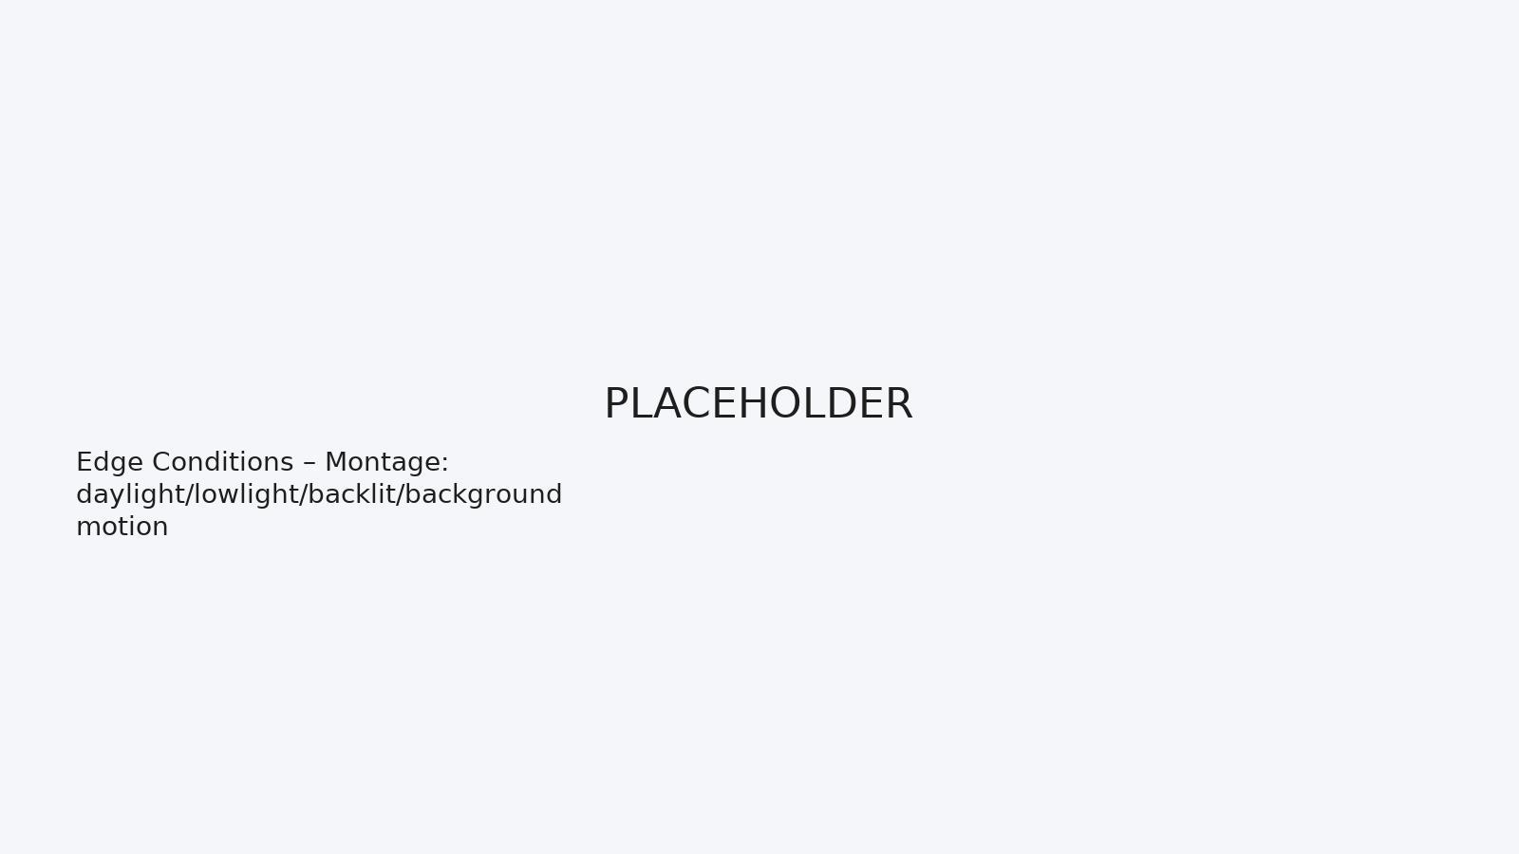

Figure 9. 9) Tuning & Edge Conditions.

# Quickstart

sudo apt update && sudo apt install -y python3-pip python3-opencv libatlas-base-dev  
python3 -m venv .venv && source .venv/bin/activate  
pip install -r requirements.txt  
python3 scripts/box_stream.py  
# visit http://<pi-ip>:8000

# Notes

• I keep dependencies in a venv so system Python stays clean.

• Logging: detections.csv appends on state flips only (compact, auditable).

• Service: use systemd/box-stream.service for boot start.

# License

MIT