STM32WLE5 LoRa Sensor Node
Hardware Design Report
Four-Layer Mixed-Signal Sensor Platform with Precision Analog Acquisition and Sub-GHz LoRa Connectivity

Design Overview  The STM32WLE5 LoRa Sensor Node is a compact mixed-signal embedded platform designed for remote sensing and low-power wireless data acquisition.  The design combines an STM32WLE5CC microcontroller with integrated Sub-GHz radio, onboard environmental and motion sensors, and a dedicated external analog path with input protection, signal conditioning, anti-alias filtering, precision voltage referencing and 14-bit ADC conversion.  The PCB uses a four-layer architecture with dedicated ground and power planes, separate analog and digital supply domains, and a controlled 50 Ω RF path to the external SMA antenna interface.  Key Design Features  - STM32WLE5CC MCU with integrated Sub-GHz / LoRa radio  - ADC141S626 14-bit external ADC with REF3033 reference  - Protected SMA external analog sensor input  - BME280 environmental sensor and MPU-6050 IMU  - Separate +3V3 digital and +3V3A analog power domains  - BGS12SN6 RF switching with matching/filter network  - 50 Ω controlled-impedance RF routing  - Four-layer PCB with dedicated GND and power planes | 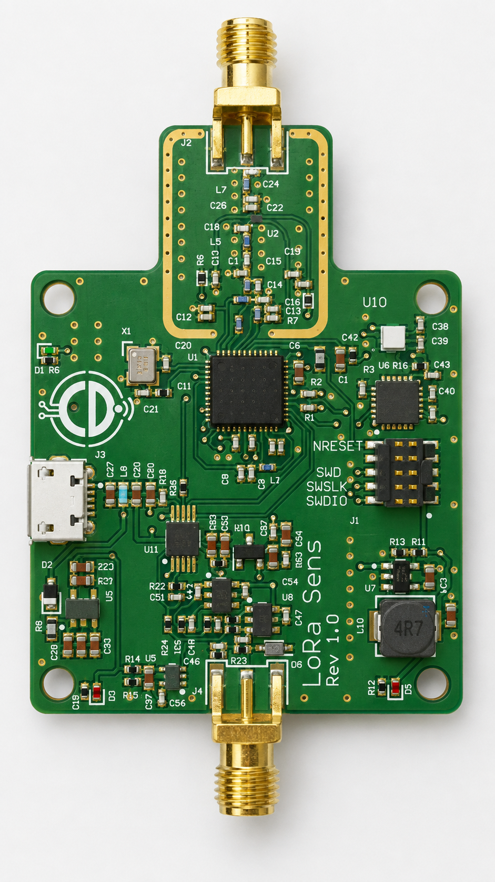  Figure 1 — STM32WLE5 LoRa Sensor Node manufactured-style PCB render.
Designed by: Caoilte Donohoe • Document Revision: 2.0 • September 2026

1. System Overview and Design Objectives
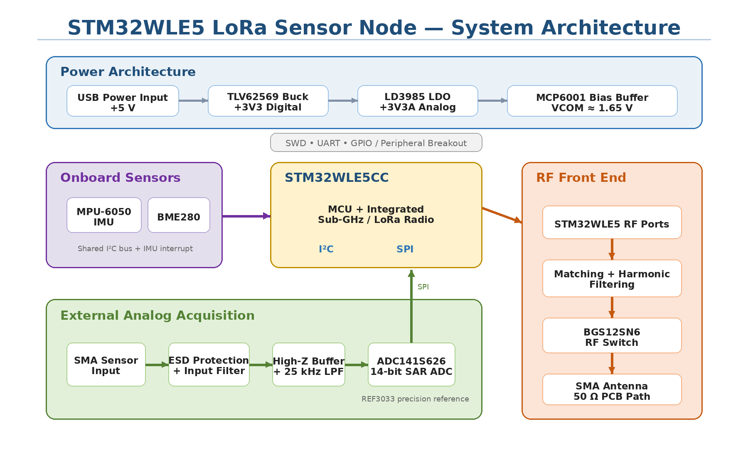
Figure 2 — STM32WLE5 LoRa Sensor Node system block diagram showing the main power, sensing, analog acquisition and RF signal paths.

1.1 Design Objective
I wanted this board to be more than a simple LoRa sensor node. The aim was to create a flexible platform that could collect useful data from sensors already fitted to the board, while also allowing an external analog sensor to be connected when a different measurement was required.
For the onboard sensing I included environmental and motion sensors. These provide temperature, humidity, pressure and movement information without needing any external hardware.
I also added a separate analog input through an SMA connector. This gives the board more flexibility and could be used, with suitable signal conditioning, for sensors such as vibration sensors, microphones, pressure sensors or other low-voltage analog outputs.
Another important part of the design was keeping the analog measurement path as clean as possible. The board contains both digital switching circuitry and an RF transmitter, so I wanted to reduce the chance of this noise finding its way into the ADC. I therefore separated the analog and digital power supplies and gave the analog section its own low-noise regulator.

1.2 System Architecture
The STM32WLE5CC sits at the centre of the design and handles the sensor interfaces, analog data acquisition and wireless communication.
The BME280 and MPU-6050 are connected to the microcontroller over I²C. The MPU-6050 also provides an interrupt output so that movement events can be detected without continuously polling the device.
The external analog input follows a separate path. The incoming signal is first protected and conditioned before passing through the anti-alias filter and into the ADC141S626 14-bit ADC. A REF3033 provides a dedicated precision reference for the ADC, and the converted data is transferred to the STM32WLE5CC over SPI.
On the RF side, I use the Sub-GHz radio already built into the STM32WLE5CC. The radio connects to the external antenna through the RF matching and filtering circuitry and a BGS12SN6 RF switch.

1.3 Main Functional Areas
I divided the board into five main areas:
- Microcontroller and Sub-GHz radio
- Environmental and motion sensing
- External analog input, AFE and ADC
- Analog and digital power supplies
- RF matching, filtering and antenna interface
Keeping these areas clearly defined also helped when I moved from the schematic into the PCB layout, particularly when separating the analog, digital and RF sections of the board.

2. Power Architecture
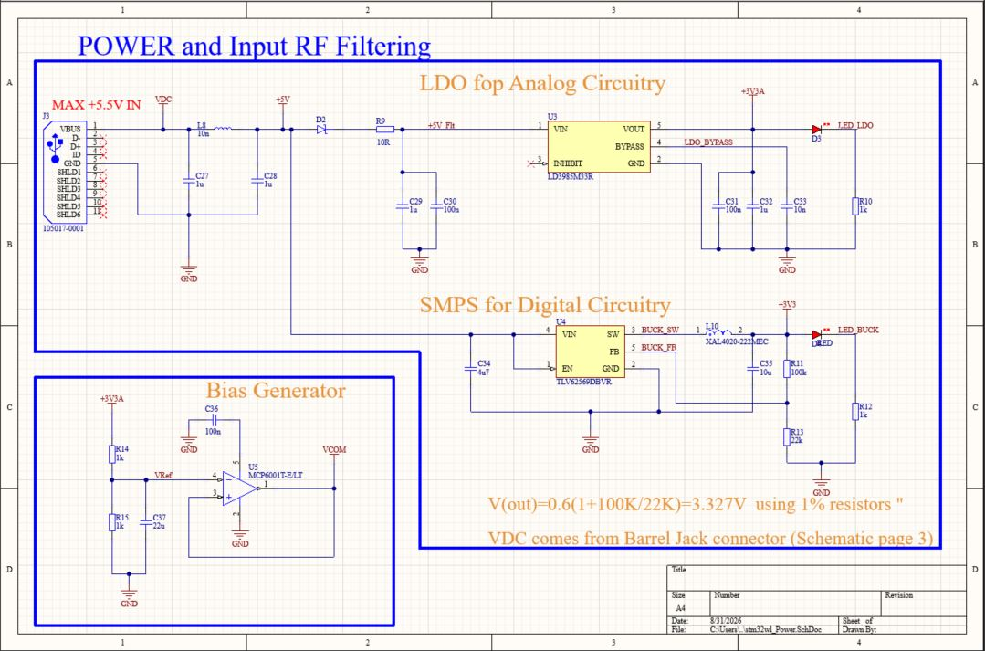
Figure 3 — Digital and analog power architecture showing the TLV62569 buck regulator, LD3985 analog LDO and MCP6001 VCOM bias generator.

2.1 Power Supply Approach
Because the board contains digital circuitry, sensitive analog circuitry and an RF section, I did not want to run everything directly from the same regulated supply.
For the main digital rail I used a TLV62569 buck converter to generate +3.3 V. A switching regulator gives good efficiency for the STM32WLE5CC and the other digital circuitry, where a small amount of switching noise is less critical.
For the analog section I took a different approach. I used an LD3985M33R low-noise LDO to generate a separate +3.3 VA rail for the ADC and analog front end. My aim here was to keep noise from the switching converter and digital circuitry away from the low-level analog signal path.
This gives the board two main 3.3 V domains:
- +3V3 — digital circuitry
- +3V3A — ADC and analog circuitry

2.2 Digital Supply
The TLV62569 is used as the main 3.3 V switching regulator. I chose a buck converter here because efficiency is more important on the digital side of the board, particularly if the design is eventually used as a remotely powered or battery-operated sensor node.
The feedback network sets the output to approximately 3.3 V, which supplies the STM32WLE5CC and the digital peripherals. The power input also includes filtering before it reaches the regulators, helping to reduce conducted noise entering the board and limit noise moving between sections.

2.3 Analog Supply
The analog circuitry is supplied from the LD3985M33R LDO. Rather than powering the ADC and analog front end directly from the switching regulator, I wanted a quieter local supply for this part of the circuit. The LDO therefore provides the separate +3V3A rail used by the analog signal chain.
This separation does not completely isolate the analog and digital sections, but it gives me better control over where switching currents and supply noise flow through the board. Decoupling is then placed locally around the analog devices to keep the supply impedance low close to the circuitry that needs it.

2.4 Analog Bias Voltage
The analog front end also requires a mid-supply bias point because the board operates from a single positive supply. I generate this VCOM level using an MCP6001 op-amp. This provides a buffered bias voltage that can be used by the analog signal path without relying on a high-impedance resistor divider alone.
VCOM is separate from the ADC precision reference. The ADC reference is provided by the REF3033 on the ADC/AFE section of the design.

3. Onboard Sensors
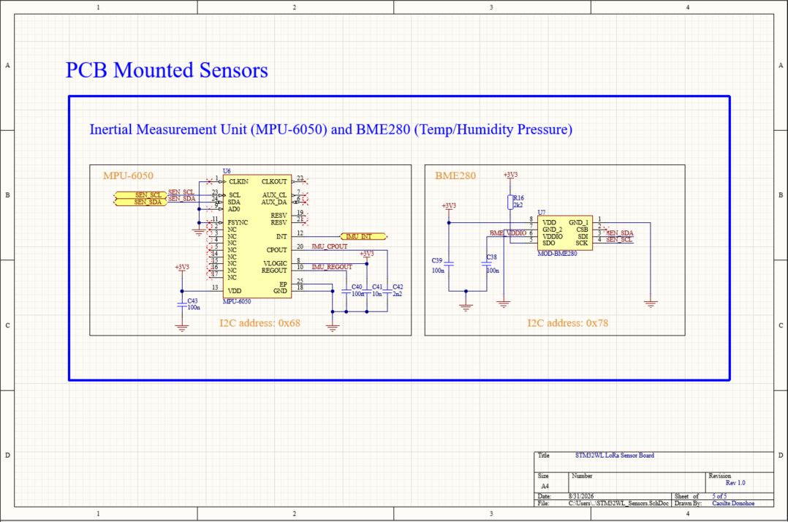
Figure 4 — BME280 environmental sensor and MPU-6050 motion sensor connected to the STM32WLE5CC through the shared I²C sensor bus.

3.1 Environmental and Motion Sensing
I wanted the board to provide useful sensing capability without relying entirely on an external sensor, so I included both environmental and motion sensing directly on the PCB.
For environmental measurements I used the BME280, which provides temperature, humidity and atmospheric pressure from a single device. For movement and orientation I used the MPU-6050, which combines a three-axis accelerometer and three-axis gyroscope.
Both sensors share the same I²C bus back to the STM32WLE5CC, which keeps the number of MCU pins required relatively low.

3.2 BME280 Environmental Sensor
I chose the BME280 because it combines three useful environmental measurements in a small digital sensor. From one device the board can measure temperature, relative humidity and atmospheric pressure.
The sensor communicates with the STM32WLE5CC over the SEN_SCL and SEN_SDA I²C lines. Using a digital sensor here also means the low-level analog measurement is handled internally by the BME280 rather than having to route additional analog signals across the PCB.

3.3 MPU-6050 Motion Sensor
The MPU-6050 provides acceleration and angular-rate information and allows the board to detect movement, vibration and changes in orientation. Like the BME280, it communicates with the STM32WLE5CC over I²C.
I also connected the MPU-6050 interrupt output to the microcontroller through the IMU_INT signal. This gives the firmware the option of responding to a motion event rather than continuously polling the sensor. That could be useful in a low-power application where the microcontroller spends much of its time in a reduced-power state and only needs to wake when something changes.

3.4 Shared Sensor Interface
Using the same I²C bus for both sensors keeps the interface simple while still allowing each device to be addressed independently. This also leaves the external analog acquisition path completely separate from the onboard digital sensors, which was important because I wanted the ADC section to remain available for sensors that provide a true analog output.

4. External Analog Input and Analog Front End

4.1 External Sensor Input
I wanted the board to have an analog input that was independent of the onboard digital sensors. This gives me the option of connecting an externally conditioned sensor without having to redesign the main board.
The signal enters through an SMA connector. I chose SMA mainly because it gives a mechanically secure connection and is convenient when working with screened cables and bench equipment.
The input is protected using a PESD3V3L1BA TVS device before the signal reaches the analog front end. This gives some protection against ESD and transient events that could otherwise be passed directly into the op-amp circuitry.
The external input is intended for appropriately conditioned, low-voltage analog signals rather than being a universal sensor interface. Depending on the external conditioning used, possible applications could include vibration, acoustic, pressure or other analog sensing.

4.2 Input Filtering and High-Impedance Buffer
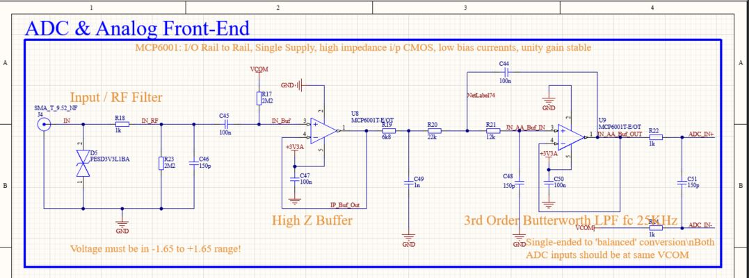
Figure 5 — External SMA analog input, ESD protection, high-impedance MCP6001 buffer and approximately 25 kHz anti-alias filter.
The first part of the analog front end provides input filtering followed by a high-impedance buffer.
I used the MCP6001 because it can operate from a single supply, has rail-to-rail input and output capability and presents a high impedance to the incoming signal. This is useful because I do not want the front end to unnecessarily load the external sensor. The buffer also gives the following filter stage a more predictable source impedance.
At the input I included filtering to reduce unwanted high-frequency content before the main anti-alias filter. This is particularly useful on a board that also contains a switching regulator and an RF transmitter.

4.3 Anti-Alias Filter
Before the signal reaches the ADC, I use a third-order low-pass filter with a cutoff region of approximately 25 kHz. I wanted a relatively flat useful passband while still getting a useful increase in attenuation above the frequencies of interest.
The third-order response is built from a first-order stage together with an active second-order Sallen-Key stage. The purpose of this filter is not just general noise reduction. It also limits the amount of high-frequency energy reaching the ADC, reducing the possibility of signals above the Nyquist frequency being aliased back into the sampled bandwidth.
The filter design and simulation are covered in more detail in Section 6.

5. ADC and Precision Reference

5.1 ADC Conversion Stage
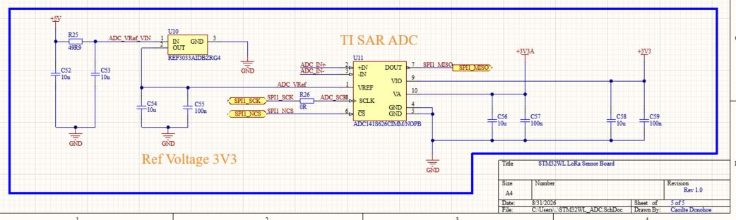
Figure 6 — ADC141S626 14-bit conversion stage, REF3033 precision reference and pseudo-differential analog input interface.
For the external analog channel I used an ADC141S626 14-bit ADC rather than relying on the ADC built into the STM32WLE5CC. This gives the analog input its own dedicated conversion stage and keeps the signal-conditioning, reference and ADC circuitry together within the analog section of the board.
The conditioned signal from the anti-alias filter is presented to the ADC through the ADC_IN+ and ADC_IN− inputs. The ADC then transfers the converted data to the STM32WLE5CC over SPI. Using SPI also keeps the analog acquisition interface separate from the I²C bus used by the onboard sensors.

5.2 Precision Voltage Reference
I used a REF3033 to provide the ADC with a dedicated 3.3 V reference. I did not want the accuracy of the conversion to depend directly on the main 3.3 V supply, particularly as that rail also powers digital circuitry. The REF3033 provides a more stable reference specifically for the ADC.
The reference is locally decoupled and powered from the analog +3V3A supply.

5.3 VCOM and Pseudo-Differential Input
Because the analog circuitry operates from a single supply, the signal needs a bias point that allows an AC waveform to move both above and below its resting level without requiring a negative supply. I generate this bias as VCOM using an MCP6001 buffer.
It is important to distinguish VCOM from the ADC reference:
- VCOM provides the bias point used by the analog signal path.
- REF3033 provides the precision reference used by the ADC for conversion.
The final ADC input is arranged as a pseudo-differential signal, with the conditioned analog signal applied to ADC_IN+ and the bias/reference side applied to ADC_IN−. This allows the ADC to measure the signal relative to the analog bias point rather than simply relative to ground.

5.4 Interface to the STM32WLE5CC
The ADC connects to the microcontroller through SPI using the clock, chip-select and data signals provided by SPI1. Once a conversion has been completed, the STM32WLE5CC can read the ADC result and combine it with measurements from the onboard environmental and motion sensors before processing or transmitting the data over LoRa.

6. Anti-Aliasing Filter Design and Simulation
For the external analog input I wanted to limit the amount of high-frequency content reaching the ADC before the signal was sampled. Rather than rely on a single RC filter, I used a third-order low-pass arrangement made up of a first-order RC stage followed by an active second-order Sallen-Key stage.
This gave me a steeper roll-off above the measurement band while keeping the circuit reasonably simple. The component values place the two filter stages in the same general region, with the RC stage at about 23.4 kHz and the Sallen-Key stage at about 25.3 kHz.
I used simulation first to check the frequency response and transient behaviour, and then repeated the analysis in Python so I could look at the same design from a signal-processing point of view.

6.1 Filter Circuit and LTspice Model
The LTspice model uses R5 and C5 as the first-order input stage, followed by the active Sallen-Key network around U1. I also included the small output RC network so that the simulation reflected the signal path presented to the ADC more closely.
For the op-amp model I used a 1 MHz gain-bandwidth product and an open-loop gain of 100 k, chosen to approximate the behaviour of the MCP6001 used in the hardware.
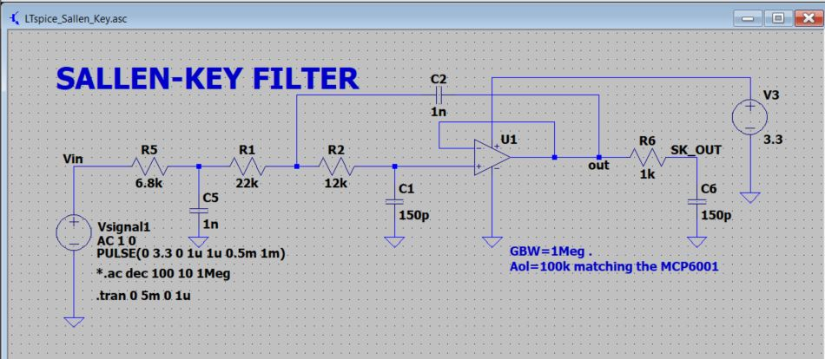
Figure 7 — LTspice model of the third-order analog low-pass filter, including the input RC stage, active Sallen-Key section and output RC network.

6.2 LTspice Frequency Response
I first checked the filter with an AC sweep. The response stays close to flat at low frequency before beginning to roll off through the 20–30 kHz region. At higher frequency the attenuation approaches the behaviour expected from a third-order low-pass network.
The LTspice cursor measurement around the transition region is useful as a practical check of the simulated cutoff, while the phase trace shows the increasing phase lag introduced as the three poles begin to dominate.
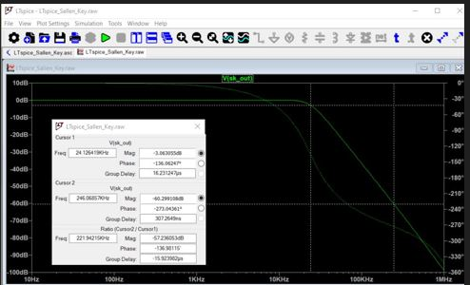
Figure 8 — LTspice AC sweep of the analog low-pass filter showing the magnitude and phase response around the transition region.

6.3 LTspice Time-Domain Response
I then moved to transient analysis. With a 10 kHz sine-wave input, the output follows the input cleanly but with the expected phase delay and a small change in amplitude. This confirmed that a signal well below the cutoff could pass through the filter without being heavily attenuated.
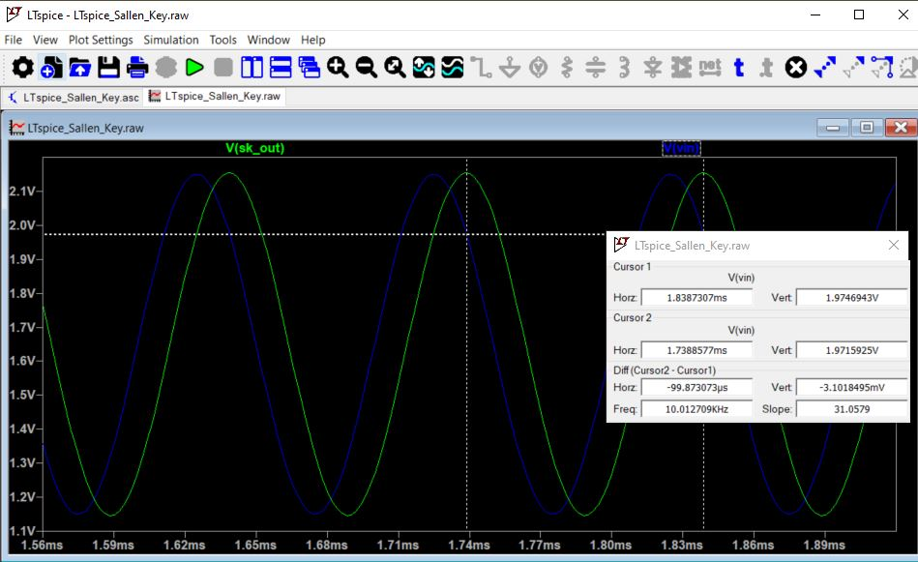
Figure 9 — LTspice 10 kHz transient response showing the input waveform and filtered output, including the expected phase delay.
A pulse test provides a more demanding check because a fast edge contains a large amount of high-frequency energy. The filter rounds the transitions and shows a small amount of overshoot and settling before reaching the steady value. This is consistent with the active second-order stage and is not a concern for the intended analog measurement path.
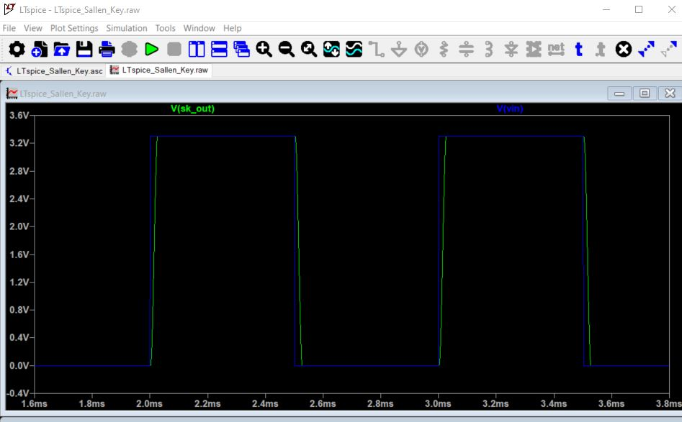
Figure 10 — LTspice pulse response showing edge smoothing, short-duration overshoot and settling produced by the analog low-pass filter.

6.4 Python Analysis Environment
After the LTspice work I repeated the main checks in Python using the Anaconda distribution and Jupyter Notebook. This made it easy to calculate the filter response, generate test signals and compare the signal before and after filtering.
Analysis tools
Anaconda — Python environment and package management
Jupyter Notebook — interactive calculation and plotting
NumPy — numerical arrays and calculations
SciPy — signal-processing and filter-analysis functions
Matplotlib — Bode, time-domain and FFT plots

6.5 Python Frequency-Domain Check
The Python calculation gave an RC cutoff of about 23.4 kHz and a Sallen-Key cutoff of about 25.3 kHz. The calculated response then rolls off toward approximately −60 dB/decade at high frequency, which is consistent with three low-pass poles.
The phase response progresses toward approximately −270° as frequency increases. This is another useful check that the complete network is behaving as a third-order filter rather than as a single low-pass stage.
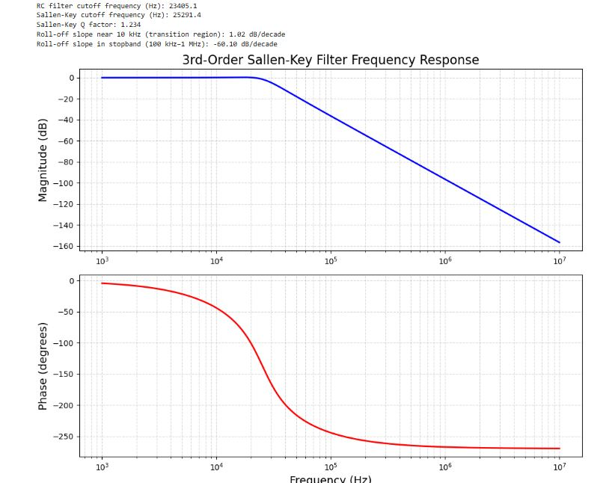
Figure 11 — Python magnitude and phase response of the third-order analog low-pass filter. The calculated transition region is centred around 25 kHz.

6.6 Python Time-Domain Check
I also generated time-domain tests in Python. The 10 kHz sine-wave result shows the same behaviour seen in LTspice: the wanted signal is retained, with a visible phase delay through the filter.
The pulse test again shows the short-duration overshoot and ringing produced by the active filter response. The important point for this design is that the waveform settles quickly and that the filter is doing what I intended—removing the high-frequency content associated with rapid transitions.
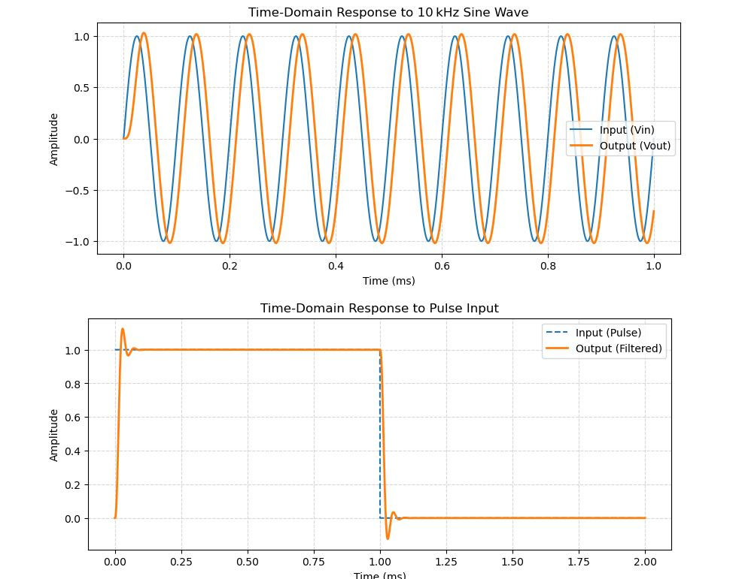
Figure 12 — Python time-domain analysis showing the 10 kHz sine-wave response and the response to a pulse input.

6.7 FFT Noise-Rejection Test
To make the filtering action easier to see, I created a test signal containing a wanted 10 kHz component together with an unwanted 100 kHz component and compared the spectra before and after filtering.
The peak at 10 kHz is the wanted signal. The second peak at 100 kHz is the deliberately added high-frequency component. After filtering, the 10 kHz component remains clearly visible while the 100 kHz peak is strongly reduced.
The deep dip between the two peaks in the unfiltered FFT should not be treated as a real notch in the hardware. It is a feature of the finite FFT calculation and the way the discrete simulated tones, FFT bins and spectral leakage combine between the two main components. For this test, the meaningful comparison is the change in amplitude at the known 10 kHz and 100 kHz frequencies.
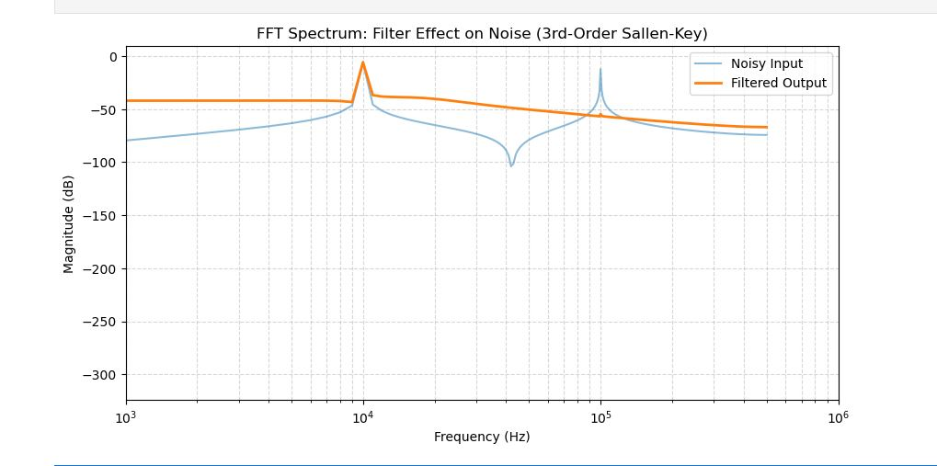
Figure 13 — FFT comparison of the noisy input and filtered output. The wanted 10 kHz component is retained while the deliberately added 100 kHz component is substantially attenuated.

6.8 Time-Domain Noise Reduction
The same test is also useful in the time domain. Before filtering, the high-frequency component is clearly visible on top of the wanted sine wave. After the filter, the waveform is much cleaner and follows the underlying 10 kHz signal.
The original Python output also produced a post-filter SNR value by comparing the filtered waveform directly with the original unshifted signal. I have not used that value in the report because the filter changes both gain and phase; without compensating for those changes, part of the wanted signal can be counted incorrectly as noise.
A more meaningful SNR calculation would first align the filtered signal in gain and phase, or calculate the wanted and unwanted power directly from the frequency-domain data.
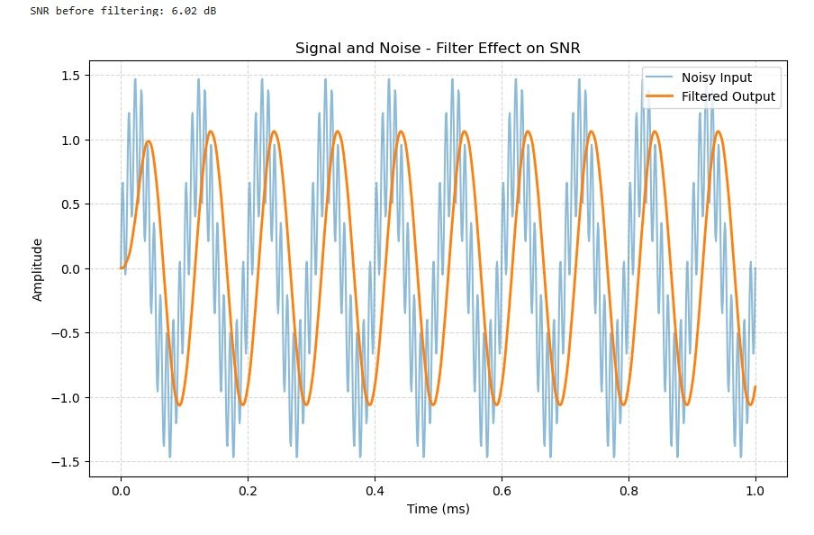
Figure 14 — Time-domain comparison of the noisy input and filtered output. The original pre-filter SNR is shown; the post-filter SNR value has been omitted because the direct calculation did not compensate for filter gain and phase.

6.9 Simulation Outcome
The LTspice and Python results gave me several independent checks on the filter before carrying it into the final analog front end.
- The transition region is centred around the intended 25 kHz range.
- A 10 kHz signal passes through with only modest attenuation and the expected phase delay.
- The high-frequency roll-off approaches the behaviour expected from a third-order low-pass network.
- The pulse response is stable, with short-duration overshoot and settling rather than sustained oscillation.
- The FFT test shows strong attenuation of the deliberately added 100 kHz component while retaining the wanted 10 kHz signal.
- The time-domain noise test gives a clear visual check that the unwanted high-frequency content is being removed.
Taken together, these results gave me enough confidence in the filter response to use the same approach in the external analog acquisition path of the STM32WLE5 sensor board.

7. RF Front-End Design and Simulation
The STM32WLE5CC already contains the Sub-GHz radio, but the RF signal still needs the correct external matching, filtering and antenna switching before it reaches the SMA connector. I treated this as a separate design area because small component values, PCB parasitics and layout all have a much greater effect at 868 MHz than they do in the lower-frequency parts of the board.
I started with a simplified LTspice model so I could understand the impedance transformation and harmonic filtering before moving to the final schematic. The simulation values shown in this section are therefore part of the RF design development; the final PCB uses the implemented component values and the BGS12SN6 RF switch shown in the current Altium design.

7.1 RF Design Approach
For this design I use the STM32WLE5 low-power RF output for the transmit path and the differential RFI_P / RFI_N inputs for receive. A single external SMA antenna is shared between transmit and receive, so the RF front end also needs a switch to route the antenna to the correct path.
The main jobs of the external RF network are to transform the STM32WLE5 RF impedance toward 50 Ω, reduce harmonic energy outside the wanted band, provide the required DC blocking and route the antenna between the transmit and receive paths.
ST's STM32WL RF matching guidance was my starting point, but I used simulation to explore the effect of the individual matching and filtering sections before laying out the final network.

7.2 Initial 868 MHz Impedance Match
For the first LTspice model I represented the STM32WL RFO_LP output at 868 MHz with a 15.27 Ω series resistance and a 144 pF series capacitance. This approximates the complex source impedance I was working from and gives a simple way of testing the impedance transformation into a 50 Ω load.
The first matching stage used an inductor of about 4.45 nH and a shunt capacitor of about 5.49 pF. The simulated response is close to 0 dB around the target frequency, with the cursor in this run showing approximately −0.87 dB at 866.7 MHz.
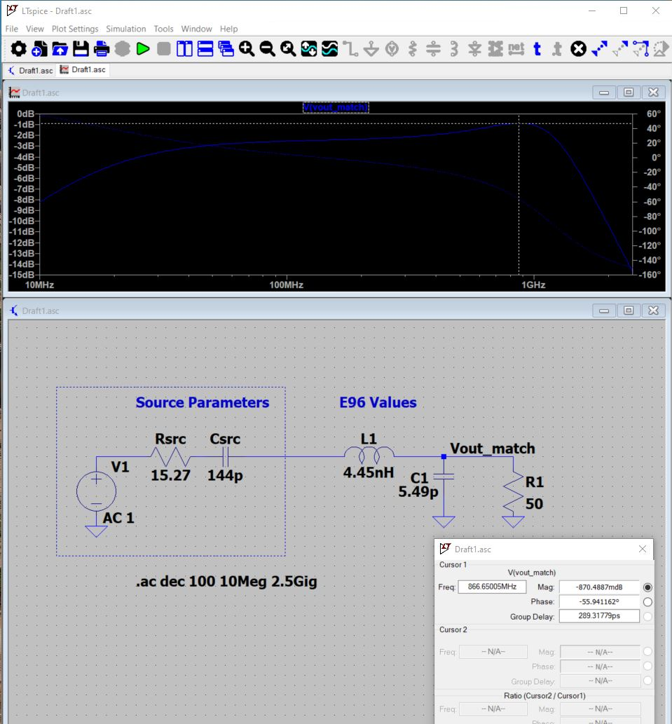
Figure 15 — Initial LTspice model of the STM32WL RF output impedance and L-match into a 50 Ω load at approximately 868 MHz.
Simulation model
This first circuit is intentionally simplified. It was useful for understanding the impedance transformation, but it does not include PCB transmission-line effects, package parasitics or the complete final RF switch and filter network.

7.3 Expanded TX Matching and Harmonic Filtering
Once the basic match was behaving as expected, I expanded the model to include the other sections I expected to need in the transmit path: the initial matching circuit, a harmonic/notch section, a DC-blocking capacitor, a π-filter and a simple RF-switch model.
For this development model I represented the RF switch as a small series resistance and inductance rather than modelling a specific device. That let me include the main insertion-loss and parasitic effects without making the early simulation unnecessarily complicated.
In the version without the additional final output π-filter, the simulation gave about −1.24 dB at 868 MHz and roughly 57–59 dB of attenuation at the second harmonic around 1.736 GHz. The simulated group delay at the wanted frequency was approximately 591 ps.
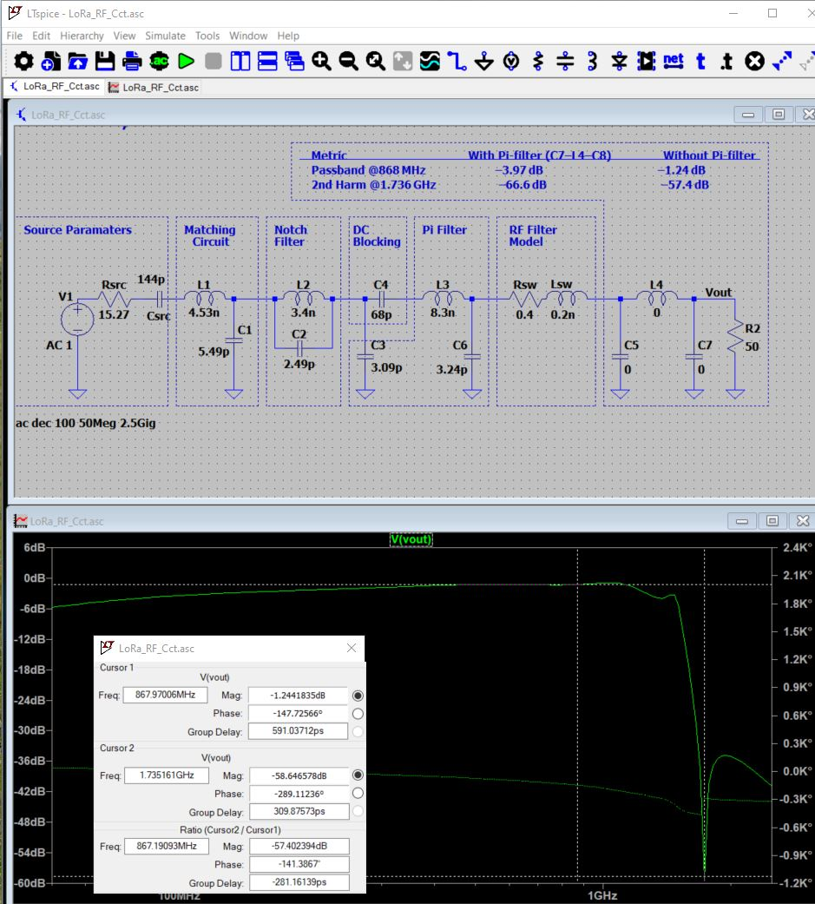
Figure 16 — Expanded LTspice transmit-path model including matching, harmonic filtering, DC blocking, π-filtering and a simplified RF-switch model.

7.4 Output π-Filter Trade-Off
I also tested an additional π-filter at the antenna side of the simulated switch. This gave better second-harmonic suppression, but it also introduced a noticeable increase in loss at the wanted 868 MHz frequency.
Simulation | Passband @ ~868 MHz | 2nd harmonic @ ~1.736 GHz
Without final output π-filter | −1.24 dB | −57.4 dB
With final output π-filter | −3.97 dB | −66.6 dB

The extra stage improved the simulated second-harmonic rejection by about 9 dB, but the passband loss increased by roughly 2.7 dB. For a low-power radio link that is a significant trade-off, because every dB lost in the output network reduces the RF power available at the antenna.
This comparison was useful because it showed that adding more filtering is not automatically an improvement. The additional π-filter only makes sense if the extra harmonic suppression is actually required and the network can be tuned without giving away too much wanted-band power.
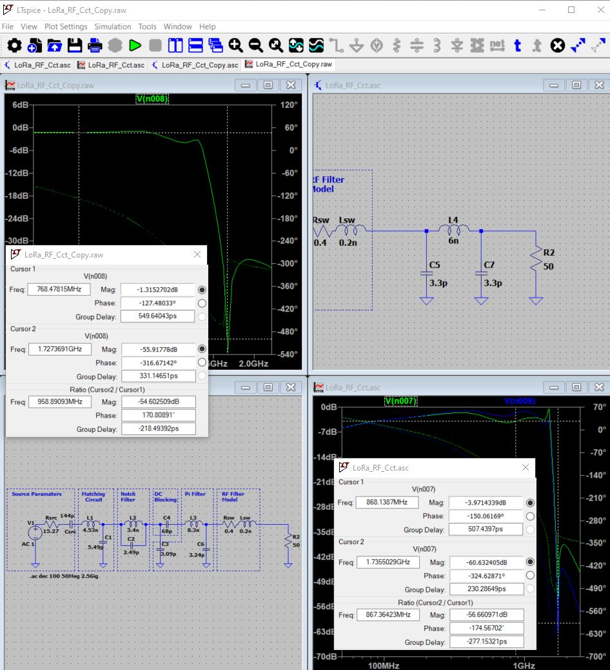
Figure 17 — LTspice comparison of the RF response with and without the additional output π-filter, showing the trade-off between harmonic rejection and passband loss.

7.5 Final Implemented RF Network
The final Altium schematic is more representative of the real hardware than the earlier LTspice development models. The simplified switch model was replaced by a BGS12SN6 RF switch, controlled from the STM32WLE5 through the FE_CTRL2 signal, so the same SMA antenna can be used for both transmit and receive.
The implemented transmit path comes from RFO_LP and uses revised matching and filter values. Examples from the final schematic include L2 = 4.4 nH, L3 = 3.4 nH, C3 = 3.5 pF, C4 = 68 pF and C5/C7 = 5.5 pF. The receive path uses the differential RFI_P and RFI_N inputs, with components including L6 = 12 nH and 4.5 pF capacitors around the receive matching section.
These values should be treated as the implemented schematic values rather than a direct copy of the LTspice values above. The simulation work helped me understand the matching and filtering behaviour, while the final component network reflects the actual STM32WLE5/BGS12SN6 implementation.
Development values versus final BOM
Figures 15–17 document the RF design process. They are not intended to be a component-for-component representation of the final PCB. The final schematic and PCB remain the source of truth for fitted RF values.

7.6 RF PCB Implementation
I placed the RF section in the narrow upper part of the PCB, directly below the antenna SMA connector. This keeps the matching and switching components grouped together and avoids routing the antenna path through unrelated digital or analog circuitry.
The RF nets use a dedicated 50 Ω routing rule in Altium. I also kept a continuous ground reference around the RF area and added a line of grounded vias around the perimeter. The exposed grounded copper boundary provides a clear physical separation around the RF section and ties the surrounding top-side ground back to the internal ground structure.
The layout view and manufactured-style render below show the same RF area from two different perspectives. The signal path is kept compact, the small RF components are clustered close to the SMA connection, and the via fence follows the outside of the RF region.
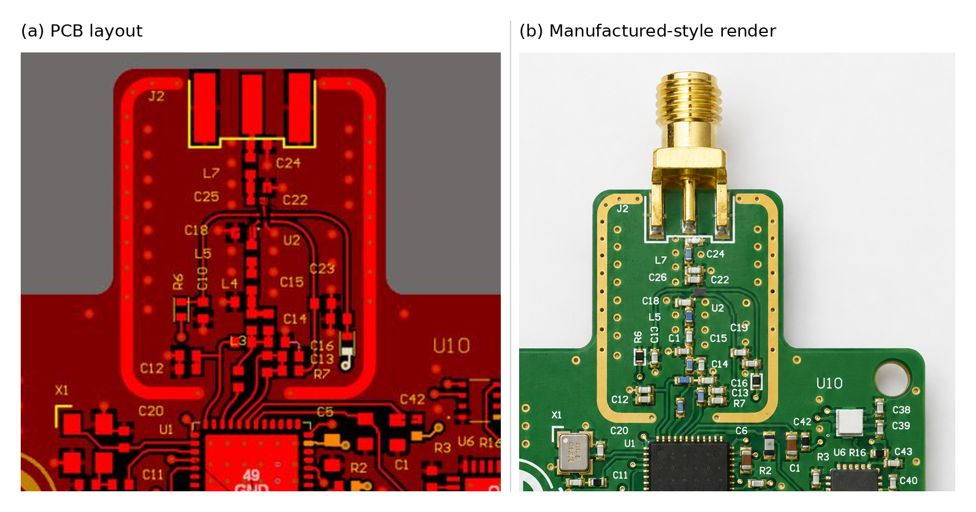
Figure 18 — Final RF PCB implementation: (a) Altium layout of the RF section and (b) manufactured-style render showing the SMA connector, RF component placement, grounded boundary and via fencing.

7.7 RF Verification Status
The LTspice work gave me a useful circuit-level check of the matching and harmonic-filtering approach, but it is not a substitute for RF measurement on the manufactured board. At these frequencies the final response will also depend on component tolerances, package parasitics, the PCB dielectric stack-up and the exact transmission-line geometry.
For hardware verification I would check the antenna port with a VNA and then measure conducted transmit power and harmonic content with suitable RF test equipment. Those measurements would allow the matching network to be tuned if required and would confirm the real insertion loss and harmonic performance of the completed PCB.

7.8 Section Summary
The RF work progressed from a simple 868 MHz impedance model, through a more complete matching and harmonic-filter simulation, and finally into the implemented STM32WLE5/BGS12SN6 front end and controlled-impedance PCB layout.
The main lesson from the simulation was that harmonic suppression and passband loss have to be considered together. That trade-off influenced the final approach and helped keep the RF path focused on the filtering that was useful rather than simply adding extra stages.

8. PCB Layout, Layer Stack and Design Rules
Once the schematic was stable, the next stage was turning the individual circuit blocks into a practical four-layer PCB. At this point the main challenge was no longer just making the connections; I also had to think about where each circuit should sit, how return currents would flow and how to keep the RF, analog and switching-power sections from interfering with each other.

8.1 PCB Placement and Functional Partitioning
I arranged the board so that the main functional areas are easy to identify. The RF section sits at the top of the board directly below the antenna SMA connector, while the STM32WLE5CC is placed centrally so that its RF, sensor, ADC and debug connections can all be kept reasonably short.
The external analog input and AFE are kept toward the lower part of the board close to the sensor SMA connector. The digital buck converter and analog LDO are grouped away from the RF matching components, and the SWD connector is positioned where it remains accessible during bring-up.
I found this functional partitioning useful because it gave each part of the design a clear area of the PCB rather than allowing unrelated signals to become mixed together during routing.
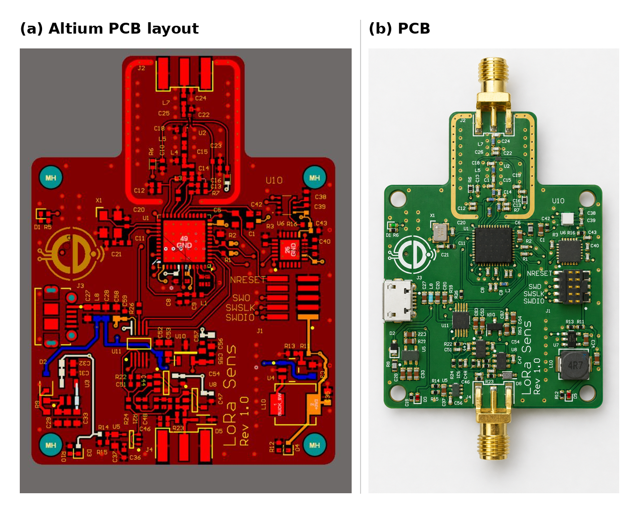
Figure 19 — Overall PCB implementation showing the Altium layout and PCB. The RF section is located at the top, the STM32WLE5CC centrally, with the analog acquisition and power sections arranged around the lower half of the board.

8.2 Four-Layer Stack-Up
I used a four-layer stack rather than trying to route the design on two layers. The extra internal layers gave me a much better ground reference for the RF and mixed-signal routing and also made the power distribution easier to control.
Layer 2 is used as the main continuous ground plane. This means the top-layer RF and signal traces have a nearby ground reference rather than relying on long return paths around routed copper. Layer 3 is used mainly for power distribution, while the two outer layers remain available for components and signal routing.
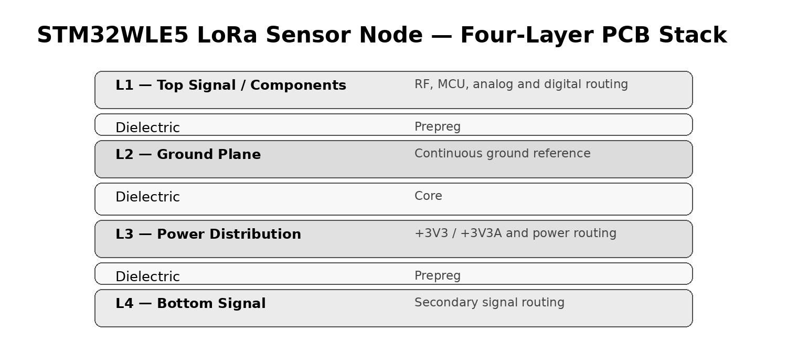
Figure 20 — Four-layer PCB stack used for the sensor board. Layer 2 provides the main continuous ground reference, while Layer 3 is used for power distribution.

8.3 Ground and Power Distribution
I kept the ground system common rather than splitting the board into separate analog and digital grounds. My aim was to control the current paths through placement, routing and power-domain separation rather than create a ground split that RF or digital return currents might have to cross.
The analog and digital sections still use separate supply rails: +3V3 for the main digital circuitry and +3V3A for the ADC and analog front end. The Layer 3 power distribution lets those rails be routed without giving up the continuous ground reference on Layer 2.
Ground vias are used throughout the board to connect top- and bottom-side ground copper back to Layer 2. The RF section uses a denser via fence because the return path and field containment are more critical around the antenna network.
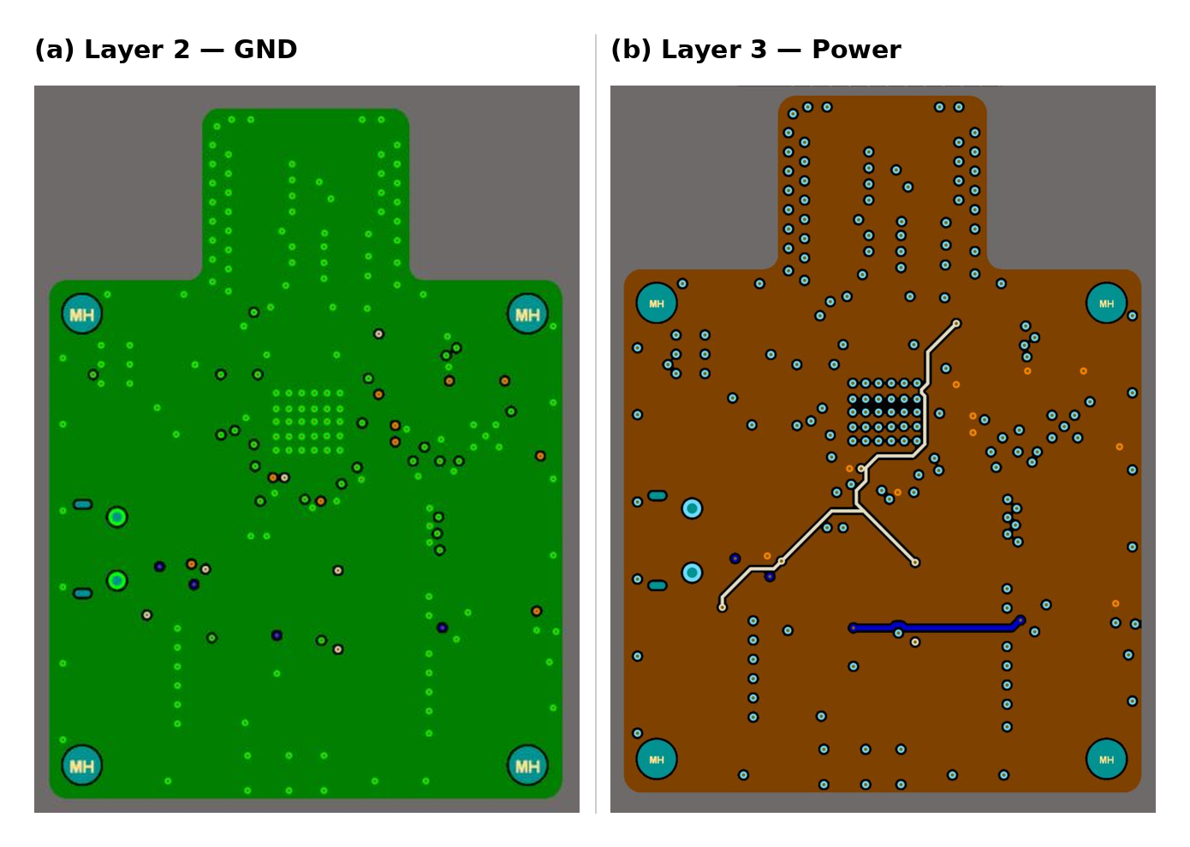
Figure 21 — Internal copper layers: (a) Layer 2 continuous GND plane and (b) Layer 3 power distribution used for the main supply rails.

8.4 Routing and Clearance Rules
I used Altium design rules rather than relying on manually selecting trace widths while routing. Most low-current signals use a preferred width of 0.20 mm, while the RF net class has its own preferred width of 0.35 mm.
The final DRC also checks a 0.15 mm general clearance and a dedicated 0.15 mm clearance between the RF_50_Ohm net class and GND. Using separate rules made it easier to keep the ordinary digital routing flexible without accidentally changing the RF path.
Rule | Current value | Reason / use
General clearance | 0.15 mm | Minimum copper-to-copper spacing used in the DRC.
General routing width | 0.20 mm preferred | Standard low-current signal routing.
RF_50_Ohm routing width | 0.35 mm preferred | Dedicated RF net-class width rule used for the RF path.
Width limits | 0.20 mm min / 0.80 mm max | Permitted routing range in the final rule set.
RF-to-GND clearance | 0.15 mm | Dedicated clearance check between RF_50_Ohm nets and GND.
Hole-to-hole clearance | 0.254 mm | Mechanical/drill spacing check.
Silkscreen-to-solder-mask | 0.15 mm | Avoids silkscreen encroaching on exposed pads.
Silkscreen-to-silkscreen | 0.254 mm | Keeps text and graphical markings legible.

8.5 Analog Layout Considerations
I kept the ADC, voltage reference and analog front-end components grouped together so that the low-level signal path does not have to travel through the digital or RF sections of the PCB.
Local decoupling capacitors are placed close to the analog devices, and the +3V3A rail is kept separate from the main digital +3V3 supply. I also tried to keep the switching node of the buck regulator confined to the power section rather than routing sensitive analog signals through that area.
The layout is not intended to create an electrically isolated analog island. Instead, it uses a common ground plane with controlled placement and supply routing, which gives the analog circuitry a short return path while avoiding unnecessary ground discontinuities.

8.6 Design Rule Check
Before treating the PCB as ready for fabrication, I ran Altium's Design Rule Check against the final rule set. The report completed with zero warnings and zero rule violations.
The checks included clearance, short circuits, unrouted nets, modified polygons, routing widths, power-plane connections, drill clearances, solder-mask and silkscreen spacing, net antennas and component-height limits.
For me this is an important final step because a board can look complete on screen while still containing a small clearance, unrouted-net or manufacturing-rule problem that is easy to miss during visual inspection.
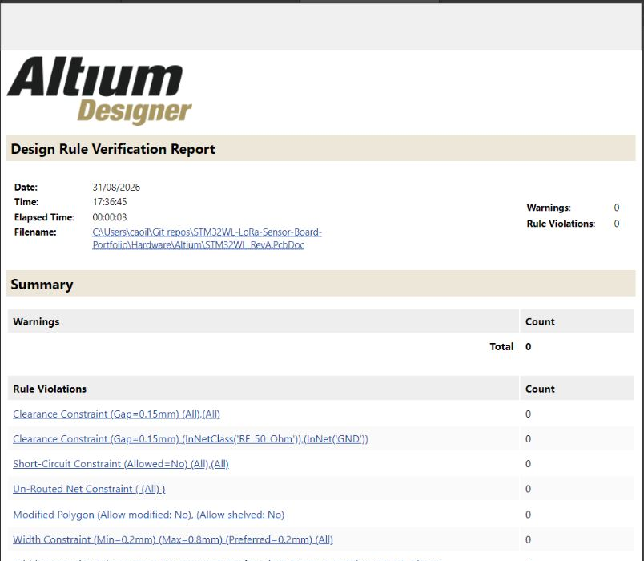
Figure 22 — Final Altium Design Rule Verification Report showing 0 warnings and 0 rule violations; the report also confirms the main clearance and routing-width checks used for the board.

8.7 Manufacturing Readiness
With the schematic, PCB routing and DRC complete, the design is at the point where fabrication outputs can be generated from Altium. The production package can include the copper and solder-mask layers, drill data, assembly information, bill of materials and pick-and-place data required by the PCB manufacturer and assembler.
A clean DRC does not prove that the circuit will perform correctly on the bench, particularly in the RF and analog sections, but it gives me confidence that the physical PCB database is internally consistent before manufacturing.

8.8 Section Summary
The four-layer layout gave me a much better structure for the mixed-signal design than a simple two-layer implementation. The continuous Layer 2 ground plane, Layer 3 power distribution, dedicated RF routing rules and functional placement all work together to keep the different parts of the board organised.
The final zero-violation DRC then provides a useful manufacturing checkpoint before the design moves from PCB layout into fabrication and hardware bring-up.

9. Design Verification and Bring-Up Plan
The schematic, PCB layout and simulation work give me a good level of confidence in the design, but they do not replace measurements on an assembled PCB. For hardware bring-up I would work through the board in stages rather than power everything and immediately start testing the full system.
My plan is to verify the supply rails first, then establish reliable access to the STM32WLE5CC through SWD. Once the basic digital platform is stable, I can move through the sensors, analog acquisition path and finally the RF section.
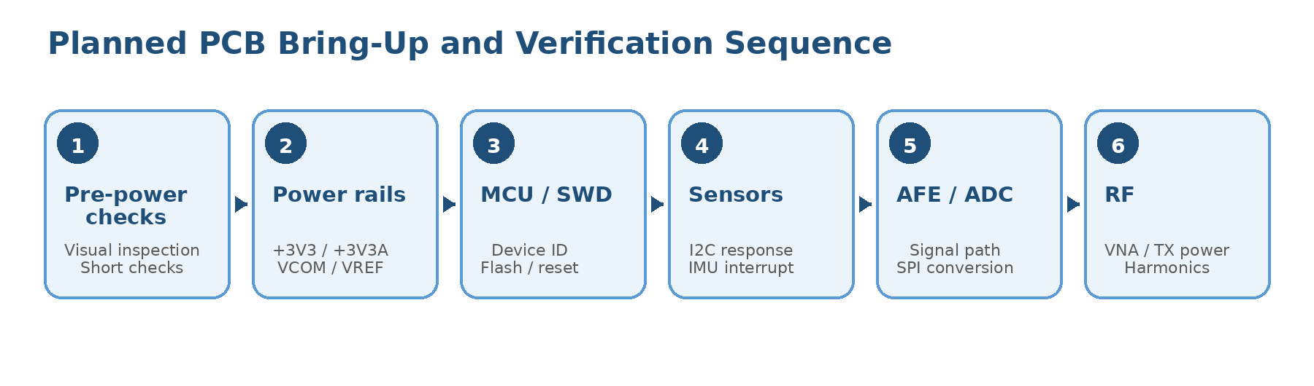
Figure 23 — Planned PCB bring-up sequence, progressing from pre-power inspection and supply checks through MCU, sensor, analog and RF verification.

9.1 Pre-Power Checks
Before applying power I would start with a visual inspection of the PCB and assembly. I would pay particular attention to device orientation, fine-pitch solder joints, the STM32WLE5 exposed pad, the ADC and reference circuitry, the RF switch and the two SMA connectors.
I would then use a multimeter to check for unexpected low resistance between the main supply rails and ground. This is a simple check, but it can prevent a solder bridge or incorrectly fitted component from becoming a more serious fault when power is first applied.
- Check +5 V, +3V3 and +3V3A rails for shorts to GND.
- Confirm polarized components and IC orientation.
- Inspect the SWD connector, SMA connectors and fine-pitch IC pins.
- Check that the regulator feedback and reference components match the schematic values.

9.2 Power and Reference Bring-Up
For the first powered test I would use a current-limited bench supply. I would bring the current limit up gradually while monitoring the input current and the main rails rather than connecting an unrestricted supply immediately.
The first measurements would be the two 3.3 V rails, followed by the VCOM bias and the ADC reference. These voltages are important because they affect nearly every later test on the board.
Test point | Expected nominal value | Purpose
+3V3 | approximately 3.3 V | Main digital supply from the TLV62569 buck converter.
+3V3A | approximately 3.3 V | Low-noise analog supply from the LD3985 LDO.
VCOM | approximately 1.65 V | Mid-supply bias used by the analog signal path.
ADC_VRef | approximately 3.3 V | Precision reference generated by the REF3033.

Once the DC levels are correct, I would look at the +3V3 and +3V3A rails with an oscilloscope. The aim is not only to confirm the voltage, but also to check regulator start-up behaviour and look for unexpected ripple or oscillation.

9.3 MCU and Debug Interface
With the supply rails confirmed, the next step would be to connect through the SWD interface and make sure the STM32WLE5CC can be identified reliably. A simple test program is enough at this stage; I mainly want to prove that the device can be programmed, reset and debugged before adding other firmware dependencies.
The UART and SWO signals can then be used as additional diagnostic paths during later tests. Having working debug access early makes the sensor, ADC and RF bring-up much easier because firmware faults can be separated from hardware faults.

9.4 Onboard Sensor Checks
After the MCU is running, I would bring up the I2C sensor bus and check the BME280 and MPU-6050 individually. The first goal is simply to confirm that both devices acknowledge on the bus and return sensible identification or measurement data.
For the MPU-6050 I would also test the IMU_INT line to confirm that the interrupt reaches the STM32WLE5CC. This gives me a check of both the I2C connection and the separate interrupt path.

9.5 Analog Front End and ADC Verification
I would test the analog path progressively rather than looking only at the final ADC reading. A known signal can be applied at the SMA sensor input and followed through the input protection, high-impedance buffer, active low-pass filter and ADC inputs.
I would start at a low frequency, for example 1 kHz, and then repeat the test at 10 kHz and around the filter transition region. A higher-frequency test above the cutoff would allow the measured attenuation to be compared with the LTspice and Python results from Section 6.
- Confirm VCOM bias at the analog stages.
- Check the buffered input for correct DC bias and gain.
- Compare the 10 kHz waveform with the simulated phase and amplitude behaviour.
- Measure attenuation around and above the approximately 25 kHz filter transition region.
- Confirm ADC_IN+ and ADC_IN- remain within the ADC input limits.
- Verify SPI clock, chip-select and DOUT activity and compare the ADC code with the applied input voltage.

9.6 RF Verification
The RF section would be the final part of the initial bring-up. The LTspice work in Section 7 is useful for understanding the matching and harmonic-filtering behaviour, but the real network will also include PCB dielectric effects, component tolerances and package parasitics.
I would therefore expect to measure and, if necessary, tune the RF network on the PCB. A VNA can be used to look at the antenna interface around 868 MHz, followed by conducted transmit-power and harmonic measurements using suitable RF test equipment.
- Check the BGS12SN6 control state and TX/RX routing.
- Measure the antenna-port response around 868 MHz with a VNA.
- Measure conducted transmit power at the wanted frequency.
- Check the second harmonic around 1.736 GHz and compare it with the simulation trend.
- Tune matching components if the measured response shows that adjustment is required.

9.7 Current Verification Status
I have kept the current status separate from the planned hardware tests. This avoids describing a simulated result as though it has already been confirmed on a physical PCB.
Area | Current status | Evidence / next step
Schematic design | Complete | Current Altium schematic set reviewed and used for the report.
PCB layout | Complete | Four-layer layout and routing completed.
PCB DRC | Pass | 0 warnings and 0 rule violations in the final Altium DRC report.
Anti-alias filter | Simulated | LTspice plus Python frequency-, time- and FFT-domain analysis.
RF network | Simulated | LTspice matching and harmonic-filter development completed.
Power rails | Hardware test pending | Measure +3V3, +3V3A, VCOM and ADC reference during bring-up.
Sensors and ADC | Hardware test pending | Verify I2C, SPI and analog signal path on the assembled PCB.
RF matching | Hardware test pending | VNA, conducted-power and harmonic measurements required.

9.8 Section Summary
The bring-up plan is deliberately staged so that a fault can be isolated to one part of the board. Power and debug access come first, followed by the sensors and analog path, with the RF section left until the basic platform is stable.
This also gives me a clear boundary between what has already been demonstrated through schematic checks, DRC and simulation and what still needs to be proven by measurement on hardware.

10. Tools and Development Environment
I used different tools for different parts of the design rather than trying to do all of the analysis in one environment. Altium Designer was used for the actual hardware design, LTspice for circuit-level simulation, and Python for numerical and signal-processing analysis.
Using the tools together was particularly useful in the analog and RF sections. LTspice let me see how the circuits behaved electrically, while Python gave me another way to examine frequency content, time-domain response and noise filtering.

10.1 Altium Designer
Altium Designer was the main hardware-development environment for the project. I used it for schematic capture, component connectivity, the four-layer PCB layout, routing rules, polygon and plane work, and final design-rule verification.
The finished PCB database includes separate analog and digital supply domains, a dedicated RF net class, the Layer 2 ground plane and Layer 3 power distribution described earlier in the report. The final DRC result of zero warnings and zero rule violations was also generated in Altium.

10.2 LTspice
I used LTspice in two main areas of the design. The first was the third-order analog low-pass filter, where I checked the AC response, phase behaviour and transient response before carrying the circuit into the PCB design.
The second was the RF transmit path. I started with a simple output-impedance and L-match model and then expanded it to look at harmonic filtering, DC blocking, switch parasitics and the trade-off introduced by an additional output pi-filter.
I treated these simulations as design-development tools rather than as replacements for hardware measurement. This is particularly important in the RF section, where the real PCB and components will add effects that are not fully represented by the simplified circuit model.

10.3 Python, Anaconda and Jupyter Notebook
For the filter analysis I used Python through the Anaconda environment and Jupyter Notebook. The notebook approach made it easy to change parameters, rerun the analysis and keep the calculations and plots together.
The main scientific libraries used were NumPy for numerical calculations and array handling, SciPy for signal-processing and filter-analysis functions, and Matplotlib for plotting the Bode, time-domain and FFT results.
Tool / library | How I used it in this project
Altium Designer | Schematic, PCB layout, layer stack, routing rules and DRC.
LTspice | Analog filter and RF matching / harmonic-filter simulation.
Anaconda | Managed Python environment for the analysis work.
Jupyter Notebook | Interactive calculations, repeatable analysis and plotting.
NumPy | Numerical calculations, arrays and generated test signals.
SciPy | Signal-processing and filter-response calculations.
Matplotlib | Bode, transient, FFT and noise-analysis plots.

10.4 Combining Circuit and Signal Analysis
One of the useful parts of this project was being able to look at the same problem from more than one direction. For example, the anti-alias filter was first checked as an electrical circuit in LTspice and then analysed again in Python using generated signals and FFTs.
The two approaches do not replace each other. The circuit simulation is useful for component-level behaviour, while the Python analysis makes it easier to see what the filter does to the signal itself. Together they gave me a more complete picture before moving the design into the PCB.

10.5 Development Outputs
The project now has a set of outputs that cover the design from schematic through PCB and simulation. These include the Altium schematic and PCB files, the DRC report, LTspice simulation files and plots, and the Python analysis figures used throughout this report.
The remaining development output will come from hardware bring-up: measured power-rail results, ADC and sensor checks, and RF measurements. Those results can then be added to the report without changing the distinction between simulated and measured performance.

10.6 Section Summary
Altium, LTspice and Python each covered a different part of the design process. Using them together let me move from circuit architecture, through simulation and PCB implementation, to a design that is ready for structured hardware bring-up.
The next stage is measurement on the assembled PCB, where the same simulations and design assumptions can be compared directly with real hardware behaviour.

11. Final Technical Summary
This project brought together the main areas I wanted to demonstrate in one design: mixed-signal electronics, sensor interfacing, analog signal conditioning, precision data conversion, embedded power design, Sub-GHz RF and practical four-layer PCB implementation.

11.1 Design Outcome
The STM32WLE5CC sits at the centre of the board and handles the onboard environmental and motion sensors, the external analog acquisition path and the Sub-GHz radio. The analog input includes protection, buffering and a third-order low-pass filter before the ADC141S626, with a REF3033 reference and VCOM bias supporting the single-supply signal chain.
I kept the analog and digital power domains separate, using the TLV62569 for the main digital rail and the LD3985 low-noise LDO for the analog section. The four-layer PCB uses Layer 2 as a continuous ground reference, Layer 3 for power distribution and a dedicated RF area with controlled routing rules and via fencing around the antenna network.

11.2 Verification Completed
The design has been checked at schematic, simulation and PCB level before hardware manufacture. The anti-alias filter was analysed in LTspice and Python, the RF matching and harmonic-filter network was explored in LTspice, and the final Altium DRC completed with 0 warnings and 0 rule violations.
- Analog filter frequency, transient and FFT behaviour checked in simulation.
- RF matching and harmonic-rejection trade-offs evaluated in LTspice.
- Four-layer PCB routing and final design rules completed and DRC-clean.

11.3 Hardware Verification Still Required
The remaining work is hardware bring-up and measurement. I would verify the power rails and bias voltages first, followed by the STM32WLE5CC and SWD interface, onboard sensors, the ADC and analog signal path, and finally the RF section.
The RF network will need particular attention because the final match depends on the real PCB stack-up, component tolerances and parasitic effects. A VNA and conducted RF measurements would be used to check the 868 MHz match, transmit loss and harmonic performance and to guide any component tuning that is required.

11.4 Final Assessment
The value of the project for me is that it shows the complete hardware-development process rather than one isolated circuit. I started from a system-level idea, divided it into functional blocks, selected the components, simulated the areas that needed deeper analysis, developed the schematic and then carried the design through placement, routing, layer-stack planning and DRC.
The next meaningful step is hardware bring-up. That will allow the simulated analog and RF behaviour to be compared directly with the completed PCB and will provide the final verification of the design.

