**Introduction : Versatile Sensor Board Design with STM32WL, Analog Front-End, LoRa Wireless, and External SMA Sensor Connector**

**By: Caoilte Donohoe**

# STM32WL Sensor Node with Analog Front-End and LoRa

This project implements a compact, low-power wireless sensing node based on the STM32WL microcontroller. It is designed for field-deployable sensing applications requiring reliable analog signal capture, anti-aliasing, and long-range LoRa wireless transmission. The system combines analog and RF circuit design, simulation-backed validation, and practical embedded design practices.

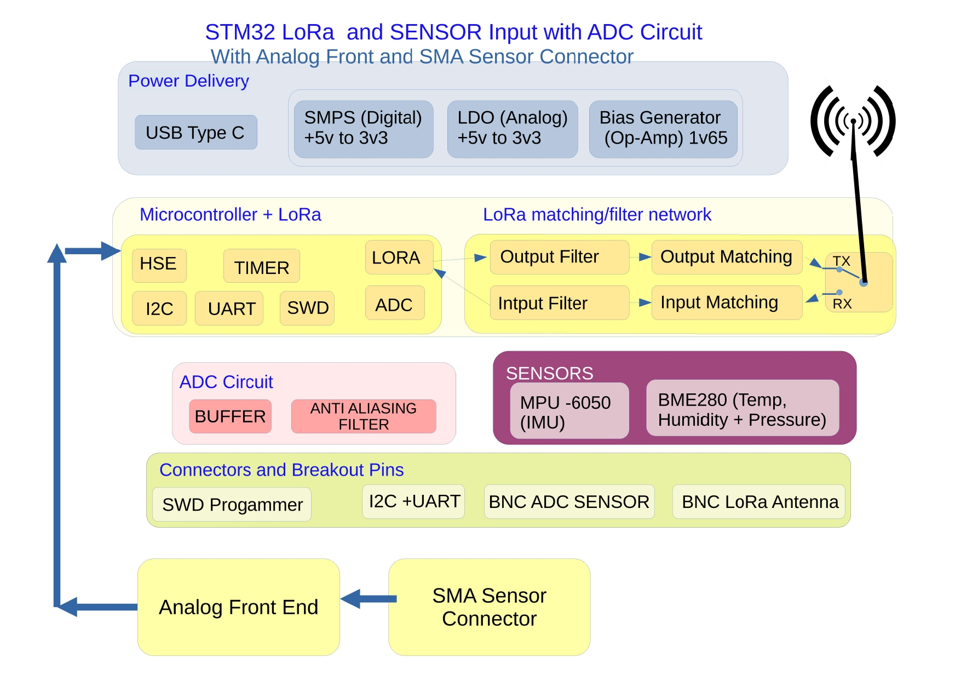

## Key Features

* - External Analog Sensor Interface: SMA and breakout headers support pseudo-differential analog inputs. The analog front-end includes filtering, biasing, and ESD protection for robust signal acquisition.
* - 3rd-Order Anti-Aliasing Filter: A Sallen-Key Butterworth topology is used to ensure flat passband and 20 kHz bandwidth, with simulation-verified roll-off and minimal phase distortion.
* - RF Output Network: Based on STM32 AN5457 guidance, the RFO_LP output is impedance-matched to 50 Ω using a discrete L-match network followed by notch and π-filters to suppress 2nd and 3rd harmonics. The full RF path is simulated in LTspice to optimize S21, group delay, and out-of-band rejection.
* - Pseudo-Differential ADC Drive: The analog input drives one side of the ADC, while the other is tied to a low-impedance reference, enabling common-mode noise rejection without needing a fully differential driver.
* - Clean Power Architecture: An SMPS supplies the digital domain, while a low-noise LDO powers the analog and RF sections to maintain high signal integrity.
* - Breakout Connectivity: UART (TX/RX), I²C, SPI for LoRa, SWD debug, and dedicated analog headers are provided for system debug and expansion.

## Tools Used

* - LTspice: RF path and anti-aliasing filter simulation, S-parameter approximation, group delay evaluation
* - Altium Designer: Professional schematic and PCB layout of 4-layer board with controlled impedance routing
* - Python (Jupyter): Post-processing of waveform simulation results and FFT harmonic analysis

## Applications

Ideal for deployment in IoT sensor networks, remote analog monitoring, field environmental data logging, or vibration-sensing telemetry platforms where accurate analog front-end performance is critical.