## How to create external models

There are a certain number of models included in the online version of WSNET. However, we could need to create our own models to support the different algorithms.

We have updated CMake for creating new models. We now copy the correct templates, according to the model type. In order to create a new model, you should do the following:

Inside the external_models folder, first (if not yet) create build/ folder:

**$ mkdir build/**

Then inside external_models/build/ you should run:

**$ cmake -DCREATE_NEW_MODULE=1 -DNEW_MODULE_TYPE=module_type -DNEW_MODULE_NAME=module_name ..**

**$ make create_new_module**

This will create a new external model.

Moreover, by setting the option -DORGANIZE_BY_TYPE, users specify to CMake that their external models are organized by type, as it occurs in models folder. CMake will then copy the files respecting the organization. Thus, the CMake command changes to:

**$ cmake -DCREATE_NEW_MODULE=1 -DORGANIZE_BY_TYPE=1 -DNEW_MODULE_TYPE=module_type -DNEW_MODULE_NAME=module_name ..**

**$ make create_new_module**

The folder structure of an exeternal model is similar to those on the kernel:

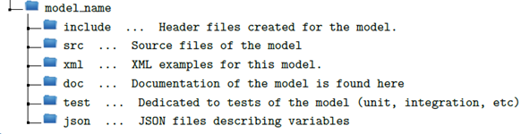

Figure 57: External model folder details

Below, one example of an external model folder created. You can verify the presence of the folders detailed above, as well as CMakeLists.txt files. They are used to declare which files will be compiled for this given external model.

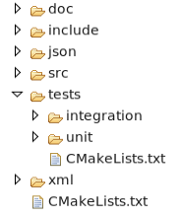

Figure 58: External model folder details

You should remember to update the CMakeLists file on the root of your model folder with the new source files you create on your src/ folder.