Southwest SWODA WIB

P.O. Box 569
Burns Flat, Oklahoma 73624
Economic Base Report

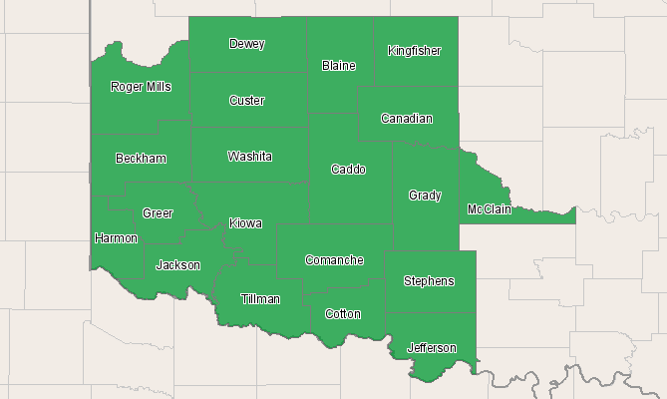

Economic Modeling Specialists, Inc. www.economicmodeling.com


Region Info

Region: SOIC
County Areas: Beckham, Oklahoma (40009), Blaine, Oklahoma (40011), Caddo, Oklahoma (40015), Canadian, Oklahoma (40017), Comanche, Oklahoma (40031), Cotton, Oklahoma (40033), Custer, Oklahoma (40039), Dewey, Oklahoma (40043), Grady, Oklahoma (40051), Greer, Oklahoma (40055), Harmon, Oklahoma (40057), Jackson, Oklahoma (40065), Jefferson, Oklahoma (40067), Kingfisher, Oklahoma (40073), Kiowa, Oklahoma (40075), McClain, Oklahoma (40087), Roger Mills, Oklahoma (40129), Stephens, Oklahoma (40137), Tillman, Oklahoma (40141), Washita, Oklahoma (40149)
2010 Economic Base

Jobs
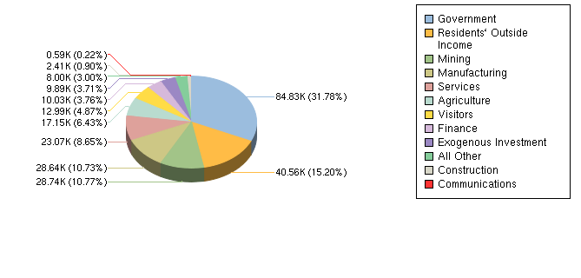

Earnings
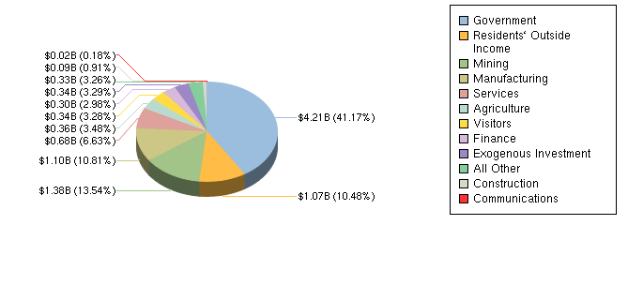

Sector | Jobs | Earnings(K) | Jobs % | Earnings % | EPW(K)
Government | 84,830 | $4,208,404 | 32% | 41% | $50
Residents` Outside Income | 40,557 | $1,071,607 | 15% | 10% | $26
Mining | 28,735 | $1,384,274 | 11% | 14% | $48
Manufacturing | 28,645 | $1,104,782 | 11% | 11% | $39
Services | 23,075 | $677,383 | 9% | 7% | $29
Agriculture | 17,149 | $355,315 | 6% | 3% | $21
Visitors | 12,990 | $335,390 | 5% | 3% | $26
Finance | 10,034 | $304,614 | 4% | 3% | $30
Exogenous Investment | 9,894 | $336,661 | 4% | 3% | $34
All Other | 8,004 | $332,955 | 3% | 3% | $42
Construction | 2,406 | $92,825 | 1% | 1% | $39
Communications | 586 | $18,502 | 0% | 0% | $32
Source: EMSI Complete Employment - 2nd Quarter 2010

Data Sources and Calculations

Input-Output Data

The input-output model in this report is created using the national Input-Output matrix provided by the federal Bureau of Economic Analysis. This is combined with the national Total Gross Output, the regional Total Gross Output, the land area of the subject region, regional DIRT data and regional in/out commuter patterns in order to calculate regional requirements, imports and exports. After using matrix algebra to calculate the regional multiplier, the resulting matrix is multiplied by the sales vector and converted back to jobs or earnings. Specifically, this data comes from the U.S. Department of Commerce, Bureau of Economic Analysis, Industry Economic Accounts: Benchmark & Annual Input-Output (I-O) Accounts.
Industry Data

In order to capture a complete picture of industry employment, EMSI basically combines covered employment data from Quarterly Census of Employment and Wages (QCEW) produced by the Department of Labor with total employment data in Regional Economic Information System (REIS) published by the Bureau of Economic Analysis (BEA), augmented with County Business Patterns (CBP) and Nonemployer Statistics (NES) published by the U.S. Census Bureau. Projections are based on the latest available EMSI industry data, 15-year past local trends in each industry, growth rates in statewide and (where available) sub-state area industry projections published by individual state agencies, and (in part) growth rates in national projections from the Bureau of Labor Statistics.
State Data Sources

This report uses state data from the following agencies: Oklahoma Employment Security Commission.

