Southwest SWODA WIB

P.O. Box 569
Burns Flat, Oklahoma 73624
Industry Report

Economic Modeling Specialists, Inc. www.economicmodeling.com


Region Info

Region: SOIC
County Areas: Beckham, Oklahoma (40009), Blaine, Oklahoma (40011), Caddo, Oklahoma (40015), Canadian, Oklahoma (40017), Comanche, Oklahoma (40031), Cotton, Oklahoma (40033), Custer, Oklahoma (40039), Dewey, Oklahoma (40043), Grady, Oklahoma (40051), Greer, Oklahoma (40055), Harmon, Oklahoma (40057), Jackson, Oklahoma (40065), Jefferson, Oklahoma (40067), Kingfisher, Oklahoma (40073), Kiowa, Oklahoma (40075), McClain, Oklahoma (40087), Roger Mills, Oklahoma (40129), Stephens, Oklahoma (40137), Tillman, Oklahoma (40141), Washita, Oklahoma (40149)
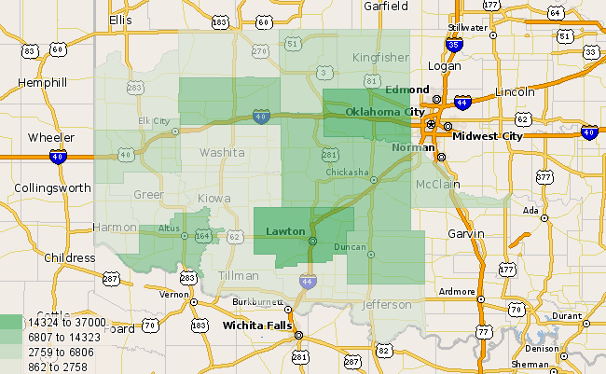

Selected Industries
Government (NAICS 90)
Agriculture, Forestry, Fishing and Hunting (NAICS 11)
Health Care and Social Assistance (NAICS 62)
Manufacturing (NAICS 31-33)
Mining, Quarrying, and Oil and Gas Extraction (NAICS 21)
Information (NAICS 51)
Educational Services (NAICS 61)
Utilities (NAICS 22)

Highest Ranked Counties

County | 2010 Jobs | Current EPW | 2010 LQ
Comanche, OK (40031) | 37,000 | $66,132 | 1.44
Canadian, OK (40017) | 17,991 | $45,783 | 1.07
Stephens, OK (40137) | 11,874 | $52,219 | 1.28
Grady, OK (40051) | 9,930 | $37,883 | 1.15
Jackson, OK (40065) | 8,633 | $54,751 | 1.50
Custer, OK (40039) | 7,931 | $41,195 | 1.19
Caddo, OK (40015) | 6,908 | $38,369 | 1.44
Beckham, OK (40009) | 6,123 | $49,132 | 1.11
Kingfisher, OK (40073) | 5,385 | $41,895 | 1.47
McClain, OK (40087) | 4,982 | $36,443 | 1.04
Blaine, OK (40011) | 3,348 | $34,079 | 1.36
Washita, OK (40149) | 2,650 | $34,949 | 1.49
Kiowa, OK (40075) | 2,297 | $33,103 | 1.46
Cotton, OK (40033) | 2,180 | $34,302 | 1.78
Tillman, OK (40141) | 2,131 | $31,033 | 1.56
Dewey, OK (40043) | 1,652 | $29,655 | 1.41
Greer, OK (40055) | 1,628 | $32,229 | 1.81
Jefferson, OK (40067) | 1,344 | $32,146 | 1.50
Roger Mills, OK (40129) | 1,287 | $33,493 | 1.76
Harmon, OK (40057) | 862 | $30,125 | 1.50
Industry Breakdown

NAICS Code | Name | 2010 Jobs | Current EPW | 2010 LQ
90 | Government | 60,822 | $60,448 | 1.66
11 | Agriculture, Forestry, Fishing and Hunting | 21,589 | $17,329 | 4.10
62 | Health Care and Social Assistance | 19,346 | $31,478 | 0.66
31-33 | Manufacturing | 15,148 | $53,544 | 0.78
21 | Mining, Quarrying, and Oil and Gas Extraction | 13,413 | $70,234 | 7.80
51 | Information | 2,535 | $38,818 | 0.50
61 | Educational Services | 1,977 | $25,511 | 0.32
22 | Utilities | 1,304 | $88,105 | 1.43
 | Total | 136,134 | $49,044

Data Sources and Calculations

Industry Data

In order to capture a complete picture of industry employment, EMSI basically combines covered employment data from Quarterly Census of Employment and Wages (QCEW) produced by the Department of Labor with total employment data in Regional Economic Information System (REIS) published by the Bureau of Economic Analysis (BEA), augmented with County Business Patterns (CBP) and Nonemployer Statistics (NES) published by the U.S. Census Bureau. Projections are based on the latest available EMSI industry data, 15-year past local trends in each industry, growth rates in statewide and (where available) sub-state area industry projections published by individual state agencies, and (in part) growth rates in national projections from the Bureau of Labor Statistics.
State Data Sources

This report uses state data from the following agencies: Oklahoma Employment Security Commission.

