Southwest SWODA WIB

P.O. Box 569
Burns Flat, Oklahoma 73624
Competency Growth Analysis Report

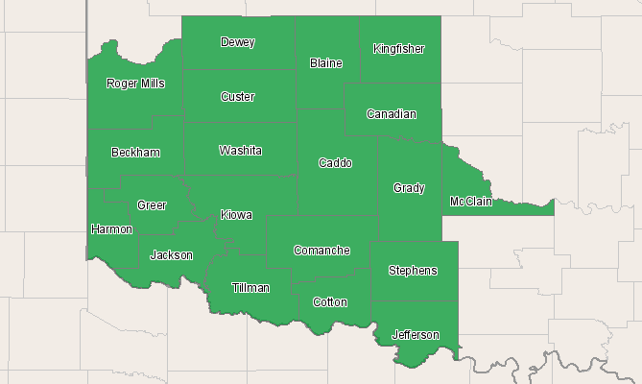

Economic Modeling Specialists, Inc. www.economicmodeling.com


Region Info

Region: SOIC
County Areas: Beckham, Oklahoma (40009), Blaine, Oklahoma (40011), Caddo, Oklahoma (40015), Canadian, Oklahoma (40017), Comanche, Oklahoma (40031), Cotton, Oklahoma (40033), Custer, Oklahoma (40039), Dewey, Oklahoma (40043), Grady, Oklahoma (40051), Greer, Oklahoma (40055), Harmon, Oklahoma (40057), Jackson, Oklahoma (40065), Jefferson, Oklahoma (40067), Kingfisher, Oklahoma (40073), Kiowa, Oklahoma (40075), McClain, Oklahoma (40087), Roger Mills, Oklahoma (40129), Stephens, Oklahoma (40137), Tillman, Oklahoma (40141), Washita, Oklahoma (40149)
Knowledge In Demand

Knowledge Description
Customer and Personal Service
English Language
Education and Training
Mathematics
Administration and Management
Clerical
Computers and Electronics
Psychology
Law and Government
Personnel and Human Resources
Public Safety and Security
Sales and Marketing
Communications and Media
Economics and Accounting
Sociology and Anthropology
Mechanical
Production and Processing
Therapy and Counseling
Geography
Philosophy and Theology
Source: EMSI Complete Employment - 2nd Quarter 2010

Skills In Demand

Skill Description
Reading Comprehension
Active Listening
Critical Thinking
Speaking
Active Learning
Instructing
Writing
Coordination
Learning Strategies
Monitoring
Social Perceptiveness
Time Management
Judgment and Decision Making
Service Orientation
Complex Problem Solving
Persuasion
Mathematics
Negotiation
Management of Personnel Resources
Equipment Selection
Source: EMSI Complete Employment - 2nd Quarter 2010

Abilities In Demand

Ability Description
Oral Expression
Oral Comprehension
Written Comprehension
Near Vision
Deductive Reasoning
Speech Clarity
Written Expression
Problem Sensitivity
Inductive Reasoning
Speech Recognition
Information Ordering
Category Flexibility
Selective Attention
Fluency of Ideas
Originality
Far Vision
Flexibility of Closure
Time Sharing
Visualization
Number Facility
Source: EMSI Complete Employment - 2nd Quarter 2010

Data Sources and Calculations

Competency Data

The competency data in this report is taken directly from the O*NET database.
State Data Sources

This report uses state data from the following agencies: Oklahoma Employment Security Commission.

