Southwest SWODA WIB

P.O. Box 569
Burns Flat, Oklahoma 73624
Human Capital Report

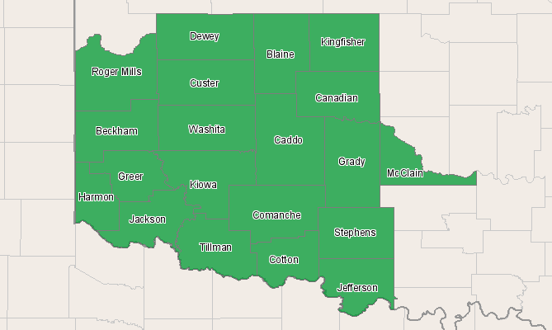

Economic Modeling Specialists, Inc. www.economicmodeling.com


Region Info

Region: SOIC
County Areas: Beckham, Oklahoma (40009), Blaine, Oklahoma (40011), Caddo, Oklahoma (40015), Canadian, Oklahoma (40017), Comanche, Oklahoma (40031), Cotton, Oklahoma (40033), Custer, Oklahoma (40039), Dewey, Oklahoma (40043), Grady, Oklahoma (40051), Greer, Oklahoma (40055), Harmon, Oklahoma (40057), Jackson, Oklahoma (40065), Jefferson, Oklahoma (40067), Kingfisher, Oklahoma (40073), Kiowa, Oklahoma (40075), McClain, Oklahoma (40087), Roger Mills, Oklahoma (40129), Stephens, Oklahoma (40137), Tillman, Oklahoma (40141), Washita, Oklahoma (40149)
Knowledge Summary

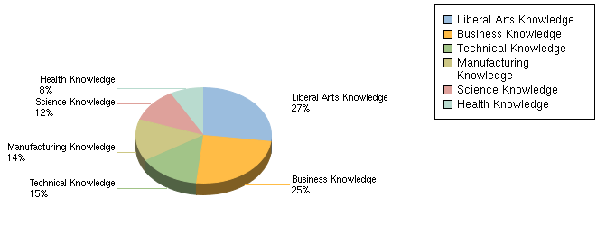

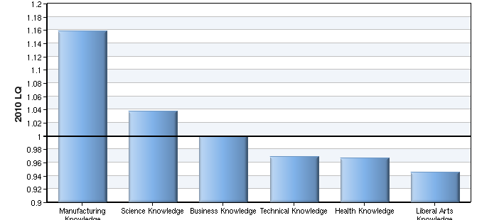

Knowledge Sector | 2010 % of All Knowledge | 2010-2015 % Growth | 2010 LQ | 2015 LQ
Manufacturing Knowledge | 14% | 6% | 1.16 | 1.16
Science Knowledge | 12% | 7% | 1.04 | 1.03
Business Knowledge | 25% | 7% | 1.00 | 1.00
Technical Knowledge | 15% | 7% | 0.97 | 0.97
Health Knowledge | 8% | 7% | 0.97 | 0.96
Liberal Arts Knowledge | 27% | 7% | 0.95 | 0.95
Source: U.S. Department of Labor / Employment and Training Administration, O*NET database version 13.

Business Knowledge Concentrations

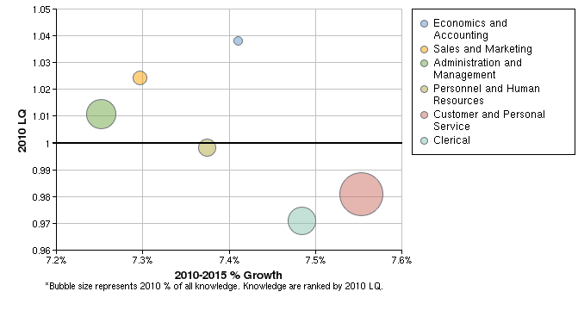

Knowledge | 2010 % of All Knowledge | 2010-2015 % Growth | 2010 LQ | 2015 LQ
Economics and Accounting | 2.87% | 7.41% | 1.04 | 1.04
Sales and Marketing | 3.33% | 7.30% | 1.02 | 1.02
Administration and Management | 4.62% | 7.25% | 1.01 | 1.01
Personnel and Human Resources | 3.60% | 7.37% | 1.00 | 1.00
Customer and Personal Service | 5.77% | 7.55% | 0.98 | 0.98
Clerical | 4.44% | 7.48% | 0.97 | 0.97
Source: U.S. Department of Labor / Employment and Training Administration, O*NET database version 13.

Manufacturing Knowledge Concentrations

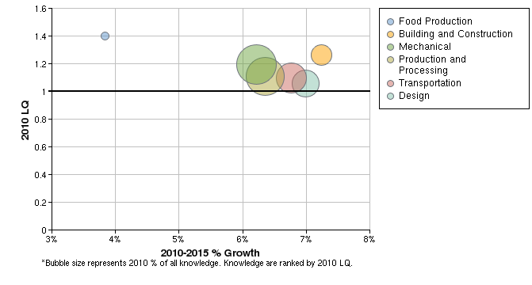

Knowledge | 2010 % of All Knowledge | 2010-2015 % Growth | 2010 LQ | 2015 LQ
Food Production | 1.32% | 3.84% | 1.40 | 1.39
Building and Construction | 2.03% | 7.24% | 1.26 | 1.26
Mechanical | 3.02% | 6.22% | 1.19 | 1.20
Production and Processing | 2.92% | 6.36% | 1.11 | 1.11
Transportation | 2.50% | 6.76% | 1.10 | 1.10
Design | 2.32% | 6.99% | 1.06 | 1.06
Source: U.S. Department of Labor / Employment and Training Administration, O*NET database version 13.

Technical Knowledge Concentrations

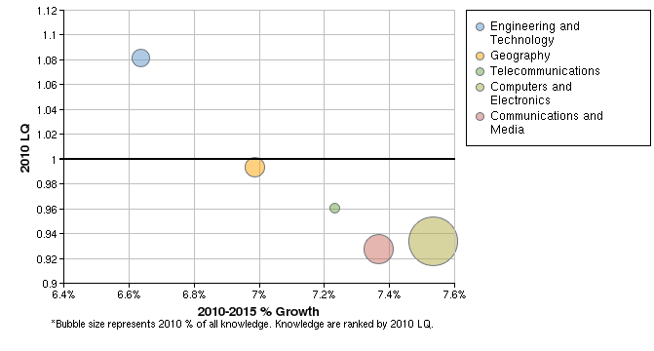

Knowledge | 2010 % of All Knowledge | 2010-2015 % Growth | 2010 LQ | 2015 LQ
Engineering and Technology | 2.47% | 6.64% | 1.08 | 1.08
Geography | 2.53% | 6.99% | 0.99 | 0.99
Telecommunications | 1.94% | 7.23% | 0.96 | 0.96
Computers and Electronics | 4.36% | 7.53% | 0.93 | 0.94
Communications and Media | 3.23% | 7.37% | 0.93 | 0.93
Source: U.S. Department of Labor / Employment and Training Administration, O*NET database version 13.

Science Knowledge Concentrations

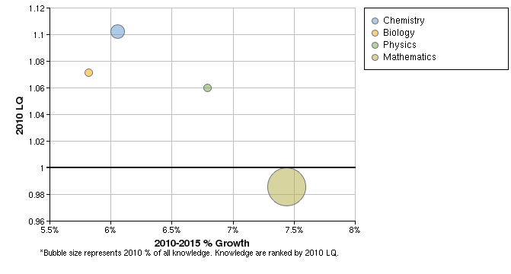

Knowledge | 2010 % of All Knowledge | 2010-2015 % Growth | 2010 LQ | 2015 LQ
Chemistry | 2.56% | 6.06% | 1.10 | 1.10
Biology | 2.00% | 5.82% | 1.07 | 1.06
Physics | 1.97% | 6.79% | 1.06 | 1.06
Mathematics | 5.00% | 7.44% | 0.99 | 0.99
Source: U.S. Department of Labor / Employment and Training Administration, O*NET database version 13.

Health Knowledge Concentrations

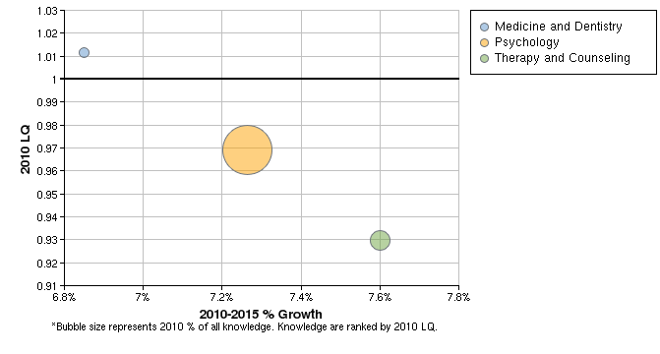

Knowledge | 2010 % of All Knowledge | 2010-2015 % Growth | 2010 LQ | 2015 LQ
Medicine and Dentistry | 1.81% | 6.85% | 1.01 | 1.00
Psychology | 3.98% | 7.26% | 0.97 | 0.97
Therapy and Counseling | 2.37% | 7.60% | 0.93 | 0.93
Source: U.S. Department of Labor / Employment and Training Administration, O*NET database version 13.

Liberal Arts Knowledge Concentrations

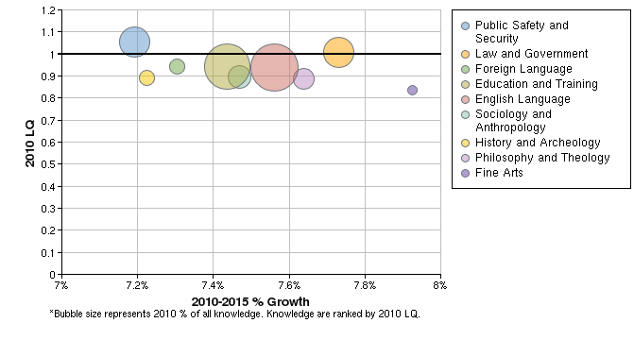

Knowledge | 2010 % of All Knowledge | 2010-2015 % Growth | 2010 LQ | 2015 LQ
Public Safety and Security | 3.56% | 7.19% | 1.06 | 1.06
Law and Government | 3.51% | 7.73% | 1.01 | 1.01
Foreign Language | 1.65% | 7.30% | 0.94 | 0.94
Education and Training | 5.29% | 7.44% | 0.94 | 0.94
English Language | 5.52% | 7.56% | 0.94 | 0.94
Sociology and Anthropology | 2.65% | 7.47% | 0.89 | 0.89
History and Archeology | 1.70% | 7.22% | 0.89 | 0.89
Philosophy and Theology | 2.30% | 7.64% | 0.89 | 0.89
Fine Arts | 0.88% | 7.92% | 0.84 | 0.84
Source: U.S. Department of Labor / Employment and Training Administration, O*NET database version 13.

Data Sources and Calculations

Competency Data

The competency data in this report is taken directly from the O*NET database.
Location Quotient

Location quotient (LQ) is a way of quantifying how concentrated a particular industry, cluster, occupation, or demographic group is in a region as compared to the nation. It can reveal what makes a particular region unique in comparison to the national average.
State Data Sources

This report uses state data from the following agencies: Oklahoma Employment Security Commission.

