Southwest SWODA WIB

P.O. Box 569
Burns Flat, Oklahoma 73624
Competency Report

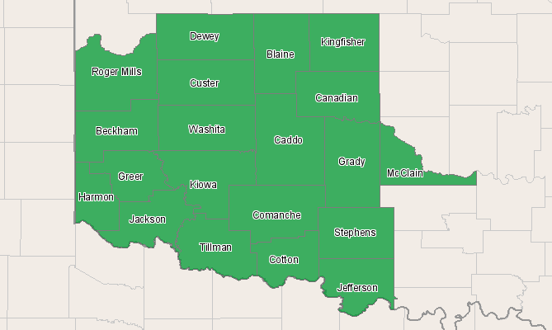

Economic Modeling Specialists, Inc. www.economicmodeling.com


Region Info

Region: SOIC
County Areas: Beckham, Oklahoma (40009), Blaine, Oklahoma (40011), Caddo, Oklahoma (40015), Canadian, Oklahoma (40017), Comanche, Oklahoma (40031), Cotton, Oklahoma (40033), Custer, Oklahoma (40039), Dewey, Oklahoma (40043), Grady, Oklahoma (40051), Greer, Oklahoma (40055), Harmon, Oklahoma (40057), Jackson, Oklahoma (40065), Jefferson, Oklahoma (40067), Kingfisher, Oklahoma (40073), Kiowa, Oklahoma (40075), McClain, Oklahoma (40087), Roger Mills, Oklahoma (40129), Stephens, Oklahoma (40137), Tillman, Oklahoma (40141), Washita, Oklahoma (40149)
Selected Competencies

Selected Competencies | Area
Fine Arts | Knowledge
Law and Government | Knowledge
Philosophy and Theology | Knowledge
Therapy and Counseling | Knowledge
English Language | Knowledge
Customer and Personal Service | Knowledge
Computers and Electronics | Knowledge
Clerical | Knowledge
Sociology and Anthropology | Knowledge
Mathematics | Knowledge
Education and Training | Knowledge
Economics and Accounting | Knowledge
Personnel and Human Resources | Knowledge
Communications and Media | Knowledge
Foreign Language | Knowledge
Sales and Marketing | Knowledge
Psychology | Knowledge
Administration and Management | Knowledge
Building and Construction | Knowledge
Telecommunications | Knowledge
History and Archeology | Knowledge
Public Safety and Security | Knowledge
Design | Knowledge
Geography | Knowledge
Medicine and Dentistry | Knowledge
Physics | Knowledge
Transportation | Knowledge
Engineering and Technology | Knowledge
Production and Processing | Knowledge
Mechanical | Knowledge
Chemistry | Knowledge
Biology | Knowledge
Food Production | Knowledge

Competency Concentration

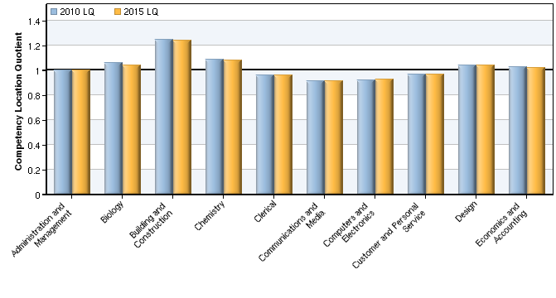

Competency | Competency Area | 2010 LQ | 2015 LQ
Administration and Management | Knowledge | 1.00 | 1.00
Biology | Knowledge | 1.06 | 1.04
Building and Construction | Knowledge | 1.25 | 1.24
Chemistry | Knowledge | 1.09 | 1.08
Clerical | Knowledge | 0.96 | 0.96
Communications and Media | Knowledge | 0.92 | 0.92
Computers and Electronics | Knowledge | 0.92 | 0.92
Customer and Personal Service | Knowledge | 0.97 | 0.97
Design | Knowledge | 1.04 | 1.04
Economics and Accounting | Knowledge | 1.02 | 1.02
Education and Training | Knowledge | 0.93 | 0.93
Engineering and Technology | Knowledge | 1.07 | 1.07
English Language | Knowledge | 0.93 | 0.93
Fine Arts | Knowledge | 0.82 | 0.83
Food Production | Knowledge | 1.38 | 1.37
Foreign Language | Knowledge | 0.93 | 0.93
Geography | Knowledge | 0.98 | 0.98
History and Archeology | Knowledge | 0.88 | 0.88
Law and Government | Knowledge | 1.00 | 0.99
Mathematics | Knowledge | 0.97 | 0.98
Mechanical | Knowledge | 1.18 | 1.18
Medicine and Dentistry | Knowledge | 1.00 | 0.99
Personnel and Human Resources | Knowledge | 0.99 | 0.99
Philosophy and Theology | Knowledge | 0.87 | 0.87
Physics | Knowledge | 1.05 | 1.05
Production and Processing | Knowledge | 1.09 | 1.10
Psychology | Knowledge | 0.96 | 0.95
Public Safety and Security | Knowledge | 1.04 | 1.04
Sales and Marketing | Knowledge | 1.01 | 1.01
Sociology and Anthropology | Knowledge | 0.88 | 0.88
Telecommunications | Knowledge | 0.95 | 0.95
Therapy and Counseling | Knowledge | 0.92 | 0.92
Transportation | Knowledge | 1.09 | 1.09
Source: U.S. Department of Labor / Employment and Training Administration, O*NET database version 13.

Top Occupations Requiring Selected Competencies

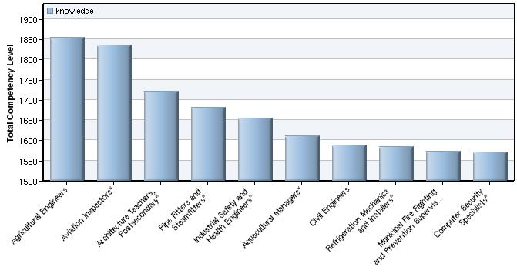

O*NET Code | Name | 2010 Jobs | 2015 Jobs | Change | % Change | Current Hourly Earnings
17-2021.00 | Agricultural Engineers | <10 | <10 | -- | -- | --
53-6051.01* | Aviation Inspectors* | 24 | 28 | 4 | 17% | $31.25
25-1031.00* | Architecture Teachers, Postsecondary* | 1,411 | 1,525 | 114 | 8% | $28.08
47-2152.01* | Pipe Fitters and Steamfitters* | 695 | 783 | 88 | 13% | $14.20
17-2111.01* | Industrial Safety and Health Engineers* | 36 | 38 | 2 | 6% | $25.26
11-9011.03* | Aquacultural Managers* | 3,425 | 3,376 | -49 | -1% | $10.06
17-2051.00 | Civil Engineers | 219 | 249 | 30 | 14% | $23.82
49-9021.02* | Refrigeration Mechanics and Installers* | 644 | 737 | 93 | 14% | $14.20
33-1021.01* | Municipal Fire Fighting and Prevention Supervisors* | 136 | 147 | 11 | 8% | $22.99
15-1071.01* | Computer Security Specialists* | 343 | 363 | 20 | 6% | $20.68
Source: EMSI Complete Employment - 2nd Quarter 2010
* The selected O*NET occupation does not map directly to SOC labor market data. For this reason, jobs, earnings, and growth data for this occupation include other, related O*NET occupations. These numbers, therefore, should be seen as estimates only - the jobs and job change values are probably overstated.

2010 Competency Location Quotients

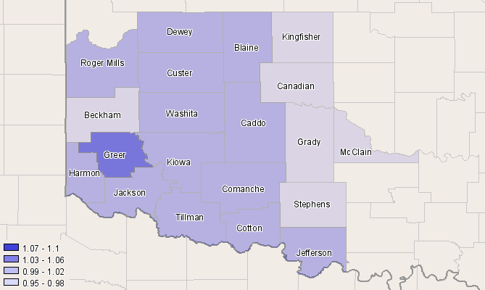

Area | 2010 Selected Competencies LQ
Greer, OK (40055) | 1.06
Cotton, OK (40033) | 1.01
Comanche, OK (40031) | 1.01
Tillman, OK (40141) | 1.01
Custer, OK (40039) | 1.00
Harmon, OK (40057) | 1.00
Roger Mills, OK (40129) | 1.00
Jackson, OK (40065) | 1.00
Jefferson, OK (40067) | 1.00
Washita, OK (40149) | 0.99
Caddo, OK (40015) | 0.99
Kiowa, OK (40075) | 0.99
Dewey, OK (40043) | 0.99
Blaine, OK (40011) | 0.99
McClain, OK (40087) | 0.98
Grady, OK (40051) | 0.98
Canadian, OK (40017) | 0.97
Beckham, OK (40009) | 0.95
Kingfisher, OK (40073) | 0.95
Stephens, OK (40137) | 0.95
Source: U.S. Department of Labor / Employment and Training Administration, O*NET database version 13.

Data Sources and Calculations

Competency Data

The competency data in this report is taken directly from the O*NET database.
Occupation Data

Organizing regional employment information by occupation provides a workforce-oriented view of the regional economy. EMSI's occupation data are based on EMSI's industry data and regional staffing patterns taken from the Occupational Employment Statistics program (U.S. Bureau of Labor Statistics). Wage information is partially derived from the American Community Survey. The occupation-to-program (SOC-to-CIP) crosswalk is based on one from the U.S. Department of Education, with customizations by EMSI.
Location Quotient

Location quotient (LQ) is a way of quantifying how concentrated a particular industry, cluster, occupation, or demographic group is in a region as compared to the nation. It can reveal what makes a particular region unique in comparison to the national average.
State Data Sources

This report uses state data from the following agencies: Oklahoma Employment Security Commission.

