Southwest SWODA WIB

P.O. Box 569
Burns Flat, Oklahoma 73624
Demographic Overview Report

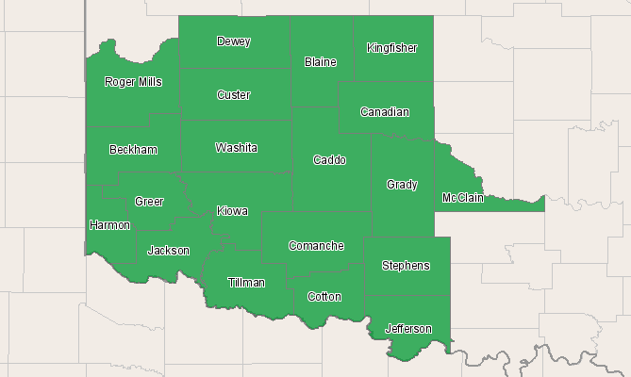

Economic Modeling Specialists, Inc. www.economicmodeling.com


Region Info

Region: SOIC
County Areas: Beckham, Oklahoma (40009), Blaine, Oklahoma (40011), Caddo, Oklahoma (40015), Canadian, Oklahoma (40017), Comanche, Oklahoma (40031), Cotton, Oklahoma (40033), Custer, Oklahoma (40039), Dewey, Oklahoma (40043), Grady, Oklahoma (40051), Greer, Oklahoma (40055), Harmon, Oklahoma (40057), Jackson, Oklahoma (40065), Jefferson, Oklahoma (40067), Kingfisher, Oklahoma (40073), Kiowa, Oklahoma (40075), McClain, Oklahoma (40087), Roger Mills, Oklahoma (40129), Stephens, Oklahoma (40137), Tillman, Oklahoma (40141), Washita, Oklahoma (40149)
Demographic Overview

2010 Race/Ethnicity Breakdown
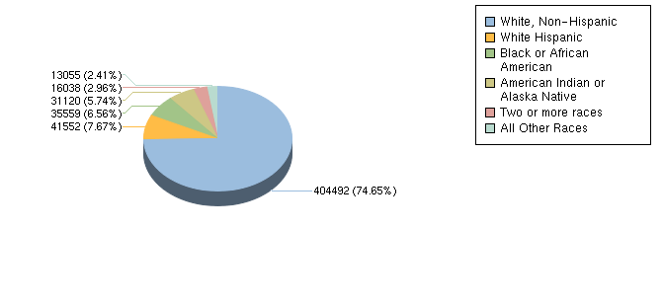

Ethnicity | 2010 Population | % of Region
White, Non-Hispanic | 404,492 | 74.65%
White Hispanic | 41,552 | 7.67%
Non-White Hispanic | 5,551 | 1.02%
Black or African American | 35,559 | 6.56%
American Indian or Alaska Native | 31,120 | 5.74%
Asian | 6,784 | 1.25%
Native Hawaiian and other Pacific Islander | 720 | 0.13%
Two or more races | 16,038 | 2.96%
Source: EMSI Complete Employment - 2nd Quarter 2010

2010 - 2015 Race/Ethnicity Size and Growth
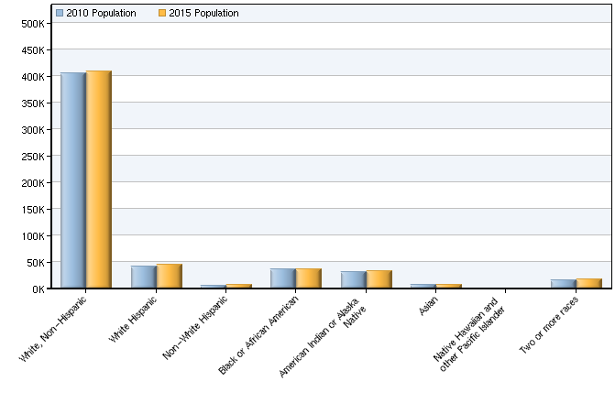

Race/Ethnicity | 2010 Population | 2015 Population | Change | % Change
White, Non-Hispanic | 404,492 | 408,571 | 4,079 | 1%
White Hispanic | 41,552 | 45,174 | 3,622 | 9%
Non-White Hispanic | 5,551 | 6,186 | 635 | 11%
Black or African American | 35,559 | 36,119 | 560 | 2%
American Indian or Alaska Native | 31,120 | 32,022 | 902 | 3%
Asian | 6,784 | 7,107 | 323 | 5%
Native Hawaiian and other Pacific Islander | 720 | 757 | 37 | 5%
Two or more races | 16,038 | 16,608 | 570 | 4%
Total | 541,815 | 552,543 | 10,728 | 2%
Source: EMSI Complete Employment - 2nd Quarter 2010

2010 - 2015 Age Size and Growth
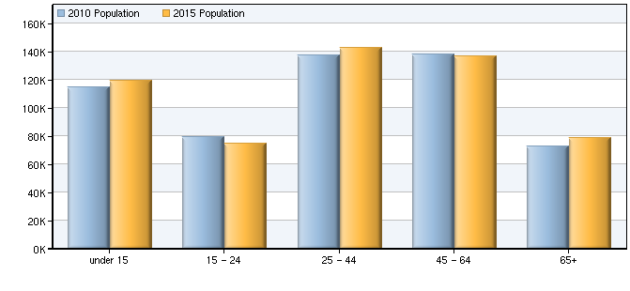

Age | 2010 Population | 2015 Population | Change | % Change
under 15 | 114,761 | 119,396 | 4,635 | 4%
15 - 24 | 79,281 | 74,610 | -4,671 | -6%
25 - 44 | 137,506 | 142,777 | 5,271 | 4%
45 - 64 | 137,898 | 136,978 | -920 | -1%
65+ | 72,369 | 78,782 | 6,413 | 9%
Total | 541,815 | 552,543 | 10,728 | 2%
Source: EMSI Complete Employment - 2nd Quarter 2010

Data Sources and Calculations

Demographic Data

The demographic data in this report is compiled from several sources using a specialized process. Sources include US Census Bureau annual estimates, birth and mortality rates from the US Health Department, and projected regional job growth.
State Data Sources

This report uses state data from the following agencies: Oklahoma Employment Security Commission.

