Southwest SWODA WIB

P.O. Box 569
Burns Flat, Oklahoma 73624
Demographics Report

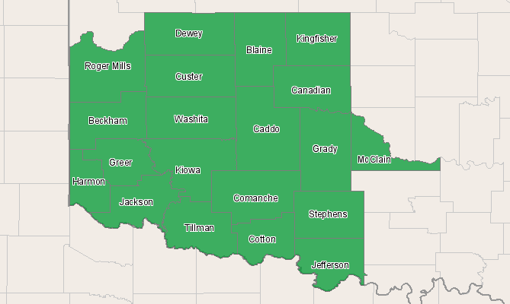

Economic Modeling Specialists, Inc. www.economicmodeling.com


Region Info

Region: SOIC
County Areas: Beckham, Oklahoma (40009), Blaine, Oklahoma (40011), Caddo, Oklahoma (40015), Canadian, Oklahoma (40017), Comanche, Oklahoma (40031), Cotton, Oklahoma (40033), Custer, Oklahoma (40039), Dewey, Oklahoma (40043), Grady, Oklahoma (40051), Greer, Oklahoma (40055), Harmon, Oklahoma (40057), Jackson, Oklahoma (40065), Jefferson, Oklahoma (40067), Kingfisher, Oklahoma (40073), Kiowa, Oklahoma (40075), McClain, Oklahoma (40087), Roger Mills, Oklahoma (40129), Stephens, Oklahoma (40137), Tillman, Oklahoma (40141), Washita, Oklahoma (40149)
Selected Demographics

Selected Demographics | Selected Cohorts
Age | Under 5 years
 | 5 to 9 years
 | 10 to 14 years
 | 15 to 19 years
 | 20 to 24 years
 | 25 to 29 years
 | 30 to 34 years
 | 35 to 39 years
 | 40 to 44 years
 | 45 to 49 years
 | 50 to 54 years
 | 55 to 59 years
 | 60 to 64 years
 | 65 to 69 years
 | 70 to 74 years
 | 75 to 79 years
 | 80 to 84 years
 | 85 years and over
Race/Ethnicity | White, Non-Hispanic
 | White Hispanic
 | Non-White Hispanic
 | Black or African American
 | American Indian or Alaska Native
 | Asian
 | Native Hawaiian and other Pacific Islander
 | Two or more races
Gender | Males
 | Females

Cohort Totals

Area | 2010 Population | 2015 Population | Change | % Change
Region | 541,815 | 552,543 | 10,728 | 2%
State | 3,704,286 | 3,783,409 | 79,123 | 2%
Nation | 310,100,040 | 320,187,890 | 10,087,850 | 3%

Age Breakdown

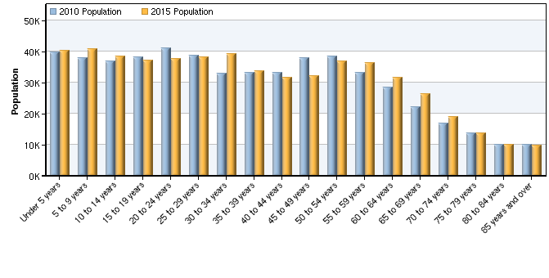

Age | 2010 Population | 2015 Population | Change | % Change | 2010 % of Cohort
Under 5 years | 39,810 | 40,174 | 364 | 1% | 7.35%
5 to 9 years | 38,023 | 40,816 | 2,793 | 7% | 7.02%
10 to 14 years | 36,928 | 38,406 | 1,478 | 4% | 6.82%
15 to 19 years | 38,287 | 37,056 | -1,231 | -3% | 7.07%
20 to 24 years | 40,995 | 37,554 | -3,441 | -8% | 7.57%
25 to 29 years | 38,588 | 38,279 | -309 | -1% | 7.12%
30 to 34 years | 32,764 | 39,202 | 6,438 | 20% | 6.05%
35 to 39 years | 33,029 | 33,700 | 671 | 2% | 6.10%
40 to 44 years | 33,126 | 31,596 | -1,530 | -5% | 6.11%
45 to 49 years | 38,023 | 32,188 | -5,835 | -15% | 7.02%
50 to 54 years | 38,327 | 36,751 | -1,576 | -4% | 7.07%
55 to 59 years | 33,197 | 36,419 | 3,222 | 10% | 6.13%
60 to 64 years | 28,351 | 31,620 | 3,269 | 12% | 5.23%
65 to 69 years | 22,050 | 26,236 | 4,186 | 19% | 4.07%
70 to 74 years | 16,907 | 18,998 | 2,091 | 12% | 3.12%
75 to 79 years | 13,644 | 13,639 | -5 | 0% | 2.52%
80 to 84 years | 9,871 | 10,058 | 187 | 2% | 1.82%
85 years and over | 9,896 | 9,851 | -45 | 0% | 1.83%
Total | 541,815 | 552,543 | 10,728 | 2% | 100.00%
Source: EMSI Complete Employment - 2nd Quarter 2010

Race/Ethnicity Breakdown

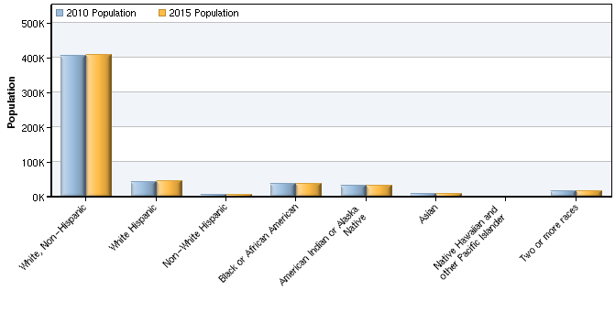

Race/Ethnicity | 2010 Population | 2015 Population | Change | % Change | 2010 % of Cohort
White, Non-Hispanic | 404,492 | 408,571 | 4,079 | 1% | 74.65%
White Hispanic | 41,552 | 45,174 | 3,622 | 9% | 7.67%
Non-White Hispanic | 5,551 | 6,186 | 635 | 11% | 1.02%
Black or African American | 35,559 | 36,119 | 560 | 2% | 6.56%
American Indian or Alaska Native | 31,120 | 32,022 | 902 | 3% | 5.74%
Asian | 6,784 | 7,107 | 323 | 5% | 1.25%
Native Hawaiian and other Pacific Islander | 720 | 757 | 37 | 5% | 0.13%
Two or more races | 16,038 | 16,608 | 570 | 4% | 2.96%
Total | 541,815 | 552,543 | 10,728 | 2% | 100.00%
Source: EMSI Complete Employment - 2nd Quarter 2010

Gender Breakdown

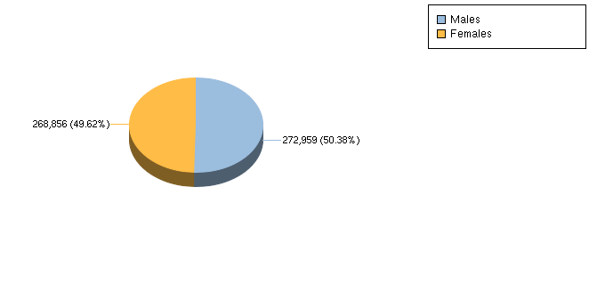

Gender | 2010 Population | 2015 Population | Change | % Change | 2010 % of Cohort
Males | 272,959 | 278,488 | 5,529 | 2% | 50.38%
Females | 268,856 | 274,055 | 5,199 | 2% | 49.62%
Total | 541,815 | 552,543 | 10,728 | 2% | 100.00%
Source: EMSI Complete Employment - 2nd Quarter 2010

Data Sources and Calculations

Demographic Data

The demographic data in this report is compiled from several sources using a specialized process. Sources include US Census Bureau annual estimates, birth and mortality rates from the US Health Department, and projected regional job growth.
State Data Sources

This report uses state data from the following agencies: Oklahoma Employment Security Commission.

