Southwest SWODA WIB

P.O. Box 569
Burns Flat, Oklahoma 73624
All Reports

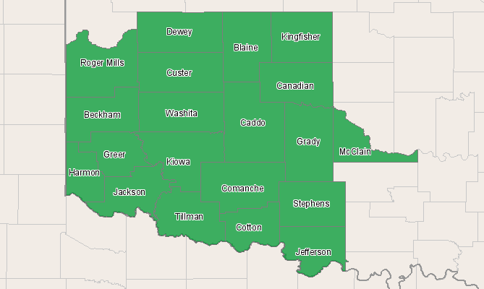

Economic Modeling Specialists, Inc. www.economicmodeling.com


Region Info

Region: SOIC
County Areas: Beckham, Oklahoma (40009), Blaine, Oklahoma (40011), Caddo, Oklahoma (40015), Canadian, Oklahoma (40017), Comanche, Oklahoma (40031), Cotton, Oklahoma (40033), Custer, Oklahoma (40039), Dewey, Oklahoma (40043), Grady, Oklahoma (40051), Greer, Oklahoma (40055), Harmon, Oklahoma (40057), Jackson, Oklahoma (40065), Jefferson, Oklahoma (40067), Kingfisher, Oklahoma (40073), Kiowa, Oklahoma (40075), McClain, Oklahoma (40087), Roger Mills, Oklahoma (40129), Stephens, Oklahoma (40137), Tillman, Oklahoma (40141), Washita, Oklahoma (40149)
Industry Size and Growth

2010 - 2015 Size and Growth
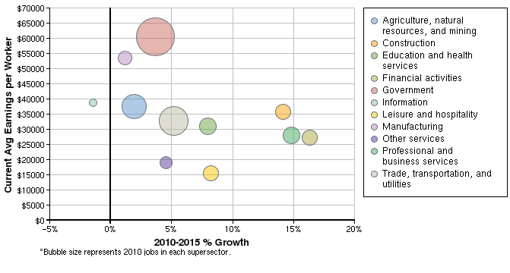

Description | 2010 Jobs | 2015 Jobs | Growth | % Growth | Current EPW
Agriculture, natural resources, and mining | 35,001 | 35,676 | 675 | 2% | $37,602
Construction | 16,471 | 18,799 | 2,328 | 14% | $35,626
Education and health services | 21,323 | 23,024 | 1,701 | 8% | $30,925
Financial activities | 19,292 | 22,442 | 3,150 | 16% | $27,265
Government | 60,822 | 63,060 | 2,238 | 4% | $60,448
Information | 2,535 | 2,499 | -36 | -1% | $38,818
Leisure and hospitality | 19,165 | 20,741 | 1,576 | 8% | $15,503
Manufacturing | 15,148 | 15,323 | 175 | 1% | $53,544
Other services | 13,034 | 13,626 | 592 | 5% | $19,002
Professional and business services | 20,273 | 23,273 | 3,000 | 15% | $28,033
Trade, transportation, and utilities | 43,842 | 46,118 | 2,276 | 5% | $32,737
Total | 266,905 | 284,581 | 17,676 | 7% | $38,301
Source: EMSI Complete Employment - 2nd Quarter 2010

2010 Industrial Makeup
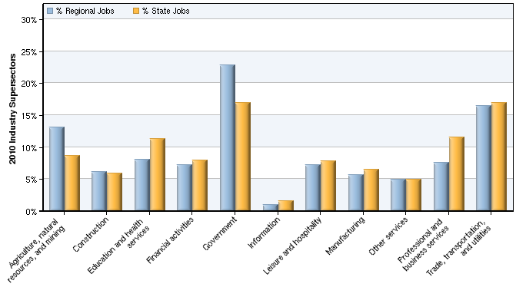

Description | 2010 Regional Jobs | % Regional Jobs | 2010 State Jobs | % State Jobs
Agriculture, natural resources, and mining | 35,001 | 13.1% | 182,036 | 8.6%
Construction | 16,471 | 6.2% | 125,277 | 5.9%
Education and health services | 21,323 | 8.0% | 239,075 | 11.3%
Financial activities | 19,292 | 7.2% | 165,948 | 7.9%
Government | 60,822 | 22.8% | 357,404 | 16.9%
Information | 2,535 | 0.9% | 32,606 | 1.5%
Leisure and hospitality | 19,165 | 7.2% | 164,839 | 7.8%
Manufacturing | 15,148 | 5.7% | 136,738 | 6.5%
Other services | 13,034 | 4.9% | 103,776 | 4.9%
Professional and business services | 20,273 | 7.6% | 243,723 | 11.6%
Trade, transportation, and utilities | 43,842 | 16.4% | 357,701 | 17.0%
Source: EMSI Complete Employment - 2nd Quarter 2010

Occupation Size and Growth

2010 - 2015 Size and Growth
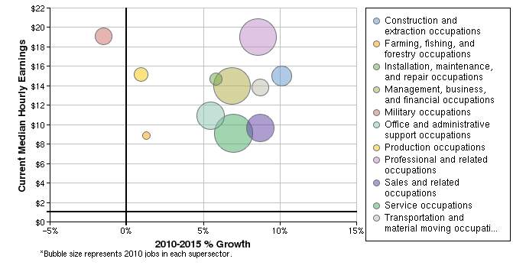

Description | 2010 Jobs | 2015 Jobs | Growth | % Growth | Current Median Hourly Earnings
Construction and extraction occupations | 19,012 | 20,937 | 1,925 | 10% | $14.98
Farming, fishing, and forestry occupations | 3,278 | 3,320 | 42 | 1% | $8.86
Installation, maintenance, and repair occupations | 10,468 | 11,076 | 608 | 6% | $14.67
Management, business, and financial occupations | 43,273 | 46,240 | 2,967 | 7% | $13.99
Military occupations | 16,547 | 16,294 | -253 | -2% | $19.07
Office and administrative support occupations | 30,389 | 32,054 | 1,665 | 5% | $10.96
Production occupations | 12,889 | 13,012 | 123 | 1% | $15.20
Professional and related occupations | 41,193 | 44,726 | 3,533 | 9% | $18.98
Sales and related occupations | 30,544 | 33,208 | 2,664 | 9% | $9.63
Service occupations | 43,848 | 46,899 | 3,051 | 7% | $9.15
Transportation and material moving occupations | 15,465 | 16,816 | 1,351 | 9% | $13.86
Total | 266,905 | 284,581 | 17,676 | 7% | $13.52
Source: EMSI Complete Employment - 2nd Quarter 2010

2010 Occupational Makeup
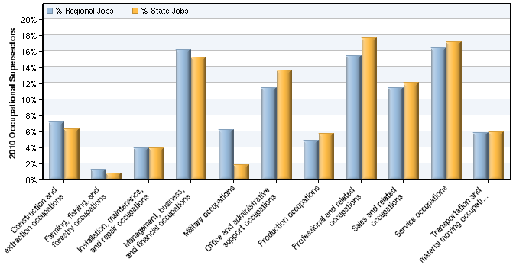

Description | 2010 Regional Jobs | % Regional Jobs | 2010 State Jobs | % State Jobs
Construction and extraction occupations | 19,012 | 7.1% | 131,961 | 6.3%
Farming, fishing, and forestry occupations | 3,278 | 1.2% | 16,112 | 0.8%
Installation, maintenance, and repair occupations | 10,468 | 3.9% | 81,784 | 3.9%
Management, business, and financial occupations | 43,273 | 16.2% | 320,413 | 15.2%
Military occupations | 16,547 | 6.2% | 38,736 | 1.8%
Office and administrative support occupations | 30,389 | 11.4% | 287,419 | 13.6%
Production occupations | 12,889 | 4.8% | 120,413 | 5.7%
Professional and related occupations | 41,193 | 15.4% | 371,772 | 17.6%
Sales and related occupations | 30,544 | 11.4% | 253,643 | 12.0%
Service occupations | 43,848 | 16.4% | 361,807 | 17.2%
Transportation and material moving occupations | 15,465 | 5.8% | 125,064 | 5.9%
Source: EMSI Complete Employment - 2nd Quarter 2010

Demographic Overview

2010 Race/Ethnicity Breakdown
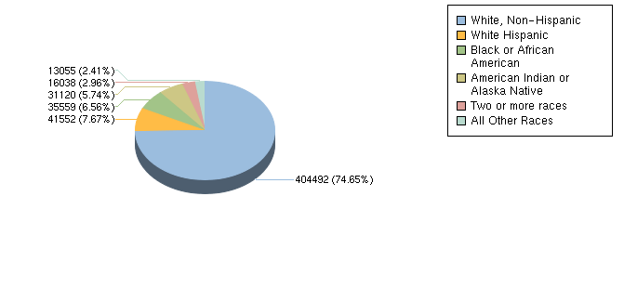

Ethnicity | 2010 Population | % of Region
White, Non-Hispanic | 404,492 | 74.65%
White Hispanic | 41,552 | 7.67%
Non-White Hispanic | 5,551 | 1.02%
Black or African American | 35,559 | 6.56%
American Indian or Alaska Native | 31,120 | 5.74%
Asian | 6,784 | 1.25%
Native Hawaiian and other Pacific Islander | 720 | 0.13%
Two or more races | 16,038 | 2.96%
Source: EMSI Complete Employment - 2nd Quarter 2010

2010 - 2015 Race/Ethnicity Size and Growth
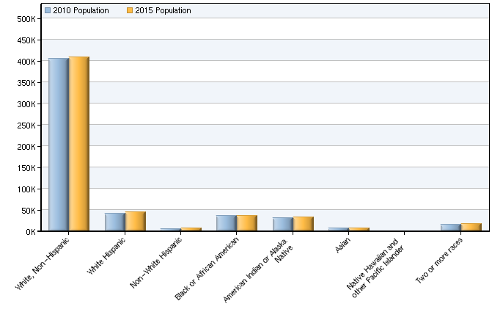

Race/Ethnicity | 2010 Population | 2015 Population | Change | % Change
White, Non-Hispanic | 404,492 | 408,571 | 4,079 | 1%
White Hispanic | 41,552 | 45,174 | 3,622 | 9%
Non-White Hispanic | 5,551 | 6,186 | 635 | 11%
Black or African American | 35,559 | 36,119 | 560 | 2%
American Indian or Alaska Native | 31,120 | 32,022 | 902 | 3%
Asian | 6,784 | 7,107 | 323 | 5%
Native Hawaiian and other Pacific Islander | 720 | 757 | 37 | 5%
Two or more races | 16,038 | 16,608 | 570 | 4%
Total | 541,815 | 552,543 | 10,728 | 2%
Source: EMSI Complete Employment - 2nd Quarter 2010

2010 - 2015 Age Size and Growth
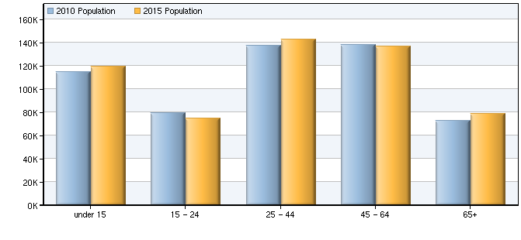

Age | 2010 Population | 2015 Population | Change | % Change
under 15 | 114,761 | 119,396 | 4,635 | 4%
15 - 24 | 79,281 | 74,610 | -4,671 | -6%
25 - 44 | 137,506 | 142,777 | 5,271 | 4%
45 - 64 | 137,898 | 136,978 | -920 | -1%
65+ | 72,369 | 78,782 | 6,413 | 9%
Total | 541,815 | 552,543 | 10,728 | 2%
Source: EMSI Complete Employment - 2nd Quarter 2010

Data Sources and Calculations

Industry Data

In order to capture a complete picture of industry employment, EMSI basically combines covered employment data from Quarterly Census of Employment and Wages (QCEW) produced by the Department of Labor with total employment data in Regional Economic Information System (REIS) published by the Bureau of Economic Analysis (BEA), augmented with County Business Patterns (CBP) and Nonemployer Statistics (NES) published by the U.S. Census Bureau. Projections are based on the latest available EMSI industry data, 15-year past local trends in each industry, growth rates in statewide and (where available) sub-state area industry projections published by individual state agencies, and (in part) growth rates in national projections from the Bureau of Labor Statistics.
Occupation Data

Organizing regional employment information by occupation provides a workforce-oriented view of the regional economy. EMSI's occupation data are based on EMSI's industry data and regional staffing patterns taken from the Occupational Employment Statistics program (U.S. Bureau of Labor Statistics). Wage information is partially derived from the American Community Survey. The occupation-to-program (SOC-to-CIP) crosswalk is based on one from the U.S. Department of Education, with customizations by EMSI.
Demographic Data

The demographic data in this report is compiled from several sources using a specialized process. Sources include US Census Bureau annual estimates, birth and mortality rates from the US Health Department, and projected regional job growth.
State Data Sources

This report uses state data from the following agencies: Oklahoma Employment Security Commission.

