Southwest SWODA WIB

P.O. Box 569
Burns Flat, Oklahoma 73624
Industry Overview Report

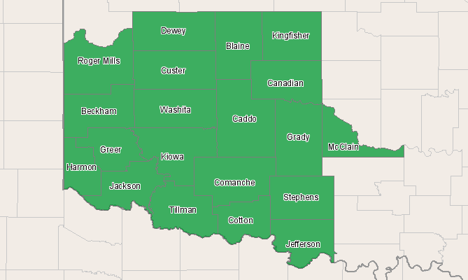

Economic Modeling Specialists, Inc. www.economicmodeling.com


Region Info

Region: SOIC
County Areas: Beckham, Oklahoma (40009), Blaine, Oklahoma (40011), Caddo, Oklahoma (40015), Canadian, Oklahoma (40017), Comanche, Oklahoma (40031), Cotton, Oklahoma (40033), Custer, Oklahoma (40039), Dewey, Oklahoma (40043), Grady, Oklahoma (40051), Greer, Oklahoma (40055), Harmon, Oklahoma (40057), Jackson, Oklahoma (40065), Jefferson, Oklahoma (40067), Kingfisher, Oklahoma (40073), Kiowa, Oklahoma (40075), McClain, Oklahoma (40087), Roger Mills, Oklahoma (40129), Stephens, Oklahoma (40137), Tillman, Oklahoma (40141), Washita, Oklahoma (40149)
Industry Size and Growth

2010 - 2015 Size and Growth
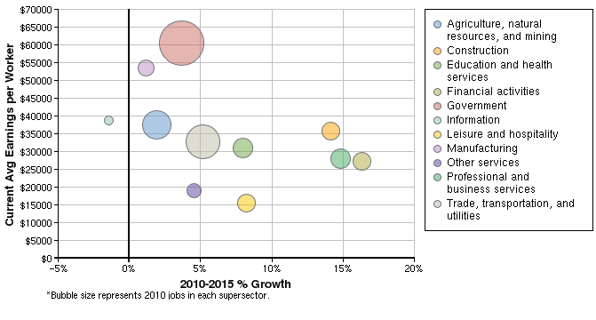

Description | 2010 Jobs | 2015 Jobs | Growth | % Growth | Current EPW
Agriculture, natural resources, and mining | 35,001 | 35,676 | 675 | 2% | $37,602
Construction | 16,471 | 18,799 | 2,328 | 14% | $35,626
Education and health services | 21,323 | 23,024 | 1,701 | 8% | $30,925
Financial activities | 19,292 | 22,442 | 3,150 | 16% | $27,265
Government | 60,822 | 63,060 | 2,238 | 4% | $60,448
Information | 2,535 | 2,499 | -36 | -1% | $38,818
Leisure and hospitality | 19,165 | 20,741 | 1,576 | 8% | $15,503
Manufacturing | 15,148 | 15,323 | 175 | 1% | $53,544
Other services | 13,034 | 13,626 | 592 | 5% | $19,002
Professional and business services | 20,273 | 23,273 | 3,000 | 15% | $28,033
Trade, transportation, and utilities | 43,842 | 46,118 | 2,276 | 5% | $32,737
Total | 266,905 | 284,581 | 17,676 | 7% | $38,301
Source: EMSI Complete Employment - 2nd Quarter 2010

2010 Industrial Makeup
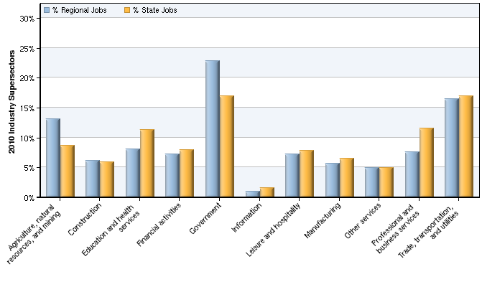

Description | 2010 Regional Jobs | % Regional Jobs | 2010 State Jobs | % State Jobs
Agriculture, natural resources, and mining | 35,001 | 13.1% | 182,036 | 8.6%
Construction | 16,471 | 6.2% | 125,277 | 5.9%
Education and health services | 21,323 | 8.0% | 239,075 | 11.3%
Financial activities | 19,292 | 7.2% | 165,948 | 7.9%
Government | 60,822 | 22.8% | 357,404 | 16.9%
Information | 2,535 | 0.9% | 32,606 | 1.5%
Leisure and hospitality | 19,165 | 7.2% | 164,839 | 7.8%
Manufacturing | 15,148 | 5.7% | 136,738 | 6.5%
Other services | 13,034 | 4.9% | 103,776 | 4.9%
Professional and business services | 20,273 | 7.6% | 243,723 | 11.6%
Trade, transportation, and utilities | 43,842 | 16.4% | 357,701 | 17.0%
Source: EMSI Complete Employment - 2nd Quarter 2010

Data Sources and Calculations

Industry Data

In order to capture a complete picture of industry employment, EMSI basically combines covered employment data from Quarterly Census of Employment and Wages (QCEW) produced by the Department of Labor with total employment data in Regional Economic Information System (REIS) published by the Bureau of Economic Analysis (BEA), augmented with County Business Patterns (CBP) and Nonemployer Statistics (NES) published by the U.S. Census Bureau. Projections are based on the latest available EMSI industry data, 15-year past local trends in each industry, growth rates in statewide and (where available) sub-state area industry projections published by individual state agencies, and (in part) growth rates in national projections from the Bureau of Labor Statistics.
State Data Sources

This report uses state data from the following agencies: Oklahoma Employment Security Commission.

