Southwest SWODA WIB

P.O. Box 569
Burns Flat, Oklahoma 73624
Occupation Report

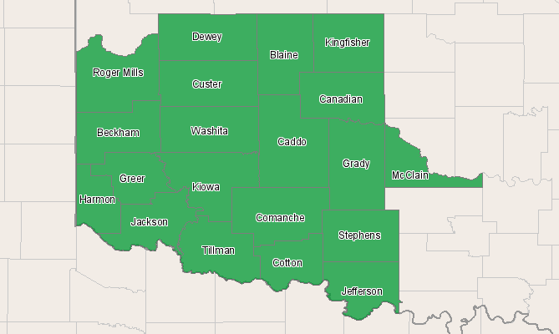

Economic Modeling Specialists, Inc. www.economicmodeling.com


Region Info

Region: SOIC
County Areas: Beckham, Oklahoma (40009), Blaine, Oklahoma (40011), Caddo, Oklahoma (40015), Canadian, Oklahoma (40017), Comanche, Oklahoma (40031), Cotton, Oklahoma (40033), Custer, Oklahoma (40039), Dewey, Oklahoma (40043), Grady, Oklahoma (40051), Greer, Oklahoma (40055), Harmon, Oklahoma (40057), Jackson, Oklahoma (40065), Jefferson, Oklahoma (40067), Kingfisher, Oklahoma (40073), Kiowa, Oklahoma (40075), McClain, Oklahoma (40087), Roger Mills, Oklahoma (40129), Stephens, Oklahoma (40137), Tillman, Oklahoma (40141), Washita, Oklahoma (40149)
Selected Occupations

Occupation | Education Level
Management occupations (SOC 11-0000) | N/A
Business and financial operations occupations (SOC 13-0000) | N/A
Computer and mathematical science occupations (SOC 15-0000) | N/A
Architecture and engineering occupations (SOC 17-0000) | N/A
Life, physical, and social science occupations (SOC 19-0000) | N/A
Community and social services occupations (SOC 21-0000) | N/A
Legal occupations (SOC 23-0000) | N/A
Education, training, and library occupations (SOC 25-0000) | N/A
Arts, design, entertainment, sports, and media occupations (SOC 27-0000) | N/A
Healthcare practitioners and technical occupations (SOC 29-0000) | N/A
Healthcare support occupations (SOC 31-0000) | N/A
Protective service occupations (SOC 33-0000) | N/A
Food preparation and serving related occupations (SOC 35-0000) | N/A
Building and grounds cleaning and maintenance occupations (SOC 37-0000) | N/A
Personal care and service occupations (SOC 39-0000) | N/A
Sales and related occupations (SOC 41-0000) | N/A
Office and administrative support occupations (SOC 43-0000) | N/A
Farming, fishing, and forestry occupations (SOC 45-0000) | N/A
Construction and extraction occupations (SOC 47-0000) | N/A
Installation, maintenance, and repair occupations (SOC 49-0000) | N/A
Production occupations (SOC 51-0000) | N/A
Transportation and material moving occupations (SOC 53-0000) | N/A
Military Occupations (SOC 55-0000) | N/A

Executive Summary

Basic Information
2010 Occupational Jobs | 266,905
2015 Occupational Jobs | 284,581
Total Change | 17,676
Total % Change | 6.62%
Openings | 50,417
Median Hourly Earnings | $13.52

Occupational Change Summary

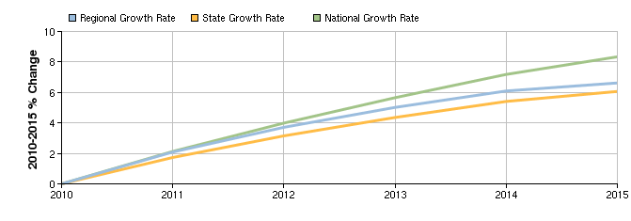

Region | 2010 Jobs | 2015 Jobs | Change | % Change | Openings | Median Hourly Earnings
Regional Total | 266,905 | 284,581 | 17,676 | 7% | 50,417 | $13.52
State Total | 2,109,123 | 2,237,053 | 127,930 | 6% | 384,616 | $15.01
National Total | 173,111,627 | 187,547,430 | 14,435,803 | 8% | 35,463,743 | $17.94
Source: EMSI Complete Employment - 2nd Quarter 2010

Top Industries for Selected Occupations

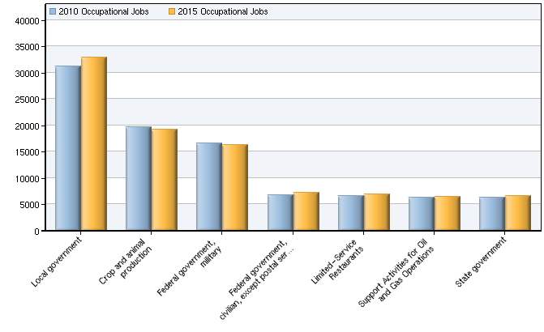

NAICS Code | Name | 2010 Jobs | 2015 Jobs | Change | % Change
930000 | Local government | 31,279 | 32,930 | 1,651 | 5%
11A000 | Crop and animal production | 19,733 | 19,204 | -529 | -3%
912000 | Federal government, military | 16,547 | 16,294 | -253 | -2%
911000 | Federal government, civilian, except postal service | 6,764 | 7,213 | 449 | 7%
722211 | Limited-Service Restaurants | 6,674 | 6,898 | 224 | 3%
213112 | Support Activities for Oil and Gas Operations | 6,239 | 6,477 | 238 | 4%
920000 | State government | 6,232 | 6,623 | 391 | 6%
Source: EMSI Complete Employment - 2nd Quarter 2010

Occupational Breakdown

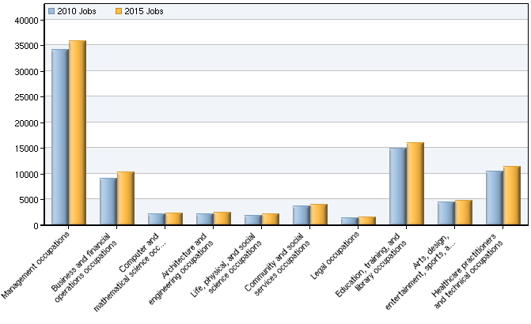

SOC Code | Description | 2010 Jobs | 2015 Jobs | Openings | Median Hourly Earnings
11-0000 | Management occupations | 34,230 | 35,872 | 5,149 | $13.48
13-0000 | Business and financial operations occupations | 9,044 | 10,368 | 2,174 | $15.91
15-0000 | Computer and mathematical science occupations | 2,225 | 2,356 | 368 | $21.56
17-0000 | Architecture and engineering occupations | 2,190 | 2,407 | 475 | $24.84
19-0000 | Life, physical, and social science occupations | 1,887 | 2,168 | 566 | $20.72
21-0000 | Community and social services occupations | 3,741 | 4,017 | 693 | $12.85
23-0000 | Legal occupations | 1,421 | 1,575 | 277 | $16.63
25-0000 | Education, training, and library occupations | 14,935 | 15,997 | 2,781 | $19.60
27-0000 | Arts, design, entertainment, sports, and media occupations | 4,388 | 4,775 | 952 | $9.02
29-0000 | Healthcare practitioners and technical occupations | 10,406 | 11,431 | 2,249 | $22.72
31-0000 | Healthcare support occupations | 5,379 | 5,827 | 837 | $9.63
33-0000 | Protective service occupations | 5,249 | 5,806 | 1,302 | $13.79
35-0000 | Food preparation and serving related occupations | 16,826 | 17,745 | 3,748 | $8.12
37-0000 | Building and grounds cleaning and maintenance occupations | 8,434 | 9,186 | 1,545 | $8.47
39-0000 | Personal care and service occupations | 7,961 | 8,335 | 1,580 | $8.67
41-0000 | Sales and related occupations | 30,544 | 33,208 | 7,054 | $9.63
43-0000 | Office and administrative support occupations | 30,389 | 32,054 | 5,002 | $10.96
45-0000 | Farming, fishing, and forestry occupations | 3,278 | 3,320 | 599 | $8.86
47-0000 | Construction and extraction occupations | 19,012 | 20,937 | 3,813 | $14.98
49-0000 | Installation, maintenance, and repair occupations | 10,468 | 11,076 | 1,848 | $14.67
51-0000 | Production occupations | 12,889 | 13,012 | 2,160 | $15.20
53-0000 | Transportation and material moving occupations | 15,465 | 16,816 | 3,364 | $13.86
55-0000 | Military Occupations | 16,547 | 16,294 | 1,879 | $19.07
 | Total | 266,905 | 284,581 | 50,417 | $13.52
Source: EMSI Complete Employment - 2nd Quarter 2010

Occupation Distribution

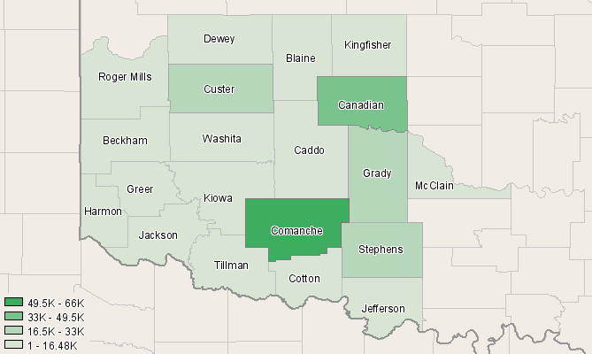

County | 2010 Jobs
Comanche, OK (40031) | 65,915
Canadian, OK (40017) | 42,966
Stephens, OK (40137) | 23,673
Grady, OK (40051) | 22,112
Custer, OK (40039) | 17,086
Jackson, OK (40065) | 14,713
Beckham, OK (40009) | 14,167
McClain, OK (40087) | 12,251
Caddo, OK (40015) | 12,243
Kingfisher, OK (40073) | 9,370
Blaine, OK (40011) | 6,281
Washita, OK (40149) | 4,539
Kiowa, OK (40075) | 4,031
Tillman, OK (40141) | 3,493
Cotton, OK (40033) | 3,126
Dewey, OK (40043) | 3,001
Greer, OK (40055) | 2,297
Jefferson, OK (40067) | 2,291
Roger Mills, OK (40129) | 1,876
Harmon, OK (40057) | 1,474
Source: EMSI Complete Employment - 2nd Quarter 2010

Data Sources and Calculations

Industry Data

In order to capture a complete picture of industry employment, EMSI basically combines covered employment data from Quarterly Census of Employment and Wages (QCEW) produced by the Department of Labor with total employment data in Regional Economic Information System (REIS) published by the Bureau of Economic Analysis (BEA), augmented with County Business Patterns (CBP) and Nonemployer Statistics (NES) published by the U.S. Census Bureau. Projections are based on the latest available EMSI industry data, 15-year past local trends in each industry, growth rates in statewide and (where available) sub-state area industry projections published by individual state agencies, and (in part) growth rates in national projections from the Bureau of Labor Statistics.
Occupation Data

Organizing regional employment information by occupation provides a workforce-oriented view of the regional economy. EMSI's occupation data are based on EMSI's industry data and regional staffing patterns taken from the Occupational Employment Statistics program (U.S. Bureau of Labor Statistics). Wage information is partially derived from the American Community Survey. The occupation-to-program (SOC-to-CIP) crosswalk is based on one from the U.S. Department of Education, with customizations by EMSI.
State Data Sources

This report uses state data from the following agencies: Oklahoma Employment Security Commission.

