CECS 346 Project 1
Traffic Light Controller with Moore FSM
© 2026 Dr. Min He, CSULB. All rights reserved.

Overview
Design and build a traffic light controller for a 4-corner intersection of two one-way streets (South and West) with a pedestrian crossing. Your system uses a Moore FSM with SysTick timer to coordinate three participants: South traffic, West traffic, and pedestrians. This project integrates all skills from Labs 1–4: GPIO initialization, FSM design, struct-based state tables, SysTick timing, and hardware interfacing.

Learning Objectives
- Design a Moore FSM with 9 states, 3 inputs (8 combinations), and multiple outputs
- Implement the FSM using an indexed data structure (struct array) in C
- Use SysTick timer for all timing delays (no software delay loops)
- Interface multiple GPIO ports: Port B (traffic LEDs), Port E (sensors), Port F (pedestrian LEDs)
- Use bit-specific addressing for all I/O access
- Build and debug a multi-port embedded system on a breadboard
- Apply round-robin fairness scheduling for competing intersection participants

Preparation
Complete before starting:
- Read textbook Sections 6.4–6.9
- Review reference projects: SimpleTrafficLight, SysTick
- Have a working Lab 4 project (starter project for this project)
Materials needed:
- TM4C123 LaunchPad
- 6 LEDs: 2 red, 2 yellow, 2 green (for South and West traffic lights)
- 3 switches: preferably slide switches or DIP switches (not momentary push buttons)
- Resistors for LED current limiting (330Ω–1kΩ)
- Breadboard and jumper wires
Note: Slide switches or DIP switches are strongly preferred because sensors must remain ON until the FSM reads them. Push buttons require holding throughout the entire state duration.

System Requirements
Design a traffic light controller for the intersection of two equally busy one-way streets. The goal is to maximize traffic flow, minimize waiting time, and avoid accidents.

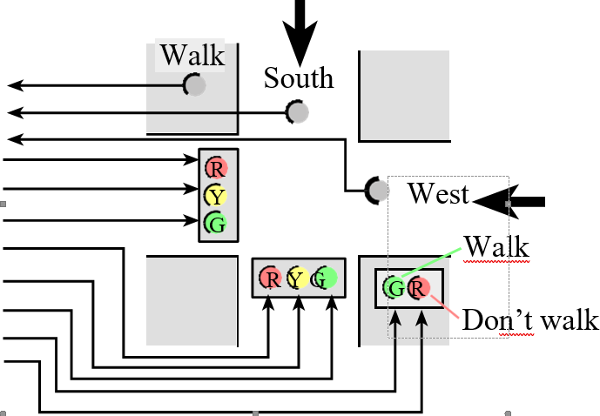
Figure 1: 4-corner intersection with South, West, and Pedestrian participants

Three Participants
Participant | Sensor | Green Lights | Logic
South | PE2 — car sensor | PB0 (G), PB1 (Y), PB2 (R) | Positive: 3.3V = car present
West | PE1 — car sensor | PB3 (G), PB4 (Y), PB5 (R) | Positive: 3.3V = car present
Pedestrian | PE0 — walk button | PF3 (walk), PF1 (don't walk) | Positive: 3.3V = ped waiting

Pedestrian Light Sequence
Phase | LED | Duration | Meaning
Walk | PF3 green ON | 2 sec | Pedestrians may cross
Hurry Up | PF1 red FLASHING | 1 sec total | Finish crossing quickly
Don't Walk | PF1 red ON steady | — | Do not enter intersection
Hurry Up flashing: 0.25s on, 0.25s off, 0.25s on, 0.25s off = 1 second total (4 states).

Timing Summary
Phase | Duration
Green / Walk | 2 seconds (8 × 0.25s)
Yellow / Hurry | 1 second (4 × 0.25s)
Base time unit: 0.25 seconds. Use SysTick timer (not software delay loops).

Fairness Rules (Round-Robin Scheduling)
When multiple participants need the intersection, service them fairly using these rules:

Rule 1: Traffic lights must follow green → yellow → red. No other transition is allowed.
Rule 2: Pedestrian lights must follow walk → hurry → don't walk. No other sequence is allowed.
Rule 3: Once a participant starts a green-yellow-red (or walk-hurry-don't walk) transition, it must complete the full sequence before giving green to another participant.
Rule 4: When two participants compete for green after a transition, neither may be the one that just had green. Alternate fairly between the two competitors.

Example (Rule 4): After GoS (South had green), if both West and Pedestrian need green, assign one in case 1 (all three competing) and the other in case 2 (only two competing). This ensures fair alternation.
The system starts with Green on South.

Implementation Requirements
⚠ No conditional branches (if-else) in the FSM engine. No #include tm4c123gh6pm.h — you must define all registers yourself.

- Implement a Moore FSM: each state has a name, output, wait time, and 8 next states
- Use SysTick timer for all delays
- Use bit-specific addressing for P_LIGHTS, T_LIGHTS, and SENSORS
- Do not embed functionality (e.g., flash twice) into the engine that is not in the state graph

GPIO Pin Assignments
Traffic Light | Pin
Green south | PB0
Yellow south | PB1
Red south | PB2
Green west | PB3
Yellow west | PB4
Red west | PB5

Sensor / Button | Pin
South car sensor | PE2
West car sensor | PE1
Pedestrian Walk | PE0
Walk light (green) | PF3
Don't Walk light (red) | PF1

Required Bit-Specific Address Definitions
#define P_LIGHTS (*(volatile uint32_t *)0x_________) // PF3, PF1
#define T_LIGHTS (*(volatile uint32_t *)0x_________) // PB5-PB0
#define SENSORS (*(volatile uint32_t *)0x_________) // PE2-PE0
You must calculate these addresses using base + (bit_mask << 2).

FSM Design

State List (9 states)
State | Time (×0.25s) | PB5-0 Output | PF3,1 | Description
GoS | 8 | 100001 | 01 | South green, West red, Don't walk
WaitS | 4 | (fill in) | (fill in) | South yellow, West red, Don't walk
GoW | 8 | (fill in) | (fill in) | South red, West green, Don't walk
WaitW | 4 | (fill in) | (fill in) | South red, West yellow, Don't walk
GoP | 8 | (fill in) | (fill in) | Both red, Walk (green on)
WaitPOn1 | 1 | (fill in) | (fill in) | Both red, Hurry flash ON (1st)
WaitPOff1 | 1 | (fill in) | (fill in) | Both red, Hurry flash OFF (1st)
WaitPOn2 | 1 | (fill in) | (fill in) | Both red, Hurry flash ON (2nd)
WaitPOff2 | 1 | (fill in) | (fill in) | Both red, Hurry flash OFF (2nd)

State Transition Table (you complete this)
Input order: PE2 (South), PE1 (West), PE0 (Pedestrian) → 3 bits → 8 combinations (000–111).
Partially filled — complete the remaining cells using the fairness rules:

State | 000 | 001 | 010 | 011 | 100 | 101 | 110 | 111
GoS | GoS | WaitS | WaitS | WaitS | GoS | WaitS | WaitS | WaitS
WaitS | GoW | GoP | GoW | GoW | GoP | GoP | GoW | GoP
GoW
WaitW
GoP | GoP | GoP | WaitPOn1
WaitPOn1 | WaitPOff1 | WaitPOff1 | WaitPOff1 | WaitPOff1 | WaitPOff1 | WaitPOff1 | WaitPOff1 | WaitPOff1
WaitPOff1 | WaitPOn2 | WaitPOn2 | WaitPOn2 | WaitPOn2 | WaitPOn2 | WaitPOn2 | WaitPOn2 | WaitPOn2
WaitPOn2 | WaitPOff2 | WaitPOff2 | WaitPOff2 | WaitPOff2 | WaitPOff2 | WaitPOff2 | WaitPOff2 | WaitPOff2
WaitPOff2

Implementation Steps
Step 1: Design the FSM. Draw the state diagram showing all 9 states, outputs, wait times, and transitions. Complete the state table above.
Step 2: Write and debug in Keil simulator. Use the Logic Analyzer to verify all input/output combinations.
Step 3: Build the switch circuits (positive logic). Wire 3 switches to PE2, PE1, PE0. Test with a simple program that maps each switch to an onboard LED.
Step 4: Build the LED circuits (positive logic). Wire 6 LEDs to PB5–PB0 arranged like a traffic intersection. Test with a program that turns all LEDs on then off.
Step 5: Integrate and debug the complete system on the LaunchPad.
⚠ Do not place or remove wires on the breadboard while power is on.

Onboard Demonstration Steps
Follow this sequence for the live demo:

1. Reset: South green on, West red, Pedestrian don't walk (red steady).

2. Single participant tests:
  - Turn on West sensor → observe South green→yellow→red, then West green
  - Turn on Pedestrian → observe West green→yellow→red, then Walk green
  - Turn on South → observe Walk→Hurry→Don't Walk, then South green
  - Turn on Pedestrian → Walk sequence, then back to another participant
  - Turn on West → transition to West green
  - Turn on South → transition to South green

3. Two participant tests (observe two full rounds):
  - South + Pedestrian: hold both, watch alternating service
  - South + West: hold both, watch alternating service
  - West + Pedestrian: hold both, watch alternating service

4. Three participant test: Hold all three, observe two full rounds of round-robin cycling.

Deliverables and Grading
# | Item | Format | Points | Due
1 | On-board demonstration (all test cases). All team members present. | Live demo | 30 | In lab
2 | Logic Analyzer simulation screenshots (test case 4: all three participants) | In report | 10 | Report
3 | Video or link for on-board demo (all test cases) | Link in report | 10 | Report
4 | Source code (.c/.h files). No startup.s, no tm4c123gh6pm.h. Define all registers. | Separate files | 20 | Report
5 | Project report (see format below) | Word or PDF | 30 | Report

Project Report Format
Hardware Design: Professional schematic and photo of your embedded system.
Operation: Include the video link for on-board demonstration.
Software Design: State table, state diagram, and list of .c/.h source files.
Conclusion: Challenges, how you solved them, and what you learned most from this project.

