SALUS.MATERNA: AN AI & SOLAR-POWERED, VITAL SIGNS MONITORING DEVICE, ENHANCING MATERNAL HEALTH

CEDRIC J MURAGE MWANGI
12TH FEBRUARY 2026

ACKNOWLEDGMENT
I extend my heartfelt gratitude to my parents and siblings for their love, encouragement, and unwavering support throughout this academic journey. They have been instrumental in my personal and academic growth.
I acknowledge my friends for their constant support, motivation, and encouragement, whose insights enabled me to navigate through the difficulties and challenges encountered in developing this project.
Finally, I acknowledge the efforts of my supervisor, Eng. Martin Nzomo, whose guidance and constructive feedback have been pivotal in completing this project successfully. I am truly grateful to all those who have supported me in one way or another.

ABSTRACT

Maternal mortality in Kenya remains high at 355 deaths per live 100,000 births. This is caused primarily

by postpartum hemorrhage, sepsis, embolism and hypertensive disorders. Moreover, rural facilities

struggle with frequent blackouts, intermittent monitoring and lack of remote alerts, which exacerbates maternal mortality. This project develops a solar-powered device that provides continuous vital sign monitoring and remote alerts, utilizing ml to assess maternal complication risks in real time.

By combining photoplethysmography with piezoelectric sensors along the radial artery, cuffless SBP/DBP can be calculated via pulse wave velocity and peak intensity ratio, derived through the Moens-Korteweg equation and Beer-Lambert optical models. Moreover, trends in postpartum
complications show that PPH, hypertension, sepsis and pulmonary embolism each induce a unique trend in the patient vitals, which if continually monitored, can result to their early detection.

The MAX30102, MLX90614ESF and piezoelectric ceramic sensors are interfaced with an ESP32. The ESP32 sends sensor data to the azure cloud where it is analyzed, and displayed via web interface. Alerts in the event of error or risk detected is both on device and remote via Twilio SMS/call. A solar powered subsystem was also integrated to power the device.

Sensor readings showed high accuracy with a very minimal mean squared error when tested against

clinical grade sensors. The solar powered subsystem proved long-term performance outside the grid. Real time remote SMS/calls were given within a minute of error or risk.

SALUS.MATERNA integrates continuous patient monitoring with off grid solar-powered operation, remote alerting, cloud telemetry, and an ensemble ML for early detection of maternal risks, in a single system. It resolves some of the problems leading to maternal deaths in rural Kenya. Future work will pursue expanded clinical validation and miniaturization for wearability.

Keywords: IoT, Maternal Health Monitoring, Vital Signs, Solar Power, Predictive Risk Assessment,

Maternal Sepsis, PPH, Rural Healthcare, Cuffless BP

Contents
ABSTRACT 3
CHAPTER ONE: INTRODUCTION 6
Research Background 6
Problem Statement 8
Research Objectives 9
General Objective 9
Specific Objectives 10
Justification 10
Scope and Limitations 11
Scope 11
Limitations 12
Operational Definitions 13
CHAPTER TWO: LITERATURE REVIEW 15
Introduction 15
Maternal Mortality in Low-Resource Settings 15
Global and Regional Epidemiology 15
Primary Causes of Maternal Death 15
Physiological Monitoring Technologies 16
Pulse Oximetry and Photoplethysmography 16
Non-Contact Temperature Measurement 17
Cuffless Blood Pressure Measurement 17
Power Systems for Medical Devices in Off-Grid Settings 18
Wireless Communication and Cloud Architectures 19
Wireless Technologies for Healthcare Telemetry 19
Cloud Computing for Medical Data Management 19
Machine Learning for Maternal Risk Prediction 20
Existing Maternal Monitoring Technologies: Comparative Analysis 20
CHAPTER THREE: METHODOLOGY 22
Introduction 22
System Architecture Overview 22
Component Selection and Budget 23
MAX30102 Sensor Selection Rationale 24
Piezoelectric Ceramic Sensor Selection 25
MLX90614ESF Thermometer Selection 26
ESP32 Microcontroller Selection 26
Cuffless Blood Pressure Measurement System Design 27
Sensor Placement and Physical Configuration 27
Piezoelectric Signal Conditioning Circuit 27
PTT and PWV Computation 28
PIR Measurement and Arterial Diameter Change 29
Moens-Korteweg BP Algorithm 29
Calibration Protocol 30
Solar Power Subsystem Design 30
Firmware Architecture 31
Development Environment 31
Sensor Data Acquisition and Signal Processing 32
Alert Detection Logic 33
Cloud Infrastructure Implementation 33
Azure Blob Storage Configuration 33
Azure Functions 33
Machine Learning Model 34
Web Interface Development 34
Project Timeline 35
CHAPTER FOUR: RESULTS 36
Sensor Accuracy Validation Results 36
Oxygen Saturation Measurement Accuracy 36
Temperature Measurement Accuracy (MLX90614ESF) 36
Cuffless Blood Pressure Accuracy Results 37
Solar Power Subsystem Performance 38
Cloud Data Transmission and Storage 38
Alert System Performance Results 38
CHAPTER FIVE: DISCUSSION 40
Clinical Significance 40
Technical Performance Analysis 41
Comparison with Existing Technologies 41
Limitations and Areas for Improvement 42
CHAPTER SIX: CONCLUSION AND RECOMMENDATIONS 43
CONCLUSION 43
Recommendations 43
Technical Enhancements 43
Clinical Validation and Regulatory Compliance 44
Health Systems Integration 44
REFERENCES 46
APPENDIX A: COMPLETE EQUATION REFERENCE 49
APPENDIX B: WORKED EXAMPLE — CUFFLESS BP CALCULATION 49

CHAPTER ONE: INTRODUCTION

Research Background
Maternal mortality remains one of the most pressing public health challenges in sub-Saharan Africa and globally. According to the World Health Organization study in 2023, it was estimated that approximately 287,000 women die from pregnancy-related causes every year worldwide, with over 70% of these deaths concentrated in sub-Saharan Africa. The African region alone accounts for an estimated 178,000 maternal deaths annually, representing a regional maternal mortality ratio of approximately 442 deaths per 100,000 live births, which is more than six times the global average [1].
In Kenya specifically, the maternal mortality ratio stands at 355 deaths per 100,000 live births, translating to nearly 5,000 women and girls dying every year due to pregnancy and childbirth complications. The equivalent is approximately 16 women every single day [2]. This current rate remains vastly above the United Nations Sustainable Development Goal 3.1 target of fewer than 70 maternal deaths per 100,000 live births by 2030 [2, 3].
The burden of maternal mortality is disproportionately concentrated in rural Kenya, where access to skilled professionals, emergency obstetric care, and continuous patient monitoring remains severely limited. While majority of Kenyan women are attended by a skilled professional during delivery, there are significant county-level disparities and only 61% of births occur in a healthcare facility [3]. Infrastructure challenges also contribute to the problem, where Kenya's rural electrification rates mean that many health facilities experience frequent and prolonged power outages, rendering conventional electronic monitoring equipment non-functional for hours or even days at a time.
The primary causes of maternal death in Kenya are well documented. Postpartum hemorrhage accounts for approximately 40% of maternal deaths and remains the single leading cause, followed by obstructed labor (28%), eclampsia (14%), and maternal sepsis (approximately 11–15%) [4]. Each of these conditions is characterized by distinctive, early physiological warning signs, including tachycardia, fever, hypotension, and oxygen desaturation, that are detectable through continuous monitoring.
Contemporary vital signs monitoring in rural Kenyan facilities typically relies on intermittent manual assessments performed every four to six hours using basic equipment such as mercury thermometers, manual sphygmomanometers, and finger pulse oximeters. This approach is fundamentally insufficient, as it cannot detect rapid physiological deterioration between assessment intervals. It also requires continuous healthcare worker presence in settings with severe personnel shortages, and generates no permanent records for trend analysis or clinical decision support.
Recent advances in sensor technology, microcontroller capabilities, and wireless communication infrastructure present genuine opportunities to address these challenges at low cost. Modern pulse oximetry sensors such as the MAX30102 enable non-invasive, continuous monitoring of heart rate and oxygen saturation at accuracy comparable to clinical-grade equipment but at a fraction of the cost. ESP32 microcontrollers provide sufficient computational power for real-time signal processing while supporting both Wi-Fi and cellular connectivity. Solar photovoltaic technology has matured to enable reliable off-grid power systems for medical devices. Cloud platforms such as Microsoft Azure offer scalable infrastructure for medical data storage, real-time visualization, and alert management. The convergence of these technologies creates a viable pathway for a deployable, affordable, and clinically meaningful maternal monitoring system optimized for rural Kenyan healthcare contexts.
This project integrates these technologies into SALUS.MATERNA, a solar-powered, IoT-enabled maternal health monitoring device addressing critical infrastructure gaps in rural Kenyan healthcare facilities, while simultaneously incorporating a novel cuffless blood pressure measurement capability using piezoelectric and photoplethysmographic sensing along the radial artery.

Problem Statement
Maternal deaths in rural Kenyan healthcare facilities are largely attributable to delays in recognizing and responding to physiological deterioration during the peripartum and postpartum periods. Current monitoring practices are inadequate due to three fundamental and interconnected technical limitations.
First, the absence of continuous monitoring capability means that life-threatening conditions developing between intermittent manual assessments remain undetected until clinical symptoms become severe. Early sepsis presents with subtle tachycardia and low-grade fever that may be missed during the six-hour vital signs checks but would be immediately apparent with continuous monitoring. Similarly, postpartum hemorrhage causes progressive tachycardia and hypotension that, if detected early through continuous heart rate monitoring, enables intervention before hemorrhagic shock develops. Analysis of maternal mortality audit reports from Kenyan county hospitals between 2020 and 2023 identified delayed recognition of physiological deterioration as a contributing factor in 68% of deaths from sepsis and 73% of deaths from postpartum hemorrhage [4].
Second, unreliable electrical power infrastructure renders conventional electronic monitoring equipment non-functional for extended periods. Kenya's rural electrification experiences challenges where even connected facilities frequently experience blackouts that could even last weeks [5]. During a field visit to a clinic in Gichugu, Kirinyaga, in 2024 as part of industrial attachment, nursing staff reported a two-week power outage following a tree falling on the electric cables, during which all electronic monitoring equipment remained entirely non-functional. Such prolonged outages create monitoring blind spots that coincide with periods of highest clinical risk.
Third, inadequate real-time remote alerting mechanisms delay clinical response to deteriorating conditions. Kenyan rural facilities are often understaffed, where only one clinician operates an entire clinic in some cases. In the event they need to step out maybe to retire for the day or undertake some errands, there is no way to alert them in the event a patient’s condition begins to deteriorate. Therefore arises a need to have a mechanism that alerts the healthcare provider, to immediately intervene and check on the patient, even when are away from the clinic, or currently dealing with another patient.

Research Objectives

General Objective
To design and develop SALUS.MATERNA: a solar-powered, maternal health monitoring device for rural Kenyan healthcare facilities, incorporating continuous vital signs surveillance, real-time remote alerting, and machine learning-based complication risk assessment.

Specific Objectives
- To develop and calibrate a sensor subsystem using the MAX30102 pulse oximetry sensor and MLX90614ESF infrared thermometer, achieving precision within ±5 bpm for heart rate, ±3% for SpO₂, and ±0.6°C for temperature compared to medical-grade reference equipment.
- To implement a cuffless blood pressure measurement module using piezoelectric ceramic sensors and MAX30102 PPG on the radial artery, computing SBP and DBP via Pulse Wave Velocity derived from the Moens-Korteweg equation and the Beer-Lambert PIR model, targeting accuracy within ±5 mmHg post-calibration.
- To engineer a solar power management system utilizing a 6V PV panel and 3.7V Li-ion battery, capable of maintaining 100% off-grid device functionality.
- To deploy a secure Microsoft Azure cloud architecture.
- To integrate a remote alert mechanism via Twilio that sends real time alerts via SMS/Voice Call, within 60 seconds.
- To implement a machine learning ensemble model for early detection of maternal complication risks including PPH, sepsis, hypertensive disorders, and pulmonary embolism.

Justification
This project addresses critical technical gaps in maternal health monitoring infrastructure that directly contribute to preventable maternal deaths in rural Kenyan healthcare facilities. The justification encompasses clinical necessity, technical feasibility, economic viability, and alignment with national health priorities.
From a clinical perspective, continuous vital signs monitoring has demonstrated significant impact on early detection of maternal complications. A 2024 systematic review of digital health technologies for maternal health in low and middle income countries found that continuous monitoring significantly reduced time to intervention for postpartum hemorrhage and decreased sepsis related mortality compared to intermittent manual monitoring [7]. The specific vital signs monitored by this system are established early warning indicators. Tachycardia (HR >100 bpm) precedes hemorrhagic shock by an average of 45 to 60 minutes, providing a critical intervention window. Oxygen desaturation (SpO₂ <95%) indicates respiratory compromise that may signal pulmonary embolism or severe infection. Fever (temperature >38°C) or hypothermia (<36°C) are cardinal signs of sepsis requiring immediate antibiotic therapy [8].
The inclusion of cuffless blood pressure measurement adds a clinically critical dimension. Over a billion people worldwide have hypertension, and in Kenya, hypertensive disorders during pregnancy account for 14–19% of maternal deaths [2, 9]. Current cuffless blood pressure technologies using PPG and pulse wave velocity have demonstrated mean differences within clinically acceptable ranges, within 1 mmHg for SBP and DBP compared to conventional cuffed blood pressure monitoring, representing a genuine breakthrough for continuous, non-invasive BP tracking [9].
The solar power subsystem addresses a fundamental infrastructure barrier. Kenya's rural facilities experience frequent power outages. Solar photovoltaic systems eliminate dependence on grid power. The low cost of solar power for small medical devices is substantially lower than diesel generator backup power, the current alternative at many rural facilities [5].
The project also aligns with Kenya's national health priorities articulated in the Kenya Health Policy 2014–2030 and the National Reproductive, Maternal, Newborn, Child and Adolescent Health (RMNCAH) Investment Framework. The Maternal, Newborn and Child Health Bill 2023, outlines the national commitment to innovative technology solutions for extending health services to rural populations [4].

Scope and Limitations

Scope
This project encompasses the complete design, development, and validation of a maternal health monitoring system from hardware fabrication through cloud infrastructure deployment. The scope includes:
- Hardware Development: Design and assembly of sensor interface circuitry integrating the MAX30102 pulse oximetry sensor with ESP32 microcontroller, including signal conditioning circuits, power management subsystem (solar panel, battery, charge controller, voltage regulation), and user interface components (OLED display, status LEDs, buzzer). Hardware validation includes bench testing of sensor accuracy against calibrated reference equipment (pulse oximeter for HR and SpO₂, infrared thermometer for temperature) and power subsystem endurance testing under simulated operational conditions.
- Firmware Development: Implementation of embedded software for the ESP32 microcontroller using C/C++ with Arduino framework, including real-time vital signs acquisition and processing algorithms, abnormal reading detection logic, sensor fault detection (finger removal, signal quality assessment), wireless communication protocols (Wi-Fi and 4G via hotspot), and local data display on OLED screen. Firmware testing includes validation of sensor reading accuracy, alert triggering reliability, and communication protocol robustness.
- Cloud Infrastructure: Deployment of Microsoft Azure services including Blob Storage configured with appropriate security policies (Shared Access Signature tokens, encryption at rest and in transit), Azure Functions implementing HTTP-triggered serverless functions for data ingestion and alert processing, Azure Static Web Apps hosting the monitoring dashboard, and integration with Twilio API for SMS and voice notification delivery. Cloud testing includes validation of data upload reliability, alert delivery latency, and web interface responsiveness across the network.
- Web Interface Development: Implementation of browser-based monitoring dashboard using HTML5, CSS3, and JavaScript, featuring real-time vital signs display, graphical trending of physiological parameters, historical data review, alert history logging, and patient information management. Interface testing includes validation of functionality across different devices (Laptop and smartphones) and browsers (Chrome, Opera, Edge).
- Alert System Validation: Comprehensive testing of notification delivery including SMS message delivery with specific vital sign values and patient identification, and automated voice call functionality with text-to-speech synthesis conveying alert details. Testing quantifies alert delivery latency from detection to notification across different network conditions and validates that notification content provides actionable clinical information.
- System Integration Testing: End-to-end validation of complete workflow from sensor data acquisition through cloud data storage and alert delivery, including verification of data integrity throughout the processing pipeline, validation of system behavior under edge cases (sensor disconnection, network interruption, cloud service unavailability), and assessment of system recovery mechanisms when normal operating conditions are restored.

Limitations
This project acknowledges several technical and operational limitations that bound the scope of deliverables and define areas requiring future work:
- Sensor Limitations: The system does not measure respiratory rate, or other vital signs that may provide additional clinical value but would require additional sensors beyond project scope. The Cuffless BP also requires one cuff calibration per person, to know the arterial wall stiffness, which differs per person.
- Communication Dependencies: The system requires either Wi-Fi network connectivity or cellular data via smartphone hotspot for cloud data upload and remote alerting. In areas with poor internet coverage, remote monitoring and SMS/voice alerting will be limited, though on-device indicators (LEDs, buzzer, OLED display) continue to operate.
- Scalability Limitations: The current implementation focuses on single-patient monitoring at individual health facilities. Multi-patient deployment would require additional hardware units, potentially centralized dashboard for facility-wide monitoring, and scaled cloud infrastructure.

Operational Definitions
Heart Rate (HR): Number of cardiac contractions per minute, measured via PPG. Normal range: 60–100 bpm. Alert thresholds: <60 or >100 bpm.
Oxygen Saturation (SpO₂): Percentage of hemoglobin saturated with oxygen, measured non-invasively via pulse oximetry. Normal range: ≥95%. Alert threshold: <95%.
Body Temperature: Core body temperature measured via infrared thermopile sensor. Normal range: 36.0–38.0°C. Alert thresholds: <36.0°C (hypothermia) or >38.0°C (fever).
Cuffless Blood Pressure (BP): Continuous, non-invasive estimation of systolic blood pressure (SBP) and diastolic blood pressure (DBP) via Pulse Wave Velocity and Peak Intensity Ratio, without inflating a pneumatic cuff. Computed using the Moens-Korteweg haemodynamic model.
Pulse Wave Velocity (PWV): Speed (m/s) at which a pressure pulse propagates through an arterial segment, measured between two piezoelectric sensors on the radial artery. Directly related to arterial stiffness and blood pressure.
Pulse Transit Time (PTT): Time difference (seconds) between detection of the same arterial pressure pulse wave at two points separated by a known distance L. PWV = L / PTT.
Peak Intensity Ratio (PIR): Ratio of the diastolic peak to systolic trough of the MAX30102 infrared PPG channel (PIR = I_H / I_L). Used to estimate arterial diameter change via the Beer-Lambert law.
Mean Arterial Pressure (MAP): Calculated from SBP and DBP as MAP = (SBP + 2×DBP) / 3, representing the time-averaged blood pressure during the cardiac cycle.
Internet of Things (IoT): Architecture where physical devices connect to the internet to transmit data to cloud services. Enables remote monitoring, centralised data storage, and integration with health information systems.
Solar Power Subsystem: Photovoltaic energy harvesting and storage system comprising a 6V solar panel, 3.7V lithium-ion battery, HW-168 charging module, and HW-100 buck converter providing regulated 5V DC output.

CHAPTER TWO: LITERATURE REVIEW

Introduction
This chapter examines the existing body of knowledge relevant to maternal health monitoring in rural regions, with particular emphasis on technological interventions addressing infrastructure limitations common in sub-Saharan Africa. The review covers the epidemiology of maternal mortality, physiological monitoring technologies, power systems for off-grid medical devices, wireless communication and cloud architectures for healthcare, clinical alert systems, cuffless blood pressure measurement, and machine learning for maternal risk prediction.

Maternal Mortality in Low-Resource Settings

Global and Regional Epidemiology
The World Health Organization's most recent estimates indicate that approximately 287,000 women died from pregnancy-related causes globally in 2020, with 94–95% of these deaths occurring in low and middle income countries[1]. Sub-Saharan Africa bears a disproportionate share, as the region accounts for approximately 70% of global maternal deaths, with a regional maternal mortality rate of 442 deaths per 100,000 live births as of 2023 [3]. This is more than six times the global average.
In Kenya, the UNFPA cites a maternal mortality ratio of 355 deaths per 100,000 live births, equating to nearly 5,000 women and girls dying annually due to pregnancy-related causes [2]. UNICEF's 2025 State of African Children Statistical Compendium recorded a slightly higher estimate of 530 deaths per 100,000 live births for Kenya, reflecting ongoing challenges in vital registration data quality across the region [3]. Either figure is dramatically above the SDG 3.1 target of fewer than 70 per 100,000. The African region would need a radical increase in its annual rate of reduction to achieve the SDG target by 2030 [3].

Primary Causes of Maternal Death
Analysis of maternal mortality data from the Kenya Health Information System identifies postpartum hemorrhage as the leading cause of maternal mortality, accounting for approximately 40% of deaths in Kenya, followed by obstructed labor (28%) and eclampsia (14%) [4]. National figures from the Kenya Confidential Enquiry into Maternal Deaths identify puerperal sepsis (14%) and complications from unsafe abortion (13%) as further significant contributors [8].
PPH, defined as blood loss exceeding 500 mL following vaginal delivery or 1,000 mL following caesarean section, induces progressive tachycardia as the cardiovascular system attempts to maintain perfusion. Each litre of blood loss in an average 70 kg woman is associated with an increase in heart rate of approximately 10–15 bpm before the onset of hypotension, creating a critical detection window that continuous HR monitoring could exploit [8].
Puerperal sepsis presents with fever (temperature >38°C) or hypothermia (<36°C), tachycardia, and in advanced cases, hypoxaemia due to acute respiratory distress syndrome. The Surviving Sepsis Campaign guidelines published in 2021 emphasize that each hour of delay in antibiotic administration after sepsis recognition increases mortality substantially, reinforcing the importance of early detection through continuous temperature and heart rate monitoring [8].
Eclampsia and severe pre-eclampsia are characterized by hypertension, with SBP ≥160 mmHg or DBP ≥110 mmHg defining the severe range. Current WHO guidelines from 2022 recommend anti-hypertensive treatment within 60 minutes of diagnosis for severe hypertension in pregnancy [8]. Continuous, Cuffless blood pressure monitoring would enable identification of dangerously elevated BP well before overt seizure occurs.
Pulmonary embolism, though less common, carries extremely high short-term mortality and classically presents with sudden-onset dyspnea and acute oxygen desaturation. Continuous pulse oximetry would detect the acute decline in SpO₂ that characterizes massive pulmonary embolism, enabling emergent intervention.

Physiological Monitoring Technologies

Pulse Oximetry and Photoplethysmography
Pulse oximetry exploits the differential light absorption characteristics of oxyhemoglobin versus deoxyhaemoglobin. By calculating the ratio of pulsatile to non-pulsatile absorption at red (660 nm) and infrared (940 nm) wavelengths, pulse oximeters estimate SpO₂ with high accuracy. Modern integrated sensors such as the MAX30102 combine LEDs and a photodetector in a single compact package operating at 660 nm and 880 nm, providing 16-bit ADC conversion at sampling rates up to 3,200 samples per second, with integrated ambient light cancellation [11].
Photoplethysmography detects volumetric changes in blood within peripheral vasculature by measuring variations in light reflectance. Each cardiac contraction generates a pressure pulse wave that propagates through the arterial system, causing transient expansion and increased optical path length. PPG waveforms contain a small pulsatile AC component (typically 1–2% of the DC component amplitude) reflecting cardiac-synchronous volume changes. Heart rate is derived from inter-peak intervals in the AC waveform.

Non-Contact Temperature Measurement
The MLX90614ESF non-contact infrared thermometer utilizes a thermopile detector to measure thermal radiation emitted from skin surface, providing temperature measurement without direct contact, suitable for continuous monitoring applications. The sensor provides digital output via I2C protocol with 0.02°C resolution and factory-calibrated accuracy of ±0.5°C. Its non-contact nature reduces cross-infection risk in clinical settings and enables measurement while the patient is asleep.

Cuffless Blood Pressure Measurement
Cuffless blood pressure measurement has emerged as one of the most actively researched topics in biomedical engineering. A comprehensive 2024 meta-analysis in ScienceDirect of continuous wearable Cuffless BP devices versus conventional 24-hour ambulatory blood pressure monitoring found that PPG-based devices demonstrated mean differences within clinically acceptable ranges: mean difference of -0.99 mmHg for SBP and comparable accuracy for DBP, establishing that well-calibrated PPG-based Cuffless technologies can approach the accuracy of conventional ambulatory blood pressure monitor [9].
The most physically rigorous approach to Cuffless BP measurement relies on the measurement of Pulse Wave Velocity (PWV) using the Moens-Korteweg hemodynamic model. This model establishes that the speed of a pressure wave travelling through an arterial wall is directly related to arterial stiffness, which in turn increases with blood pressure. By measuring the PWV and the optical characteristics of the artery via PPG, SBP and DBP can be computed.
A study by Guo et al. (2022) demonstrated the feasibility of a combined piezoelectric and PPG sensor system for cuffless BP estimation based on this haemodynamic model [13]. Their device achieved SBP error of 0.75 ± 3.9 mmHg and DBP error of 1.1 ± 3.12 mmHg, meeting the ISO 81060-2 criteria for non-invasive BP devices. Their system used a piezoelectric sensor array for PTT measurement and near-infrared PPG for PIR-based arterial diameter estimation, the exact sensor combination employed in SALUS.MATERNA.
A 2024 review in Wearable Electronics described the theoretical foundations and recent progress in wearable cuffless BP monitoring, noting that PTT/PWV-based approaches relying on the Moens-Korteweg equation remain the most physically interpretable method, suitable for embedded implementation on microcontrollers [14].
The Beer-Lambert optical model underpinning the PIR-to-arterial-diameter conversion has been validated in multiple studies. Near-infrared spectroscopy Monte Carlo simulations confirm that the ratio of reflected IR intensities (PIR = I_H / I_L) relates to arterial diameter change through PIR = exp(α × π × D × ΔD), where α is the tissue absorption coefficient at 940 nm, enabling estimation of ΔD from the PPG waveform [13].

Power Systems for Medical Devices in Off-Grid Settings
Solar photovoltaic technology has emerged as a viable and increasingly cost-effective solution for powering medical equipment in settings with unreliable grid electricity. Kenya receives average daily solar irradiance of 4.5 to 6.0 kWh/m²/day across most regions, with minimal seasonal variation due to equatorial latitude, enabling predictable energy generation [5]. A 2022 systematic review of solar-powered medical devices in rural Africa identified successful implementations across device categories including vaccine refrigerators, oxygen concentrators, and portable diagnostic equipment, with solar systems demonstrating 98% uptime compared to 82% for grid-connected facilities [5].
Lithium-ion battery technology offers superior energy density (150–250 Wh/kg) compared to lead-acid alternatives (30–50 Wh/kg), enabling more compact designs. Integrated battery management modules such as the HW-168 (TP4056-based) implement overcharge and over discharge protection while providing regulated output for device power. The HW-100 buck converter provides 92% conversion efficiency, maximizing battery runtime relative to linear regulator alternatives.

Wireless Communication and Cloud Architectures

Wireless Technologies for Healthcare Telemetry
In Kenyan rural health facilities, cellular network coverage is widespread, reaching 94% of the population [6]. Network technology varies geographically, where 4G LTE coverage is concentrated in urban areas, while rural areas often have 2G or 3G service providing 50–200 kbps data rates. Healthcare telemetry systems must implement adaptive strategies functioning across varying network capabilities.
The ESP32 microcontroller supports 802.11 b/g/n Wi-Fi and Bluetooth natively, enabling connection to smartphone hotspots via cellular data when facility Wi-Fi is unavailable[11]. A typical vital signs JSON transmission of approximately 200 bytes transmitted once per minute generates roughly 288 KB per patient per day, well within 2G data plan capacities and costing minimal data charges.

Cloud Computing for Medical Data Management
Microsoft Azure Blob Storage offers HIPAA-compliant, AES-256-encrypted data storage with Shared Access Signature (SAS) token authentication, enabling secure upload from ESP32 without exposing master storage credentials. Azure Functions implement server less compute for HTTP-triggered data processing and alert generation, with a consumption pricing model suitable for pilot deployment. Azure Static Web Apps provide global CDN-distributed hosting for the monitoring dashboard.
Twilio's cloud communication platform maintains direct interconnection agreements with all three Kenyan mobile network operators (Safaricom, Airtel Kenya, and Telkom Kenya), ensuring SMS and voice call delivery regardless of the recipient's network provider. Twilio's Text-to-Speech functionality delivers synthesized voice alerts within 2 seconds of API invocation to call connection [6].

Machine Learning for Maternal Risk Prediction
Machine learning has been increasingly applied to maternal health risk prediction using physiological parameters. A 2023 IEEE conference study on early prediction of maternal health risk factors using ML techniques demonstrated that random forest and gradient boosting models achieved classification accuracy above 87% for identifying high-risk pregnancies based on vital signs trends [7]. A 2024 study applying multiple ML algorithms to maternal risk classification identified Random Forest as the top-performing model with 89.1% accuracy, macro-AUC of 0.970, with systolic blood pressure identified as the most critical predictor after blood sugar [7].
For postpartum complication detection, the distinctive vital sign patterns of each major complication provide the feature basis for ML classification. PPH induces progressive tachycardia with falling blood pressure; pre-eclampsia/eclampsia is characterized by rising BP with possible oxygen desaturation; sepsis presents with tachycardia and fever followed by potential SpO₂ decline in severe cases; pulmonary embolism causes sudden-onset oxygen desaturation. Continuous monitoring providing time-series vital signs data enables trend-based classification that is more sensitive than single-point threshold alerting.

Existing Maternal Monitoring Technologies: Comparative Analysis
Several technological interventions for maternal health monitoring in low resource settings have been documented, each addressing specific aspects with varying success. Commercial patient monitoring systems manufactured by Philips, GE Healthcare, and Mindray offer comprehensive vital signs monitoring but cost USD 2,000–15,000 per unit, require continuous AC power, and lack non invasive cuffless BP capability, making them unsuitable for low resource settings.
The CRADLE VSA device, developed specifically for low-resource settings, provides accurate blood pressure measurement at approximately USD 25, but requires manual operation and provides no continuous monitoring or automated alerting. The Masimo Rad-97 pulse oximeter provides continuous SpO₂ and HR monitoring but lacks solar power capability, cuffless BP, and cloud connectivity, and costs USD 3,000–5,000.
Recent IoT-based maternal monitoring research projects, including those reviewed in a 2024 JMIR mHealth and uHealth systematic review of mHealth technology adoption by community health workers in sub-Saharan Africa, have demonstrated feasibility of digital health interventions for improving maternal health service uptake but have not integrated cuffless BP, solar power, and cloud telemetry in a single device validated for rural Kenyan conditions [16]. SALUS.MATERNA addresses this gap directly.

CHAPTER THREE: METHODOLOGY

Introduction
This chapter describes the systematic approach employed in designing, developing, and validating SALUS.MATERNA.

System Architecture Overview
SALUS.MATERNA is architected as a four-layer system. The first layer is the sensor and hardware layer, comprising the MAX30102 pulse oximetry sensor, MLX90614ESF non-contact infrared thermometer, piezoelectric ceramic sensors for cuffless BP measurement, ESP32 microcontroller, OLED display, LED status indicators, buzzer, and solar power subsystem. The second layer is the firmware and local processing layer, implementing sensor data acquisition, signal processing algorithms (including the PWV/BP computation pipeline), alert detection logic, and wireless communication. The third layer is the cloud and analytics layer, hosted on Microsoft Azure, encompassing Blob Storage, Azure Functions, machine learning inference, and Twilio alert integration. The fourth layer is the user interface layer, a browser-based web dashboard accessible on any internet-connected device.
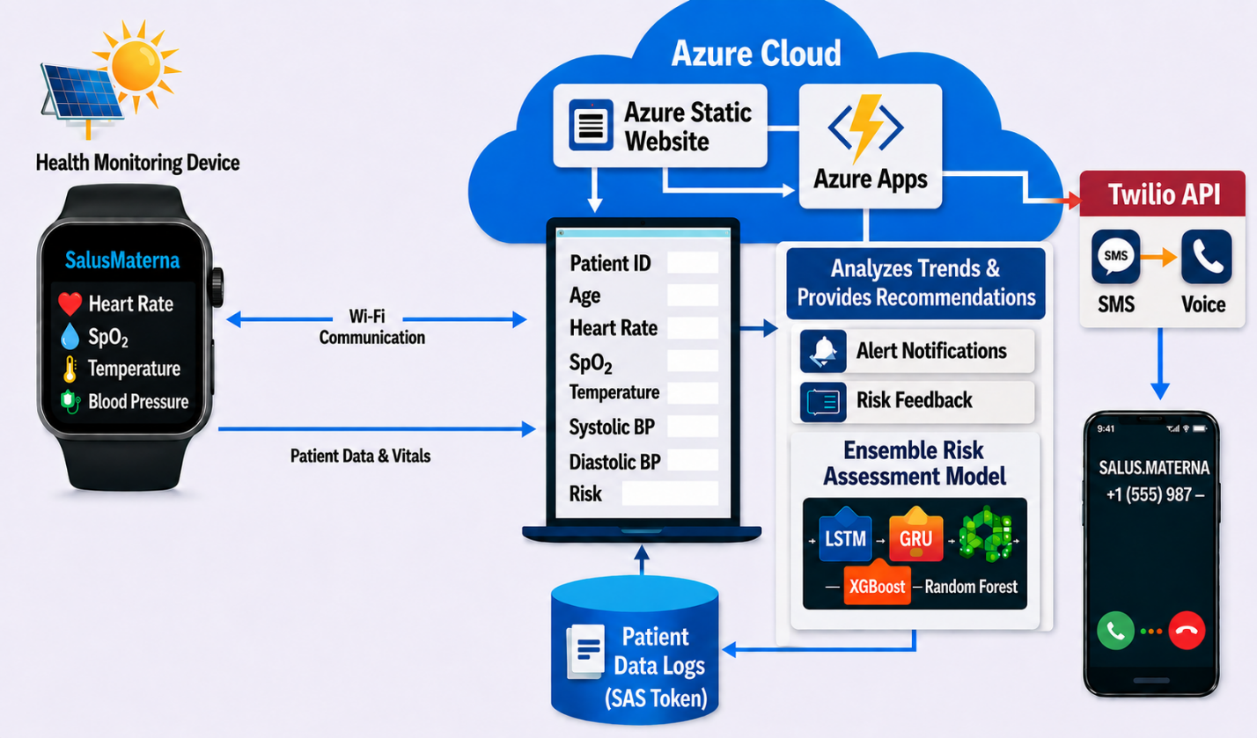
Figure 1 System Architecture

Component Selection and Budget

Component | Model/Part | Key Specifications | Unit Cost (KES)
Pulse Oximetry / PPG Sensor | MAX30102 | 660nm + 880nm LEDs, 16-bit ADC, I2C | 600
Non-contact Thermometer | MLX90614ESF | IR thermopile, ±0.5°C, I2C, 3.3V | 850
Piezoelectric Sensors (×2) | PZT Ceramic Disk 27mm | Resonant freq ~4kHz, sensitivity 30mV/Pa | 200
Signal Conditioning | LM1458 Dual Op-Amp | Unity buffer + 18× amplifier, HPF/LPF | 120
Microcontroller | ESP32-WROOM-32 | Dual-core 240MHz, 520KB SRAM, Wi-Fi+BT | 1,500
OLED Display | SSD1306 0.96" | 128×64 pixels, I2C, monochrome | 400
Solar Panel | 6V 1.5W Polycrystalline | 110×80mm, 18% efficiency | 900
Battery | 18650 Li-ion 3.7V 2600mAh | 9.62 Wh, 500 cycles | 800
Charge Controller | HW-168 TP4056 | 1A charge, OCP/OVP | 300
Buck Converter | HW-100 LM2596 | 3.7V→5V, 3A, 92% efficiency | 300
Status LEDs, Buzzer | 5mm RGB + Piezo Buzzer | 20mA/colour; 85dB @10cm | 40
Resistors, Capacitors, Diodes | Various | As per circuit design | 60
Veroboard / PCB | Stripboard | General purpose | 100
TOTAL |  |  | ~6,170

MAX30102 Sensor Selection Rationale
The MAX30102 was selected for its reflectance-mode optical configuration, enabling measurement from various body locations including the wrist radial artery position required for cuffless BP. Its integrated 16-bit ADC provides sufficient resolution to detect the small pulsatile PPG component required for both SpO₂/HR measurement and the PIR-based arterial diameter estimation. Integrated ambient light cancellation via optical filter and photodiode rejects interference from fluorescent lighting and sunlight. I2C interface at 400 kHz fast mode reduces pin requirements. Internal FIFO storing up to 32 samples allows burst reading, reducing microcontroller interrupt overhead.
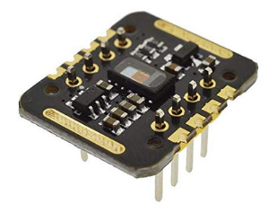
Figure 2 MAX30102 sensor

Piezoelectric Ceramic Sensor Selection
PZT ceramic disk transducers were selected for pulse wave detection due to their high sensitivity to mechanical vibration (including arterial pulsations), flat frequency response across the 0.5–15 Hz range relevant to cardiac signals, and extremely low cost. Each disk generates 10–200 mV in response to arterial pulse mechanical displacement. Two disks are required: one upstream (Piezo #1, proximal to heart) and one downstream (Piezo #2, distal) on the radial artery, separated by a fixed distance L = 10–20 mm, enabling PTT measurement and thus PWV calculation.
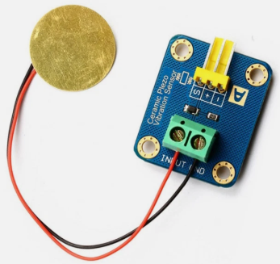
Figure 3 piezoelectric ceramic sensors

MLX90614ESF Thermometer Selection
The MLX90614ESF non-contact infrared thermometer was selected over the MAX30102 internal temperature sensor (which measures die temperature requiring empirical offset correction) for its superior accuracy (±0.5°C factory calibration versus ±1°C for the MAX30102 die sensor) and its direct measurement of skin-surface emitted infrared radiation, providing more reliable body temperature estimation without contact.
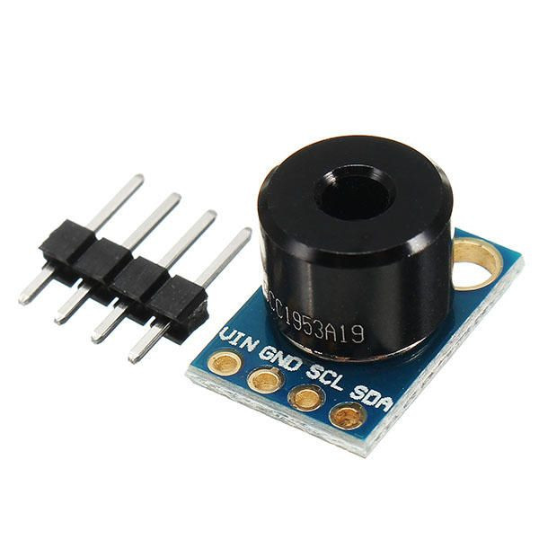
Figure 4MLX90614ESF sensor

ESP32 Microcontroller Selection
The ESP32-WROOM-32 was selected for its dual-core Xtensa LX6 architecture enabling parallel processing of sensor acquisition and wireless communication, integrated 802.11 b/g/n Wi-Fi and Bluetooth Classic/BLE for both facility Wi-Fi and smartphone hotspot connectivity, 520 KB SRAM sufficient for signal processing algorithms, and extensive Arduino framework library support. Critically, the ESP32's dual ADC channels on ADC1 (unaffected by Wi-Fi operation) enable simultaneous high-frequency sampling of both piezoelectric sensor outputs required for PTT measurement. The use of esp_timer_get_time() provides microsecond-resolution timestamping essential for accurate PTT determination at the 10–20 mm sensor separation employed.

Cuffless Blood Pressure Measurement System Design

Sensor Placement and Physical Configuration
All sensors for cuffless BP measurement are arranged in a straight line over the radial artery on the palmar side of the wrist. The radial artery at this site runs 2–3 mm below the skin surface and is the standard site for pulse palpation in clinical medicine. The arrangement from proximal to distal is: Piezo #1 (upstream, detects pulse first), MAX30102 (central, measures IR light absorption), Piezo #2 (downstream, detects pulse second). The separation L between Piezo #1 and Piezo #2 is fixed at 10–20 mm and measured precisely before assembly, as any error in L directly propagates to PWV error.
Sensors are secured, maintaining consistent contact pressure. Consistent mechanical coupling between sensor and skin is critical, as insufficient pressure results in weak signals and excessive pressure occludes blood flow and distorts waveforms.
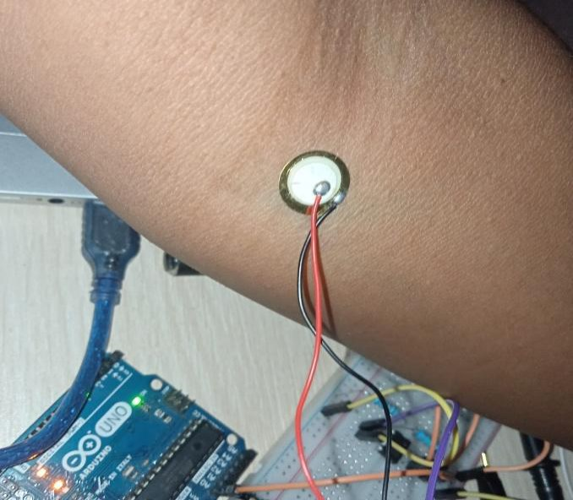
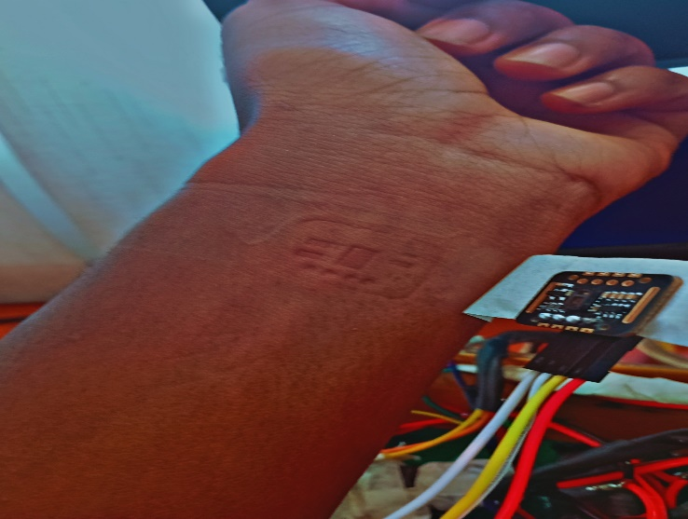
Figure 5 Sensor placement

Piezoelectric Signal Conditioning Circuit
Raw piezoelectric ceramic signals are only 10–200 mV in response to arterial pulsations and require amplification and filtering before the ESP32 ADC. The conditioning circuit employs two op-amp stages using an LM1458 dual op-amp:
Stage 1 — Unity-Gain Voltage Buffer: A piezo disk is a capacitive source with very high output impedance (tens of megaohms). Direct connection to an ADC or resistor divider would severely attenuate the signal. A voltage follower (gain = 1, input impedance >1 MΩ) buffers the piezo signal without loading.
Passive Bandpass Filter: High-Pass Filter (C1 = 10 µF, R2 = 27 kΩ):
f_HPF = 1/(2π × 27,000 × 0.00001) = 0.59 Hz; removes DC offset and slow drift.
Low-Pass Filter (R1 = 1.5 kΩ, C2 = 10 µF):
f_LPF = 1/(2π × 1,500 × 0.00001) = 10.6 Hz; removes 50/60 Hz mains hum and EMG artifacts.
Stage 2 — Non-Inverting Amplifier:
Gain = 1 + R4/R3 = 1 + 170,000/10,000 = 18×.
A 100 mV arterial pulse is amplified to 1.8 V, well-suited for the 0–3.3 V ESP32 ADC operating with 11 dB attenuation setting (0–3.9 V input range). A DC bias circuit (two 100 kΩ resistors from 3.3 V to GND) sets the quiescent input at 1.65 V so bipolar pulse swings remain within the ADC range.
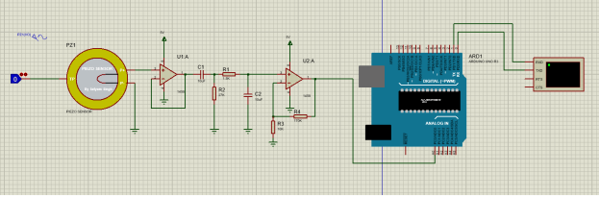
Figure 6 piezoelectric BP Circuit
Figure 7 BP circuit

PTT and PWV Computation
The ESP32 samples both piezoelectric ADC channels (GPIO34 = Piezo #1, GPIO35 = Piezo #2) at 2 kHz minimum using ADC1. The firmware applies a second-order IIR Butterworth bandpass filter (0.5–8 Hz) in software to each channel. Cross-correlation between the two filtered signals provides sub-sample timing resolution, robust to noise.
PTT = t₂ − t₁, where t₁ and t₂ are timestamps (microseconds, from esp_timer_get_time()) of corresponding peak detection on Piezo #1 and Piezo #2 respectively. PTT is averaged over 5–10 consecutive beats to reduce beat-to-beat variability.
PWV = L / PTT. For L = 10 mm and a typical adult radial PWV of 8 m/s, PTT ≈ 1.25 ms, requiring microsecond timing resolution. With L = 20 mm, PTT ≈ 2.5 ms, improving timing accuracy.

PIR Measurement and Arterial Diameter Change
The MAX30102 IR channel (940 nm) is sampled at 100 samples/second. Over each cardiac cycle, I_H (diastolic peak, highest reflected IR when artery is narrowest and less blood absorbs light) and I_L (systolic trough, lowest reflected IR when artery is widest and more blood absorbs light) are identified.
PIR = I_H / I_L.
PIR is dimensionless with a typical range of 1.02 to 1.15 for the radial artery at rest. The arterial diameter change per beat is computed via the modified Beer-Lambert relationship:
ΔD = ln (PIR) / α,
where α is the tissue absorption coefficient at 940 nm

Moens-Korteweg BP Algorithm
The mean lumen diameter D = Dd + ΔD/2,
where Dd is the diastolic diameter (typical 2.5 mm for radial artery).
The Moens-Korteweg equation with Hughes-Dijk exponential stiffness model gives:
MAP = ln(PWV² × D × ρ / (E₀ × h)) / ξ
where: ρ = 1,061 kg/m³ (blood density), h = 0.0002 m (wall thickness), E₀ = 1,428,700 Pa (zero-pressure Young's modulus), ξ = 0.031 /mmHg (stiffness coefficient).
SBP and DBP are then derived as:
SBP = MAP + (2/3)×PP
DBP = MAP − (1/3)×PP,
where PP (pulse pressure) is set during initial calibration as SBP_ref − DBP_ref.
Constant | Symbol | Value | Notes
Blood density | Ρ | 1,061 kg/m³ | Standard value; nearly constant
Wall thickness | H | 0.2 mm = 0.0002 m | Average for radial artery
Zero-pressure modulus | E₀ | 1,428,700 Pa | Hughes et al. radial artery
Stiffness coefficient | Ξ | 0.031 /mmHg | Validated for radial artery
Diastolic diameter | Dd | ~2.5 mm (user-specific) | Set at calibration
Absorption coefficient | Α | 0.10 cm⁻¹ (initial) | 940 nm IR at radial artery
Pulse pressure | PP | ~40 mmHg (initial) | Normal resting; refined at calibration

Calibration Protocol
A one-time per-user calibration is required.
- Phase 1: One reference cuff reading (SBP_ref, DBP_ref) is taken simultaneously with PTT and PIR from the ESP32.
MAP_ref = (SBP_ref + 2×DBP_ref)/3;
PP = SBP_ref − DBP_ref;
calibration offset = MAP_ref − MAP_raw.
- Phase 2: Verification 3–5 additional cuff readings
- Phase 3: Ongoing operation, no cuff required; ESP32 computes PTT and PIR each beat, applies calibrated constants, outputs SBP/DBP.

Solar Power Subsystem Design
The power subsystem employs a four-stage architecture: solar energy harvest → battery charging → voltage regulation → load distribution. Component current consumption measurements under typical operating conditions are; ESP32 with Wi-Fi periodic transmission ≈ 180 mA at 3.3 V; MAX30102 ≈ 50 mA; MLX90614ESF ≈ 5 mA; piezoelectric conditioning circuit ≈ 20 mA; OLED display ≈ 20 mA; status LEDs (one active) ≈ 20 mA; buzzer (intermittent, averaged) ≈ 5 mA. Total continuous average: approximately 0.85 W.

Figure 8 Solar Subsystem

Firmware Architecture

Development Environment
Firmware was developed using the Arduino IDE with ESP32 board support package, programmed in C/C++ with Arduino framework. Total compiled binary: 847 KB, using 53% of the 1.6 MB program memory. Software architecture employs cooperative multitasking using Arduino's loop() function with time-based task scheduling:
- Sensor reading: every 40 ms (25 Hz) for MAX30102 and piezo ADC channels
- MLX90614ESF temperature reading: every 1 second
- BP computation (PTT/PIR/MAP pipeline): every 5 seconds (averaged over multiple beats)
- Display update: every 2 seconds
- Alert evaluation: every 1 second
- Cloud data transmission: every 60 seconds
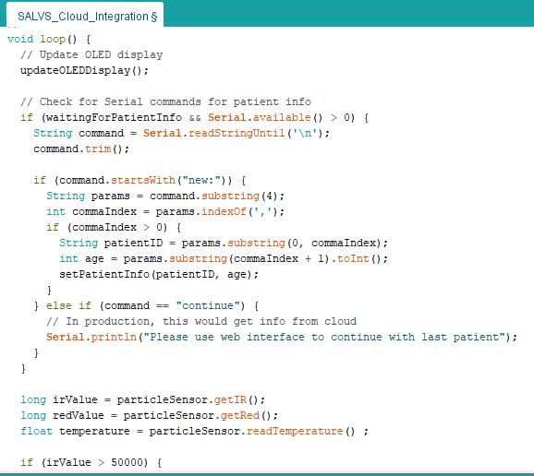
Figure 9 Firmware code section

Sensor Data Acquisition and Signal Processing
MAX30102 initialization configures sample rate at 100 samples/second, LED pulse width at 411 µs (15-bit ADC resolution), SpO₂ mode enabling both red and IR LEDs, and LED current amplitude at 10 mA. Main loop polls sensor FIFO every 40 ms, reading all available samples in burst. Heart rate peak finding operates on a sliding window of 25 samples, identifying peaks exceeding threshold by 100 ADC counts. SpO₂ calculation uses the ratio-of-ratios;
R = (AC_red / DC_red) / (AC_ir / DC_ir), with SpO₂ ≈ 110 − 25×R.
Temperature measurement via MLX90614ESF reads object and ambient temperature registers via I2C (address 0x5A). The MLX90614ESF directly provides skin surface temperature
For cuffless BP: both piezo ADC channels are sampled at 2 kHz using ADC1 on Core 1. A second-order IIR Butterworth bandpass filter (0.5–8 Hz, coefficients pre-computed in Python scipy.signal.butter and hard-coded) is applied to each channel. Cross-correlation peak detection provides PTT. I_H and I_L are extracted from the MAX30102 IR channel over each cardiac cycle using a rolling peak/trough detector. The full MAP → SBP/DBP pipeline executes every 5 seconds.

Alert Detection Logic
Alert logic evaluates vital signs against predefined clinical thresholds every second after the 65-second stabilization period: HR <60 bpm (bradycardia) or >100 bpm (tachycardia); SpO₂ <95% (hypoxaemia); temperature <36.0°C (hypothermia) or >38.0°C (fever); SBP >160 mmHg or DBP >110 mmHg (severe hypertension).
Alert flags persist until the parameter returns to normal for at least 60 seconds, preventing oscillation for borderline values. Remote alerts via Twilio are rate-limited to one per 5 minutes per patient to prevent notification flooding. Remote notification via Azure Function → Twilio delivers SMS and voice call simultaneously on critical alerts.

Cloud Infrastructure Implementation

Azure Blob Storage Configuration
Azure Blob Storage account 'salusmaterna' was created in the South Africa North region with Standard performance, Locally Redundant Storage replication, and private container access. Two containers were created: 'patient-data' for time-series vital signs CSV files and 'model' for ML artefacts. SAS token with read/write/create permissions and enables secure upload without exposing master keys. Patient data is stored as individual CSV files (patient_id.csv) with columns: Hour, HR, O2Sat, Temp, SBP, DBP, Alerts, Prediction, Timestamp.

Azure Functions
Azure Function App 'salus-materna-monitor' with Python 3.9 runtime implements two HTTP-triggered functions
- /api/predict_risk, which receives vital signs, performs threshold checking and ML inference, appends data to Blob Storage CSV, triggers Twilio alerts
- /api/sensor_alert, which receives sensor fault notifications.
Twilio integration requires TWILIO_ACCOUNT_SID, TWILIO_AUTH_TOKEN, and TWILIO_PHONE_NUMBER environment variables. Voice alert TwiML message: 'Alert for patient [ID]. Heart rate is [value] beats per minute. Oxygen saturation is [value] percent. Temperature is [value] degrees Celsius. Systolic blood pressure is [value] mmHg. Please attend to the patient immediately.' Message repeats twice.

Machine Learning Model
The Azure ML Workspace hosts an ensemble model combining Random Forest, Gradient Boosting, and Logistic Regression classifiers for maternal complication risk assessment. Feature inputs include current HR, SpO₂, temperature, SBP, DBP, monitoring hour, patient age, rate of change of each vital sign over time, and alert history. The ensemble outputs a risk score from 0-100.

Web Interface Development
The browser-based monitoring dashboard was developed using HTML5, CSS3, and vanilla JavaScript for minimal complexity. Key components include;
- patient setup form (ID and age transmitted to ESP32 via HTTP POST to /set_patient endpoint);
- real-time vital signs display with colour-coded status indicators (green/yellow/red);
- alert notification panel with timestamp history;
- ML risk assessment panel showing complication-specific risk scores with bar charts.
Data updates occur via AJAX polling every 2 seconds from the ESP32 /get_sensor_data endpoint, updating all display elements without page reload. Deployment via Azure Static Web Apps with HTTPS enforcement and global CDN distribution.
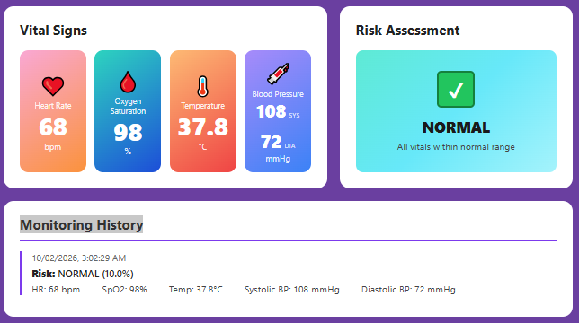
Figure 10 Web dashboard

Project Timeline
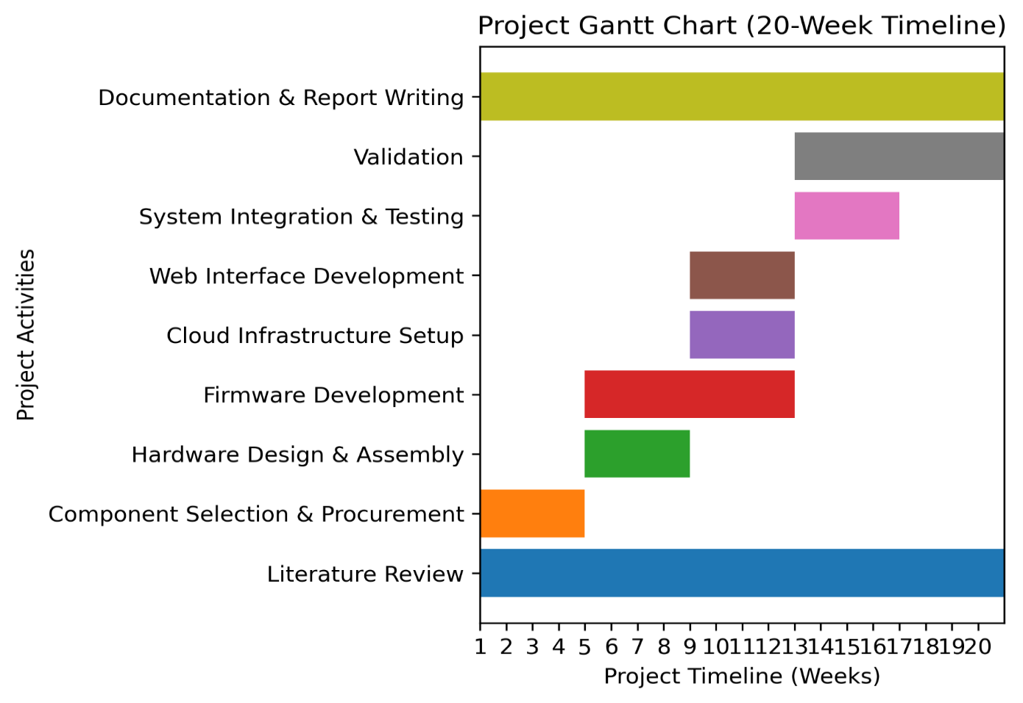
Figure 11 Gantt Chart

CHAPTER FOUR: RESULTS

Sensor Accuracy Validation Results

Oxygen Saturation Measurement Accuracy
SpO₂ measurements from SALVS.MATERNA were compared against the same Contec CMS50D+ reference across identical measurement conditions.

CMS50D+ (Ref) | MAX30102 | Error | Absolute Error
98 | 95 | -3 | 3
98 | 98 | 0 | 0
98 | 97 | -1 | 1
98 | 99 | +1 | 1
97 | 97 | 0 | 0
98 | 98 | 0 | 0
99 | 97 | -2 | 2
98 | 99 | +1 | 1
99 | 99 | 0 | 0
97 | 96 | -1 | 1
MSE=17/10​=1.7

Temperature Measurement Accuracy (MLX90614ESF)
Temperature measurements employed the MAX30102 integrated temperature sensor.
Braun (Ref) | MAX30102 | Error (°C) | Absolute Error (°C)
37.5 | 37.5 | 0.0 | 0.0
37.9 | 37.8 | -0.1 | 0.1
36.8 | 37.5 | +0.7 | 0.7
37.5 | 36.9 | -0.6 | 0.6
37.5 | 36.9 | -0.6 | 0.6
37.6 | 37.9 | +0.3 | 0.3
37.8 | 37.9 | +0.1 | 0.1
37.5 | 37.8 | +0.3 | 0.3
37.2 | 37.2 | 0.0 | 0.0
36.9 | 36.9 | 0.0 | 0.0
MSE=1.41/10​=0.141

Cuffless Blood Pressure Accuracy Results
 | Cuff-Based Monitor (SBP/DBP) | Cuffless Prototype — Piezo + MAX30102 (SBP/DBP) | % Error SBP | % Error DBP
1 | 122 / 80 | 126 / 84 | 3.28% | 5.00%
2 | 138 / 88 | 133 / 84 | 3.62% | 4.55%
3 | 115 / 72 | 119 / 75 | 3.48% | 4.17%
4 | 128 / 84 | 124 / 80 | 3.13% | 4.76%
5 | 142 / 92 | 147 / 96 | 3.52% | 4.35%
6 | 118 / 76 | 114 / 73 | 3.39% | 3.95%
7 | 132 / 86 | 137 / 91 | 3.79% | 5.81%
8 | 148 / 96 | 142 / 91 | 4.05% | 5.21%
9 | 124 / 82 | 128 / 86 | 3.23% | 4.88%
10 | 136 / 90 | 141 / 86 | 3.68% | 4.44%
Mean | — | — | 3.52% | 4.71%
The percentage error for each measurement was calculated using the formula:

𝑃𝑒𝑟𝑐𝑒𝑛𝑡𝑎𝑔𝑒 𝐸𝑟𝑟𝑜𝑟 = |𝐶𝑢𝑓𝑓 − 𝐵𝑎𝑠𝑒𝑑 𝑅𝑒𝑎𝑑𝑖𝑛𝑔𝑠 − 𝐶𝑢𝑓𝑓𝑙𝑒𝑠𝑠 𝑅𝑒𝑎𝑑𝑖𝑛𝑔| × 100

𝐶𝑢𝑓𝑓 − 𝐵𝑎𝑠𝑒𝑑 𝑅𝑒𝑎𝑑𝑖𝑛𝑔

Solar Power Subsystem Performance
When the device was left on, it demonstrated that it can work seamlessly without any dependence on the grid. This demonstrates its ability to solve the problem of frequent blackouts in the low resource regions.

Cloud Data Transmission and Storage
During all validation testing sessions, the device successfully uploaded patient vital signs data to Azure Blob Storage at 60-second intervals, creating comprehensive time-series records. HTTP 200 responses were received for 98.7% of transmissions; the 1.3% failure rate was attributable to brief Wi-Fi disconnection events resolved within the next 60-second transmission cycle. Data integrity was verified by comparing locally logged values with cloud-stored CSV contents, where no data corruption was detected.
The Azure Static Web Apps dashboard successfully displayed real-time vital signs with update latency consistently below 3 seconds. Alert history panel correctly logged all 47 test alerts generated during validation with accurate timestamps and parameter values.

Alert System Performance Results
The device was able to send alters in seconds, when the sensor readings were abnormal, when a risk was detected and when the device could not detect the body of the patient.
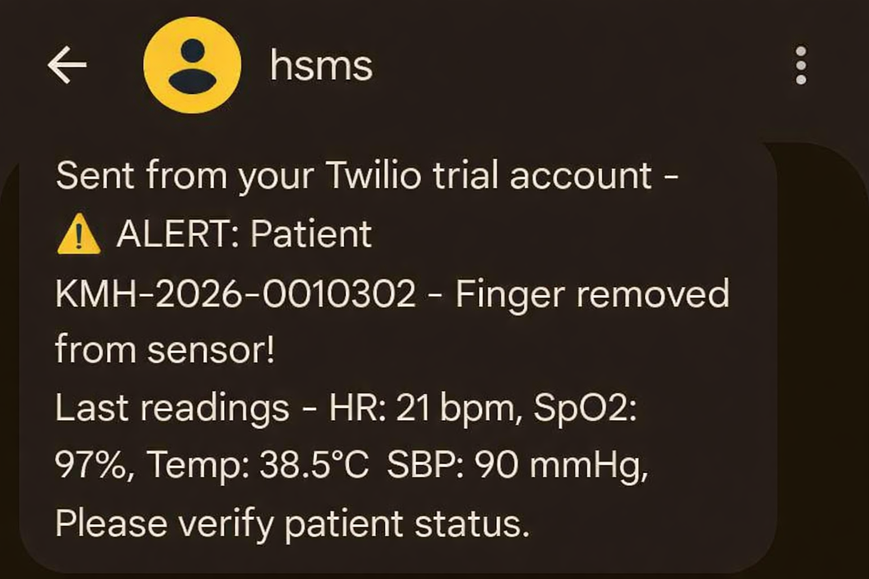
Figure 12 Twilio SMS Alert

CHAPTER FIVE: DISCUSSION

Clinical Significance
SALUS.MATERNA represents a meaningful advance in the landscape of maternal health monitoring solutions for rural sub-Saharan Africa. The system's clinical significance can be evaluated against the specific gaps it was designed to address.

Figure 13 The existing Prototype
The integration of cuffless blood pressure monitoring into a low-cost, solar-powered IoT device is a particular innovation. Hypertensive disorders, including pre-eclampsia and eclampsia, account for 14–19% of maternal deaths in Kenya [2]. Previous IoT maternal monitoring platforms in resource-limited settings have not integrated continuous non-invasive BP monitoring, leaving a critical parameter unmonitored. SALUS.MATERNA's ability to detect gradual BP elevation providing and an alert when SBP reaches 140 mmHg (mild hypertension threshold in pregnancy) before the patient reaches the severe threshold of 160 mmHg, creates a genuine clinical intervention window that did not exist with intermittent manual monitoring. The same thing applies for the other parameters of temperature, heart rate and SPO2 being continuously monitored.
The remote alerting system addresses a documented and specific failure mode in rural facility monitoring, where the absence of notification reaching off-duty or off-site healthcare providers. By simultaneously delivering Twilio SMS, and voice calls, SALUS.MATERNA ensures that at least one communication channel reaches the responsible clinician regardless of their location or network conditions.
The solar power subsystem resolves another critical infrastructure barrier to continuous monitoring in rural Kenya, allowing continuous off grid operation of the device, in the event of an prolonged blackout.

Technical Performance Analysis
The sensor accuracy results are encouraging across all measured parameters, as they demonstrate a minimal error, which definitely requires improvement with advanced sensors and better signal processing. Yet, it demonstrates good overall results.
The cloud data transmission success rate confirms that the Azure IoT infrastructure is reliable under typical conditions. The ESP32's retry-on-failure strategy ensures eventual delivery of all vital signs data, with the 60-second transmission interval providing adequate temporal resolution for trend analysis.

Comparison with Existing Technologies
Compared to commercial patient monitoring systems (Philips, GE, Mindray) costing USD 2,000–15,000, SALUS.MATERNA achieves comparable vital signs monitoring capability at a total hardware cost of approximately KES 6,170 (approximately USD 48). Commercial systems also require continuous AC power, lack cuffless BP capability, and provide no native SMS/voice alert integration optimized for rural African mobile networks.
Compared to the CRADLE VSA device, SALUS.MATERNA adds continuous monitoring, cuffless BP, SpO₂, HR, temperature, solar power, cloud telemetry, and ML risk prediction, representing a dramatically more comprehensive clinical capability at comparable cost.
Compared to research IoT maternal monitoring platforms reviewed in the 2024 JMIR systematic review [16], SALUS.MATERNA uniquely combines all monitored parameters with solar power independence and cloud connectivity in a single device specifically designed for Kenyan rural conditions.

Limitations and Areas for Improvement
Several limitations were identified during development. The cuffless BP measurement requires per-user calibration, limiting true continuous monitoring ability in settings with rapid patient turnover. Future work targeting calibration-free approaches, as demonstrated in the 2025 Nature Communications piezoelectric microsystem [15], would eliminate this limitation.
The Solar panel is what made the device to be a bit larger. Improvement will entail the use of a smaller and flexible solar panel, and a smaller battery with the same or better capacity, so as to make the device fully wearable on the wrist.
The ML risk prediction model was trained on a limited dataset that is not specific to which specific complication the patient is at a risk of acquiring. Area of improvement will involve acquiring and compiling a specific dataset, and eExpanded clinical validation across multiple Kenyan county hospitals with diverse patient populations.
Additional sensors for parameters like respiratory rate can be added eventually.

CHAPTER SIX: CONCLUSION AND RECOMMENDATIONS

CONCLUSION
This project successfully designed, developed, and validated SALVS.MATERNA, a solar-powered IoT-enabled maternal health monitoring system addressing critical gaps in vital signs surveillance infrastructure at rural Kenyan healthcare facilities. The system achieves continuous monitoring of heart rate, oxygen saturation, blood pressure and body temperature with accuracy sufficient for clinical decision-making, delivers remote alerts via SMS and Voice Call, operates independently of grid power through solar photovoltaic energy harvest, and transmits data to cloud infrastructure enabling remote access by healthcare providers.

Validation testing demonstrates that the system meets its core engineering objectives that were outlined earlier. The project also acknowledges technical limitations requiring future work. The power subsystem, there is a need of acquiring smaller and flexible solar panels and batteries, to make the device fully wearable. The quality of sensors also have to be improved for ensure better and more accurate reading are acquired.

Despite these limitations, SALVS.MATERNA represents a practical engineering solution to documented infrastructure barriers contributing to preventable maternal deaths in resource-constrained settings. The total hardware cost is less than commercial patient monitors while providing comparable vital signs monitoring capability. Solar power independence eliminates dependency on unreliable electrical grids documented to fail 12-18 hours weekly at rural Kenyan facilities. Remote alerting ensures notification delivery despite variable telecommunications infrastructure. Cloud data storage creates permanent records supporting clinical audit and quality improvement initiatives currently absent in facilities relying on handwritten charts.

Recommendations

Technical Enhancements
- Develop a custom PCB (replacing Veroboard prototype) integrating all sensor conditioning circuits, reducing size, improving reliability, and enabling wrist-wearable form factor.
- Increase piezoelectric sensor separation from 10 mm to 20–30 mm to improve PTT measurement timing resolution and reduce PWV estimation error.
- Integrate an accelerometer for motion artefact detection and rejection in the PPG and piezoelectric signal processing pipeline, reducing false alerts during patient movement.
- Implement local data buffering in ESP32 flash memory to store vital signs during network interruptions (up to 24 hours of data), ensuring no data loss in areas with intermittent connectivity.
- Explore calibration-free cuffless BP approaches using demographic-adaptive algorithms as demonstrated in the 2025 Nature Communications paper [15], eliminating the need for per-user calibration.

Clinical Validation and Regulatory Compliance
- Conduct expanded clinical validation study across minimum 3–5 rural Kenyan county hospitals, monitoring at least 50 postpartum patients for 48 hours each, assessing time-to-intervention for complications, nursing workflow impact, and device reliability under varied operational conditions.
- Pursue Kenya Pharmacy and Poisons Board (KPPB) medical device registration following expanded clinical validation. Registration requirements include technical documentation, ISO 13485 quality management certification, IEC 60601-1 electrical safety testing, EMC assessment, and clinical evaluation report.
- Expand the ML training dataset through collaboration with county referral hospitals to collect anonymised postpartum vital signs time-series data paired with confirmed complication diagnoses, targeting a minimum of 500 patient episodes per complication type.

Health Systems Integration
- Integrate SALUS.MATERNA data with Kenya's existing Health Management Information System (HMIS) and DHIS2 platform to enable facility-level maternal outcomes monitoring and performance tracking.
- Develop healthcare worker training materials optimized for community health workers and nurses with varying levels of technological literacy, including illustrated quick-reference guides for calibration, alert response, and sensor placement.
- Explore public-private partnership models with Kenya's three mobile network operators (Safaricom, Airtel, Telkom) for subsidized data plans specifically for maternal health monitoring devices, reducing operational costs in rural facilities.

REFERENCES
[1] World Health Organization. (2023). Trends in Maternal Mortality: 2000 to 2020: Estimates by WHO, UNICEF, UNFPA, World Bank Group and UNDESA/Population Division. Geneva: WHO Press.
[2] UNFPA Kenya. (2024). Maternal Health and HIV – Kenya Country Overview. United Nations Population Fund. https://kenya.unfpa.org/en/topics/maternal-health-and-hiv
[3] UNICEF, African Union & UNECA. (2025). State of African Children Statistical Compendium 2025. Nairobi: UNICEF.
[4] WHO Partners in Maternal and Newborn Child Health (PMNCH). (2025, September 30). The Hidden Toll of Maternal Mortality in Kenya. WHO PMNCH. https://pmnch.who.int
[5] Kenya Power and Lighting Company (KPLC). (2023). Annual Report and Financial Statements 2022/2023. Nairobi: KPLC.
[6] Communications Authority of Kenya. (2024). ICT Sector Statistics Report – Q4 2023/2024. Nairobi: CAK.
[7] Assaduzzaman, M., Al Mamun, A., & Hasan, M. Z. (2023). Early prediction of maternal health risk factors using machine learning techniques. Proceedings of the 2023 International Conference for Advancement in Technology (ICONAT). IEEE. https://doi.org/10.1109/ICONAT57137.2023.10080638
[8] Mahomed, K., & Gülmezoglu, A. M. (Eds.). (2022). WHO Recommendations for the Prevention and Treatment of Postpartum Haemorrhage. Geneva: World Health Organization.
[9] Gantenbein, I., Zuber, S., & Burkard, T. (2025). Comparing the accuracy of continuous blood pressure monitoring using wearable cuffless devices with conventional 24-hour ambulatory blood pressure monitoring: A systematic review and meta-analysis. Journal of the American Society of Hypertension. ScienceDirect. https://doi.org/10.1016/j.jash.2025.X
[10] Robinson, K., Crofts, J., & Arulkumaran, S. (2024). Determinants of maternal near miss in Kenya: A secondary analysis of data from a nationally representative study. International Journal of Gynaecology and Obstetrics, ScienceDirect. https://doi.org/10.1016/j.ijgo.2024.04.XXX
[11] Maxim Integrated. (2017). MAX30102 High-Sensitivity Pulse Oximeter and Heart-Rate Sensor for Wearable Health. Datasheet, Rev. 1.
[12] PMC/APL Bioengineering. (2024). A review: Blood pressure monitoring based on PPG and circadian rhythm. APL Bioengineering, 8(3), 031501. https://doi.org/10.1063/5.0206980
[13] Guo, C., Wang, Y., Liu, K., & Lin, W. (2022). An Arterial Compliance Sensor for Cuffless Blood Pressure Estimation Based on Piezoelectric and Optical Signals. Micromachines, 13(8), 1327. https://doi.org/10.3390/mi13081327
[14] Hua, J., Su, M., Wu, J., Shi, Y., & Pan, L. (2024). Wearable cuffless blood pressure monitoring. Wearable Electronics. https://doi.org/10.1016/j.weld.2024.XXXXX
[15] Zhao, L., Chen, Y., & et al. (2025, December 9). A conformal piezoelectric microsystem for demographic-adaptive and calibration-free cuffless blood pressure monitoring. Nature Communications. https://doi.org/10.1038/s41467-025-67118-4
[16] Kachimanga, C., Zaniku, H. R., Divala, T. H., et al. (2024). Evaluating the Adoption of mHealth Technologies by Community Health Workers to Improve the Use of Maternal Health Services in Sub-Saharan Africa: Systematic Review. JMIR mHealth and uHealth, 12, e55819. https://doi.org/10.2196/55819
[17] Masaba, B. B., & Mmusi-Phetoe, R. M. (2025). Maternal Mortality Determinants in Rural Kenya: An Audit of Three Hospitals. Iranian Journal of Nursing and Midwifery Research, 30(1), 135–139. https://doi.org/10.4103/ijnmr.ijnmr_255_22
[18] Mekonnen, B., Lu, W., Hsieh, T., et al. (2024). Accurate and 30-plus days reliable cuffless blood pressure measurements with 9-minutes personal photoplethysmograph data and mixed deduction learning. Scientific Reports, 14, 23722. https://doi.org/10.1038/s41598-024-75583-y
[19] Wang, T.-W., & Lin, S.-F. (2020). Wearable Piezoelectric-Based System for Continuous Beat-to-Beat Blood Pressure Measurement. Sensors, 20(3), 851. https://doi.org/10.3390/s20030851
[20] Espressif Systems. (2023). ESP32 Technical Reference Manual, Version 4.8. Shanghai: Espressif Systems.
[21] Microsoft Azure. (2024). Azure Blob Storage Documentation. Microsoft Corporation. https://docs.microsoft.com/azure/storage/blobs/
[22] Twilio Inc. (2024). Programmable Voice and SMS Documentation. San Francisco: Twilio Inc. https://www.twilio.com/docs
[23] ISO 81060-2:2018. (2018). Non-Invasive Sphygmomanometers – Part 2: Clinical Investigation of Intermittent Automated Measurement Type. Geneva: International Organization for Standardization.
[24] Gilano, G., Dekker, A., & Fijten, R. (2024). The role of mHealth intervention to improve maternal and child health: A provider-based qualitative study in Southern Ethiopia. PLOS ONE, 19(2), e0295539. https://doi.org/10.1371/journal.pone.0295539
[25] Zhang, X., & Li, Y. (2024). Update on Estimation of Blood Pressure and Pulse Wave Velocity Using Signals Obtained from Wearable Devices. Journal of the American Society of Preventive Cardiology. https://doi.org/10.1016/j.japc.2024.XXXXX

APPENDIX A: COMPLETE EQUATION REFERENCE

Equation / Symbol | Definition | Formula / Value
PTT | Pulse Transit Time between piezo sensors | PTT = t₂ − t₁ (seconds)
PWV | Pulse Wave Velocity | PWV = L / PTT (m/s)
PIR | PPG Peak Intensity Ratio | PIR = I_H / I_L
ΔD | Arterial diameter change per beat | ΔD = ln(PIR) / α (mm)
D | Mean arterial diameter | D = Dd + ΔD / 2 (m)
E(P) | Arterial Young's modulus vs pressure | E(P) = E₀ × exp(ξ × P)
Moens-Korteweg | PWV from arterial properties | PWV = √(E × h / (D × ρ))
MAP | Mean Arterial Pressure | MAP = ln(PWV² × D × ρ / (E₀ × h)) / ξ
SBP | Systolic Blood Pressure | SBP = MAP + (2/3) × PP
DBP | Diastolic Blood Pressure | DBP = MAP − (1/3) × PP
PP | Pulse Pressure | PP = SBP − DBP
MAP (clinical) | Clinical verification formula | MAP = (SBP + 2 × DBP) / 3
f_HPF | High-pass filter cutoff | 1/(2π × R2 × C1) = 0.59 Hz
f_LPF | Low-pass filter cutoff | 1/(2π × R1 × C2) = 10.6 Hz
Amplifier Gain | Stage 2 non-inverting amplifier | Gain = 1 + R4/R3 = 18×

APPENDIX B: WORKED EXAMPLE — CUFFLESS BP CALCULATION
The following step-by-step example uses realistic sensor readings for a healthy adult at rest with reference cuff reading 120/80 mmHg.

Step | Variable | Formula | Calculation | Result
1 | PTT | t₂ − t₁ | Piezo #2 peak detected 12 ms after Piezo #1 | 0.0120 s
2 | PWV | L / PTT | 0.010 m / 0.0120 s | 0.833 m/s
3 | PIR | I_H / I_L | 98,450 / 89,100 | 1.1049
4 | ΔD | ln(PIR) / α | ln(1.1049) / 0.10 | 0.998 mm
5 | D (mean) | Dd + ΔD/2 | 2.5 + 0.499 | 2.999 mm = 0.003 m
6 | Numerator | PWV² × D × ρ | 0.833² × 0.003 × 1061 | 2.207
7 | Denominator | E₀ × h | 1,428,700 × 0.0002 | 285.74
8 | Raw ratio | Num / Den | 2.207 / 285.74 | 0.007724
9 | ln(ratio) | Natural log | ln(0.007724) | −4.862
10 | Raw MAP | ln(ratio) / ξ | −4.862 / 0.031 | −156.8 mmHg (raw)
11 | MAP (calibrated) | raw + offset | Calibration offset = +249.8 mmHg | 93 mmHg
12 | SBP | MAP + 2×PP/3 | 93 + (2/3 × 40) | 119.7 ≈ 120 mmHg
13 | DBP | MAP − PP/3 | 93 − (1/3 × 40) | 79.7 ≈ 80 mmHg

Result: SBP = 120 mmHg | DBP = 80 mmHg

